Factors Report 20080102-20161230

**1. factor12**

**截面指标累计曲线:**

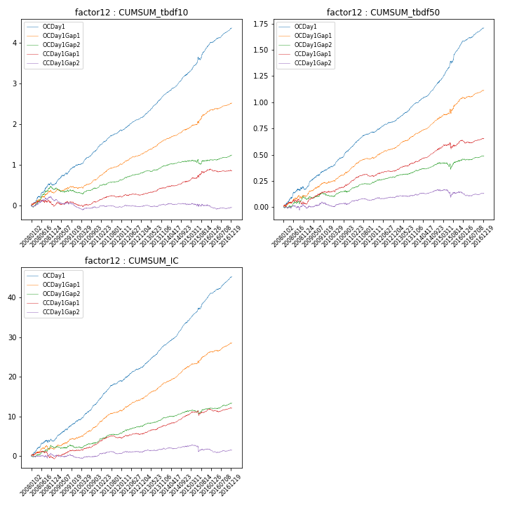

**因子换手率:** 48.53%

**截面指标_OCDay1:**

|  |  |  |  |  |  |  |  |  |
| --- | --- | --- | --- | --- | --- | --- | --- | --- |
| year | annret_tbdf10 | sharpe_tbdf10 | maxdd_tbdf10 | annret_tbdf50 | sharpe_tbdf50 | maxdd_tbdf50 | mean_IC | tstat_IC |
| 2008 | 0.52 | 4.27 | -0.07 | 0.17 | 3.22 | -0.03 | 0.02 | 3.2 |
| 2009 | 0.5 | 5.63 | -0.04 | 0.2 | 5.72 | -0.01 | 0.02 | 6.3 |
| 2010 | 0.45 | 6.8 | -0.02 | 0.2 | 6.89 | -0.01 | 0.02 | 7.25 |
| 2011 | 0.42 | 7.38 | -0.01 | 0.15 | 6.88 | -0.01 | 0.02 | 7.62 |
| 2012 | 0.32 | 6.14 | -0.02 | 0.11 | 4.55 | -0.01 | 0.01 | 5.11 |
| 2013 | 0.57 | 10.28 | -0.01 | 0.18 | 7.31 | -0.01 | 0.02 | 8.89 |
| 2014 | 0.49 | 8.79 | -0.02 | 0.2 | 8.41 | -0.01 | 0.02 | 9.59 |
| 2015 | 0.74 | 6.35 | -0.07 | 0.37 | 7.92 | -0.02 | 0.03 | 8.8 |
| 2016 | 0.4 | 7.44 | -0.01 | 0.15 | 6.45 | -0.01 | 0.02 | 8.0 |

**截面指标_CCDay1Gap1:**

|  |  |  |  |  |  |  |  |  |
| --- | --- | --- | --- | --- | --- | --- | --- | --- |
| year | annret_tbdf10 | sharpe_tbdf10 | maxdd_tbdf10 | annret_tbdf50 | sharpe_tbdf50 | maxdd_tbdf50 | mean_IC | tstat_IC |
| 2008 | -0.01 | -0.07 | -0.14 | 0.03 | 0.72 | -0.05 | -0.0 | -0.53 |
| 2009 | 0.05 | 0.57 | -0.07 | 0.11 | 3.24 | -0.01 | 0.01 | 2.86 |
| 2010 | 0.08 | 1.3 | -0.07 | 0.1 | 3.42 | -0.01 | 0.01 | 3.17 |
| 2011 | 0.12 | 2.18 | -0.04 | 0.07 | 3.05 | -0.02 | 0.01 | 2.41 |
| 2012 | 0.04 | 0.83 | -0.03 | 0.04 | 1.93 | -0.01 | 0.0 | 1.49 |
| 2013 | 0.16 | 2.97 | -0.02 | 0.09 | 3.74 | -0.01 | 0.01 | 3.63 |
| 2014 | 0.15 | 2.79 | -0.02 | 0.12 | 5.27 | -0.01 | 0.01 | 4.78 |
| 2015 | 0.31 | 3.06 | -0.04 | 0.09 | 1.67 | -0.06 | 0.01 | 1.64 |
| 2016 | -0.03 | -0.56 | -0.07 | 0.02 | 0.7 | -0.03 | 0.0 | 0.52 |

**风格暴露:**

|  |  |  |  |  |
| --- | --- | --- | --- | --- |
|  | long | short | corr_OCDay1 | corr_CCDay1Gap1 |
| liquidity10 | 0.06 | -0.05 | -0.04 | -0.03 |
| liquidity20 | 0.03 | -0.03 | -0.06 | -0.04 |
| liquidity5 | 0.1 | -0.08 | 0.01 | 0.03 |
| logmktcap | 0.18 | 0.14 | 0.12 | 0.04 |
| momentum15 | 0.08 | -0.06 | 0.16 | 0.08 |
| momentum30 | 0.05 | -0.03 | 0.13 | 0.06 |
| momentum5 | 0.08 | -0.06 | 0.2 | 0.16 |
| retvolatility30 | 0.02 | -0.01 | -0.04 | 0.02 |