Wish you where here

Pink Floyd
Source : https://www.youtube.com/watch?v=Aip8W2W44s0
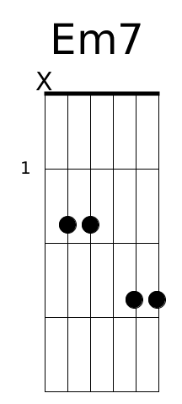 | 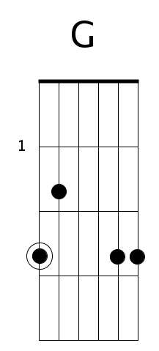 | 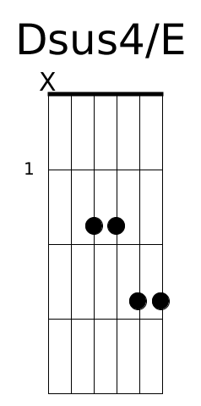
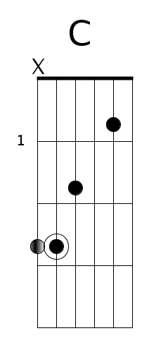 | 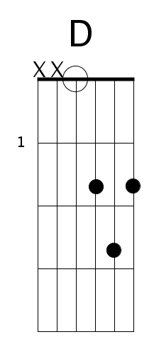 | 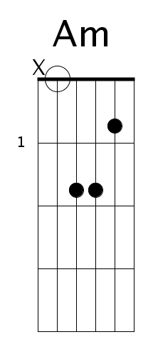

Intro
Em7 G
|-------------------|--3-------3-----3--|-------------------|--3-------3-----3--|
|-------------------|--3-------3-----3--|-------------------|--3-------3-----3--| x2
|-------------------|--0-------0-----0--|-------0-----------|--0-------0-----0--|
|-----------0---2---|--2-------2-----2--|---2-------2---0---|--0-------0-----0--|
|-------0h2---------|--2-------2-----2--|-------------------|--2-------2-----2--|
|---3---------------|--x-------x-----x--|-------------------|--3-------3-----3--|
⇓ ⇑ ⇑ ⇓ ⇑ ⇑
Em7 Dsus4/E
|-------------------|--3-------3-----3--|-------------------|--3----3-----3--3--|
|-------------------|--3-------3-----3--|-------------------|--3----3-----3--3--| x2
|-------------------|--0-------0-----0--|---2---0-----------|--2----2-----2--2--|
|-----------0---2---|--2-------2-----2--|-----------2---0---|--2----2-----2--2--|
|-------0h2---------|--2-------2-----2--|-------------------|--0----0-----0--0--|
|---3---------------|--x-------x-----x--|-------------------|--x----x-----x--x--|
⇓ ⇑ ⇑ ⇓ ⇑ ⇑ ⇓
G
|-------------3--3--|-3--3--3--3--3-----|-3--3--3-----------|
|-------------3--3--|-3--3--3--3--3-----|-3--3--3-----------|
|-------------0--0--|-0--0--0--0--0-----|-0--0--0-----------|
|-------------0--0--|-0--0--0--0--0-----|-0--0--0-----------|
|--0--2p0--- -2—-2--|-2--2--2--2--2-----|-2--2--2-----------|
|----------3--3--3--|-3--3--3--3--3--3--|-2--2--2-----------|
⇓ ⇑ ⇑ ⇓ ⇑ ⇑ ⇓ ⇓ ⇑ ⇑

Paroles

C D
So, so you think you can tell

Am
Heaven from Hell

G
Blue Skies from pain

D
Can you tell a green field

C
From a cold steel rail

Am
A smile from a veil

G
Do you think you can tell

C
Did they get you to trade

D
Your heroes for ghosts

Am
Hot Ashes for trees

G
Hot air for a cool breeze

D
Cold comfort for change

C
Did you exchange?

Am
A walk on part in the war

G
For a lead role in a cage

Refrain

C D
How I wish, how I wish you were here

Am G
We're just two lost souls swimming in a fish bowl

D
Year after year.

C
Running over the same old ground.

Am
What have we found the same old fears

G
Wish you were here...

