Guaranteed

Eddie Vedder
Source :
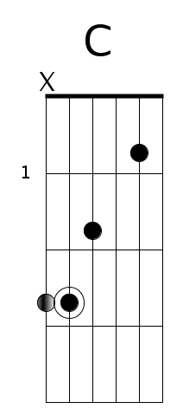
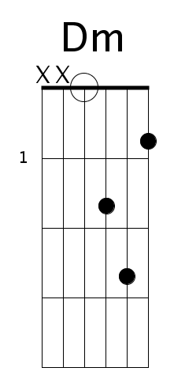

Accords
G Bm G7 C/E
|--------|--------|--------|--------|

C G D D2 D D4 D5
|--------|--------|--------|--------|
xn

Arpège
G Bm
|--3---------3-----3---------3------|--2---------2-----2---------2------|
|--------3-------3-------3-------3--|--------3-------3-------3-------3--|
|------4-------4-------4-------4----|------4-------4-------4-------4----|
|--5-------5-------5-------5--------|--4-------4-------4-------4--------|
|-----------------------------------|-----------------------------------|
|-----------------------------------|-----------------------------------|

G7 C/E
|--1---------1-----1---------1------|--0---------0-----0---------0------|
|--------3-------3-------3-------3--|--------1-------1-------1-------1--|
|------0-------0-------0-------0----|------0-------0-------0-------0----|
|--3-------3-------3-------3--------|--2-------2-------2-------2--------|
|-----------------------------------|-----------------------------------|
|-----------------------------------|-----------------------------------|

C G
|--0---------0-----0---------0------|--3---------3-----3---------3------|
|--------1-------1-------1-------1--|--------0-------0-------0-------0--|
|------0-------0-------0-------0----|--------------0---------------0----|
|-----------------------------------|------0---------------0------------|
|--3-------3-------3-------3--------|-----------------------------------|
|-----------------------------------|--3-------3-------3-------3--------|

D Dsus2 D (Dsus4 D5)
|--2---------2-----0---------0------|--0h2-------2-------3-----5--------|
|--------3-------3-------3-------3--|--------3-------3---3-----3--------|
|------2-------2-------2-------2----|------2-------2-----2-----2--------|
|--0-------0-------0-------0--------|--0-------0---------0-----0--------|
|-----------------------------------|-----------------------------------|
|-----------------------------------|-----------------------------------|

Paroles

[Verse 1]

G Bm
On bended knee is no way to be free
G7 C/E
Lifting up an empty cup, I ask silently
C G
All my destinations will accept the one that's me
D Dsus2 D Dsus4 D5
So I can breathe...

[Verse 2]

G Bm
Circles they grow and they swallow people whole
G7 C/E
Half their lives they say goodnight to wives they'll never know
C G
A mind full of questions, and a teacher in my soul
D Dsus2 D Dsus4 D5
And so it goes...

[Verse 3]

G Bm
Don't come closer or I'll have to go
G7 C/E
Holding me like gravity are places that pull
C G
If ever there was someone to keep me at home
D Dsus2 D Dsus4 D5
It would be you...

[Verse 4]

G Bm
Everyone I come across, in cages they bought
G7 C/E
They think of me and my wandering, but I'm never what they thought
C G
I've got my indignation, but I'm pure in all my thoughts
D Dsus2 D Dsus4 D5
I'm alive...

[Verse 5]

G Bm
Wind in my hair, I feel part of everywhere
G7 C/E
Underneath my being is a road that disappeared
C G
Late at night I hear the trees, they're singing with the dead
D Dsus2 D Dsus4 D5
Overhead...

[Verse 6]

G Bm
Leave it to me as I find a way to be
G7 C/E
Consider me a satellite, forever orbiting
C G
I knew all the rules, but the rules did not know me
D Dsus2 D Dsus4 D5
Guaranteed

Ooh ooh

