Dream a little dream

Mamas & Papas
Source : http://www.licknriff.com/2012/05/dream-a-little-dream/
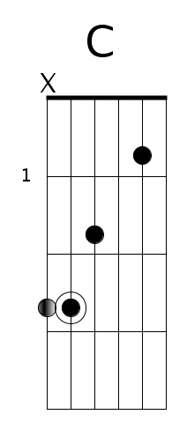 | 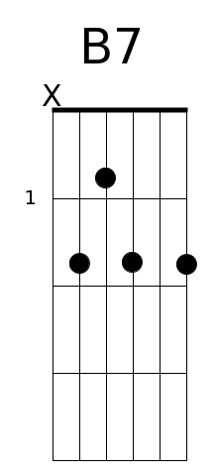 | 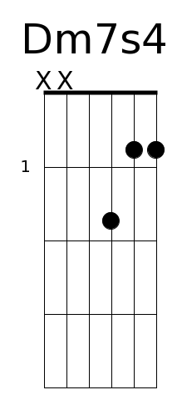 | 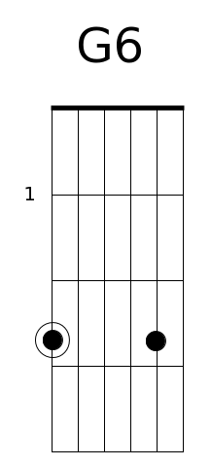

Intro
C B7 Dm7s4 G6 C C#0 Dm7 G13
|---3-0---|---2-----|-3-1-----|-0-------|---0-3-5-|-6-5-3---|-------3-|---------|
|-------1-|-0-----0-|-1---1---|---3-----|---------|-5-------|-6-5-6---|-5-5-1---|
|-----2---|---------|-2-----2-|---------|---------|---------|-5-------|-4-4-----|
|---------|-----1---|-0-------|-----0---|-----2---|---------|-0-------|-3-3-----|
|-3-------|-2-------|---------|---------|-3-------|-4-------|---------|---------|
|---------|---------|---------|-3-------|---------|---------|---------|-3-3-----|

Couplets

|-----------------------------------|-----------------------------------|
|-----------------------------------|-----------------------------------|
|-----------------------------------|-----------------------------------|
|-----------------------------------|-----------------------------------|
|-----------------------------------|-----------------------------------|
|-----------------------------------|-----------------------------------|

|-----------------------------------|-----------------------------------|
|-----------------------------------|-----------------------------------|
|-----------------------------------|-----------------------------------|
|-----------------------------------|-----------------------------------|
|-----------------------------------|-----------------------------------|
|-----------------------------------|-----------------------------------|

|-----------------------------------|-----------------------------------|
|-----------------------------------|-----------------------------------|
|-----------------------------------|-----------------------------------|
|-----------------------------------|-----------------------------------|
|-----------------------------------|-----------------------------------|
|-----------------------------------|-----------------------------------|

|-----------------------------------|-----------------------------------|
|-----------------------------------|-----------------------------------|
|-----------------------------------|-----------------------------------|
|-----------------------------------|-----------------------------------|
|-----------------------------------|-----------------------------------|
|-----------------------------------|-----------------------------------|

|-----------------------------------|-----------------------------------|
|-----------------------------------|-----------------------------------|
|-----------------------------------|-----------------------------------|
|-----------------------------------|-----------------------------------|
|-----------------------------------|-----------------------------------|
|-----------------------------------|-----------------------------------|

Paroles

C B7 Ab G
Stars shining bright above you;
Night breezes seem to whisper 'I love you'.
Birds singing in the sycamore tree.
Dream a little dream of me.
Say nighty-night and kiss me;
Just hold me tight and tell me you'll miss me.
While I'm alone, blue as can be,
Dream a little dream of me.
Stars fading but I linger on, dear -
Still craving your kiss.
I'm longing to linger till dawn, dear,
Just saying this...
Sweet dreams till sunbeams find you -
Sweet dreams that leave all worries behind you.
But in your dreams, whatever they be,
Dream a little dream of me.
Stars fading but I linger on, dear -
Still craving your kiss.
I'm longing to linger till dawn, dear,
Just saying this...
Sweet dreams till sunbeams find you -
Sweet dreams that leave all worries far behind you.
But in your dreams, whatever they be,
Dream a little dream of me.

