Laboratory Assignment AND Assessment Requirements Specification

Version 1.0

March, 2025

Developed by:

Florea Răzvan-Ștefan, Geanovu Medeea-Elena

933/1

Version History

|  |  |  |  |
| --- | --- | --- | --- |
| Version | Description of Change | Author | Date |
| V01 | First check of the design document | Florea Răzvan-Ștefan  Geanovu Medeea-Elena | 08.03.2025 |
|  |  |  |  |

**Contents**

Laboratory Assignment AND Assessment Requirements Specification 1

Version 1.0 1

March, 2025 1

1 Functional Requirements 3

2 Actors 3

3 Use cases – diagram 3

3.1 Use case number 1 (Description of the use case) 3

4 Analysis 3

4.1 Entities 3

4.2 Relations between entities 3

4.3 Attributes 3

4.4 System behavior 4

4.4.1 Use case 1-2-3 4

4.5 System events 4

5 Design 4

**Analysis and design Document**

# Functional Requirements

List the functional requirements (FR) of the system.

|  |  |
| --- | --- |
| Section/ Requirement ID | Requirement Definition |
| FR1.0. | Add a new student |
| FR1.1 | Remove a student |
| FR1.1.1 | Update student |

# Actors

Teacher

# Use cases – diagram

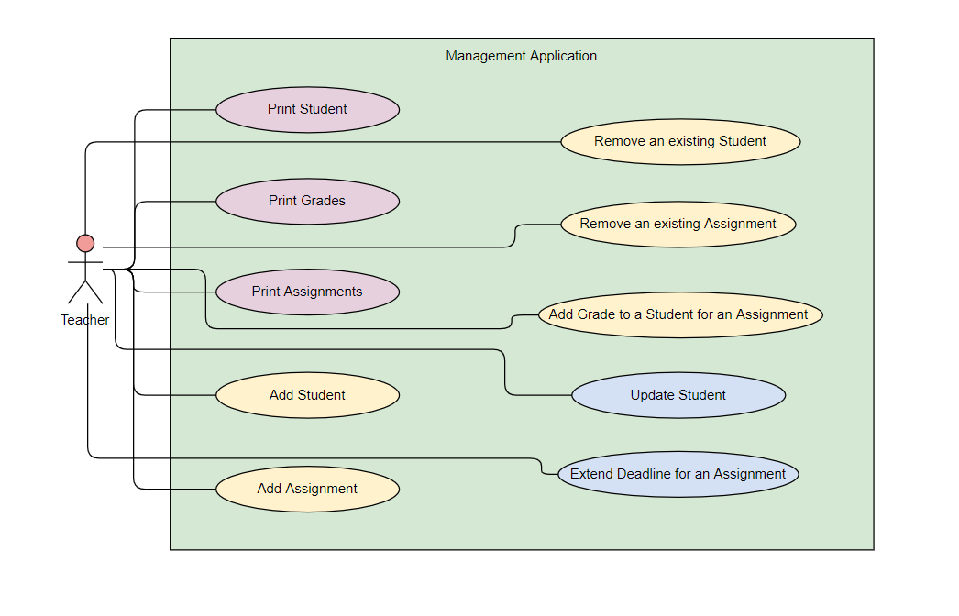

## Use case number 1 (Description of the use case)

Actors: teacher

Description: create a new student

Precondition: - all fields are specified

Postcondition: - a new student was added in the list

|  |  |
| --- | --- |
| Action | System Response |
| 1 Completes the necessary fields for adding |  |
|  | 2 Checks if everything is alright, adds a new element in the list if so |
| 3 - | 3. If the input is invalid, throws an exception |

Exceptions: When the fields aren’t filled.

## 3.2 Use case number 2 (Description of the use case)

Actors: teacher

Description: delete student

Precondition: - valid id belonging to an existing student is specified

Postcondition: - the student with the specified id is removed from the list

|  |  |
| --- | --- |
| Action | System response |
| 1 Give an id as input |  |
|  | 2 Checks if it is a valid id and there is a student with that id and deletes the student |
| 3 - | 3. If the input is invalid, throws an exception |

## 3.3 Use case number 3 (Description of the use case)

Actors: teacher

Description: update student

Precondition: - valid id belonging to an existing student and all other fields for student are specified

Postcondition: - the student with the specified id has the data updated

|  |  |
| --- | --- |
| action | System response |
| 1 Give an id and all other fields for the Student entity as input |  |
|  | 2 Checks if it is a valid id and there is a student with that id, than checks if the rest of the input is valid, and updates the data for that student |
| 3 - | 3. If the input is invalid, throws an exception |

# Analysis

## Entities

Student, Assignment, Grade

## Relations between entities

One student can have multiple assignments and one assignment can be assigned to many students. It is a many-to-many relationship between the two classes. Class Grade has as id, a pair consisting of studentId and assignmentId and it is the association class between the Student and Assignment classes.

## Attributes

Student: id, name, group, email, professor name

Assignment: id, description, deadline, assignation date

Grade: id(studentId, assignmentId), value, deliver date, feedback

## System behavior

## Use case 1-2-3

The system will act as a subsystem to a larger environment, in order to speed up a certain process in the company’s workflow.

## System events

After each operation a message is shown to the user either if the command terminated succesfully or with an error message.

# Design

* 1. **Class diagram**

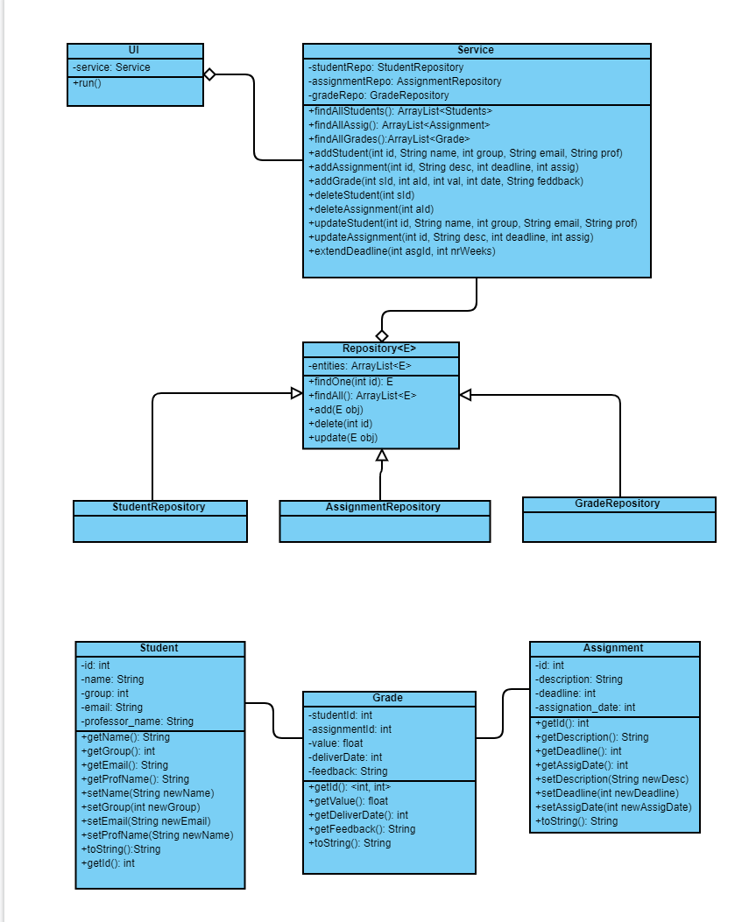

* 1. **Sequence diagrams (for each use case)**
* **Add Student Sequence Diagram**

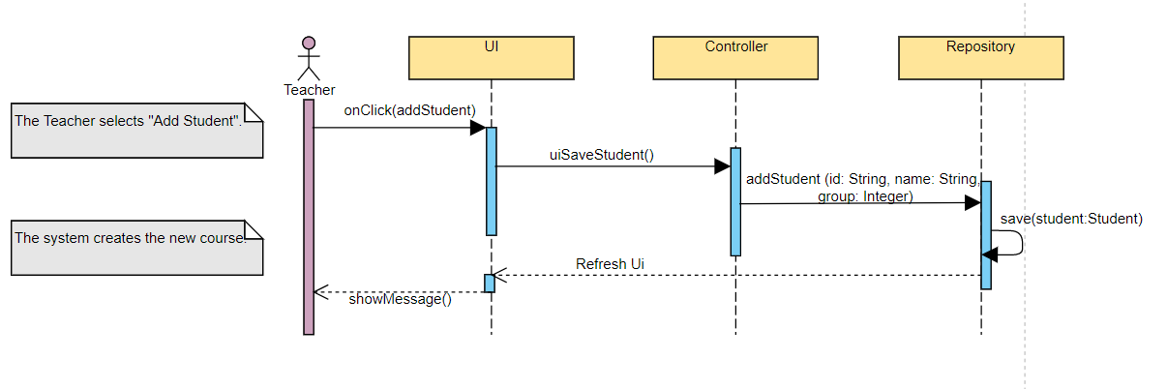

* **Delete Student Sequence Diagram**

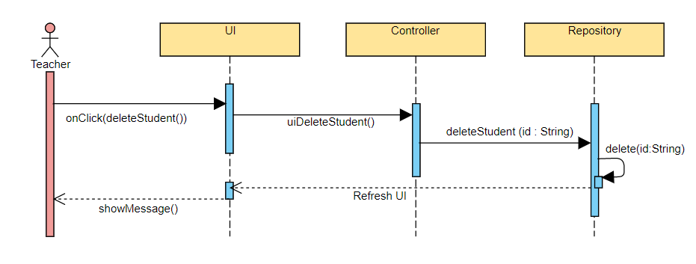

* **Update Student Sequence Diagram**

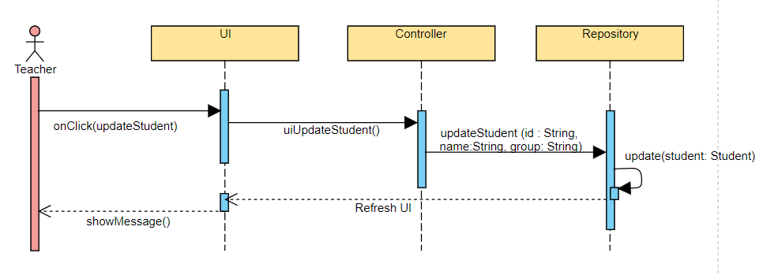

* 1. **GRASP**

GRASP is set of exactly 9 **G**eneral **R**esponsibility **A**ssignment **S**oftware **P**atterns:

1. Information Expert

2. Creator

3. Controller

4. Low Coupling

5. High Cohesion

6. Indirection

7. Polymorphism

8. Pure Fabrication

9. Protected Variations