Main login activity. Typing in a wrong username/password combo shows a toast message.

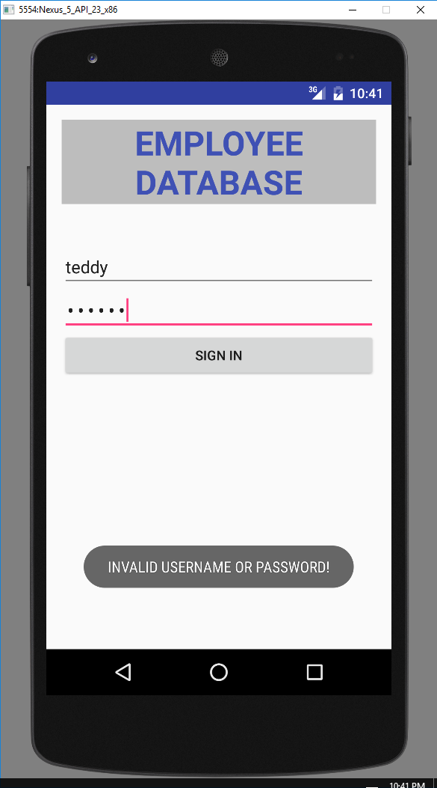

\*After fixing the password, click ‘sign in’ brings the user to…

EMPLOYEE LIST. This activity is shown after successful login and shows all current employees in the database. List scrolls. Users can click on name for additional information or click the add employee button in the corner to add a new record (if user has admin access).

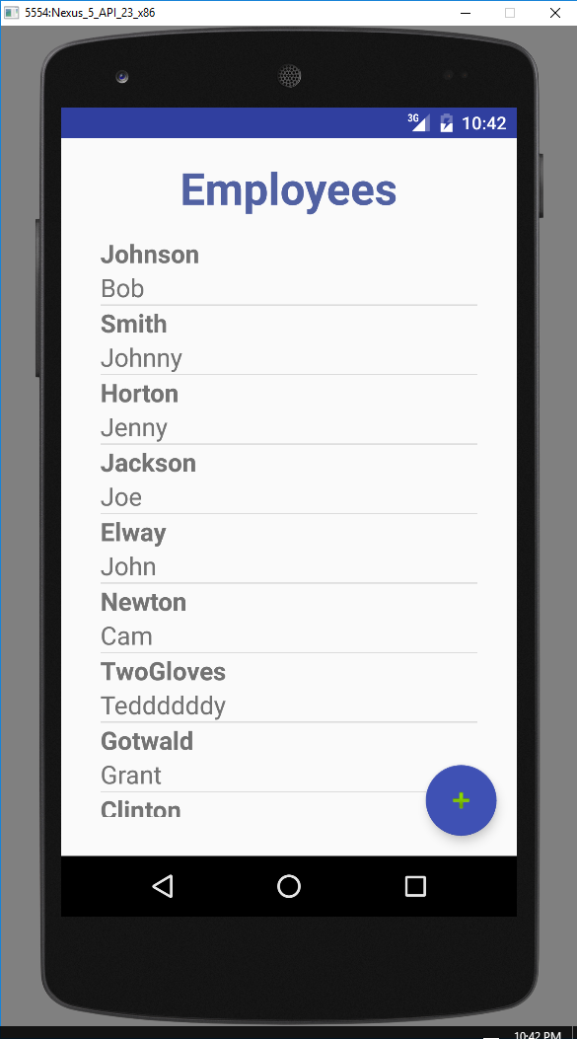

After admin user clicks ‘Add New Employee’

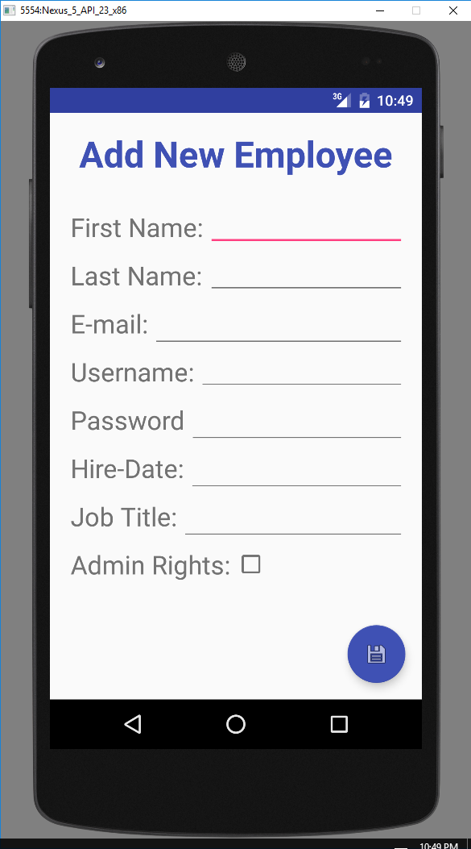

Typing in all of the information but leaving anything blank gives an error when pressing save button in corner (error on bottom)

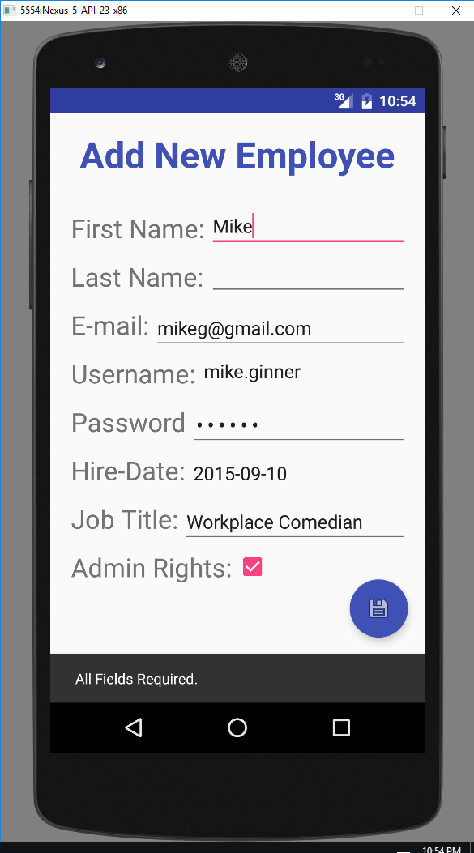

All fields complete, press save in corner.

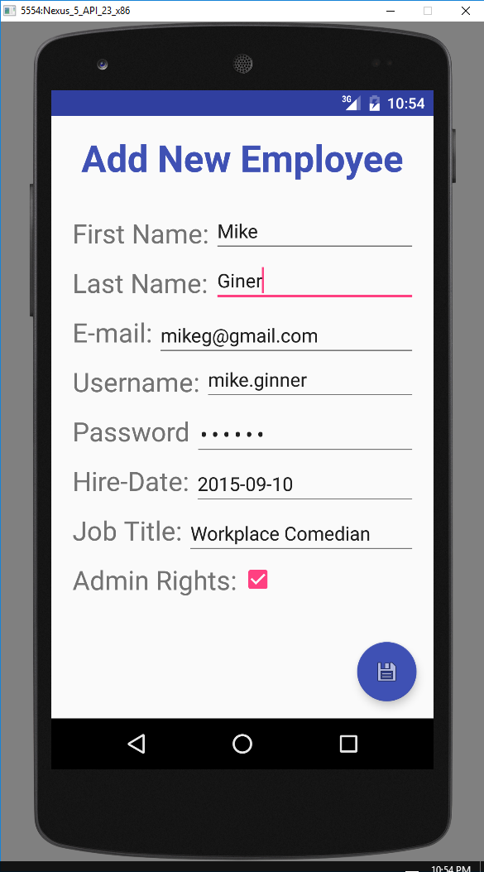

Brings user back to employee list. Now scroll down and there is the new employee.

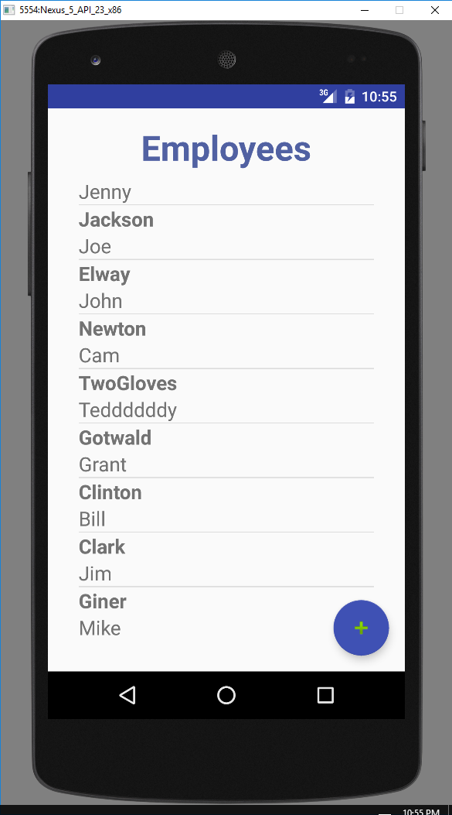

Click on an employee’s name from the list brings up the employee details page. Scrolling job history list included. Edit/Modify button on bottom right.

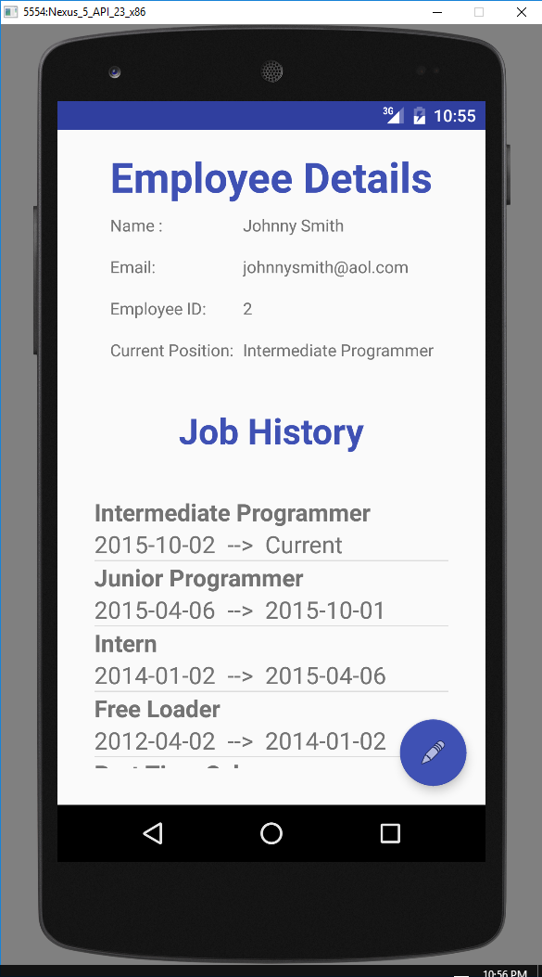

Clicking the modify button (if admin access) gives a modify employee page. Allows for modifying certain fields or completely deleting employee. Here user changes first name from ‘Johnny’ to ‘John’ and clicks save.

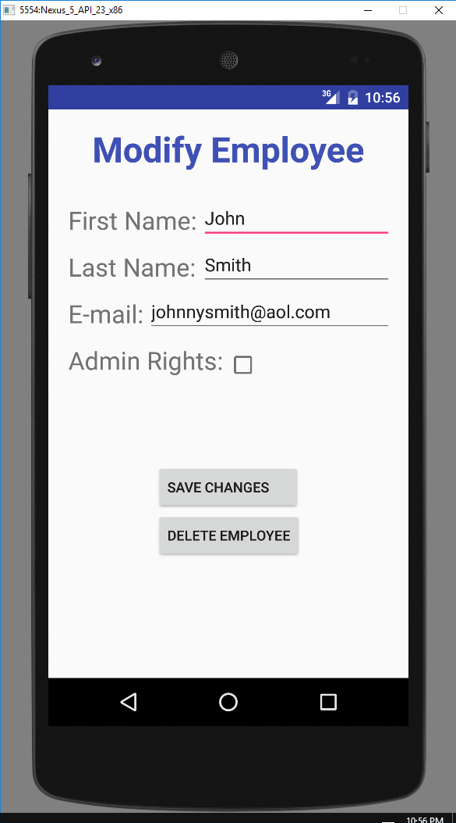

Saving, brings user back to details page. Here we can see the name has been updated.

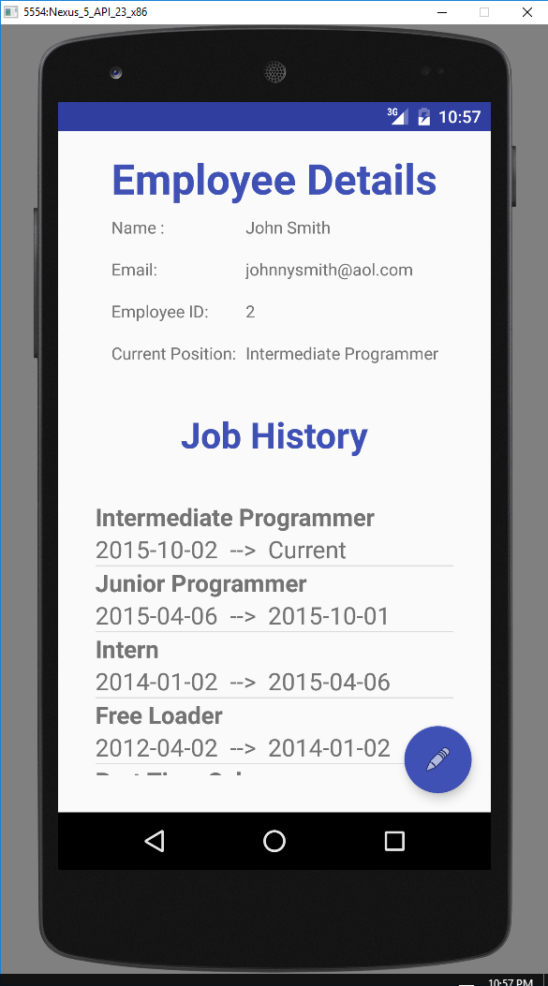

Modifying the employee we added a few steps ago.

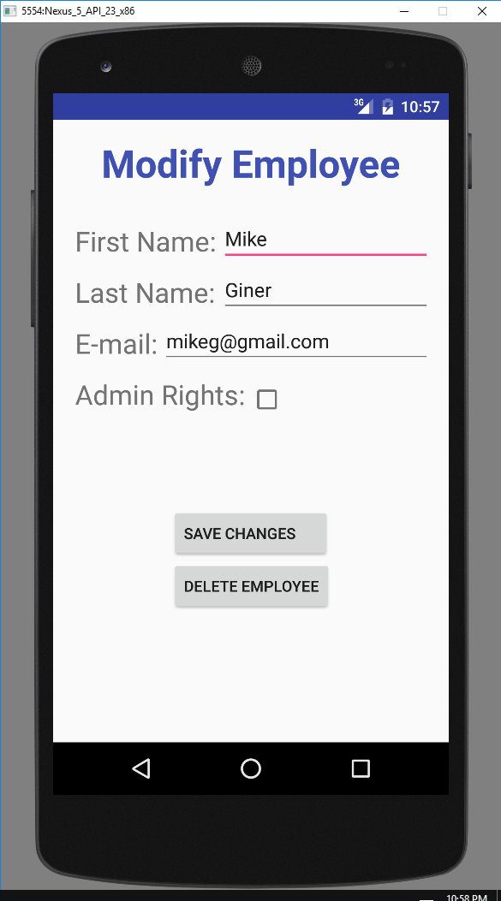

Clicking delete brings up action dialog confirming the deletion.

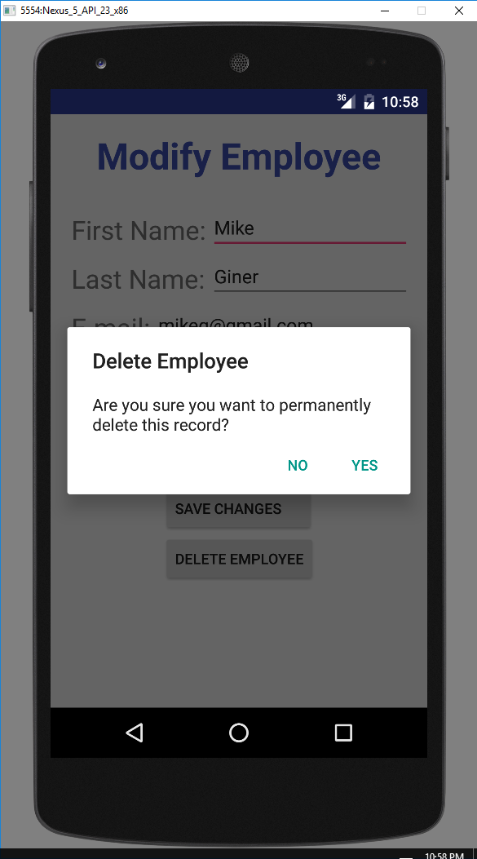

Confirming delete brings user back to employee list. We can see that Mike’s record is no longer present.

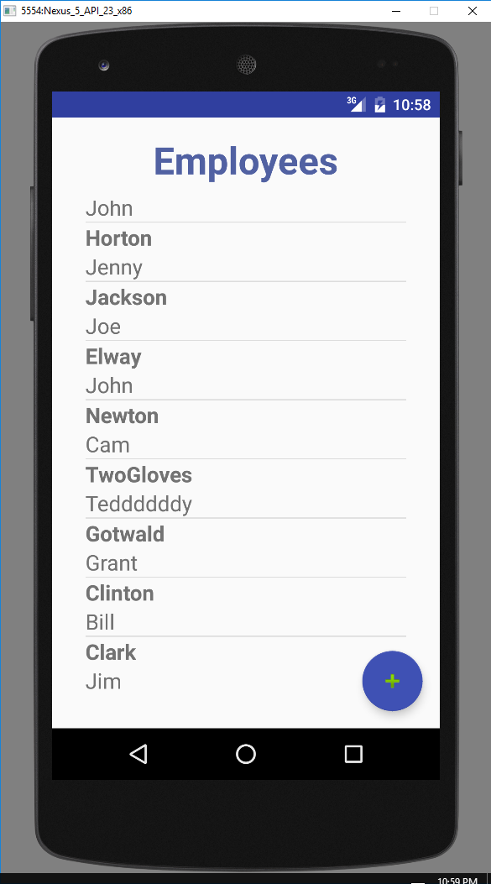

Signing in to the app with a user without admin access.

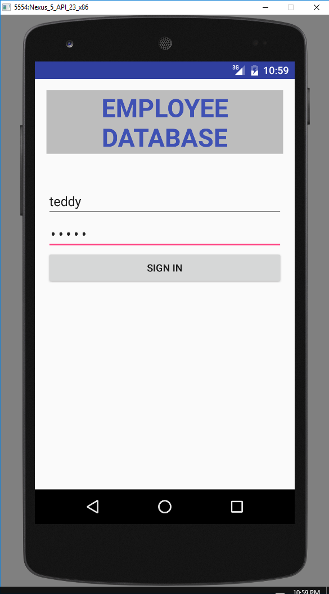

Trying to add an employee via the list gives the error message on the bottom.

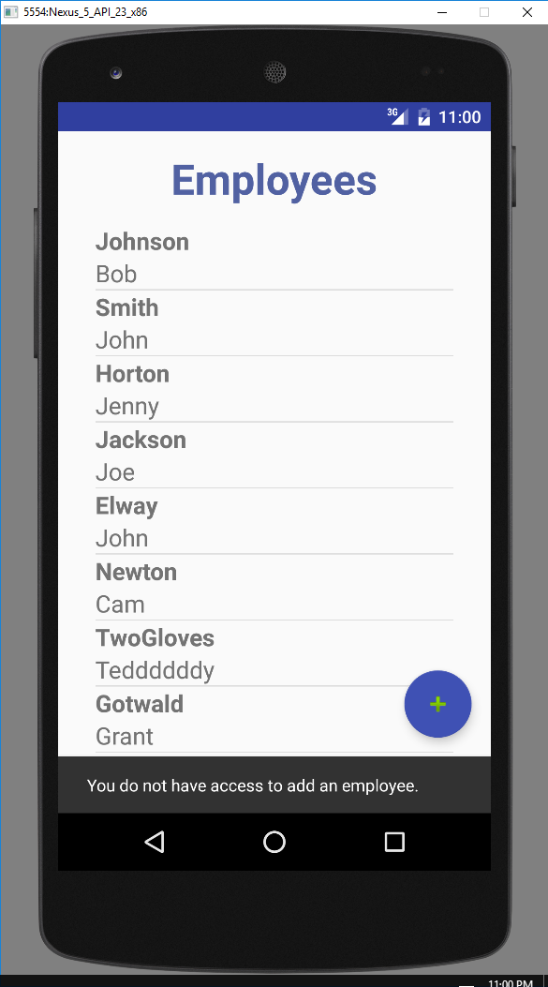

Pressing the edit button from the details page gives an error on the bottom.

