## 300(1)\CPU 314C-2 PN/DP\S7 Program(1)\Symbols

**Properties of symbol table**

Name: Symbols

Author:

Comment:

Created on 11/25/2023 05:50:50 PM

Last modified on: 11/27/2023 10:19:29 AM

Last filter criterion: All Symbols

Number of symbols: 27/27

Last Sorting: Symbol Ascending

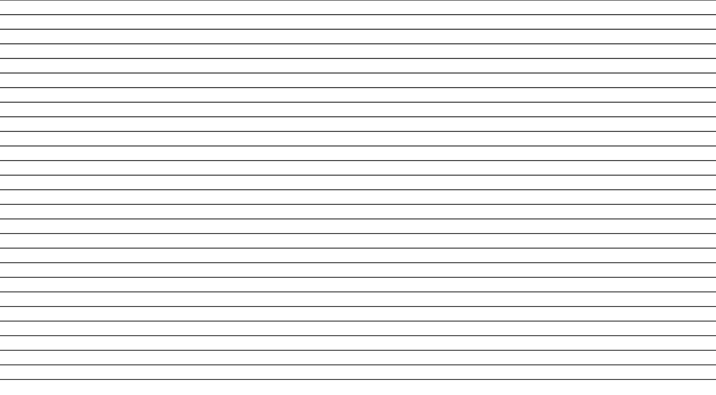

**Status**

**Symbol** 1st_ass_state Area_1_lever Area_2_lever Ass_area_1 Ass_area_2 Collect_Area_1 Collect_Area_2 Conveyor_state counter reset Counter Set Emergency Stop G7_STD_3

Inductive_sensor Initial_Release L_conveyor metal_releasing_sol metal=3 optical_sensor1 optical_sensor2 peg_releasing_sol plastic_releasing_sol plastic=3 Solenoid_metal Solenoid_plastic Start

TIME_TCK

U_conveyor

**Address**

0.3

1.0

1.1

1.0

1.1

0.6

0.7

0.0

1.2

0.5

0.4

72

0.2

0.2

0.1

0.5

0.1

0.0

0.1

0.7

0.6

0.2

0.3

0.4

0.3

**Data type Comment**

BOOL BOOL BOOL BOOL BOOL BOOL BOOL BOOL BOOL BOOL BOOL FC 72 BOOL BOOL BOOL BOOL BOOL BOOL BOOL BOOL BOOL BOOL BOOL BOOL BOOL

M Q Q I

I I I

M Q I

I FC I Q

Q Q M I

I Q Q M Q Q

I

SFC 64

SFC

BOOL

64

Read the System Time

Q

0.0

**OB1 - <offline>**

""

**Name: Family:**

**Author: Version:** 0.1

**Block version:** 2

**Time stamp Code:**

**Interface:**

### 11/26/2023 10:32:40 PM

02/15/1996 04:51:12 PM

**Lengths (block/logic/data):** 00282 00144 00020

|  |  |  |  |
| --- | --- | --- | --- |
| Name | Data Type | Address | Comment |
| TEMP |  | 0.0 |  |
| OB1_EV_CLASS | Byte | 0.0 | Bits 0-3 = 1 (Coming event), Bits 4-7 = 1 (Event class 1) |
| OB1_SCAN_1 | Byte | 1.0 | 1 (Cold restart scan 1 of OB 1), 3 (Scan 2-n of OB 1) |
| OB1_PRIORITY | Byte | 2.0 | Priority of OB Execution |
| OB1_OB_NUMBR | Byte | 3.0 | 1 (Organization block 1, OB1) |
| OB1_RESERVED_1 | Byte | 4.0 | Reserved for system |
| OB1_RESERVED_2 | Byte | 5.0 | Reserved for system |
| OB1_PREV_CYCLE | Int | 6.0 | Cycle time of previous OB1 scan (milliseconds) |
| OB1_MIN_CYCLE | Int | 8.0 | Minimum cycle time of OB1 (milliseconds) |
| OB1_MAX_CYCLE | Int | 10.0 | Maximum cycle time of OB1 (milliseconds) |
| OB1_DATE_TIME | Date_And_Time | 12.0 | Date and time OB1 started |

**Block: OB1 "Main Program Sweep (Cycle)"**

Network: 1 Initially Starting machine

### I0.3

"Start"

### Q0.0

"U_ conveyor"

S

Q0.2

"Initial_ Release"

Network: 2

### I0.4

"Emergency Stop"

### Q0.0

"U_ conveyor"

### R

Q0.1

"L_ conveyor"

### R

Network: 3 Inductive Sensor only supply input when a metal ring is detected

|  |  |  |
| --- | --- | --- |
| I0.2 | I0.1 | Q0.3 |
| "Inductive | "optical_ | "Solenoid_ |
| _sensor" | sensor2" | metal" |
|  |  | Q0.2  "Initial_ Release" |

Network: 4 Optical Sensor supply a input for metal or plastic

I0.2

"Inductive

_sensor"

### I0.1

"optical_ sensor2"

### Q0.4

"Solenoid_ plastic"

Q0.2

"Initial_ Release"

Network: 5 Counting in metal collecting chute

### Q0.3

"Solenoid_ metal"

### M0.3

C1 "1st_ass_ state"

S_CUD

CU Q

### M0.1

"metal=3"

### Q0.5

"metal_ releasing_

CD CV

CV_BCD

S PV

sol"

### I0.5

"Counter

Set" C#3

### Q1.2

"counter

R

reset"

Network: 6 Counting in plastic collecting chute

### Q0.4

"Solenoid_ plastic"

### M0.3

C2 "1st_ass_ state"

S_CUD

CU Q

### M0.2

"plastic= 3"

### Q0.6

"plastic_ releasing_

CD CV

CV_BCD

S PV

sol"

### I0.5

"Counter

Set" C#3

### Q1.2

"counter

R

reset"

Network: 7 Simultaneously releasing parts, activte lever for collect area1

### M0.1

"metal=3"

### M0.2

"plastic= 3"

### Q0.6

"plastic_ releasing_ sol"

Q0.5

"metal_ releasing_ sol"

Q1.0

"Area_1_ lever"

S

M0.3

"1st_ass_ state"

S

Network: 8 metal in ass_area_1 & plastic in ass_area_2 & L_conveyor start

### I1.0

"Ass_area_ 1"

### I1.1

"Ass_area_ 2"

### Q0.7

"peg_ releasing_ sol"

Q0.1

"L_ conveyor"

S

Network: 9 When assembly reach area 1, lever close & metal part release

### I0.6

"Collect_ Area_1"

### Q1.0

"Area_1_ lever"

R

Q0.5

"metal_ releasing_ sol"

Network: 10 peg release & area_2 lever activate

### I1.0

"Ass_area_ 1"

### Q0.7

"peg_ releasing_ sol"

Q1.1

"Area_2_ lever"

S

Network: 11 When assembly reach area 2, lever close & plastic part release

### I0.7

"Collect_ Area_2"

### Q1.1

"Area_2_ lever"

R

Q0.6

"plastic_ releasing_ sol"

Network: 12 peg release & area_2 lever activate

### I1.1

"Ass_area_ 2"

### Q0.7

"peg_ releasing_ sol"

Q1.1

"Area_2_ lever"

S

Network: 13 lever close and 1st_ass state resets for another itteration

### I0.7

"Collect_ Area_2"

### Q1.1

"Area_2_ lever"

### R

M0.3

"1st_ass_ state"

R 

Project

# T12

|  |  |  |
| --- | --- | --- |
|  | Step1 | |
| R | "U_conveyor" |
| R | "L_conveyor" |

**S1**

Step1

"Emergency

Stop"

# T1

"Start"

Trans1

|  |  |  |
| --- | --- | --- |
|  | Step2 | |
| S | "U_conveyor" |
| N | "Initial_Release" |

# S2

Step2

# T12

Trans1 2

# S1

"optical_

sensor2"

_sensor"

"Inductive

# T3

Trans3

|  |  |  |
| --- | --- | --- |
|  | Step4 | |
| N | "Initial_Release" |
| N | "Solenoid_plastic" |

# S4

Step4

"Inductive

_sensor"

sensor2"

"optical_

# T2

Trans2

# S3

Step3

Step3

N "Initial_Release" N "Solenoid_metal"

"plastic=

"metal=3"

3"

# T4

Trans4

# T11

|  |  |  |
| --- | --- | --- |
|  | Step5 | |
| N | "plastic_releasing_  sol" |
| N | "metal_releasing_sol" |
| S | "Area_1_lever" |
| S | "1st_ass_state" |

**S5**

"Ass_area_

1"

2"

"Ass_area_

"Collect_

Area_1"

Step5

# T5

Trans5

# S6

|  |  |  |
| --- | --- | --- |
|  | Step6 | |
| N | "peg_releasing_sol" |
| S | "L_conveyor" |

Step6

# T6

Trans6



2



1

"Ass_area_

**S7**

Step7

**T7**

Trans7

**S8**

Step8

**T8**

Trans8

**S9**

Step9

**T9**

Trans9

**S10**

Step10

**T10**

Trans1 0

**S11**

Step11

**T11**

Trans1 1

**S5**

|  |  |
| --- | --- |
| Step7 | |
| R | "Area_1_lever" |
| N | "metal_releasing_sol" |

1"

"Collect_

|  |  |  |
| --- | --- | --- |
|  | Step8 | |
| N | "peg_releasing_sol" |
| S | "Area_2_lever" |

Area_2"

"Ass_area_

|  |  |  |
| --- | --- | --- |
|  | Step9 | |
| R | "Area_2_lever" |
| N | "peg_releasing_sol" |

2"

"Collect_

|  |  |  |
| --- | --- | --- |
|  | Step10 | |
| N | "peg_releasing_sol" |
| S | "Area_2_lever" |

Area_2"

"plastic=

|  |  |  |
| --- | --- | --- |
|  | Step11 | |
| R | "Area_2_lever" |
| R | "1st_ass_state" |

"metal=3"

3"