Gear Academy: Learn How to Become an Expert in Building Decentralized Applications

Gear Foundation is delighted to introduce its new educational initiative, Gear Academy. Gear's first offering - the 'Gear Smart Contract Developer' course – will be free, providing an in-depth introduction to developing decentralized applications with Rust on networks like [Vara Network](https://vara-network.io/).

Through comprehensive guidance, learners will configure a development environment, build DApps from scratch and delve into powerful features such as delayed messages, system signals or gas reservations enabled by the Gear Protocol.

The course consists of seven engaging, easy-to-understand lessons that gradually reveal the features and details of program development on Gear Protocol.

| **Lesson Number** | **Description** |
| --- | --- |
| **1** | Learn to create and test your first smart contract program and understand how to read the program's state to retrieve important information. |
| **2** | Understand escrow smart contracts and how they work. |
| **3** | Learn about cryptographic tokens - Fungible and Non-Fungible tokens (NFTs) and their main functions, including examples of trading tokens. |
| **4** | Learn the handling of incomplete transactions. |
| **5** | Receive a step-by-step guide to implementing the English auction and learn about automatic program execution. |
| **6** | Understand the concept of a factory contract and its utilization in initializing new contract instances. |
| **7** | Learn to read the states of other contracts and work with their data, featuring Tamagotchi battle - a couple of smart contracts that represent virtual pets Tamagthies fighting each other. |

At the end of each lesson, learners will complete an assignment and upload it to the platform for review by the Gear Academy instructor. The course culminates in a final project that combines all the knowledge gained throughout the course. Upon completion, learners will receive a certificate and a commemorative gift NFT.

**Sign up and enroll in the Gear Academy!**

**Join Gear and Start Building**

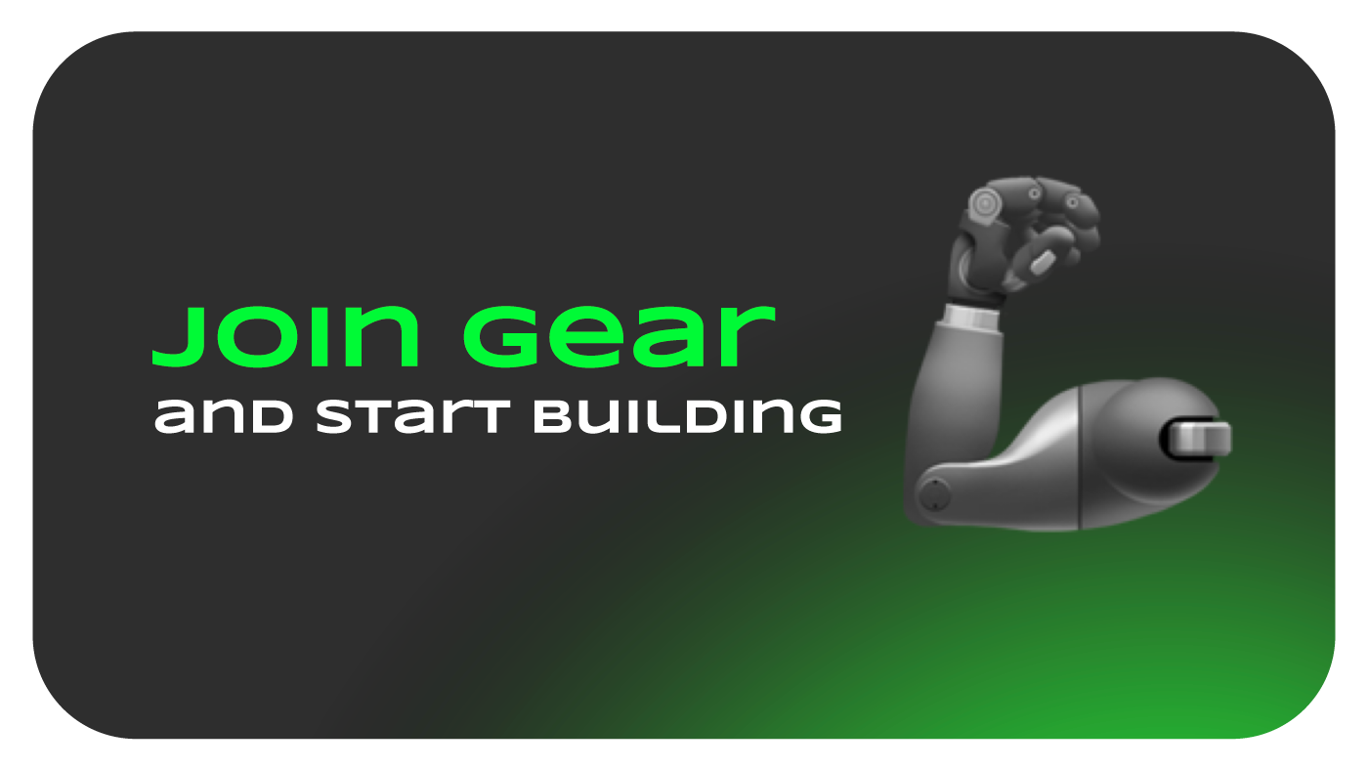

If you're a builder or developer looking to leverage Gear Protocol's unique capabilities for decentralized and autonomous smart contract development, join the Gear community. Asynchronous messaging and gas reservation support enable multiple use cases, facilitating new decentralized functionality and value for users in the blockchain ecosystem.

Contact Gear at hello@gear-tech.io to learn more and start collaborating with the [Gear Community](https://www.gear-tech.io/#join-to-community).