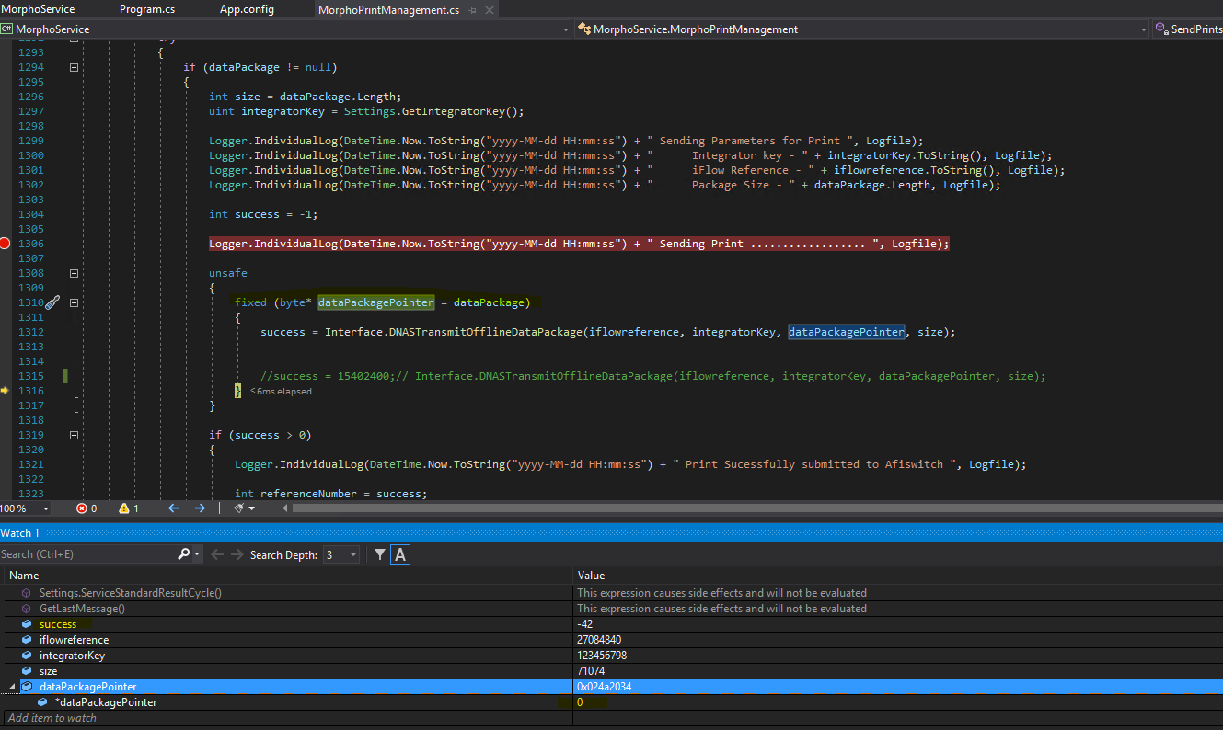

Success = -42 (Transmit of offline package failed: Invalid data size (1))

IntegratorKey : 123456798

Package size : 71074