Linear Lights Out Report
  - CSSE 220, Will Gebelein, Luke Mowery
Note: Before starting this report, consult the README for this assignment. This report only applies to Part 2, the Linear Lights Out game, but be sure to implement Part 1 too.

Section 1: Design Phase
- Prepare at least two designs (UML class diagrams) for the Linear Lights Out game, using LinearMain.java as a starting point.
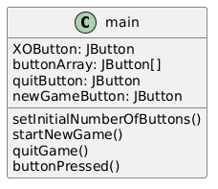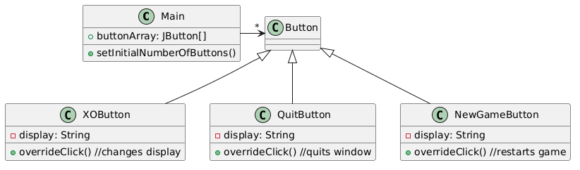
- Briefly explain your designs. Why did/didn’t you extend one or more of the built-in Java Swing classes? How did you select your event listeners and make sure they have access to the needed data/methods?
The first design was a first design made to fit within the single main, but upon realizing that was an extremely compacted design, expanded it to take the form of the second design (ironically, Copilot returned it to the first form). The main listener is the button click, each one for each descendant button having a different role.

Section 2: Implementation/Testing Phase
Using a GenAI chatbot tool of your choice, give it one of your UML designs for Linear Lights Out, along with appropriate context, and prompt it for an implementation of your design. Refer to the CSSE 220 Prompting Guide.
- Which GenAI tool did your team select, and why?
Copilot. It’s easy enough to add files to.

- Include link(s) to your one or more GenAI tool conversations.
 | Link | Notes
Conversation #1: | https://m365.cloud.microsoft/hwav2/chat/conversation/c212c397-7412-4a51-966c-cabe0945c5b2?version=19.2610.35011.0&capabilities=interopPromise%2CsuspendOnClose%2CautoStart&client-request-id=de1d109c-2f4b-f449-9808-35eb19da5528&appstate=suspended&SSRDesktopTest=2 | Was able to get a successful Linear Lights Out from one conversation _________________ignorethese__
Conversation #2:

- Compare the GenAI-produced solution against your UML. How closely does the implementation match your design? Take note of any significant additions/changes, and consider prompting the GenAI tool to explain certain implementation decisions.
The solution matches closely, the Copilot created new functions that listed in our UML to make sure the code worked properly.
- Test out the GenAI-produced solution by manually playing the game. Try to cover edge cases and anticipate "bad" user behavior. For any bugs you encounter, try fixing them manually. If you get stuck, prompt the GenAI tool to fix the bug, providing sufficient detail of what went wrong and what you think might be the root cause. Take note of bugs you found and fixed here.
The main bug was button disappearing, which was due to a sizing issue; the screen was not big enough for all Os sometimes, and would stop showing up. The AI’s solution (when I thought it was a bigger problem) required a new package, and I probably could have solved it without the AI.

Section 3: Evaluation Phase
Evaluate your GenAI-assisted Linear Lights Out implementation using our Object-Oriented Design Principles and documentation/style guidelines.
- If you find significant design flaws, look back at your original UML design. In hindsight, can you see the flaws in your UML?
My UML was very lightweight for what was to be. I needed to flesh it out more.
- Based on this activity, what do you think are the strengths and weaknesses of GenAI tools when it comes to writing code? Explain.
GenAI can easily get entire apps online in a matter of minutes, but are extremely prone to bugs, especially with larger code productions. The bugs come from a dropping of context.

Section 4: Experimentation Phase
Customize your Linear Lights Out game by adding at least one new feature. You may use GenAI assistance to add the feature, or you can manually modify the code.
- What new feature(s) are you adding? Briefly describe.
We can add a new feature where we can ask the player if they would like to customize their own game or generate a random game. (Custom Game)

- If you added the feature manually, what resources did you use? If you used GenAI assistance, how did it go? Include a link to your chatbot conversation.
Copilot was able to satisfy the conditions.
LINK

Section 5: Reflection Phase
- Summarize (in 1-2 paragraphs with complete sentences) what you learned from this assignment about event-based programming and/or GenAI-assisted software dev. Consider your target audience to be next quarter’s CSSE 220 students.
AI works well as a way to quickly create large amounts of code. You do need to have a vision that you want to deploy, and you need to have a clear view as for what each part of the vision needs. Doing so makes sure that the AI is much less buggy, and lowers the amount of conversations/manual work, and as such, time, that you need to use.

Also, make sure you try to learn what the AI is doing.

