Vapor Sales Implementation Report
  - CSSE 220, [Will Gebelein (writing this report)], [Luke Mowery]

Section 1: GenAI Part Preparation
- What context do you think you should provide to the GenAI tool when you ask it to implement each task? Explain your answer.
We need to give the GenAI tool the context of the actual source files, and the context of their tasks. In effect, all of the tests, and the src.
- For each of the three tasks, sketch out an idea of what you think will be the best way to implement the feature. (This could be on a whiteboard, or with comments forming an outline/pseudocode in the method.)
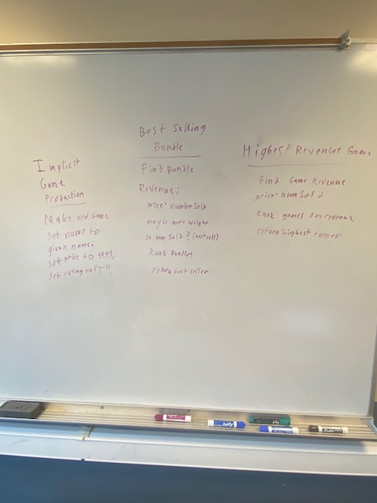

- Which GenAI tool did your team select, and why?
We used ChatGPT and Copilot. ChatGPT was selected by Luke, and I followed suit until I couldn’t upload more files to chat, where I switched to copilot.

Section 2: GenAI Part Reflection
- Did the GenAI tool tend to produce code that was:
  - worse than (CHAT),
  - better than (COPILOT*), or
  - about as good
as you expected? Explain.
ChatGPT (at least for me) produced sub-optimal code that did not complete the tasks. Copilot’s code was better than I was expecting from it (I have extremely low expectations for Copilot. If another GenAI model produced its code, it would be as good as I expected).
- Include link(s) to your one or more GenAI tool conversations. (Copy/paste links from the tools’ built-in “Share” features.)
 | Link | Notes
Conversation #1 (Chat): | https://chatgpt.com/share/6abec245-7ef8-83ea-8da4-bd82d893e8e7 | Used to attempt to complete all GenAI tasks
Conversation #2 (CoP): | https://m365.cloud.microsoft/hwav2/chat/conversation/36b34617-215f-4c5e-afde-e5384ba784c8?version=19.2609.52011.0&capabilities=interopPromise%2CsuspendOnClose%2CautoStart&client-request-id=81ada577-fa14-1940-a120-79d384414c68&appstate=suspended&SSRDesktopTest=2 | Used to determine issues with GenAI tasks
Conversation #3 (CoP) | https://m365.cloud.microsoft/hwav2/chat/conversation/94a645f7-7c48-4b56-8919-1490b86c2f8a?version=19.2609.52011.0&capabilities=interopPromise%2CsuspendOnClose%2CautoStart&client-request-id=81ada577-fa14-1940-a120-79d384414c68&appstate=suspended&SSRDesktopTest=2 | Used to complete all GenAI tasks

- Summarize (in 1-2 paragraphs with complete sentences) what you learned from this assignment about GenAI-assisted software development. Consider your target audience to be next quarter’s CSSE 220 students.
I have more experience here due to an internship I took. You can assign AI tasks, but you usually want to assign “focused” work as opposed to “Hey ChatGPT, complete everything here.”
You ALWAYS want to run a triple check on produced work. First, have the model confirm its own work; this process won’t work if lumped in with the same prompt as the production. Then, read over the work yourself.
Also, for this class, try not to use AI. This is to help you learn, and without some coding experience, you won’t know what to do when the AI messes up.

