Project Title: Pharmacy Inventory and Sales Management Database.

Phase 1.1: Requirement Analysis & Scoping

1 — Project scope
Build an RDBMS to manage a pharmacy’s products, suppliers, inventory levels, sales transactions, prescriptions, customers, staff/roles, billing/payments, and regulatory/audit logging. The system must support core pharmacy operations (purchase, stock management, dispensing/sales, returns), basic reporting, and features needed for secure, auditable production use (encryption of sensitive data, role-based access, backups).
1. Main Entities and Attributes
Entity | Description | Key Attributes
Medicine | Stores information about each drug available in the pharmacy. | MedicineID (PK), MedicineName, Category, Manufacturer, UnitPrice, StockQty, ExpiryDate
Supplier | Holds data on companies or individuals supplying medicines. | SupplierID (PK), SupplierName, ContactNumber, Email, Address
Customer | Represents pharmacy customers buying medicines. | CustomerID (PK), FullName, Phone, Email, Address
Sales | Records each sales transaction made. | SaleID (PK), SaleDate, CustomerID (FK), TotalAmount, PaymentMethod
SalesDetail | Line-items of each sale (many medicines per sale). | SaleDetailID (PK), SaleID (FK), MedicineID (FK), Quantity, UnitPrice, Subtotal

2. Business Rules
- Each medicine must belong to one supplier.
- A sale must involve at least one medicine.
- Stock quantity of a medicine decreases automatically after each sale.
- SalesDetail entries must match existing Sales and Medicine records (referential integrity).
- A medicine that is expired cannot be sold.
- A customer can make multiple sales.
- TotalAmount in Sales equals the sum of all Subtotal values in its SalesDetail rows.
- Supplier contact details must be unique (no duplicate phone/email).
- UnitPrice of medicine cannot be negative or zero.
- Every transaction must be timestamped for audit and reporting.

3. Functional Requirements, Use Cases, and User Roles

User Roles
- Admin: Manages users, medicines, suppliers, and system settings.
- Pharmacist/Clerk: Handles daily sales and inventory updates.
- Manager: Views reports, tracks low stock and revenue summaries.
- Auditor: Reviews logs, sales history, and system integrity.

Core Functional Requirements
- Add/update/delete medicine records.
- Record sales transactions and automatically update stock levels.
- Manage suppliers and purchase restocks.
- Maintain customer profiles and history.
- Generate sales and stock reports (daily, weekly, monthly).
- Prevent selling expired or out-of-stock medicines.
- Log all data changes for audit tracking.
- Backup and recover the database safely.
- Encrypt sensitive information such as customer data.
- Support transaction rollback for partial failures.

Main Use Cases
- Add new medicine
- Process sale (create Sales + SalesDetail)
- Update stock after sale
- Add new supplier
- Generate sales report
4. Non-Functional Requirement
Category | Specification
Performance | System must handle at least 100 sales/day with minimal response time (< 3 seconds/query).
Data Volume | Expected ≈ 10 000 medicine records, 100 suppliers, and daily transaction growth.
Security | Role-based access control (least privilege), data encryption for customers and credentials.
Availability | 24/7 operation with daily backup and recovery capabilities.
Scalability | Easy to add branches (distributed database support in Phase 2.7).
Integrity | Enforced by foreign keys, constraints, and triggers.
Usability | Simple forms for sales entry and stock management.

Phase 1.2: Conceptual Design – ER Diagram
1 Entities and Primary Keys
Entity | Primary Key | Main Attributes
Medicine | MedicineID | MedicineName, Category, Manufacturer, UnitPrice, StockQty, ExpiryDate, SupplierID (FK)
Supplier | SupplierID | SupplierName, ContactNumber, Email, Address
Customer | CustomerID | FullName, Phone, Email, Address
Sales | SaleID | SaleDate, CustomerID (FK), TotalAmount, PaymentMethod
SalesDetail | SaleDetailID | SaleID (FK), MedicineID (FK), Quantity, UnitPrice, Subtotal

2 Relationships
Relationship | Type | Description
Supplier → Medicine | 1 : N | One supplier provides many medicines.
Customer → Sales | 1 : N | One customer can make many sales.
Sales → SalesDetail | 1 : N | One sale has multiple sale details.
Medicine ↔ SalesDetail | 1 : N (through SalesDetail) | One medicine can appear in many sales details.

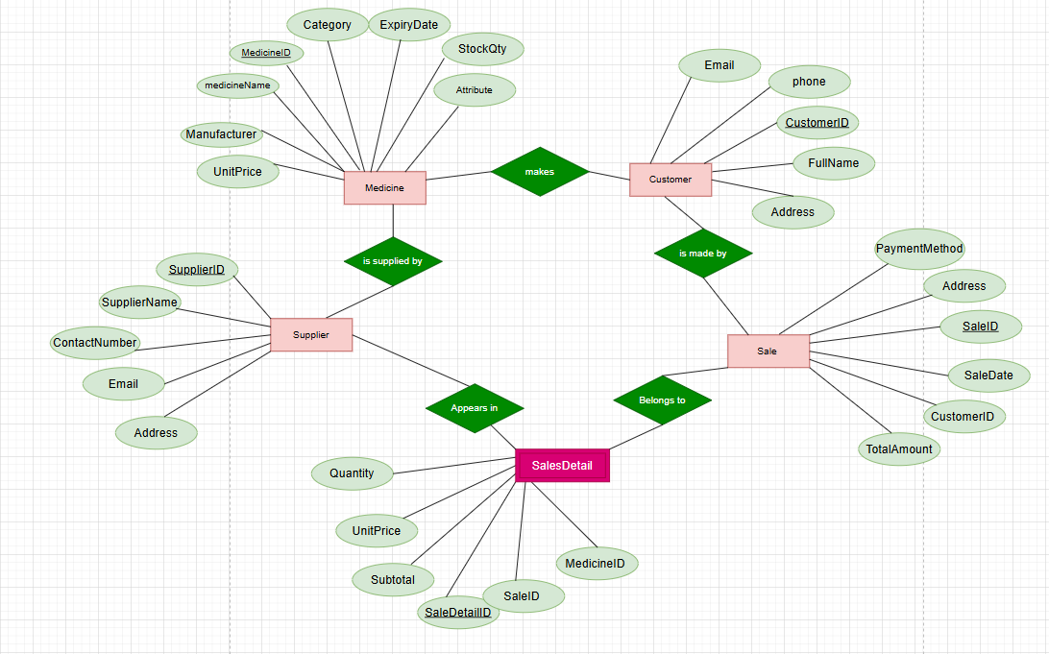

Phase 1.3 – Relational Schema
In this phase We converted the ER diagram (conceptual design) into relational tables with all primary keys (PK), foreign keys (FK), and integrity constraints.

Table List and Schema Definition
  - Supplier
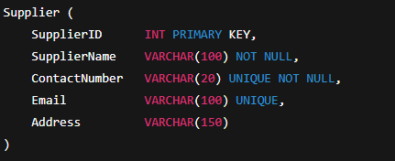

2. Medicine
