CareConnect Telehealth Platform
Product Requirements Document (PRD)
Prepared for Getachew Ekubay
5 August 2026

Document control
Field | Value
Product | CareConnect Telehealth Platform
Document | Product Requirements Document
Version | 1.0
Status | Build-ready baseline
Owner | Getachew Ekubay
Target release | MVP after security, clinical, and legal review
Primary market assumption | United States
Primary client | Patient mobile application
Supporting clients | Clinician web portal and operations/admin portal
Important: This PRD is an engineering and product-planning baseline, not a legal certification. A production launch requires healthcare counsel, clinical governance, security risk analysis, vendor Business Associate Agreements (BAAs), operational policies, workforce training, and jurisdiction-specific review. The UI must not claim “HIPAA compliant” until the full organization and deployed system have been independently validated.

1. Executive summary
CareConnect is a patient-centered telehealth platform that lets users discover licensed clinicians, book virtual visits, complete a pre-call connection check, join secure video consultations, exchange messages, view health records, manage prescriptions, and maintain profile and insurance information.
The supplied Figma screens already cover the core patient experience:
- onboarding and health-concern selection;
- clinician discovery, search, filters, and profile;
- appointment date and time selection;
- upcoming and past appointments;
- waiting room and active call;
- secure inbox;
- records and prescription details;
- patient profile and preferences.
The production product must add the backend, provider workflows, secure identity, consent, auditability, error states, interoperability adapters, accessibility, testing, observability, and deployment controls required to operate safely.

1.1 Product decision summary
Decision | Baseline
Product name | CareConnect Telehealth; replace mixed “TeleHealth” and “CareConnect” branding
Platform | React Native patient app, Next.js clinician/admin web, FastAPI backend
Data store | PostgreSQL with encrypted object storage for documents
Video | Vendor-neutral video adapter with a production provider that signs a BAA
Interoperability | HL7 FHIR R4 adapter for patient, appointment, encounter, record, and medication exchange
Identity | Managed OpenID Connect provider; MFA required for workforce accounts
Security target | OWASP ASVS Level 2 and OWASP MASVS baseline
Accessibility target | WCAG 2.2 AA, including mobile guidance
MVP prescribing | Display and manage non-controlled prescriptions; exclude EPCS and controlled substances
Compliance language | “Designed to support a HIPAA-compliant deployment,” never an unverified compliance claim

2. Design baseline and readiness review
The following screens were reviewed as the product-design baseline.
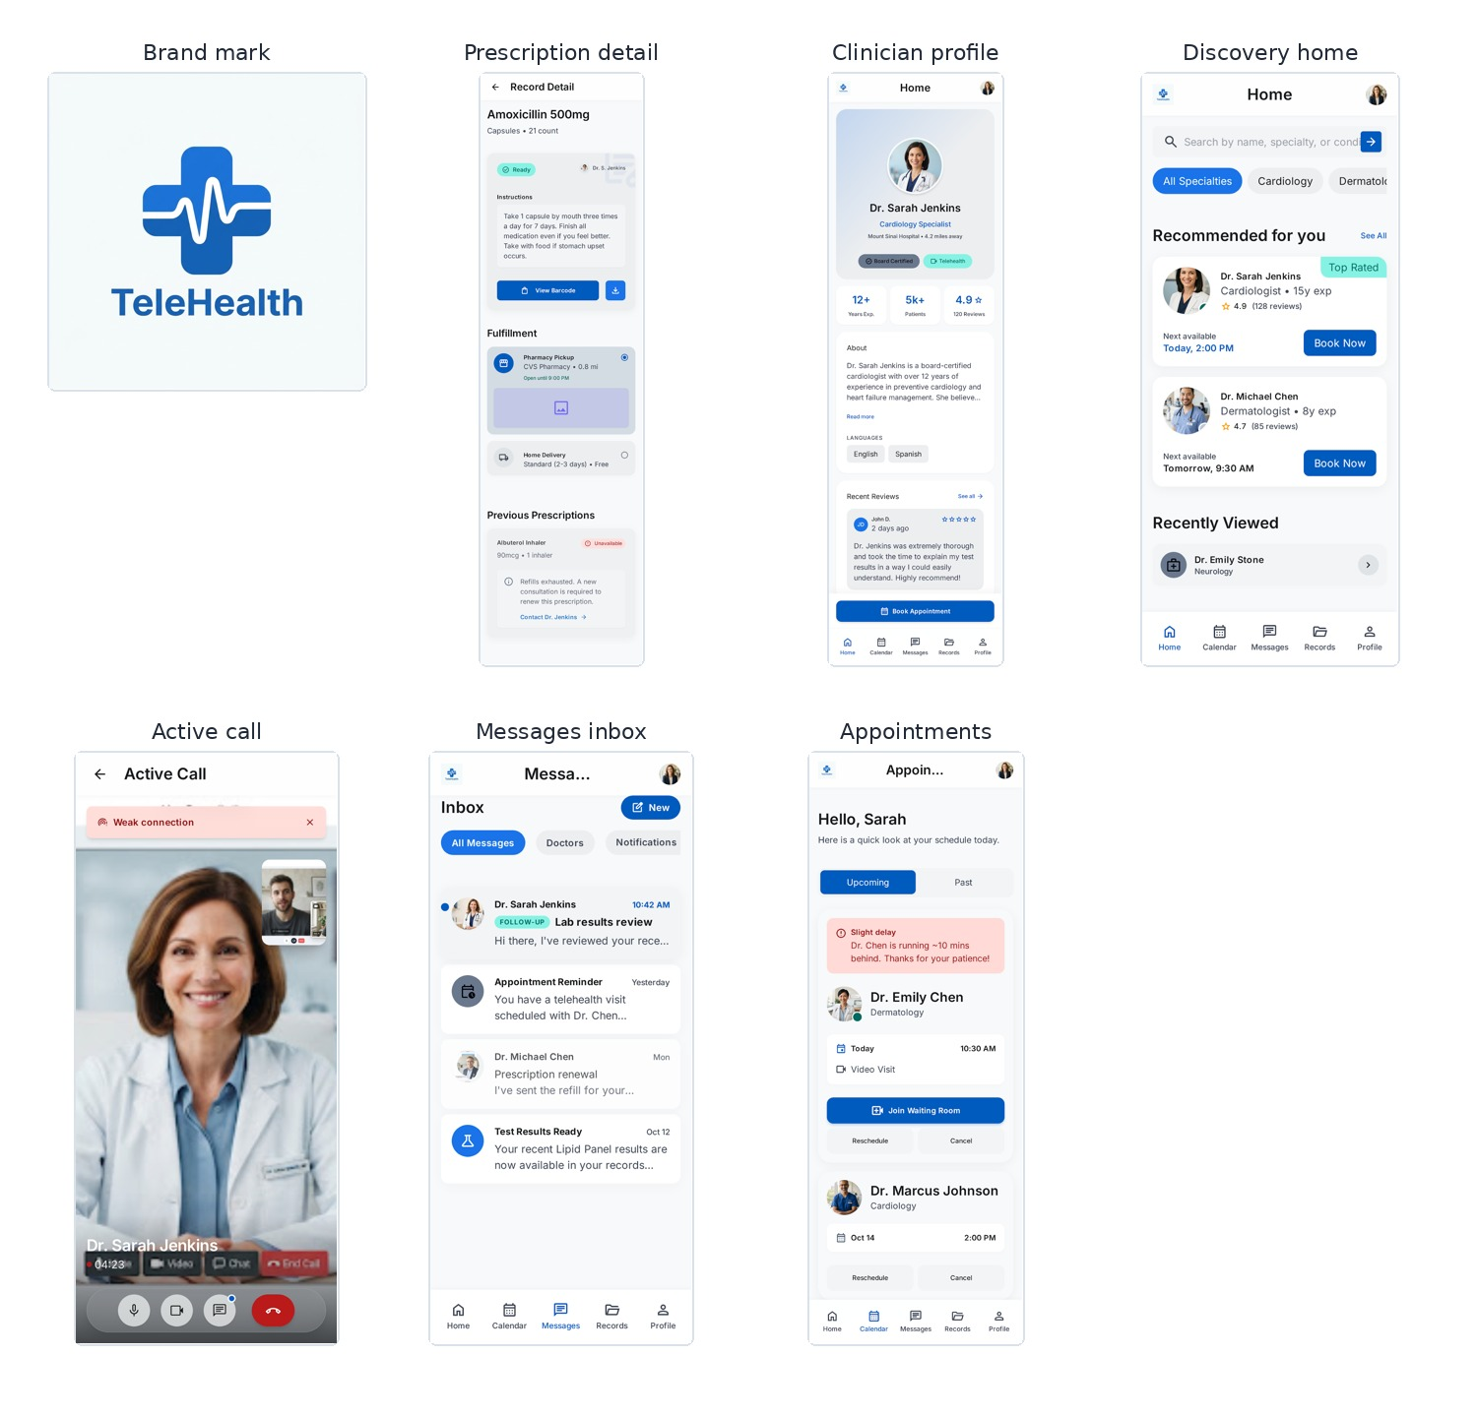
CareConnect design screens, part 1
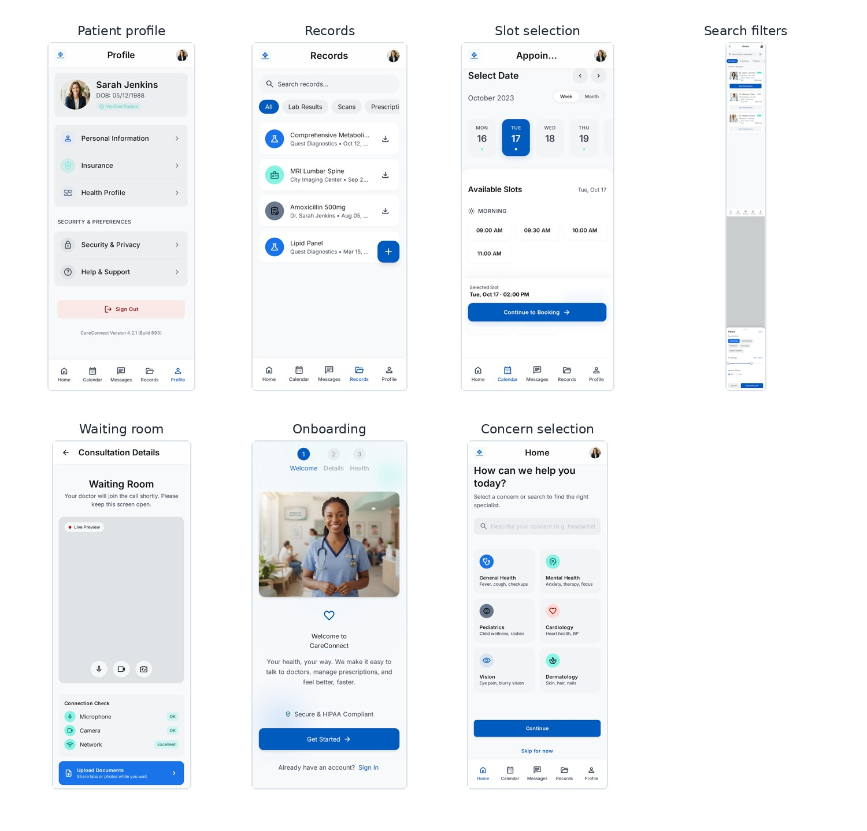
CareConnect design screens, part 2

2.1 Screen inventory
Area | Existing design
Brand | Logo/splash
Onboarding | Welcome and health-concern selection
Discovery | Search, specialties, recommendations, filters
Clinician | Profile, reviews, availability, booking
Appointments | Slot selector, upcoming/past list, reschedule/cancel
Visit | Waiting room, device/network check, active call, weak-connection state
Communication | Inbox and notification cards
Records | Searchable records list and downloads
Prescription | Medication instructions, pharmacy pickup/home delivery, previous prescriptions
Account | Patient profile, insurance, security, support, sign out

2.2 Required design corrections before implementation
- Unify branding. Use “CareConnect Telehealth” consistently in the logo, onboarding, app header, metadata, emails, and notifications.
- Fix identity conflicts. “Sarah Jenkins” appears as both clinician and patient. Use distinct seeded identities.
- Fix clinician inconsistencies. The appointment list references “Dr. Emily Chen,” while discovery shows “Dr. Michael Chen.” Seed data must be coherent.
- Remove stale dates. Replace October 2023 and fixed timestamps with dynamic, timezone-aware dates.
- Fix selection mismatch. The slot screen displays “2:00 PM” as selected although that visible slot is not selected.
- Prevent text clipping. Headers such as “Messa…” and “Appoin…” and specialty chips must adapt to device width and dynamic text size.
- Remove unverified compliance claims. Replace “Secure & HIPAA Compliant” with “Secure telehealth experience” until a verified deployment supports the claim.
- Add missing system states. Loading, empty, offline, permissions denied, retry, expired session, failed payment, appointment conflict, provider cancellation, document upload failure, and record unavailable.
- Add missing safety flows. Emergency disclaimer, crisis routing, informed consent, privacy notice, location confirmation before a visit, and clear limits of telehealth.
- Improve call UI. Remove duplicate controls shown inside the video image, provide connection recovery, audio-only fallback, and clear device-permission states.
- Improve accessibility. Minimum touch targets, scalable text, screen-reader labels, non-color status indicators, focus order, captions/interpretation support, and reduced-motion support.
- Add confirmation steps. Appointment confirmation, cancellation reason, reschedule confirmation, prescription fulfillment confirmation, and sign-out confirmation.

3. Product vision

3.1 Vision statement
Enable patients to access trusted virtual care, understand the next action, and manage follow-up information from one secure, accessible application.

3.2 Problem statement
Patients commonly face fragmented discovery, scheduling, video, messaging, record, and prescription experiences. This causes abandoned bookings, missed appointments, repeated data entry, poor follow-up, and reduced trust. Clinicians and support teams also need a consistent workflow for availability, patient context, communication, and audit history.

3.3 Product principles
- Safety before speed: emergency and clinical limits must be visible.
- One clear next action: each screen should prioritize the next task.
- Trust through transparency: explain data use, permissions, statuses, and failures.
- Accessible by default: do not treat accessibility as a later enhancement.
- Privacy by design: collect, display, and retain only necessary information.
- Interoperable, not isolated: use standard adapters for EHR, laboratory, and pharmacy connections.
- Resilient on weak networks: support reconnect, low-bandwidth mode, and recoverable workflows.

4. Target users and personas

4.1 Primary persona: patient
Name: Maya Johnson
Context: Working adult managing routine care and occasional specialist visits.
Needs: Find an appropriate clinician, compare availability and price, book quickly, join without technical difficulty, receive follow-up messages, and access records.
Pain points: Unclear availability, forgotten appointments, unreliable video, repeated form entry, fragmented records.

4.2 Secondary persona: clinician
Name: Dr. Daniel Bekele
Context: Licensed clinician providing virtual consultations alongside in-person work.
Needs: Control availability, review patient-submitted information, start visits on time, document outcomes, send follow-up instructions, and avoid duplicate messages.
Pain points: Incomplete patient context, no-shows, poor device readiness, excessive administrative work.

4.3 Secondary persona: operations administrator
Name: Helen Brooks
Context: Supports patients and clinicians, resolves scheduling and account issues, and monitors service quality.
Needs: Search users and appointments, view permitted audit information, manage escalations, and monitor integration health.
Pain points: Insufficient traceability, manual coordination, and inability to distinguish user error from system failure.

5. Goals, non-goals, and metrics

5.1 MVP goals
- A patient can discover and book an eligible clinician in fewer than three minutes.
- A confirmed patient can join a scheduled visit with a successful device check.
- Patients and clinicians can exchange secure messages tied to care context.
- Patients can view and download authorized records and prescription information.
- Every sensitive action is authorized, logged, and auditable.
- The system can be deployed with synthetic data in a production-like environment.

5.2 Non-goals for MVP
- emergency diagnosis or emergency dispatch;
- autonomous symptom diagnosis;
- controlled-substance prescribing or EPCS;
- insurance claim adjudication;
- full hospital electronic health record replacement;
- medical-device functionality;
- AI-generated clinical decisions;
- recording video visits by default;
- multi-country regulatory support in the first release.

5.3 North-star and supporting metrics
Metric | MVP target
Completed bookings / started booking flows | ≥ 70%
Median time from discovery to confirmed booking | < 3 minutes
Visit join success | ≥ 97%
Video sessions requiring support intervention | < 3%
Appointment no-show rate | Reduce by 15% from baseline
Crash-free mobile sessions | ≥ 99.5%
API availability | ≥ 99.9% monthly, excluding planned maintenance
Patient task success in usability tests | ≥ 90% for booking and joining
Accessibility critical defects | 0 at release
Unauthorized data access defects | 0 at release

6. Scope and release plan

6.1 MVP scope: P0

Patient mobile app
- registration, sign-in, password recovery, device session management;
- consent, privacy acknowledgement, emergency disclaimer, communication preferences;
- health-concern and specialty selection;
- clinician search, filters, profile, reviews, pricing, and next availability;
- date/time selection and appointment confirmation;
- upcoming/past appointments, cancellation, and rescheduling;
- reminders and push notifications without PHI in notification text;
- waiting room, microphone/camera/network checks, document upload;
- secure video session with reconnect and audio-only fallback;
- secure message threads;
- records list, details, and authorized download;
- prescription details and fulfillment preference;
- patient profile, insurance, security, privacy, support, and sign out.

Clinician web portal
- secure workforce sign-in with MFA;
- profile and license metadata;
- availability management;
- appointment queue and patient-provided pre-visit information;
- start/end virtual visit;
- secure messaging;
- upload or link visit summary, document, and prescription record;
- basic appointment status management.

Operations/admin portal
- user and appointment lookup;
- clinician activation/suspension;
- support case notes that exclude unnecessary clinical content;
- audit-event search based on least privilege;
- system and integration health dashboard;
- configurable specialty, cancellation, and notification settings.

Platform
- REST API and event-driven background jobs;
- PostgreSQL persistence;
- encrypted object storage;
- managed identity integration;
- audit trail;
- FHIR R4 adapter;
- video provider adapter;
- email/SMS/push adapters;
- CI/CD, infrastructure as code, monitoring, backup, and recovery procedures.

6.2 P1 after MVP
- dependents and caregiver access;
- integrated copay and payment;
- electronic intake forms and e-signatures;
- multilingual content and interpretation scheduling;
- insurance eligibility verification;
- richer laboratory result views;
- provider ratings moderation;
- patient-generated device data;
- EHR SMART-on-FHIR launch.

6.3 P2 future
- cross-organization referrals;
- AI-assisted navigation with human review;
- remote patient monitoring;
- regional regulatory packs;
- advanced analytics;
- claims workflows;
- approved e-prescribing integration for controlled substances.

7. Core user journeys

7.1 New patient books a visit
- Install/open application.
- Review welcome, privacy summary, emergency limitation, and consent.
- Create account and verify email/phone.
- Complete minimum profile and timezone.
- Select health concern or search.
- Review eligible clinicians.
- Open clinician profile.
- Select visit type, date, and available slot.
- Confirm price/coverage information and appointment details.
- Receive confirmation and calendar/reminder options.
Success condition: Appointment is persisted, conflict-free, visible to patient and clinician, and confirmed by notification.

7.2 Patient joins a video consultation
- Open upcoming appointment.
- Confirm current physical location and emergency contact.
- Review telehealth consent if expired or changed.
- Enter waiting room.
- Grant microphone/camera permissions.
- Run device and network checks.
- Upload optional documents.
- Join when clinician starts.
- Recover from connection degradation or switch to audio.
- End visit and view follow-up summary.
Success condition: Encounter status and timestamps are recorded, media tokens expire, and patient receives follow-up actions.

7.3 Patient reviews a prescription
- Receive generic notification that a new item is available.
- Authenticate and open prescription.
- Review medication, instructions, prescriber, warnings, and status.
- Choose supported pharmacy pickup or home-delivery option.
- Confirm preference.
- Track fulfillment status or contact care team if unavailable.
Success condition: Only authorized prescription data is displayed, and fulfillment preference is recorded with an audit event.

8. Product epics and user stories

Epic A: Identity, consent, and onboarding

A1. Account creation
Story: As a patient, I want to create and verify an account so that only I can access my health information.
Acceptance criteria
- Email or phone verification is required before protected data is shown.
- Password policy and breached-password checks are enforced by the identity provider.
- The user can review active sessions and revoke other sessions.
- Sensitive profile changes trigger re-authentication.
- Authentication errors do not reveal whether an account exists.

A2. Consent and safety
Story: As a patient, I want to understand what telehealth can and cannot do before I use it.
Acceptance criteria
- The user accepts Terms, Privacy Notice, Telehealth Consent, and communication preferences with version and timestamp.
- The app displays a persistent “not for emergencies” message at appropriate entry points.
- High-risk symptom content presents jurisdiction-configured emergency guidance instead of continuing normal booking.
- The system records consent history and supports withdrawal where legally permitted.

Epic B: Clinician discovery

B1. Search and filter
Story: As a patient, I want to find an appropriate clinician based on specialty, availability, language, price, and visit type.
Acceptance criteria
- Search supports name, specialty, and configured condition synonyms.
- Filters are combinable and removable.
- Results show licensing/service-area eligibility for the patient’s confirmed location.
- Sorting supports recommended, soonest availability, rating, and price.
- Empty results offer clear alternatives without inventing clinicians.

B2. Clinician profile
Acceptance criteria
- Profile includes verified name, credentials, specialty, organization, languages, years of experience, visit types, price range, rating summary, and availability.
- Review counts and ratings are based only on approved records.
- “Book appointment” remains reachable without obscuring content.
- The app does not expose private clinician contact information.

Epic C: Scheduling

C1. Slot selection and booking
Acceptance criteria
- Availability is loaded in the patient’s timezone and displays the clinician timezone where useful.
- A temporary slot hold prevents double booking during confirmation.
- Booking is idempotent; retries cannot create duplicate appointments.
- The final confirmation includes clinician, date/time, timezone, visit type, estimated charge, cancellation policy, and preparation instructions.
- Calendar export excludes sensitive medical details.

C2. Reschedule and cancellation
Acceptance criteria
- The user sees policy impact before confirmation.
- Rescheduling creates an audit history and preserves the appointment relationship.
- Clinician cancellation triggers alternative options and support escalation.
- The user receives confirmation through configured channels.

Epic D: Visit readiness and video

D1. Waiting room
Acceptance criteria
- The user can test microphone, camera, speaker, and network.
- Permission denial includes device-specific instructions.
- The user can upload allowed document types with malware scanning and size limits.
- The screen shows appointment identity and estimated delay.
- The patient can leave without cancelling the appointment.

D2. Active call
Acceptance criteria
- Media access uses short-lived, single-session tokens.
- Controls include mute, camera, chat, switch camera, audio route, and end call.
- A connection-quality banner provides retry and audio-only actions.
- Reconnection preserves the encounter and shows the user what is happening.
- Video is not recorded unless a separately reviewed feature and explicit consent are introduced.

Epic E: Messaging and notifications

E1. Secure messaging
Acceptance criteria
- Threads are limited to authorized participants and care context.
- Attachments are scanned, encrypted, and downloaded with expiring links.
- Read/unread and delivery status are supported.
- Users can report inappropriate content and contact support.
- Notification previews contain no diagnosis, medication name, or laboratory result.

Epic F: Records

F1. Record list and detail
Acceptance criteria
- Records can be filtered by type and date.
- Each item displays source, service date, status, and document type.
- Downloads require active authorization and produce an audit event.
- Unsupported or unavailable documents show a clear explanation and support route.
- Imported records preserve source provenance.

Epic G: Prescriptions and fulfillment

G1. Prescription display
Acceptance criteria
- Display medication name, strength, form, quantity, instructions, prescriber, status, refills, and safety text supplied by the source.
- The product does not independently calculate or modify dosage.
- Expired, cancelled, or unavailable prescriptions are clearly distinguished.
- Controlled-substance prescribing and EPCS are excluded from MVP.

G2. Fulfillment choice
Acceptance criteria
- Available pharmacy and delivery options are obtained from an integration or marked as demo data.
- The user confirms the selected option.
- Failures do not alter the underlying prescription.
- The system records request status separately from medication status.

Epic H: Profile and preferences
Acceptance criteria
- Users can manage personal information, communication preferences, insurance, language, accessibility preferences, and security settings.
- Changes to legal name, birth date, phone, or email use elevated verification.
- The user can request an export or account closure subject to retention rules.
- Sign-out removes locally cached protected data and invalidates the session token.

Epic I: Clinician and operations workflows
Acceptance criteria
- Workforce users use role-based access and MFA.
- Clinicians can manage only their authorized appointments and patients.
- Support users see only the minimum information needed for the support task.
- Every privileged view and modification produces an audit event.
- Administrators cannot silently edit clinical records.

9. UX, content, and design-system requirements

9.1 Information architecture
Primary patient navigation:
- Home
- Calendar
- Messages
- Records
- Profile
Appointment and call actions may use contextual full-screen flows but must return to the originating location.

9.2 Visual system
Token | Baseline
Primary | #0B5FC6 or accessible equivalent
Accent | Teal used only where contrast passes
Background | Neutral near-white
Text | Near-black, not pure black for body copy
Danger | Red with icon and text, never color alone
Radius | 12–24 px depending on component scale
Spacing | 4 px base grid
Minimum touch target | 44 × 44 CSS px equivalent
Body text | 16 px equivalent minimum, scalable
Contrast | WCAG 2.2 AA

9.3 Content requirements
- Use plain language and define medical terms.
- Never use “all clear,” “safe,” or diagnostic certainty without clinical authority.
- Show local timezone on all appointment confirmations.
- Avoid PHI in push, SMS, email subject lines, and lock-screen previews.
- Use “clinician” where multiple provider types are supported.
- Preserve the source wording of medication instructions; do not paraphrase dosage.
- Provide human-readable and machine-readable error identifiers for support.

9.4 Accessibility
- Full screen-reader labeling and logical focus order.
- Dynamic type without clipping at 200% text scaling where platform guidance applies.
- Captions or interpretation support for video where operationally available.
- Keyboard access for all web workflows.
- Visible focus indicators.
- Reduced-motion setting.
- Error summaries and field-level instructions.
- No essential meaning conveyed only through color, animation, or sound.

10. Privacy, security, and clinical guardrails

10.1 Required privacy controls
- minimum-necessary data access;
- role- and context-based authorization;
- consent and notice versioning;
- audit logs for view, create, update, download, and administrative actions;
- configurable retention and legal hold;
- encryption in transit and at rest;
- secure deletion of local mobile caches;
- no PHI in analytics, crash reports, URLs, logs, or notification previews;
- vendor inventory and BAA tracking;
- breach-response and incident-response procedures.

10.2 Clinical safety controls
- emergency warning and configured crisis resources;
- patient location confirmation before each visit;
- clinician licensure/service-area validation;
- explicit distinction between submitted patient information and verified clinical information;
- allergy and contraindication data displayed only when supplied by an authoritative source;
- no automated diagnosis or medication change;
- no clinical alert suppression without authorized workflow;
- clear escalation when the clinician does not join or the call fails.

11. Analytics and observability

11.1 Product events
Events must use pseudonymous identifiers and exclude PHI.
- onboarding_started/completed;
- consent_accepted;
- clinician_search_performed;
- filter_applied;
- clinician_profile_viewed;
- slot_selected;
- appointment_booked/rescheduled/cancelled;
- waiting_room_entered;
- device_check_result;
- call_joined/reconnected/ended;
- message_thread_opened/message_sent;
- record_viewed/downloaded;
- prescription_viewed/fulfillment_requested;
- support_contacted.

11.2 Operational dashboards
- API latency and error rate;
- video join and reconnect rate;
- notification delivery;
- integration failures;
- queue depth and background job failures;
- authentication anomalies;
- audit pipeline health;
- mobile crash-free sessions;
- backup and restore status.

12. Rollout plan

Phase 0: design and compliance readiness
- fix listed design inconsistencies;
- confirm target jurisdiction and clinical operating model;
- complete data-flow diagram and threat model;
- select BAA-capable vendors;
- define consent and retention policy;
- establish synthetic-data environments.

Phase 1: foundation
- monorepo, CI/CD, identity, database, audit, observability;
- patient profile and clinician directory;
- provider availability and appointment service;
- basic clinician portal.

Phase 2: vertical slice
- discovery → profile → booking → reminder → waiting room → mock video → visit completion;
- full automated tests for the slice.

Phase 3: follow-up features
- messaging, records, prescriptions, profile/insurance;
- EHR/FHIR adapter and document storage.

Phase 4: hardening and pilot
- penetration test;
- accessibility audit;
- disaster-recovery exercise;
- load test;
- clinical and legal review;
- limited pilot with support coverage.

13. Key risks and mitigations
Risk | Mitigation
Unverified HIPAA claim | Use cautious language; complete formal risk analysis and independent review
Double booking | Database constraints, slot holds, idempotency keys, transaction isolation
PHI leakage in logs/notifications | Central redaction, allowlist analytics schema, automated tests
Weak network | Pre-call test, adaptive quality, reconnect, audio fallback
Vendor lock-in | Adapter interfaces for video, identity, notifications, EHR, and pharmacy
Clinician licensure mismatch | Confirm patient location and enforce service-area rules
Patient identity mismatch | Verified identifiers, duplicate detection, controlled merge process
Unsafe emergency use | Persistent emergency notice and high-risk routing
Accessibility defects | WCAG acceptance criteria and automated/manual testing in each sprint
Agent-generated insecure code | Human review, threat modeling, static analysis, dependency scanning, and security tests

14. MVP release acceptance gates
The MVP may not be released until all items below pass:
- all P0 acceptance criteria completed;
- no open critical or high security findings;
- no known cross-tenant or cross-patient access defect;
- successful backup restore and disaster-recovery exercise;
- accessibility audit with no critical blockers;
- representative device and browser test matrix passed;
- 99.9% availability target demonstrated in staging load/soak tests;
- third-party BAAs and vendor security review completed where required;
- privacy notice, telehealth consent, emergency content, retention, and support procedures approved;
- audit logs verified for all sensitive operations;
- synthetic data removed from production configuration;
- incident response and on-call ownership documented.

15. References
- U.S. HHS, Summary of the HIPAA Security Rule.
- U.S. HHS Telehealth, HIPAA Rules for telehealth technology.
- U.S. HHS, Guidance on Risk Analysis.
- HL7, FHIR Appointment resource.
- ONC, Fast Healthcare Interoperability Resources.
- W3C, Web Content Accessibility Guidelines 2.2.
- OWASP, Application Security Verification Standard.
- OWASP, Mobile Application Security Verification Standard.

