Mastering Embedded System Online Diploma

First Term - Final Project 1

High Pressure Detection Project

Mohamed Nagy

Contents

Case Study 2

Assumptions 2

Requirements 3

System Analysis : Use Case Diagram 3

System Analysis : Activity Diagram 4

System Analysis : Sequence Diagram 5

System Design 5

Pressure Sensor 6

Main Algorithm 7

Alarm Actuator 8

Monitor Alarm 9

Implementation 11

Memory Sections 11

Symbol Table 12

PROTEUS 13

The output in case of Low-Pressure value, so the alarm is OFF 13

The output in case of High-Pressure value, so the alarm is ON 13

# 

# Case Study

* A Pressure Controller informs the crew of cabin with an alarm when the pressure exceeds 20 Bars in the cabin.
* The Alarm duration equals 60 Seconds.
* Keep track of the measured values.

# Assumptions

* The System setup and shutdown procedures are not modeled.
* The System maintenance is not modeled.
* The Pressure Sensor never fails.
* The Alarm never fails.
* The System never faces power cut.

# A computer screen shot of a computer Description automatically generated with medium confidenceRequirements

**

## A diagram of a flowchart Description automatically generatedSystem Analysis : Activity Diagram

## System Analysis : Sequence Diagram

# System Design

## Pressure Sensor

## Main Algorithm

## Alarm Actuator

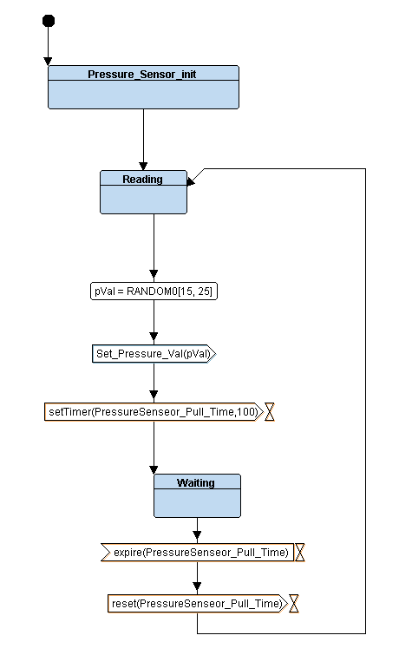Monitor AlarmPressure Sensor

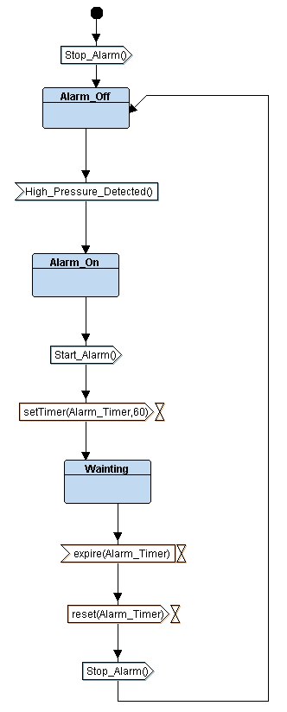

**Simulation trace from ttool**

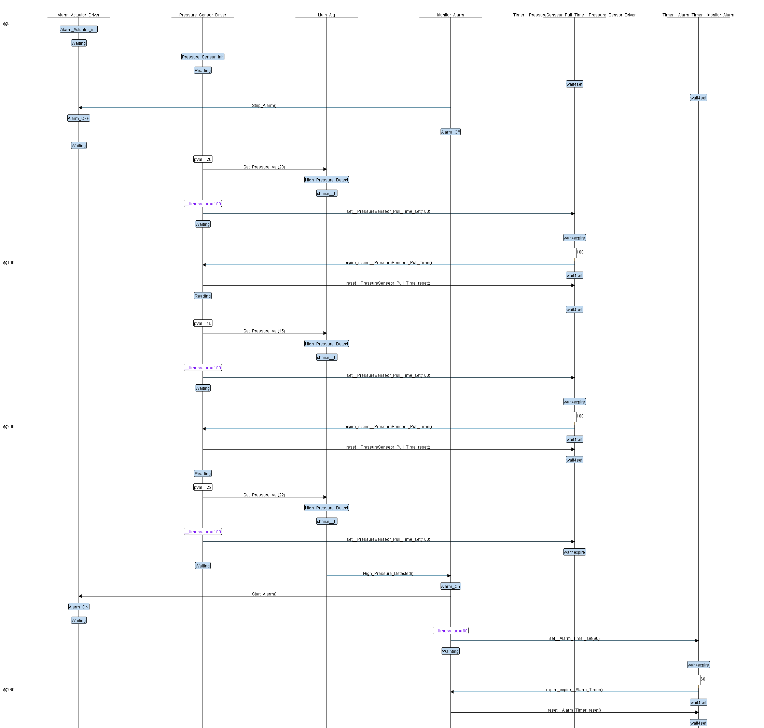

# Implementation

**Press the Link below.**

# Memory Sections

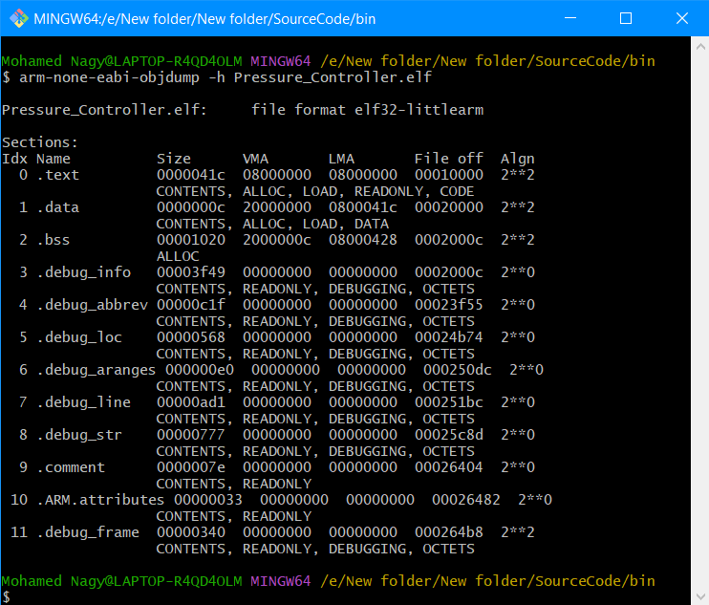

# Symbol Table

# PROTEUS

## The output in case of Low-Pressure value, so the alarm is OFF

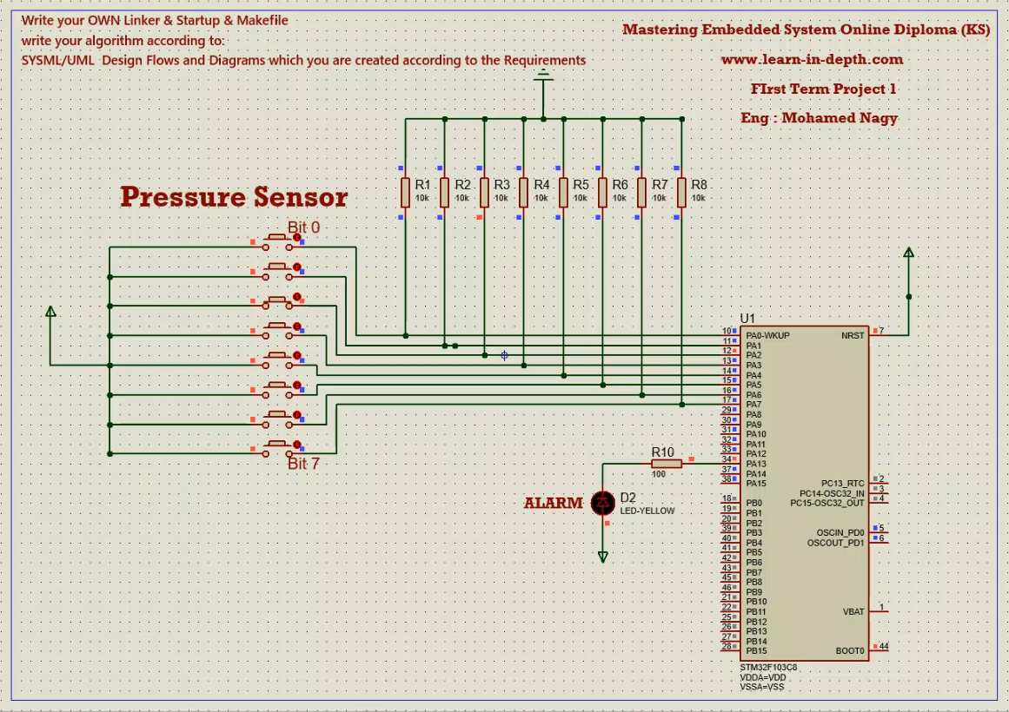

The output in case of High-Pressure value, so the alarm is ON

