Mastering Embedded System Online Diploma

First Term - Final Project 2

Student Management System Project

Mohamed Nagy

Table of Contents

Problem Statement 3

Approach 3

Implementation 4

Simulation 4

Test Cases 5

Add Students Manually 5

Add Students From text File 6

Find Student with its ID Number 7

Find Student with its First Name 8

Find Total Number of Students 9

Delete Student by Its ID Number 10

Update Student Information by Its ID Number 11

Print All Students 13

# Problem Statement

Write a program to build simple software for a student information management system that can perform the following operations:

* Store the first name of the student.
* Store the last name of the student.
* Store the unique roll number (ID) for every student.
* Store the GPA of every student.
* Store the courses registered by the student.

# Approach

Using a queue to be the database that contains the students Information. There are 10 options each forming individual function specific to its operations used it to handle the Student Information.

* Add the Student Details Manually.
* Add the Student Details Form File.
* Find the Student Details by giving the id Number of Student.
* Find the Student Details by Given Student First Name.
* Find the Student Details by Given Student Last Name.
* Count total Number of Students.
* Delete Specific Student by Given his ID Number.
* Update Student Information by Given his ID Number.

1. Change Student ID Number.
2. Change Student First Name.
3. Change Student Last Name
4. Change Student Courses.

* Print All Student Information.
* Exit The Program.

# Implementation

**The Project contains four files :**

* main.c which has the main program interface and calling functions.
* student.h which has the functions prototypes, a global struct for student data, another global struct for the queue and an array of students to be the buffer.
* student.c which has the functions definitions.
* Student_DataStructure.txt which has a set of student’s data.

[To Access Source Files Please Press.](https://github.com/Ged0oo/LearnInDepth/tree/main/Projects/02_StudentMannagmentSystem/SourceCode/StudentMannagmentSystem)

# Simulation

The given text file Contains some Students data just as a sample to test the Functions and check that the code is Bus free.

# Test Cases

## Add Students Manually

## Add Students From text File.

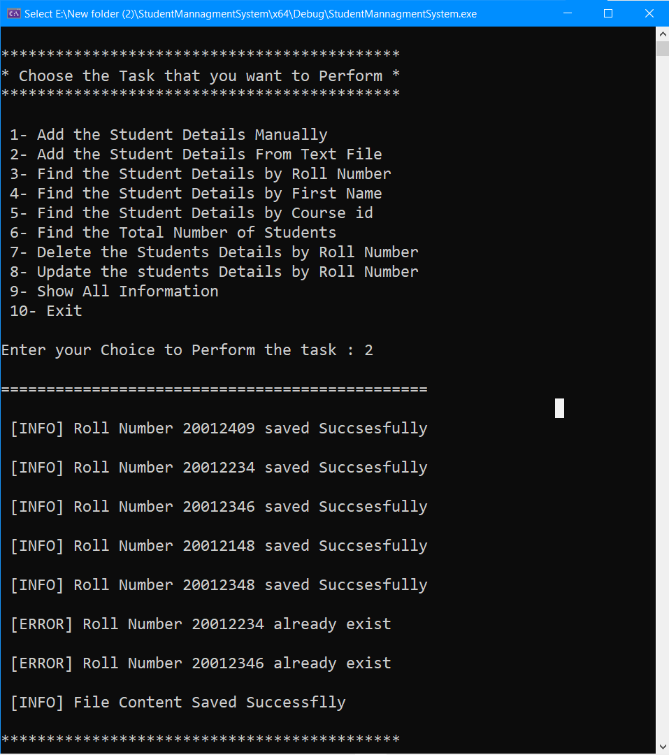

## Find Student with its ID Number

## Find Student with its First Name

## A black screen with white text Description automatically generatedFind Total Number of Students

## A screenshot of a computer Description automatically generatedDelete Student by Its ID Number

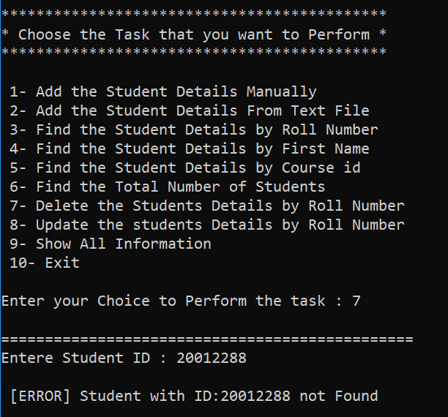

## Update Student Information by Its ID Number

1. A screenshot of a computer

   Description automatically generated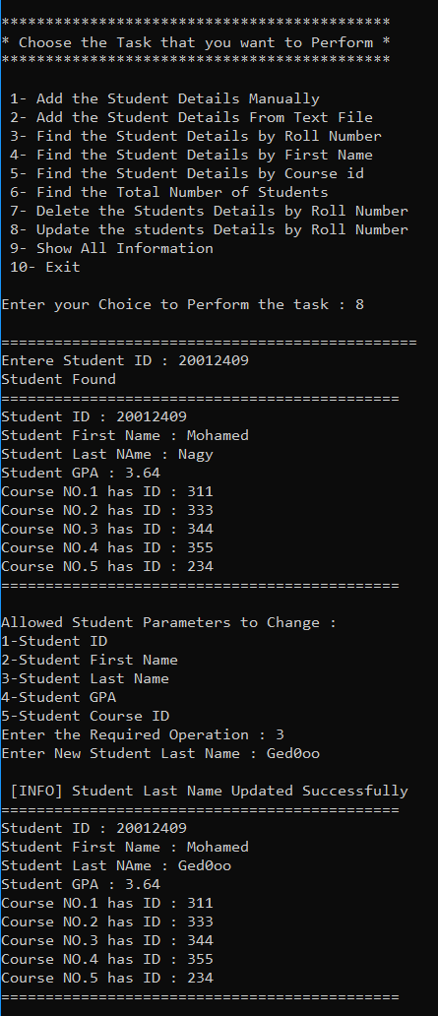Update First Name 2. Update Second Name
2. 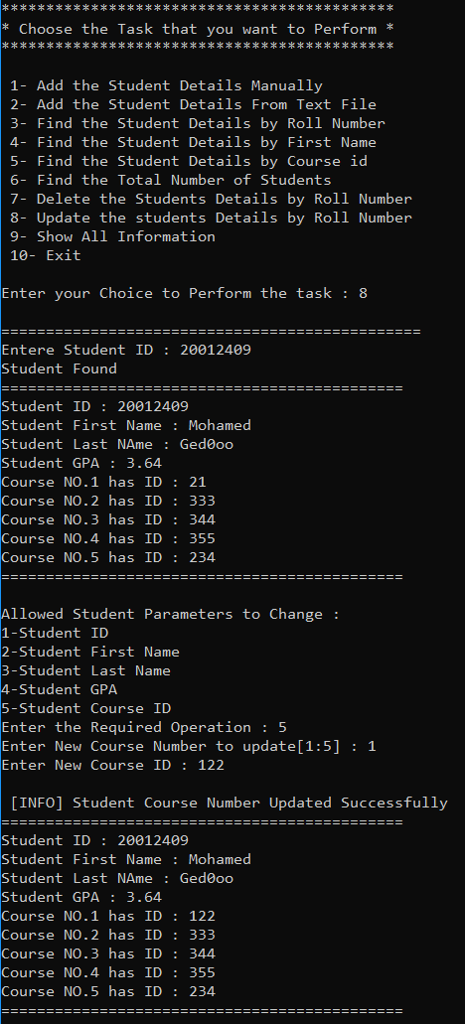A screen shot of a computer

   Description automatically generatedUpdate ID Number 4. Update Specific Course Number

## Print All Students