**LAPORAN PRAKTIKUM**

**ANALISIS ALGORITMA**



**DISUSUN OLEH**

Gede Bagus Darmagita - 140810180068

**PROGRAM STUDI TEKNIK INFORMATIKA**

**FAKULTAS MATEMATIKA DAN ILMU PENGETAHUAN ALAM**

**UNIVERSITAS PADJADJARAN**

**2020**

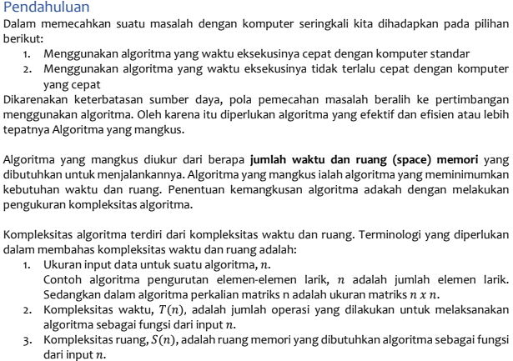

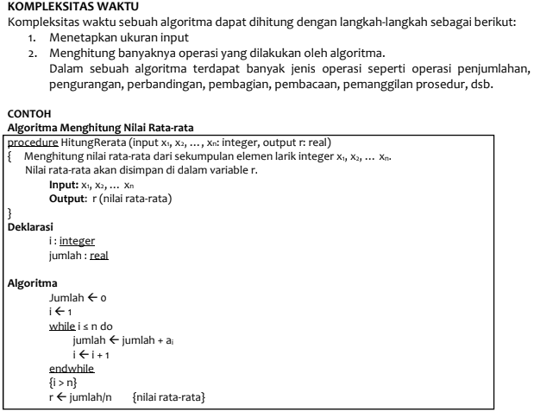

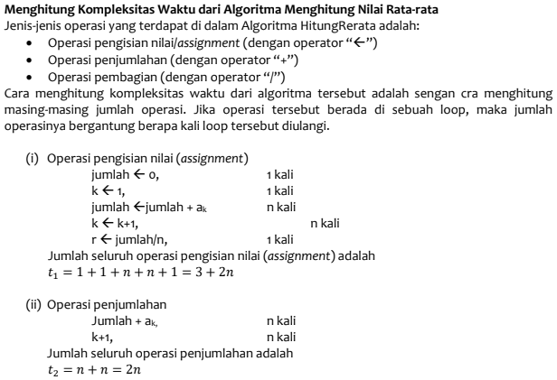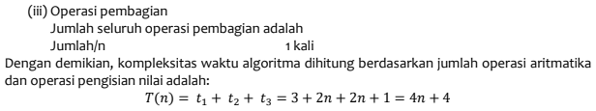

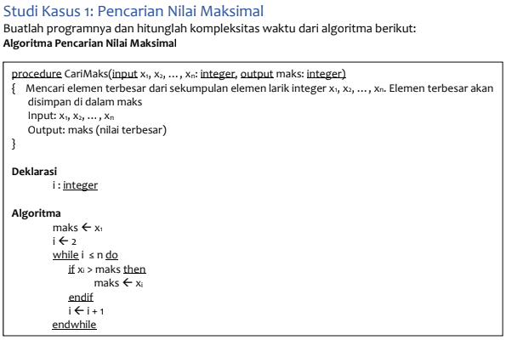

Answer:  
1.Operasi Assignment = 1 + 1 + (n-1) + (n-1) = 2n

2.Operasi Perbandingan = n-1

3.Operasi Penjumlahan = n-1

**Maka Tmax(n) = 4n-2**

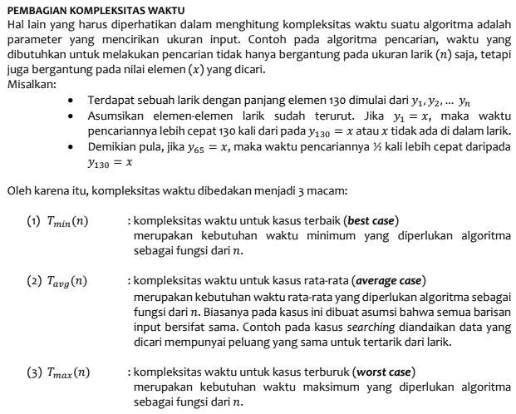 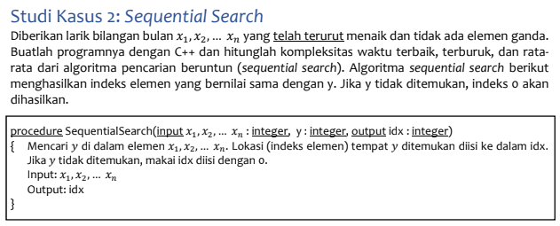 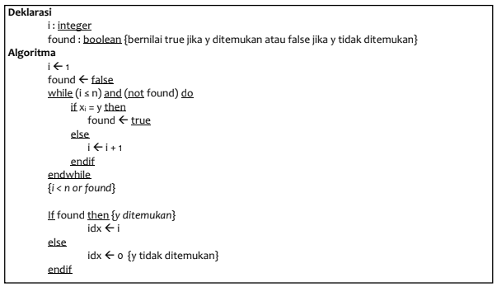

Answer:

1.Operasi Assignment = 4

2.Operasi Perbandingan = 2

**Tmin(n) = 4 + 2 = 6**

1.Operasi Assignment = 1 + 1 + n + 1 = 3 + n

2.Operasi Perbandingan = n + 1

3.Operasi Penjumlahan = n

**Tmax(n) = 3+n+n+1+n=3n+4**

(Tmin(n) + Tmax(n)) / 2 = (6+4+3n) / 2 = (10+3n) / 2

**Tavg(n) = (10+3n) / 2**

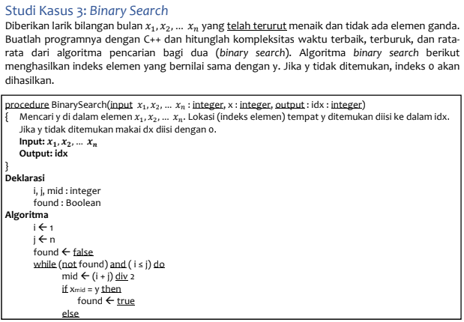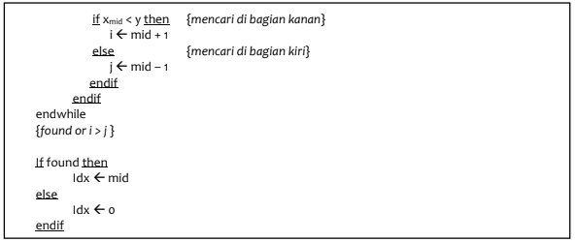

Answer:

1.Operasi Assignment = 6

2.Operasi Perbandingan = 2

**Tmin(n) = 6 + 2 = 8**

Panjang array akan berubah pada setiap iterasi:

•Iterasi 1 = n

•Iterasi 2 = n/2

•Iterasi 3 = n/22

•Iterasi x = n/2k-1 ~ n/2k (-1 diabaikan karena kecil dibanding n/2k)

Panjang array menjadi 1.

Maka,

n/2k= 1

n= 2k

log 2(n) = log 2(2k) = k log 2(2)

k= log 2(n)

**Tmax(n) = (log 2(n))**

(Tmin(n) + Tmax(n)) / 2 = (1 + log 2(n)) / 2

**Tavg(n) = (1 + log 2(n)) / 2**

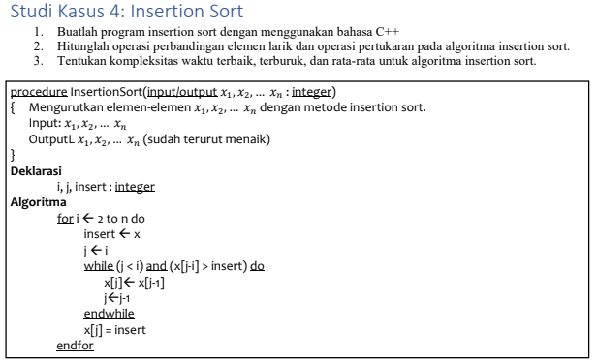

Answer:

1.Operasi Assignment: 2(n-1) + (n-1) = 3n-3

2.Operasi Perbandingan: 2*((n-1) + (n-1)) = 2*(2n-2) = 4n-4

3.Operasi Pertukaran: (n-1) * n = n2-n

**Tmin(n) = 3n-3 + 4n-4 + 1 = 7n – 6**

**Tmax(n) = 3n-3 + 4n-4 + n2-n = n2+6n-6**

(Tmin(n) + Tmax(n)) / 2 = (7n–6 + n2+6n-6) / 2

**Tavg(n) = (n2 + 13n - 12) / 2**

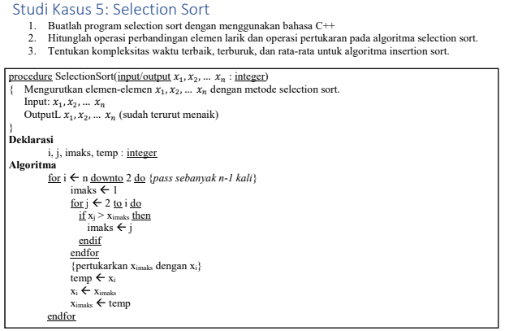

Answer:

1.Operasi Perbandingan = ½(n^2-n)

2.Operasi Pertukaran = n-1

**Tmin(n) = (4n-4) + ½(n2-n) +1 ~ n2**

**Tmax(n) = ½(n2-n) + (n-1) ~ n2**

(Tmin(n) + Tmax(n)) / 2 = (n2+ n2) / 2

**Tavg(n) = n2**