Quarto 使用例 (Jupyter + Python 3.9.6)

ill-identified

2021/10/2

|  |
| --- |
| 注意 |
| Quarto は最近公開されたばかりで開発中なので**ここの記述もすぐ時代遅れになる可能性がある**ことに注意してほしい. |

# Markdown の確認

1. 番号付きの
2. 箇条書き
   1. ネストも
   2. できる

## 数式表示

ブラック=ショールズ方程式 (式 1)

$$\frac{∂C}{∂t}+\frac{1}{2}σ^{2}S^{2}\frac{∂^{2}C}{∂C^{2}}+rS\frac{∂C}{∂S} =rC \left(1\right)$$

# テキスト出力の確認

!python --version

Python 3.9.6

1 + 1

2

# コード実行と実行オプションの動作確認

Matplotlib 公式の用例[1] から作成した 図 1 を見よ. コードは長いので HTML 版では折りたたみ, PDF 版では非表示とした.

import numpy as np  
import matplotlib.pyplot as plt  
  
  
category_names = ['Strongly disagree', 'Disagree',  
 'Neither agree nor disagree', 'Agree', 'Strongly agree']  
results = {  
 'Question 1': [10, 15, 17, 32, 26],  
 'Question 2': [26, 22, 29, 10, 13],  
 'Question 3': [35, 37, 7, 2, 19],  
 'Question 4': [32, 11, 9, 15, 33],  
 'Question 5': [21, 29, 5, 5, 40],  
 'Question 6': [8, 19, 5, 30, 38]  
}  
  
  
def survey(results, category_names):  
 labels = list(results.keys())  
 data = np.array(list(results.values()))  
 data_cum = data.cumsum(axis=1)  
 category_colors = plt.get_cmap('RdYlGn')(  
 np.linspace(0.15, 0.85, data.shape[1]))  
  
 fig, ax = plt.subplots(figsize=(9.2, 5))  
 ax.invert_yaxis()  
 ax.xaxis.set_visible(False)  
 ax.set_xlim(0, np.sum(data, axis=1).max())  
  
 for i, (colname, color) in enumerate(zip(category_names, category_colors)):  
 widths = data[:, i]  
 starts = data_cum[:, i] - widths  
 rects = ax.barh(labels, widths, left=starts, height=0.5,  
 label=colname, color=color)  
  
 r, g, b, _ = color  
 text_color = 'white' if r * g * b < 0.5 else 'darkgrey'  
 ax.bar_label(rects, label_type='center', color=text_color)  
 ax.legend(ncol=len(category_names), bbox_to_anchor=(0, 1),  
 loc='lower left', fontsize='small')  
  
 return fig, ax  
  
  
survey(results, category_names)  
plt.show()

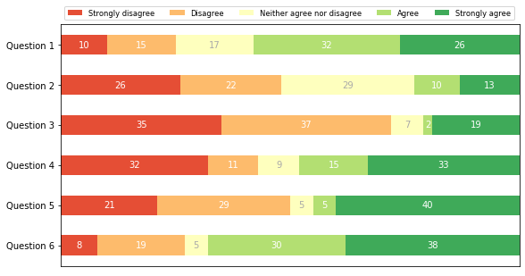

図 1: matplotlib のコードはとても長い

Plotnine で作成した 図 2 を見よ.

from plotnine import *  
import pandas as pd  
d = pd.DataFrame(results).assign(  
 cat=pd.Categorical(category_names, category_names),  
).melt(id_vars="cat").assign(  
 variable=lambda d: pd.Categorical(d['variable'], list(reversed(results.keys())))  
)  
  
(  
 ggplot(d, aes("variable", "value", group="cat", fill="cat", label="value")  
 ) +  
 geom_col(width = .5) + geom_text(position = position_stack(vjust=.5), color="darkgrey") +  
 coord_flip() + scale_y_reverse() +  
 scale_fill_brewer("div", "RdYlGn") +  
 theme(axis_title=element_blank(), axis_text_x=element_blank(), axis_ticks_major_x=element_blank(),  
 legend_position='top', legend_title=element_blank())  
).draw();

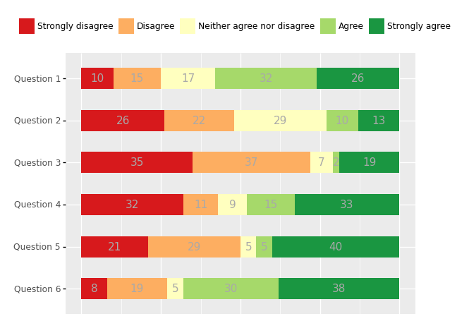

図 2: Plotnine で同等のグラフを作成

しかし, 図 3 のように Altair は表示されない? 公式の用例[2]はいろいろと設定が必要そう

import altair as alt  
from vega_datasets import data  
cars = data.cars()  
alt.Chart(cars).mark_point().encode(  
 x='Horsepower',  
 y='Miles_per_Gallon',  
 color='Origin',  
 tooltip=['Name', 'Origin'] # show Name and Origin in a tooltip  
).interactive()

|  |
| --- |
| alt.Chart(...)  図 3: Altair を使用したインタラクティブなグラフ |

# 表の表示

**?@tbl-table1** を見よ. 現時点では pandas データフレームの表示を表として相互参照できない?

cat variable value  
0 Strongly disagree Question 1 10  
1 Disagree Question 1 15  
2 Neither agree nor disagree Question 1 17  
3 Agree Question 1 32  
4 Strongly agree Question 1 26  
5 Strongly disagree Question 2 26  
6 Disagree Question 2 22  
7 Neither agree nor disagree Question 2 29  
8 Agree Question 2 10  
9 Strongly agree Question 2 13  
10 Strongly disagree Question 3 35  
11 Disagree Question 3 37  
12 Neither agree nor disagree Question 3 7  
13 Agree Question 3 2  
14 Strongly agree Question 3 19  
15 Strongly disagree Question 4 32  
16 Disagree Question 4 11  
17 Neither agree nor disagree Question 4 9  
18 Agree Question 4 15  
19 Strongly agree Question 4 33  
20 Strongly disagree Question 5 21  
21 Disagree Question 5 29  
22 Neither agree nor disagree Question 5 5  
23 Agree Question 5 5  
24 Strongly agree Question 5 40  
25 Strongly disagree Question 6 8  
26 Disagree Question 6 19  
27 Neither agree nor disagree Question 6 5  
28 Agree Question 6 30  
29 Strongly agree Question 6 38

**?(caption)**

# 文献引用

[@R-quarto], @R-rmdja

1. <https://matplotlib.org/stable/gallery/lines_bars_and_markers/horizontal_barchart_distribution.html#sphx-glr-gallery-lines-bars-and-markers-horizontal-barchart-distribution-py>
2. <https://jjallaire.github.io/visualization-curriculum/altair_introduction.html>