**Software Engineering course Project**

**AKFA University**

**Software Requirements Specification (SRS)**

**For**

**“UzWallet”**

Version **________________**

Timur Urunbaev

Bobir Ibragimov

Elbek Erkinboev

Ravshan Zaripov

Asadbek Fazliddinov

Samandar Kambaraliev

Muhammad Irshad-Nazeer

21-12-2022

| Project Code | Not applicable |
| --- | --- |
| Supervisor | Muhammad Irshad-Nazeer |
| Project Manager | Timur Urunbaev |
| Project Team | Samandar Kambaraliev  Ravshan Zaripov  Asadbek Fazliddinov  Elbek Erkinboev  Bobir Ibragimov |
| Submission Date | 21-12-2022 |

**1. Introduction** **2**

1.1 Purpose of Document 2

1.2 Intended Audience 2

1.3 Document Convention 2

1.4 Project Scope 3

1.5 Not in Scope 3

**2. Overall System Description** **3**

2.1 Project Background 3

2.2 Project Objectives 4

2.3 Stakeholders 4

2.4 Operating Environment 4

2.5 System Constraints 4

2.6 Assumptions & Dependencies 4

**3. External Interface Requirements** **5**

3.1 Hardware Interfaces 5

3.2 Software Interfaces 5

3.3 Communication Interfaces 5

**4 Functional Requirements** **5**

4.1 Functional Hierarchy 5

4.2 Use cases (User) 6

4.2.1 [New User Registration] 7

4.2.2 [User Log in] 8

4.2.3 [Add New Card] 9

4.2.4 [Order New Card] 10

4.2.5 [Notification Subscription] 11

4.3 Use cases (Admin) 12

4.3.1 [New Store Registration] 12

4.3.2 [Login] 13

4.3.3 [Manage Posts] 14

**5. Non-functional Requirements** **14**

5.1 Performance Requirements 14

5.2 Safety Requirements 15

5.3 Security Requirements 15

5.4 User Documentation 16

**6. References** **16**

# 1. Introduction

## 1.1 Purpose of Document

The purpose of this document is to outline the requirements of the project. SRS helps developers reduce the time and cost of achieving goals required by a specific software system. A good SRS is a document that shows how the system will interact with system hardware, software programs, and humans in different real-time scenarios.

The purpose of this document is to define each possible functional and non-functional requirements of the project “UzWallet”. Using this SRS, we can design our system later to meet the desired system goal by having a look at this document. Moreover, it will also help to reduce the time and effort for the development of the system.

## 1.2 Intended Audience

This document will be used by the development team of this project “UzWallet”. Also, testers and evaluators can use this document to quickly understand the system's requirements. Tests and verification of system requirements will be conducted using the SRS document by the supervisor. If this project is deployed for the government or any private organization then this document will be a detailed overview and will help them to understand the entire system.

Type of users:

1. Usual people (Users).
2. Administrators of retail organizations (Partner Company).

## 1.3 Document Convention

The following settings are used in this document:

* Font - Times New Roman
* Heading font size - 14
* Subheading font size - 13
* Sub Sub Heading font size - 12
* Font size - 11

| Term | Meaning |
| --- | --- |
| PC | Partner company, legally registered organization, with which UzWallet has business relationships. |
| User | A person who uses UzWallet mobile application and has accepted Terms of Use with the company. |
| Terms of Use | These are the rules that user need to agree to before using UzWallet. |
| LC | Loyalty card, which guarantees access to the motivational and incentive measures of influence for regular customers (users). |
| UWR | UzWallet requirement. |
| Application | A mobile application functioning on operating systems Android and iOS, the exclusive right to which belongs to UzWallet. |
| Website | Internet sites administered by Uzwallet. |

## 1.4 Project Scope

The main scope of this system is to collect LC in one place. Also, the application provides information about discounts and promotions in partner stores. Inside the application, users can order new loyalty cards from available stores, so users do not have to go to this store to register a new card. The main components of this:

1. Adding and registering new LC.
2. Storing LC and account information.
3. Monitoring partner stores promotions.
4. Local store locations are shown on map.
5. Notification about special offers.

For the live map locating nearby stores, there will be integrated YandexMaps. Furthermore, updates about sales and promotions will be notified via app notifications.

## 1.5 Not in Scope

1. Our system does not provide any banking (acquiring) services.

2. Our system does not integrate with bank accounts.

3. Our system does not support a payment system.

4. Our system is local-oriented, functioning only in Uzbekistan.

5. Our system does not share information about its users to third parties.

# 2. Overall System Description

## 2.1 Project Background

In big cities, there are a variety of shopping malls, supermarkets, and other kinds of retail organizations. Along with this, there is also a great number of consumers. Under such circumstances, retailers have to provide special offers to attract as many customers as they can. In cases, when a customer lives near a particular grocery or department store, they have no choice, but to use only these nearby shops.

However, for faster shopping operations, people have small local stores, which provide a limited range of essential products. Therefore, to gain as much market capitalization, big retail companies have created a system of loyalty and discount programs. These features involve having a physical plastic card with barcodes or in-app QR codes. In other words, customers need to take these cards or have applications from each store with them, to use them, gain cashback or discounts, or participate in promotional programs or sales. As a result, difficulties may arise, for example, not having enough memory storage in the phone for many shopping applications, or taking all loyalty cards inside one wallet. Due to such factors, people often miss opportunities to save money and join sale promotions which could save them a lot of money.

## 2.2 Project Objectives

The objective of this project is to develop a platform that can increase the number of potential users of loyalty programs along with boosting regular customers of the particular chain of stores. People will be able to add existing loyalty, cashback, and discount cards into the app. And also, they can open new cards, by just sending a request to the shop via the application. Additionally, the software will have an advertisement notifications section about sales and discounts in nearby interesting shops.

## 2.3 Stakeholders

Our stakeholders are people, who are interested in discounts and sales. Major chain of stores, willing to expand the permanent clients’ base. Users can order to issue new online cards via the application, after which they will use the cards in the markets with discounts on the purchase. According to the sales rate of particular products, retailers will be able to make efficient sales and promotions of their brands and advertise them.

## 2.4 Operating Environment

The software will run on the Android operating system, as well as on iOS. Any version of the OC systems will be able to hold the software.

## 2.5 System Constraints

* **Software constraints** 
  + The operating system of mobile phones can stop working due to any software failure.
  + Internet connection is needed for sending and receiving data from their live location.
* **Hardware constraints**
  + The user and retailer company should have an electronic device.
  + Users for the full functionality of the application should have a stable internet connection. (But still the user can use the app and its features if he downloads a minimal data package).
* **Cultural constraints** 
  + The user and retailer company must know Uzbek, Russian, or English languages.
* **User constraints**
  + The mobile application is developed for people who are from 6 years old. Assumed they are well-educated and tech-aware of usual smartphones.
* Off-the-shelf components that might be used in the project may have their constraints that are consequently transferred to the project.
  + NA

## 2.6 Assumptions & Dependencies

* The user should have an active Internet connection while the app is using.
* The Internet issues can delay the process of updating card details and advertisements.
* The user is supposed to have a smartphone and an understanding of using it.

# 3. External Interface Requirements

## 3.1 Hardware Interfaces

The only hardware interface required is the smartphone capable to install and to utilize the application.

## 3.2 Software Interfaces

The application will be available for Android as well as iOS users. It will help consumers to store all their LC in the application, to use them whenever it is needed to receive discounts, cashback, and other types of rewards. Also, consumers will be able to order virtual loyalty cards for free. All information about discounts and sales available will be displayed on a specific basis, to keep tracking them. Any user can register on an app who has an active mobile number, email, and the application itself.

## 3.3 Communication Interfaces

Smartphones are required to be connected to the internet for the application to be fully functional. Users can only access saved LC information otherwise.

# 4 Functional Requirements

## 4.1 Functional Hierarchy

The following diagram describes the functional hierarchy of each user role in this system. All the roles need to be authorized and authenticated to use the system features. Users will have a mobile application that will run on any smartphone. After installation, the user is required to fill out a registration form, then the user can use the application in the way it was intended.

## 4.2 Use cases (User)

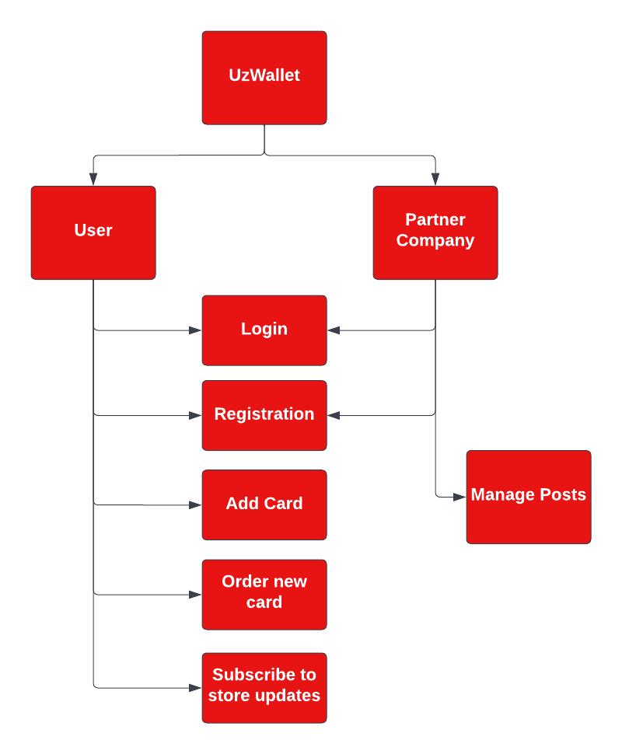

### 

### 4.2.1 [New User Registration]

**[Use case Description]:**

This use case is for registering new users in the app. A person can register himself as a new customer. He must not be registered before, using the same email and phone number . So that new user needs to provide a unique phone number and email. Otherwise, he will not be registered.

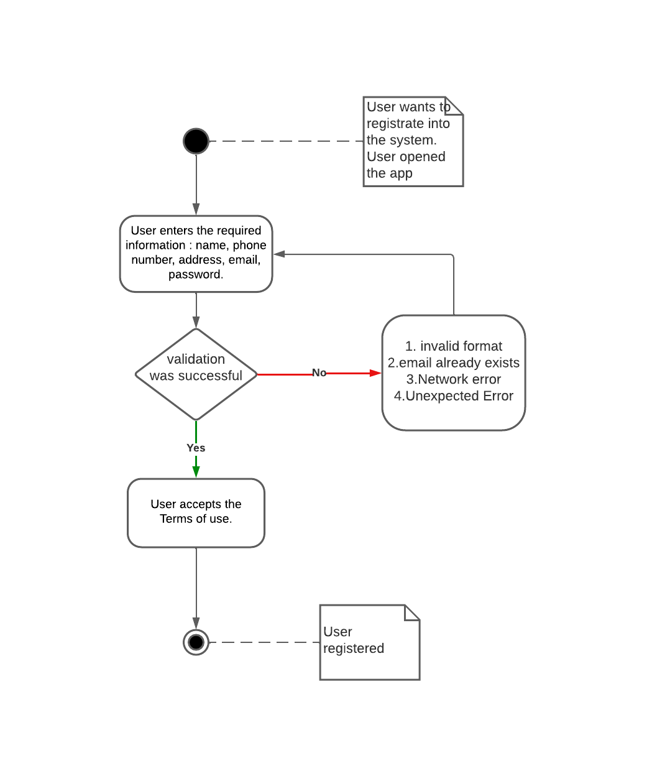

| **UWR01**: New User Registration | | | | | |
| --- | --- | --- | --- | --- | --- |
| **Use Case ID** | | UWR01 | | | |
| **Actors**: User | | | | | |
| **Feature:** Registration management | | | | | |
| **Pre-condition:** | | The user has not been registered yet | | | |
| **Scenarios:** User will access a simple registration page where he will create a new account writing specific information about the user. However, the sign up button will redirect the user to Profile page where he should complement with other relevant data like name, address and etc. about the person. | | | | | |
| **Steps**# | | **Action** | | **Software Reaction** | |
| 1. | | User enters the required information : name, phone number, address, email, password. | | System checks email and phone number if they were not used before.  System verifies format of written information. | |
| 2. | | User accepts the Terms of use. | | System records the user's credentials in the database. | |
| 3. | | Registration has successfully ended. | | System redirects to the Main page. | |
| **Alternative Scenarios:** | | | | | |
| **1a:** Account with written phone number or email is already exists <System shows warning message>  **1b:** Invalid format of phone number, email or password <System shows warning message>  **3a:** Network error <Unstable network connection>  **3b:** Unexpected error <Exit from application and shows error message> | | | | | |
| **Post-condition:** | | | | | |
| **Steps**# | | **Description** | | | |
| 1. | | A user specific account is created at the backend database. | | | |
| 2. | | A user is redirected to the user specific Main page or registration failed message is displayed. | | | |
| **Use Case Cross referenced** | | | None | | |

### 

### 4.2.2 [User Log in]

**[Use case Description]:**

The use case is about “login” of the user (customer). This use case includes the unique telephone number and password features that will be used to login into the account that have already been registered.

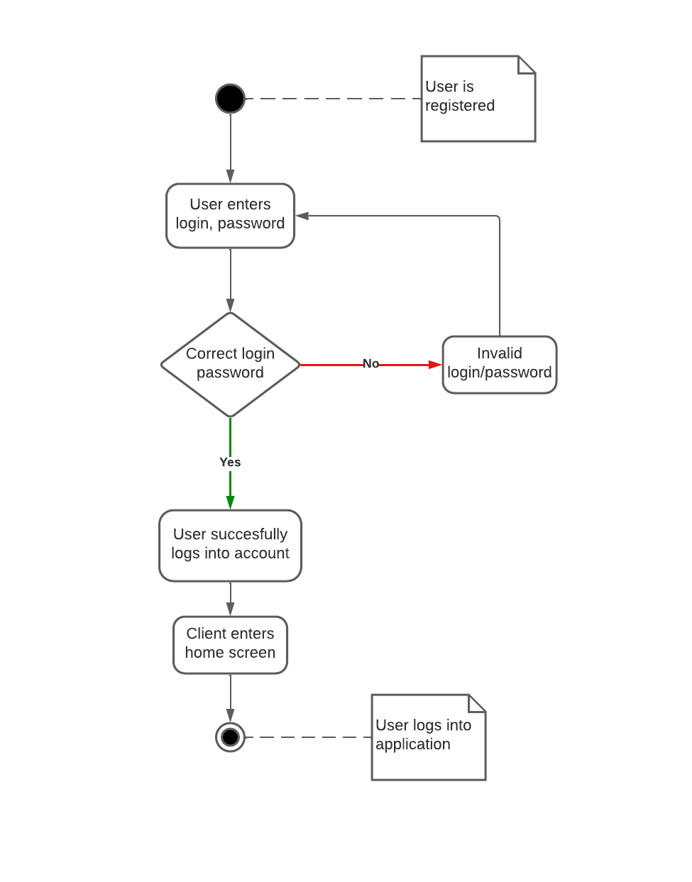

| **UWR02:** User Log in | | | | | |
| --- | --- | --- | --- | --- | --- |
| **Use Case ID** | | UWR02 | | | |
| **Actors:** User | | | | | |
| **Feature:** Log in management | | | | | |
| **Pre-condition:** | | Users have an active Internet and have already been registered before logging in | | | |
| **Scenario:**  The registered user accesses the system via mobile application and clicks on the “Login” button. The user needs to be logged in in case to access any personal information or interact with the system. After redirecting to the login page the following steps will take place. | | | | | |
| **Step#** | | **Action** | | **Software Reaction** | |
| **1.** | | Fill out the page with email and password. | | System verifies the format of the email.  System verifies the password length.  System validates login information. | |
| **2.** | | Commit Log in. | | System opens the Main page. | |
| **Alternative Scenarios:** | | | | | |
| **1a:** User enters wrong email format <System shows warning message>  **1b:** User enters wrong credentials (email or password) <System shows error message>  **2a:** Network error <Unstable network connection> | | | | | |
| **Post Conditions:** | | | | | |
| **Step#** | | **Description** | | | |
| **1.** | | User’s specific account is created at the backend database. | | | |
| **2.** | | User is redirected to the user's specific login page or registration failed message is displayed. | | | |
| **Use Case cross referenced** | | | New User Registration | | |

### 

### 4.2.3 [Add New Card]

**[Use case Description]:**

A user can add existing LC to his wallet and use them with previously saved credentials. To do this, user required to provide bar code number by typing or scanning it via camera, as well as other information if necessary. After the confirmation, the card will successfully be added.

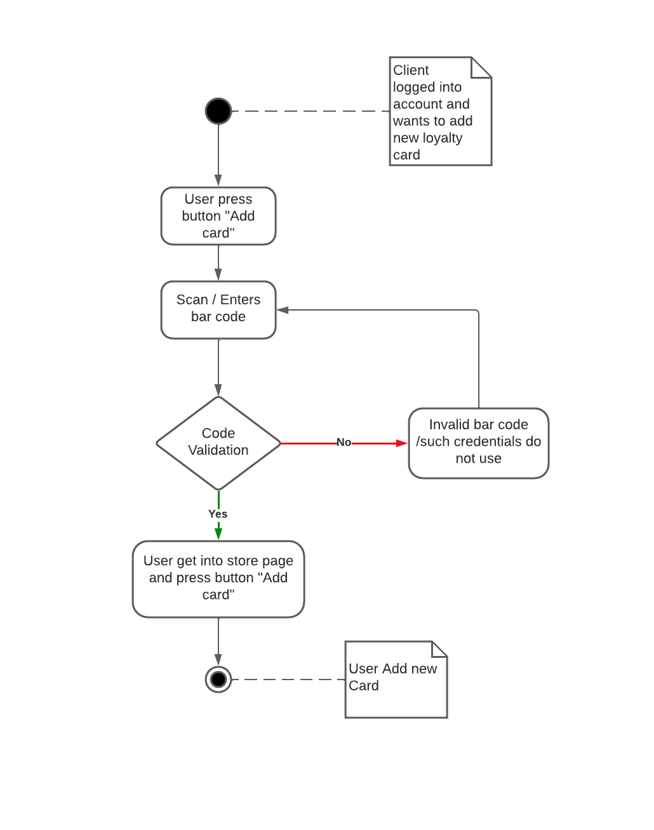

| **UWR03**: Add Card | | | | | |
| --- | --- | --- | --- | --- | --- |
| **Use Case ID** | | UWR03 | | | |
| **Actors**: User | | | | | |
| **Feature:** Cards management | | | | | |
| **Pre-condition:** | | User have to be logged in | | | |
| **Scenarios:** | | | | | |
| **Steps**# | | **Action** | | **Software Reaction** | |
| 1. | | User enters or scans card number. | | System sends verification code to the attached phone number. | |
| 2. | | User enters verification code to pass the card validation. | | System adds the card to the user’s collection. | |
| **Alternative Scenarios:** | | | | | |
| **1a:** Card not found <System shows error message>  **2a:** Verification failure <System shows error message>  **2b:** Network error <Unstable network connection>  **2c:** Unexpected error <Exit from application and shows error message> | | | | | |
| **Post-condition:** | | | | | |
| **Steps#** | | **Description** | | | |
| 1. | | System redirects a user to the Main page. | | | |
| 2. | | System recorded the Add card operation. | | | |
| 3. | | The card is added to the collection and now can be reached at any time. | | | |
| **Use Case Cross referenced** | | | None | | |

### 

### 4.2.4 [Order New Card]

**[Use case Description]:**

If a user wants to get a new LC from the new store, he is asked to request an issuance. By choosing the store from available options, the user is supposed to click on a button, after which a new LC will be created and recorded in the store's database. Therefore, the user can instantly use the new card.

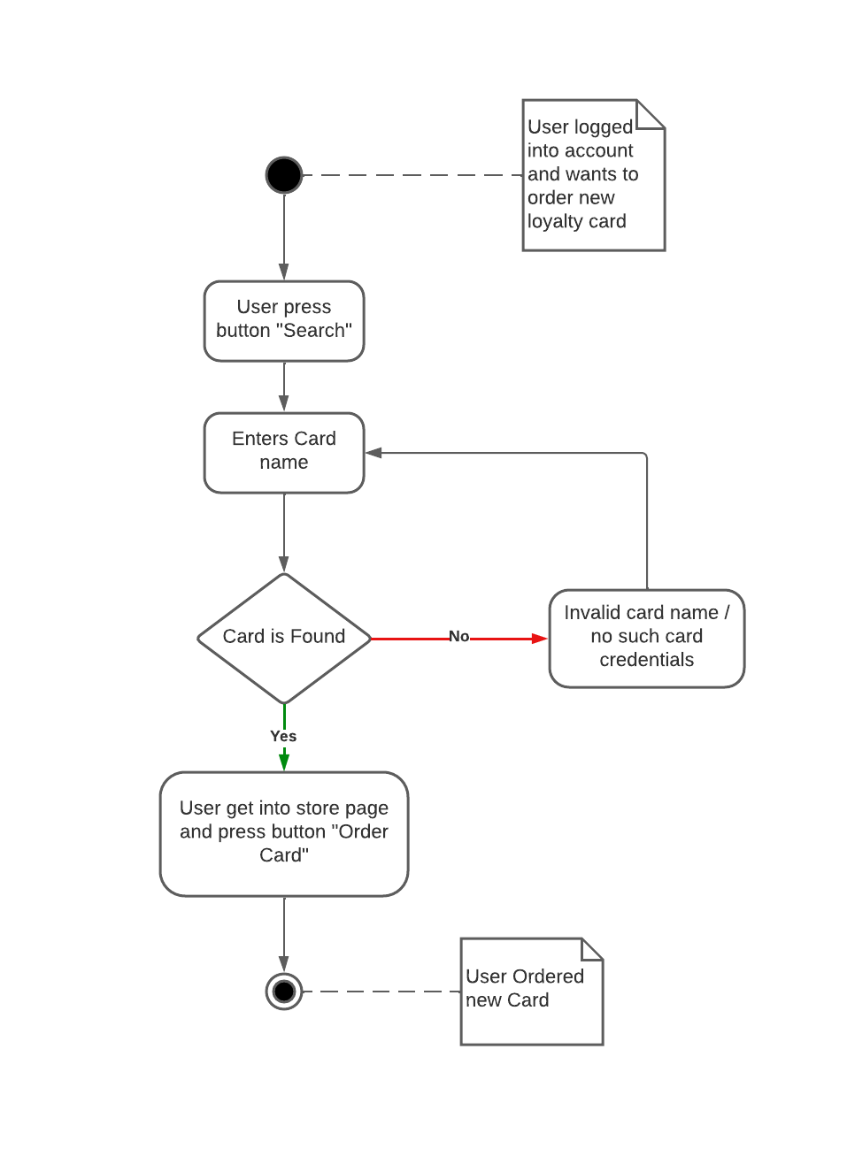

| **UWR04**: Order New Card | | | | | |
| --- | --- | --- | --- | --- | --- |
| **Use Case ID** | | UWR04 | | | |
| **Actors**: User | | | | | |
| **Feature:** Card management | | | | | |
| **Pre-condition:** | | User have to be logged in | | | |
| **Scenarios:** | | | | | |
| **Steps**# | | **Action** | | **Software Reaction** | |
| 1. | | User chooses the store his wants to become a regular customer in. | | System informs the user with the Terms of regulations and other guidelines if there are any. | |
| 2. | | User agrees with all rules and guidelines. | | System initiates creating new LC. | |
| **Alternative Scenarios:** | | | | | |
| **1a:** Stores may suspend issuing new LC <System shows warning message>  **1b:** The user has already released the card <Sytem shows warning message>  **2a:** Network error <Unstable network connection>  **2b:** Unexpected error <Exit from application and shows error message> | | | | | |
| **Post-condition:** | | | | | |
| **Steps#** | | **Description** | | | |
| 1. | | System forwards the user to the Main page. | | | |
| 2. | | System recorded the Create new card operation. | | | |
| 3. | | System transmits the registered procedure to the organization. | | | |
| 4. | | The card is added to the collection and now can be reached at any time. | | | |
| **Use Case cross referenced** | | | None | | |

### 

### 4.2.5 [Notification Subscription]

**[Use case Description]:**

Customers should subscribe for specific stores or retailers to follow their updates likes, like promotions, sales or news. User receives push notifications whenever announcements are published by stores. Also, notifications are available in section “Messages” of the application.

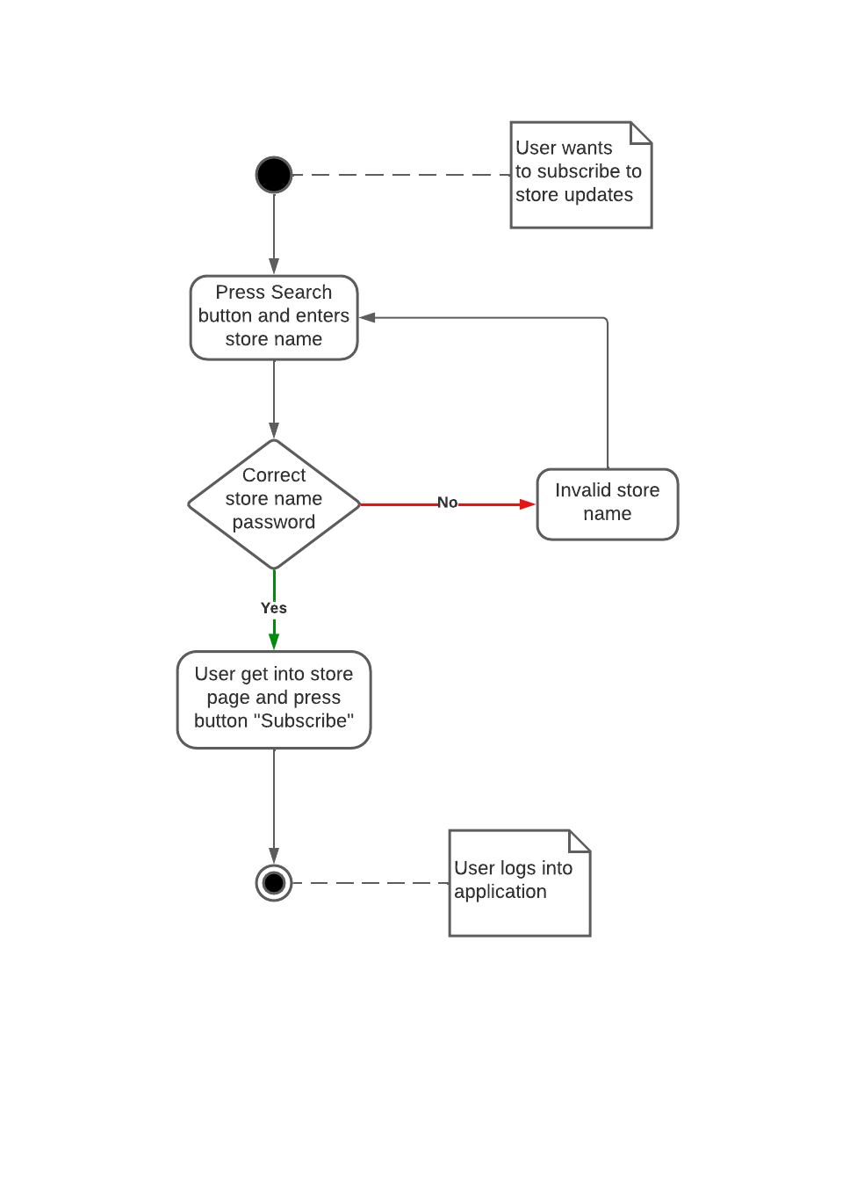

| **UWR05:** Notification Subscription | | |
| --- | --- | --- |
| **Use Case ID** | UWR05 | |
| **Actors:** User | | |
| **Feature:** Manage notifications | | |
| **Pre-condition:** | User have to be logged in | |
| **Scenarios:** | | |
| **Step#** | **Action** | **Software Reaction** |
| **1.** | User finds the desired store. | System redirects user to the Store page. |
| **2.** | User turns-on push notifications, by clicking the special button. | System records the activation of notifications at the backend. |
| **Alternative Scenarios:** | | |
| **2a:** Store notifications are not available <Unavailability of notification button>  **2b:** Network error <Unstable network connection>  **2c:** Unexpected error <Exit from application and shows error message> | | |
| **Post Conditions:** | | |
| **Step#** | **Description** | |
| **1.** | Notification mode is updated. | |
| **Use Case cross referenced** | | None |

### 

## 4.3 Use cases (Partner Company)

### 4.3.1 [New Store Registration]

**[Use case Description]:**

Company, which wants to establish business partnership, should fill out special form in UzWallet website.

It contains all the company's necessary information. After the validation of partner’s information, system will create an account for this organization, where it can manage all features of UzWallet application.

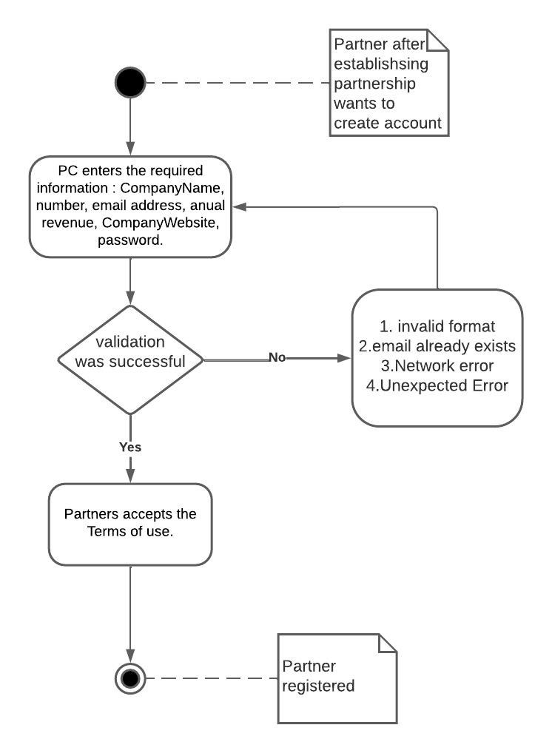

| **UWR05:** New Store Registration | | |
| --- | --- | --- |
| **Use Case ID** | UWR06 | |
| **Actors:** Partner Company | | |
| **Feature:** Organization management | | |
| **Pre-condition:** | PC should be established as legal entity | |
| **Scenarios:** | | |
| **Step#** | **Action** | **Software Reaction** |
| **1.** | PC fills out the application. | Website records the application. |
| **2.** | UzWallet and PC make up a contract. After which, PC gets access to the system and can use all features of UzWallet. | A new PC is being registered to the system.  System grants control over new account of PC. |
| **Alternative Scenarios:** | | |
| **2a:** The deal does not take place <Contract has not been performed> | | |
| **Post Conditions:** | | |
| **Step#** | **Description** | |
| **1.** | PC is able to manage its account in UzWallet system. | |
| **Use Case cross referenced** | | None |

### 4.3.2 [Login]

**[Use case Description]:**

Through UzWallet website, PC can access the system at any time and from anywhere. At the registration stage, PC receives login information.

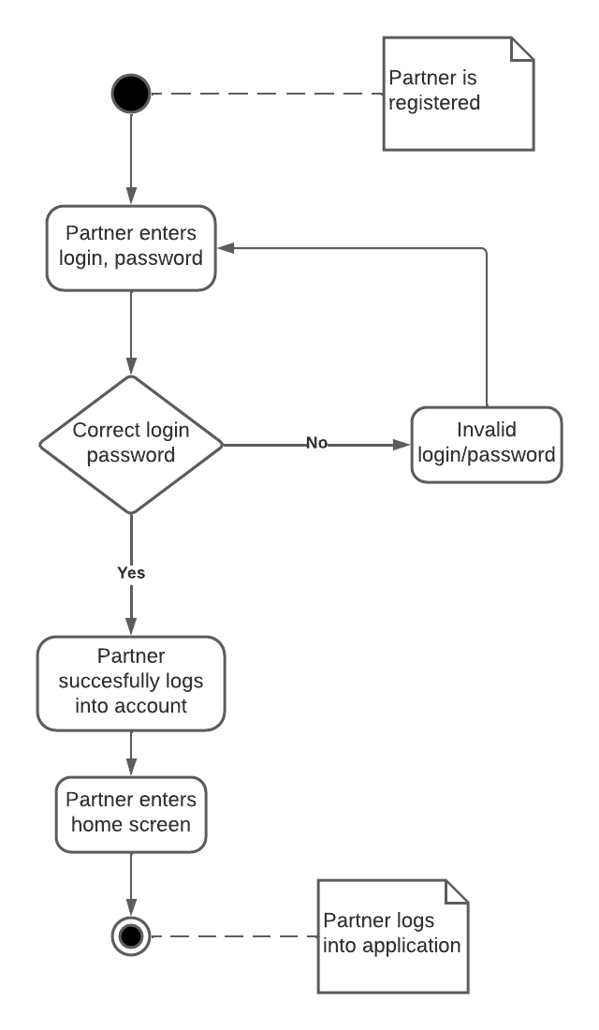

| **UWR07:** Login | | |
| --- | --- | --- |
| **Use Case ID** | UWR07 | |
| **Actors:** Partner Company | | |
| **Feature:** Organization management | | |
| **Pre-condition:** | PC should be registered | |
| **Scenarios:** | | |
| **Step#** | **Action** | **Software Reaction** |
| **1.** | Fill out the page with login and password. | System verifies the password length.  System validates login information. |
| **2.** | Commit Log in. | System opens the Main page. |
| **Alternative Scenarios:** | | |
| **1a:** PC enters wrong credentials (login or password) <System shows error message>  **2a:** Network error <Unstable network connection> | | |
| **Post Conditions:** | | |
| **Step#** | **Description** | |
| **1.** | PC is able to manage its account in UzWallet system from new place. | |
| **Use Case cross referenced** | | New Store Registration |

### 

### 4.3.3 [Manage Posts]

**[Use case Description]:**

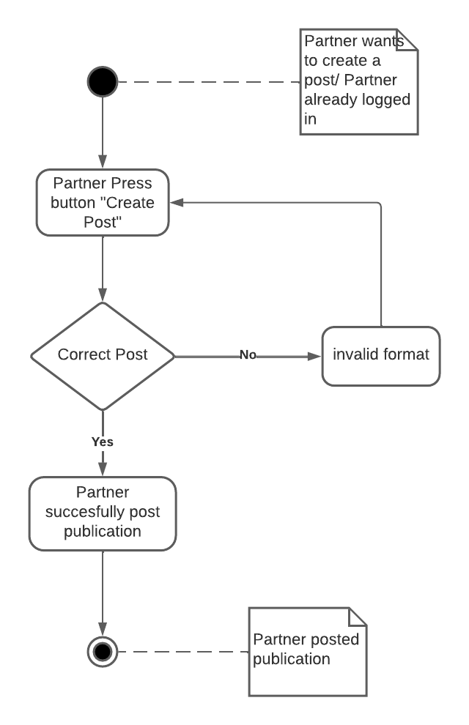

| **UWR08:** Manage Posts | | |
| --- | --- | --- |
| **Use Case ID** | UWR09 | |
| **Actors:** Partner Company | | |
| **Feature:** Account management | | |
| **Pre-condition:** | PC have to be logged in | |
| **Scenarios:** | | |
| **Step#** | **Action** | **Software Reaction** |
| **1.** | PC writes post and publishes it in the Main page. | System publishes the post in the “Messages” section of all users who are subscribed to this particular store or have LC added to their wallet collection. |
| **2.** | The post appears in users' news feeds. | Users receive a notification on their phones. |
| **Alternative Scenarios:** | | |
| **1a:** Network error <Unstable network connection> | | |
| **Post Conditions:** | | |
| **Step#** | **Description** | |
| **1.** | PC Main page is updated. | |
| **2.** | User “Messages” section is updated. | |
| **Use Case cross referenced** | | None |

### 

# 5. Non-functional Requirements

## 5.1 Performance Requirements

Performance is a critical component of a system in the development process. To ensure better performance of a system the following points are indicated.

* Reliability
  + The system and its results should be reliable enough to help users to see all necessary information about LC and stores.
  + The system provides a good support for automation and integration with standard tools.
  + The system is available when needed.
  + Fault tolerance.
* Efficiency
  + The system helps people to keep LC and information about stores in one place.
  + The system provides advertisements about desired stores.
  + The system provides a good default behavior.
* Maintainability
  + Testability of the system.
  + The system should be modifiable.
  + The system can be expanded in the future.
* Usability
  + The user interface should be simple and user-friendly.
  + The system should be easy to learn.

Further, we will anticipate the future problem and solving them before they occur.

## 5.2 Safety Requirements

The requirements are it has the ability to operate normally or abnormally without threat to the environment. These are the reasons that have less than 100% certainty of fault tolerance.

* Hardware malfunction - causing exceed limits of the software.
* Incorrect input - the system will generate a pop-up message to input correct data.
* Incorrect data format - it will not store the data in the incorrect format and guides the user in formatting data.

The preferred methods to lessen the chance of safety failure are:

* Hazard avoidance - The risk will be avoided to prevent the loss of data from a database.
* Hardware failure - The undergoing process and transaction will be rolled back.

## 5.3 Security Requirements

sIn this type of requirement the lack of security comprise to availability and reliability. We have some of the term in this requirement such as:

* Vulnerability: To get rid of vulnerabilities we authorize the inputs, application design flow and misconfigured web servers.
* Confidentiality: To preserve the access control and disclosure the restriction on information. Problems like rule break and information privacy will be addressed.

The system can be used by any smartphone user. The user will authorize once registered for the use of the system.

## 5.4 User Documentation

We will provide users with the user’s manual and our contact details inside the application if they need any help then we will be available for them.

# 6. References

We haven’t used any external documents in exception with those that were given by professor:

SRS_Smart Ambulance: [SRS_Smart Ambulance](https://docs.google.com/document/d/15fZx-O6jgC0PeLCkNWxUQ_c4OVvYjIt7SAvL74D6e3A/edit)

Automated Fundraising System - SRS: [Automated Fundraising System - SRS](https://docs.google.com/document/d/1O57cBEhs8J8Oou1lPyFX1EvH4M6ikC4ciCuD3E_3hGk/edit)