**Assignment 1**

Submitted by: Anirban Nath

Register number: 20242019

**Question 1b.**

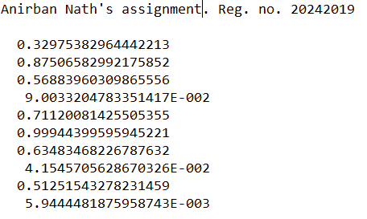

**Question 1c. and 1d.**

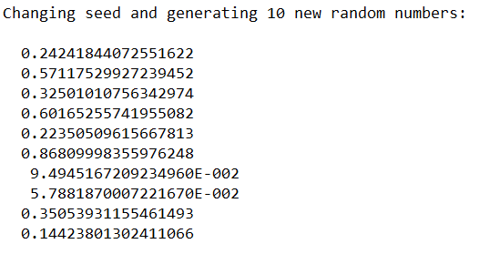

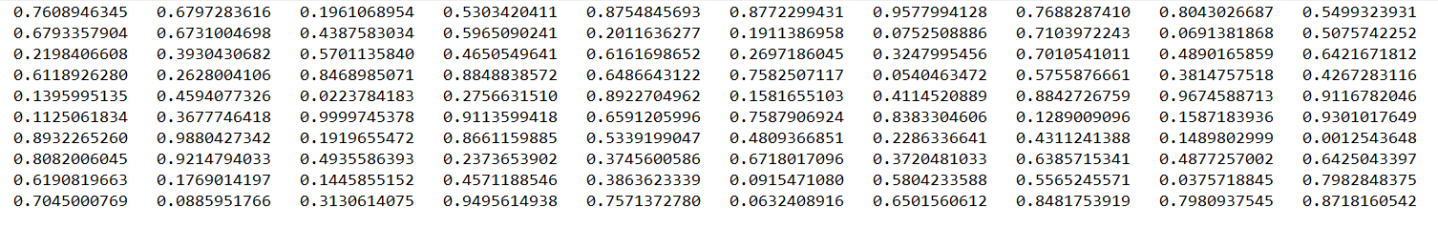

**Question 1e. and 1f. and 1g.**

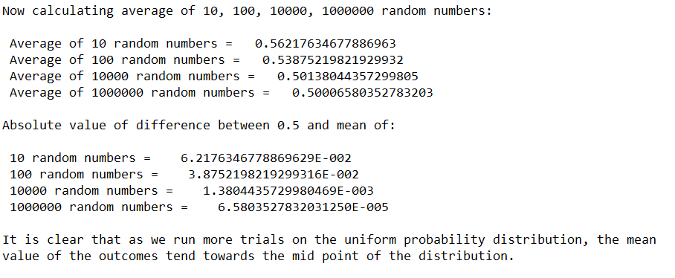

**Question 1h.**

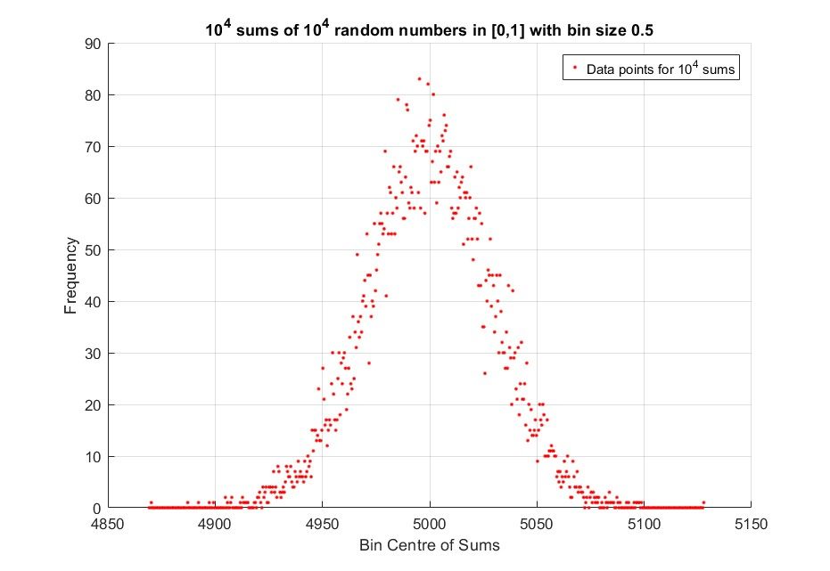

Comments:

These first two graphs correspond to bin size 0.5.

In the normalised graph, it is normalised in such a way that the area under the curve (Gaussian) is 1.

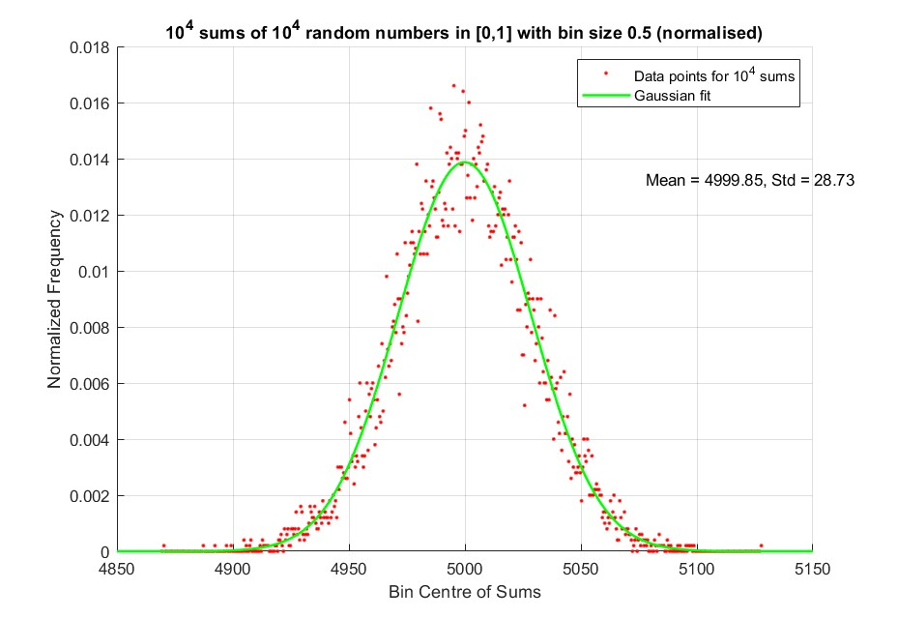

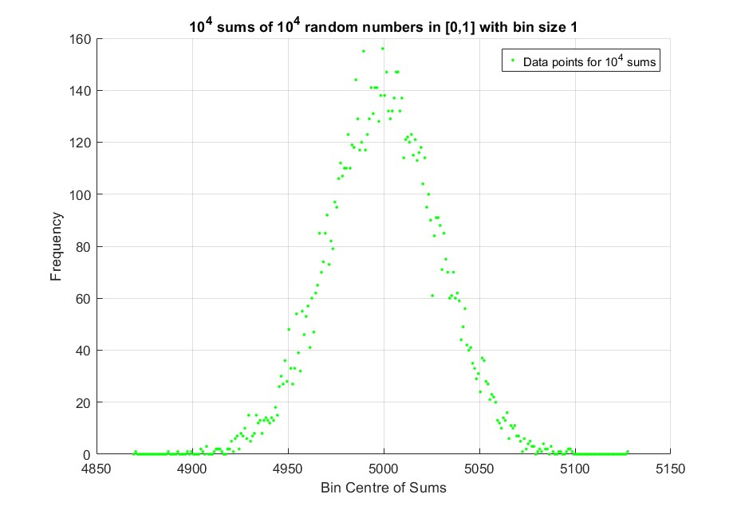

Comments:

The first two graphs on this page correspond to a bin size of 1.

The final graph is for bin size 2.

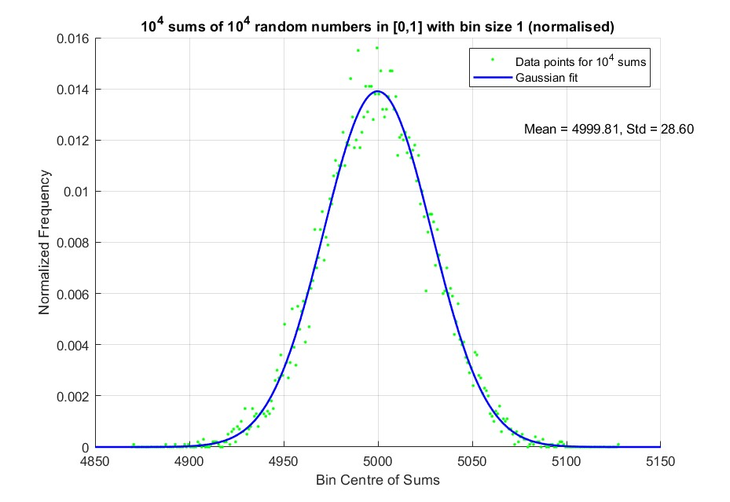

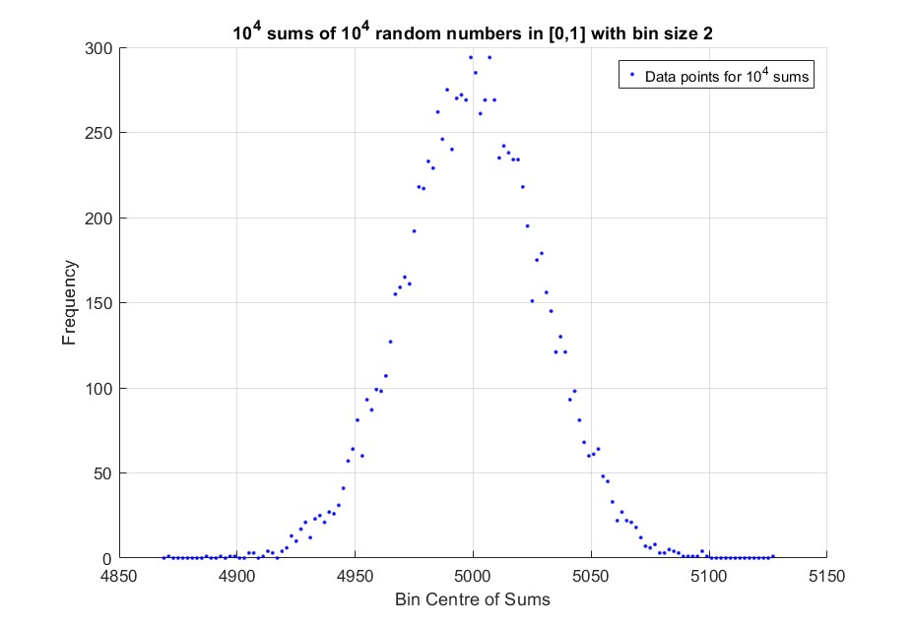

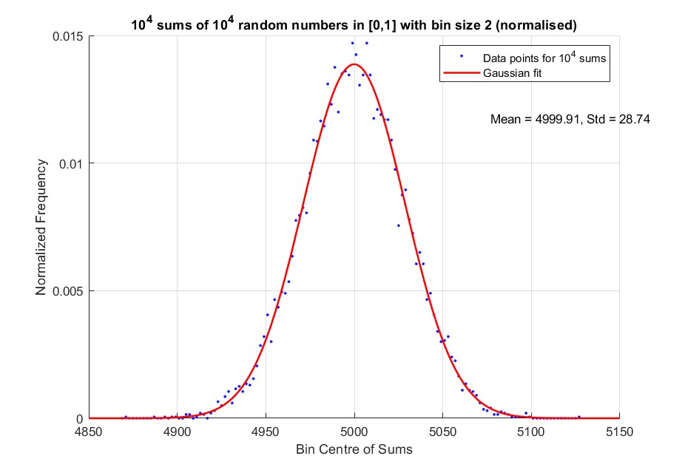

Comments:

We note that as we increase the bin size the points are closer to the fitted curve.

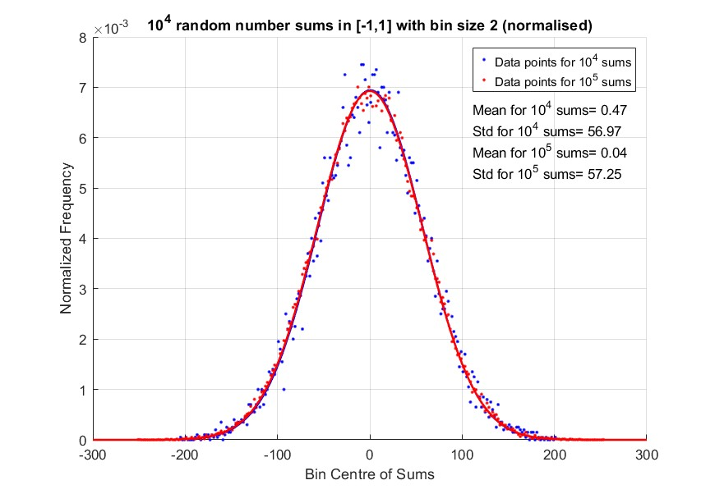

Comments:

Since we set a bin size of 1 in this case, and we are adding even numbers an even number of times; all the sums are even numbers. Therefore, the bins corresponding to the odd numbers are empty and so their frequency is 0. This is the reason for the solid line at y=0. This also makes the fitted curve not according to the actual data points. We can get rid of this problem by increasing the bin size or excluding the zero frequency points.

Comments:

This graph is plotted for random numbers in [-1,1]. We see that the data points corresponding to the higher number of sums has less deviation from the fitted curve. Both the fitted curves are almost overlapping.

**Question 1i.**

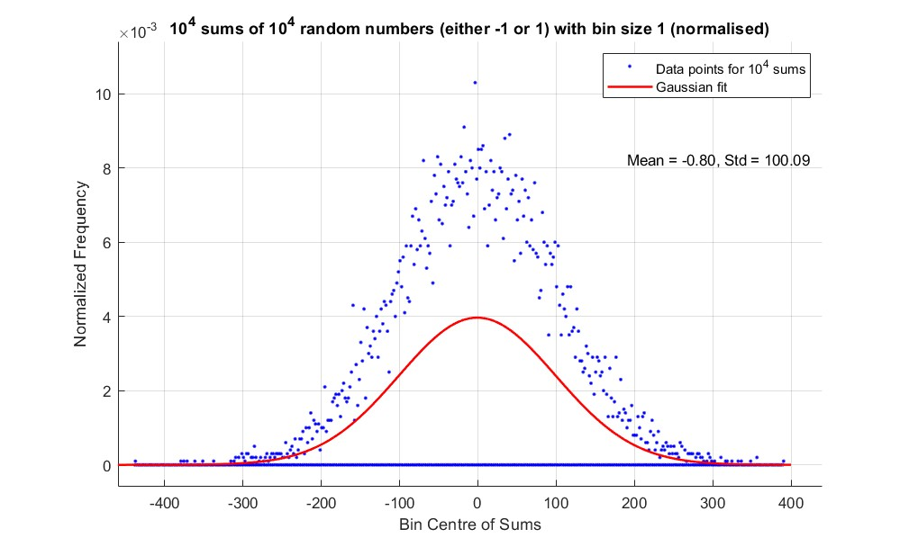

**Question 1j.**

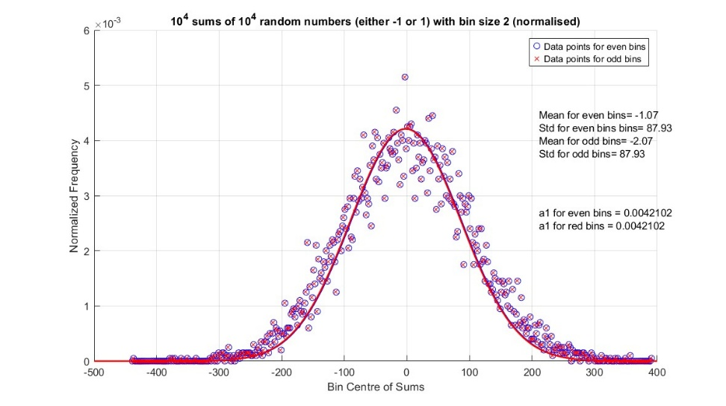

Comments:

Here is the same data as of before, with bin size 2 (both even and odd bins). We note that a choice of even and odd bins can shift our mean. Also, we see that the problem in Question 1i. has been fixed by increasing bin size.

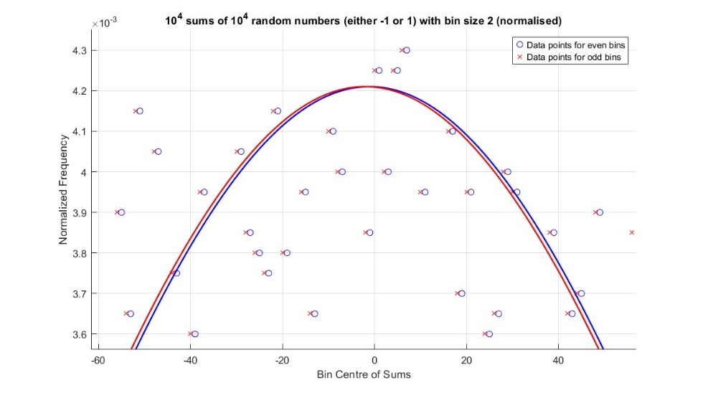

Comments:

Here is the same graph but zoomed near the maxima so that we can notice the shifting. We note that the mean gets shifted by 1 when we change from even to odd bins

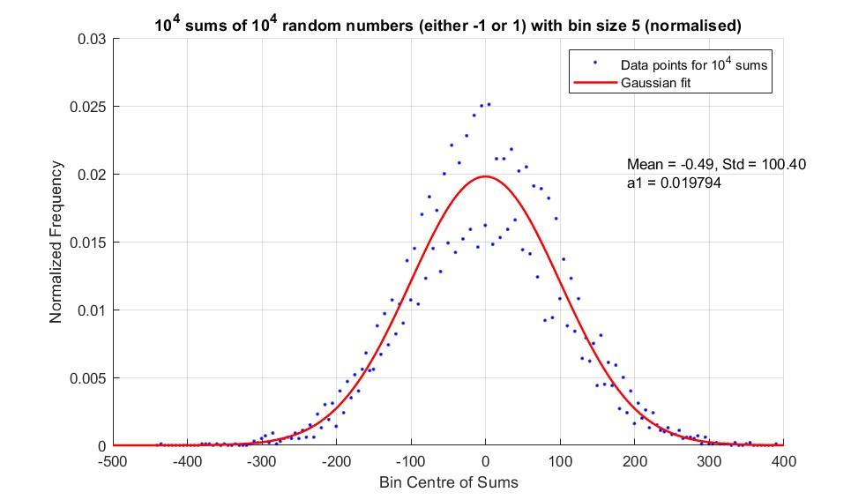

Equation of fitted curve, f (x) = 0.019794 exp(-((x+0.49)/141.56)2)

Probability of finding a sum between x and x+dx = f (x) dx

**Comments:**

Here the same data is plotted with a bin size 5. We note the data points seem to show two different peaks. The reason is that in the bin 0-5 there are 3 frequencies going in (i.e. 0, 2, 4) whereas in the bin 5-10 there are 2 frequencies going in (i.e. 6, 8). So, the alternate bins have alternate heights, resulting in the visual of two different peaks.

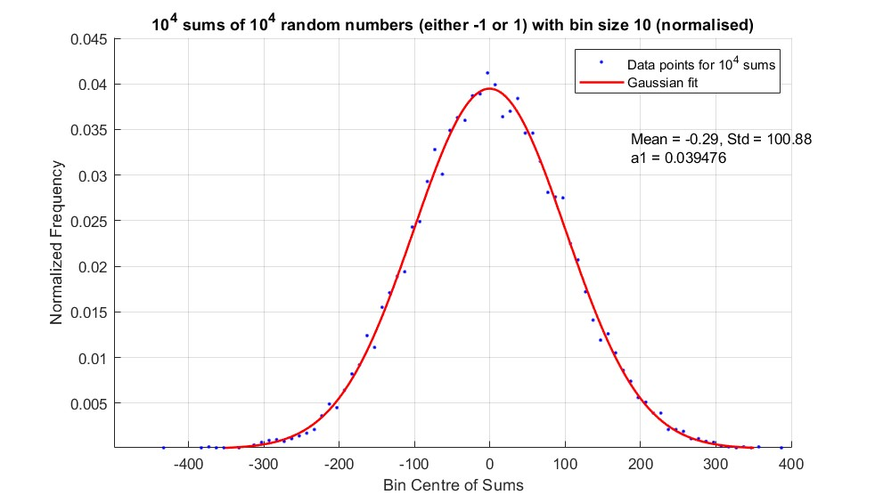

Comments:

In this case, bin size is 10. We see that the fluctuation in the data points is gone and the data points are near the fitted curve.

**Question 1k.**

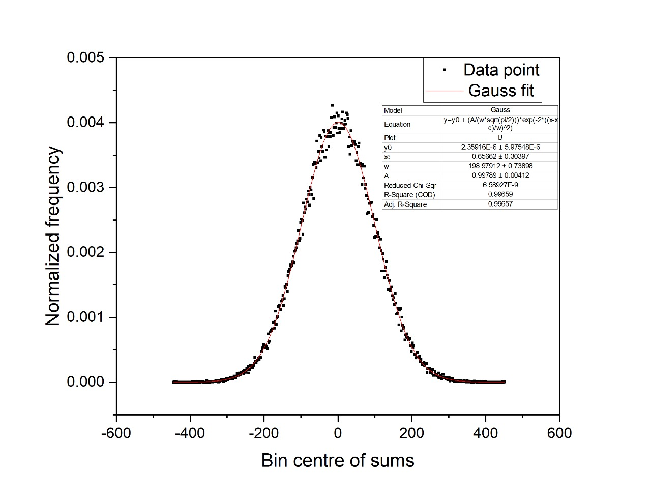

104 random numbers (either -1 or 1) added 105 times with bin size 2

**Question 1l.**

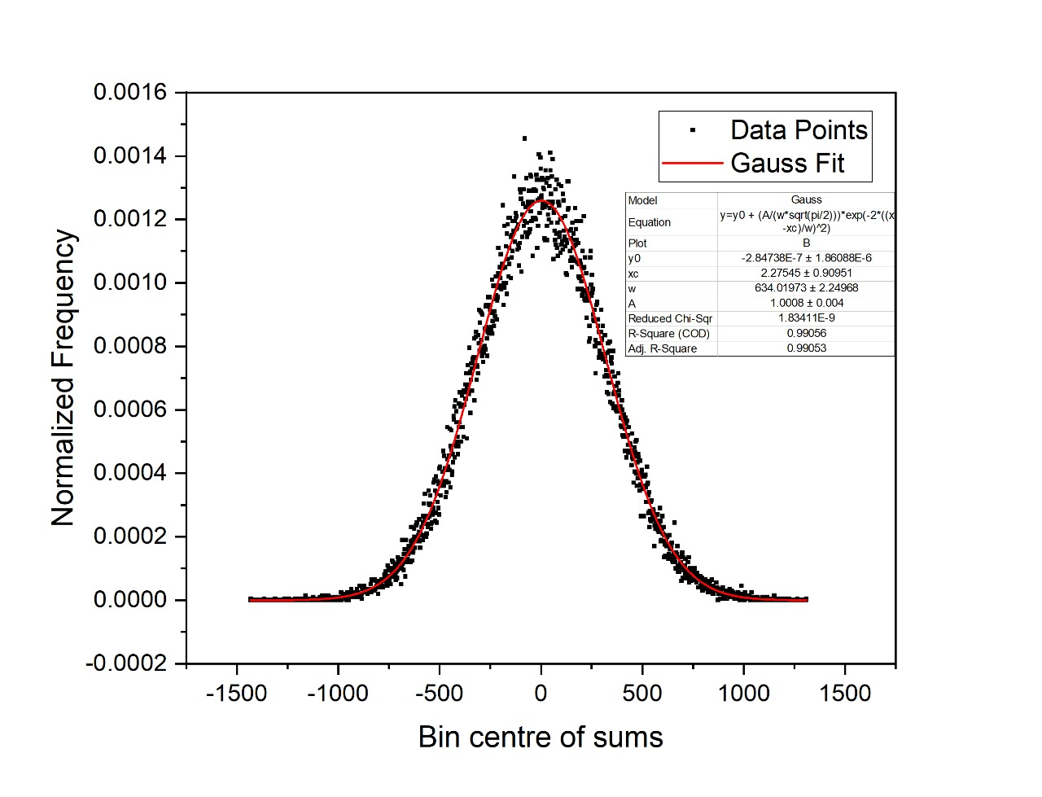

105 random numbers (either -1 or 1) added 105 times with bin size 2