**Assignment 2**

Submitted by: Anirban Nath

Register number: 20242019

**Question 1a. and 1b.**



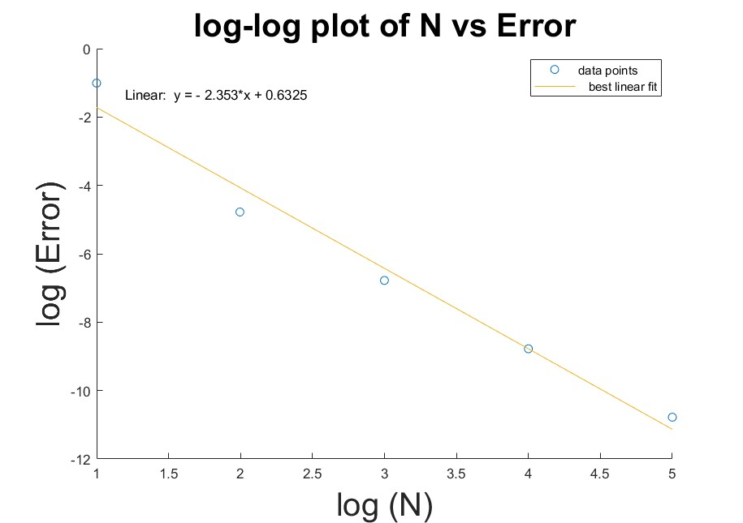

**Question 1c.**

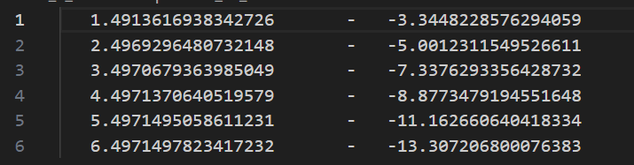

**Question 1d.**

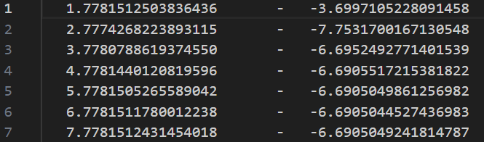

**Question 2a.**

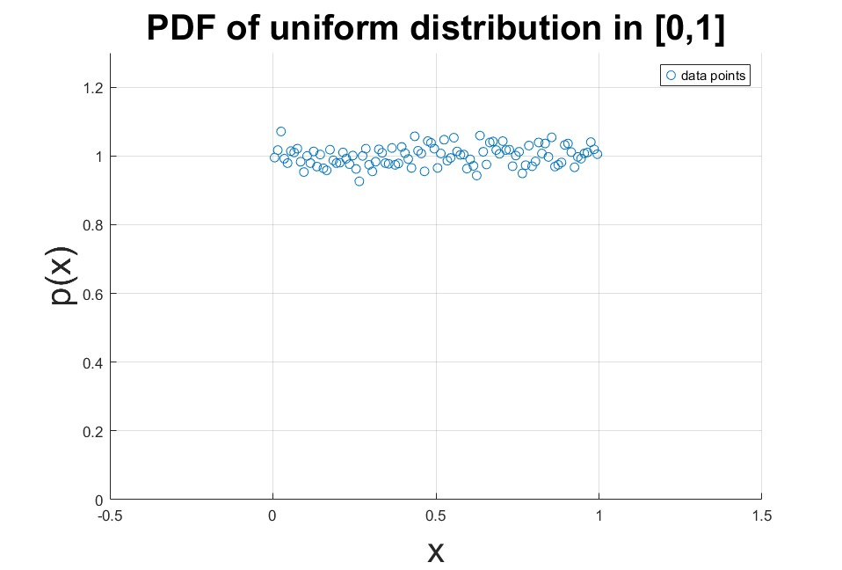

**Question 2b.**

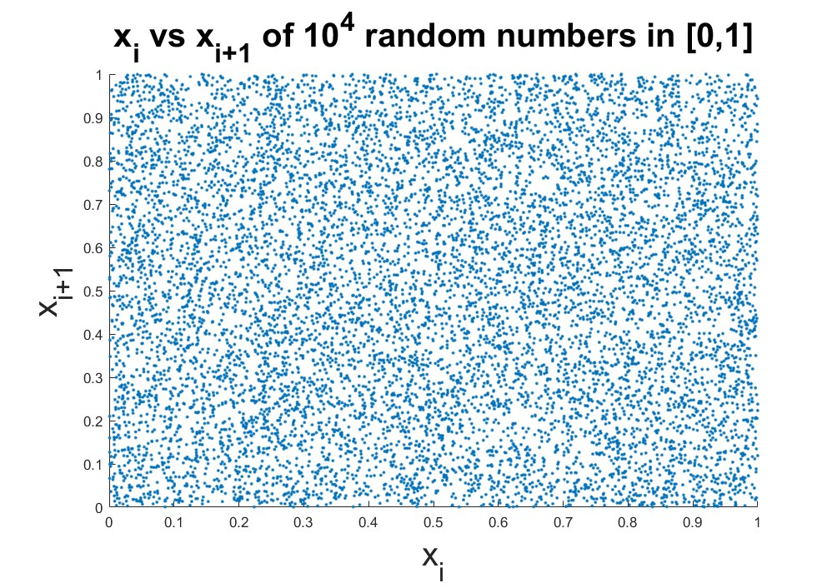

**Question 2c.**

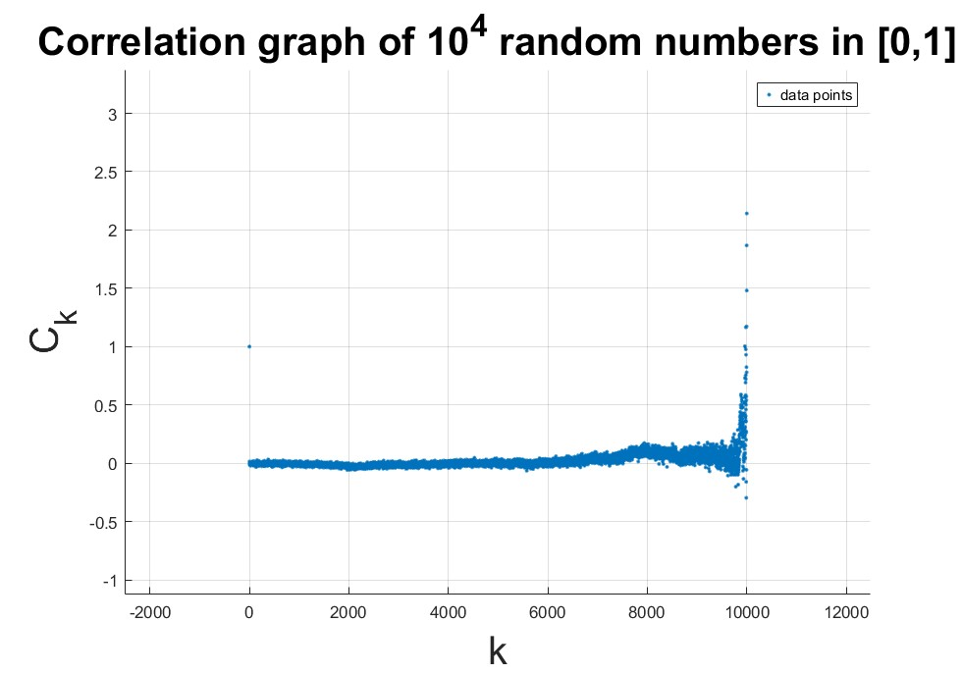

**Question 2d.**



**Question 4a.**

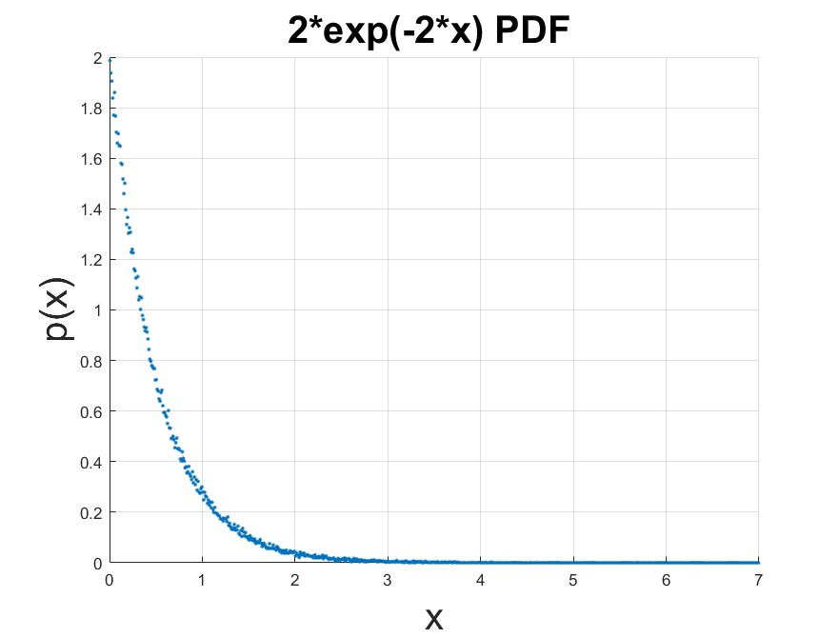

**Question 4b.**

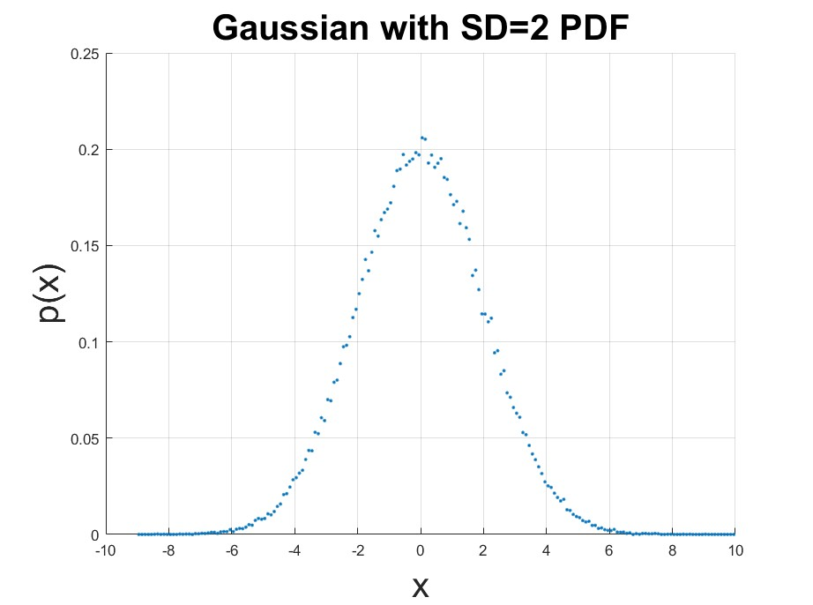

**Question 5a.**

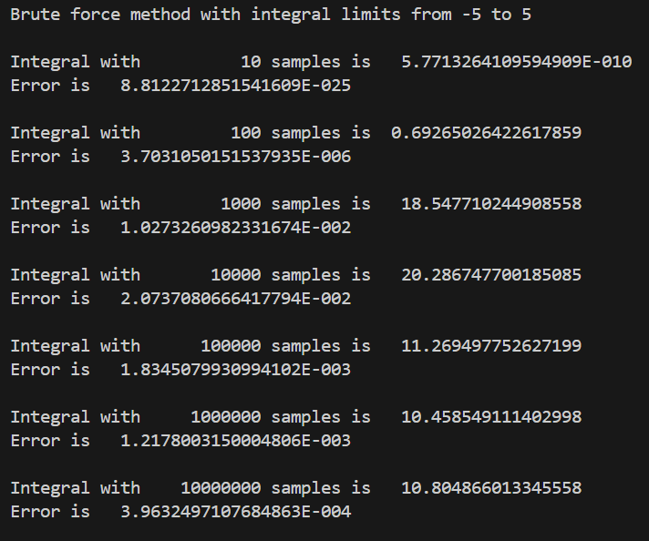

**Question 5b.**

