**Module 6**

Submitted by: Anirban Nath

Register number: 20242019

**Question 2.**

Parameters used: sigma = 1, epsilon = 1, KBT = 1, rcutoff = 2.5 sigma, thermostat OFF, niter = 20000, sampling rate = 50 itrns.

We see PE fluctuates around -1.92 and KE fluctuates around 1.8. TE fluctuates around -0.107.

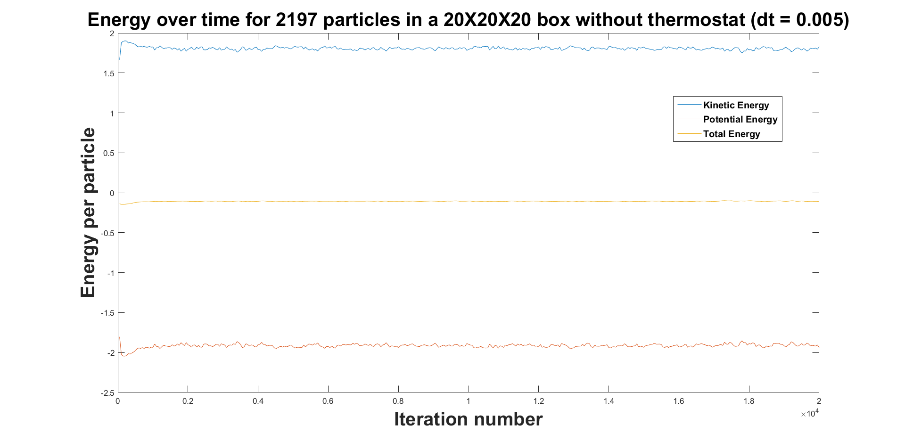

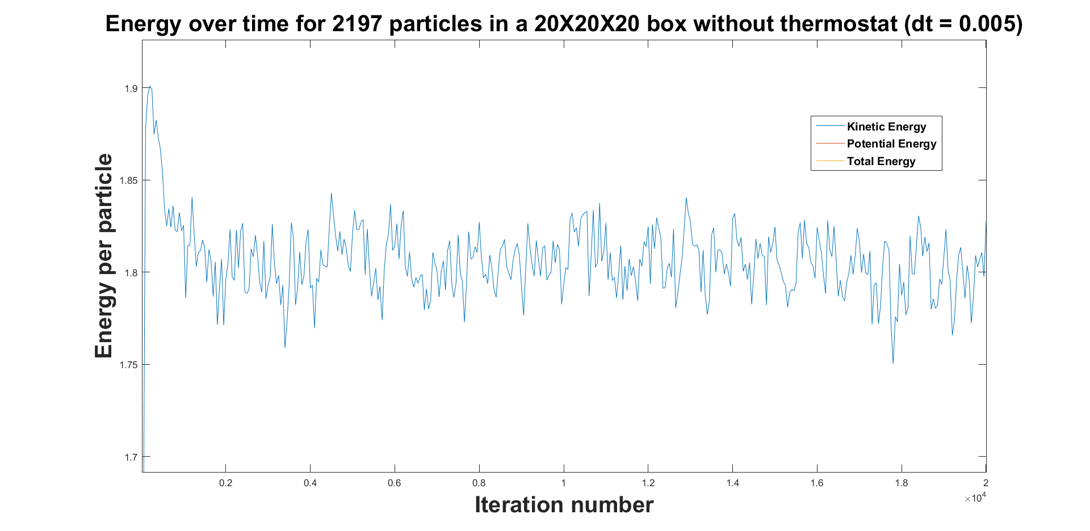

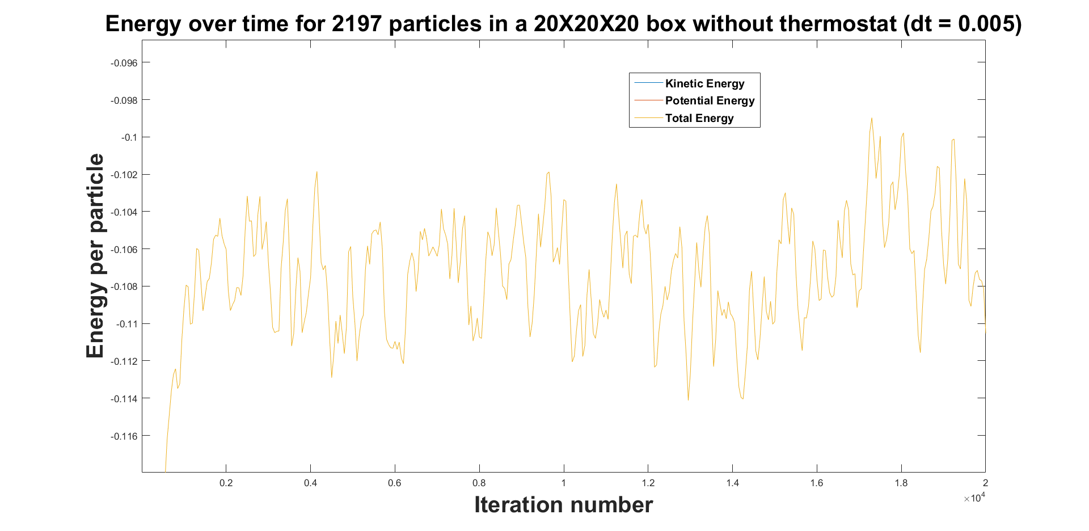

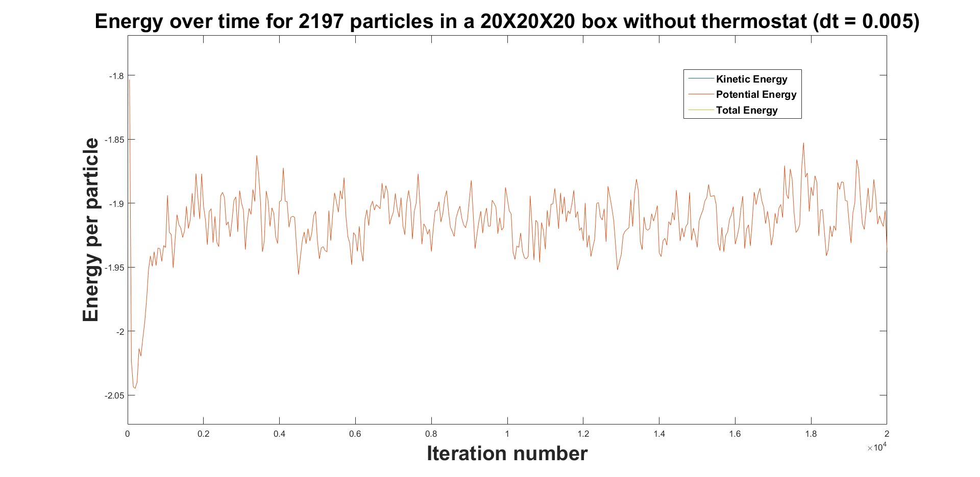

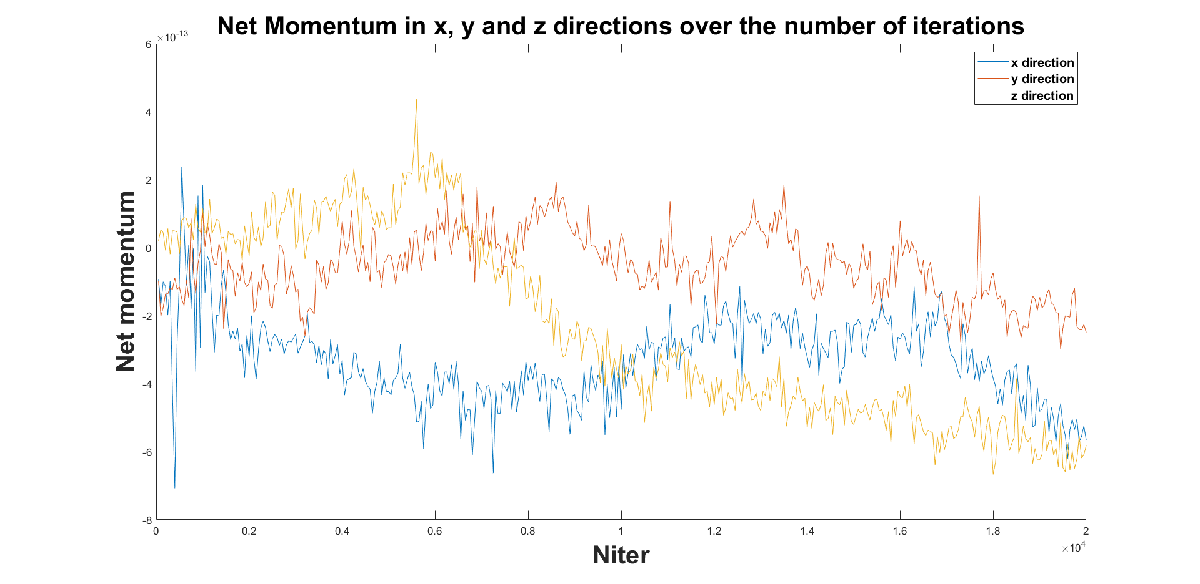

**Question 3.**

Parameters used: sigma = 1, epsilon = 1, KBT = 1, rcutoff = 2.5 sigma, thermostat ON, niter = 250000, sampling rate = 50 itrns.

We see PE fluctuates around -2.1 and KE fluctuates around 1.5. TE fluctuates around -0.6.

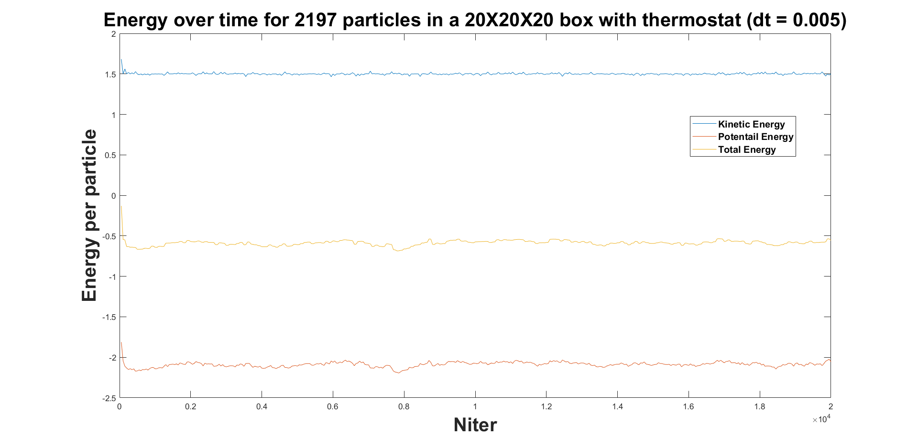

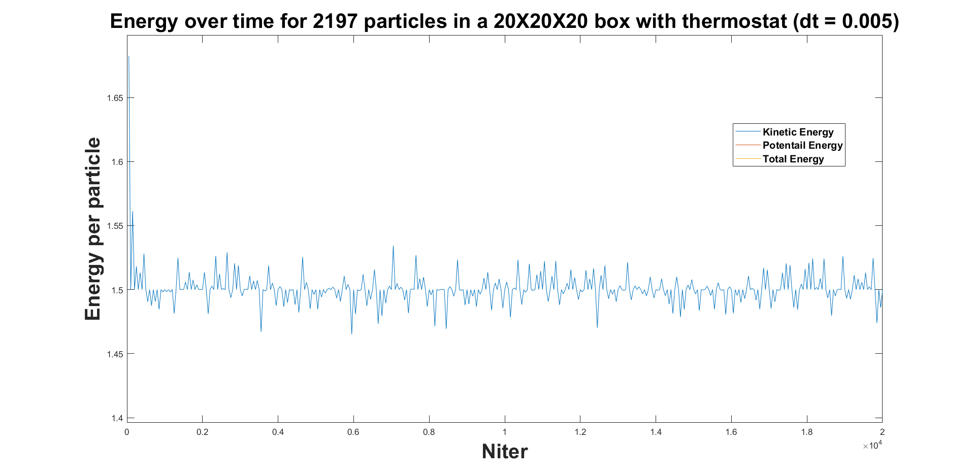

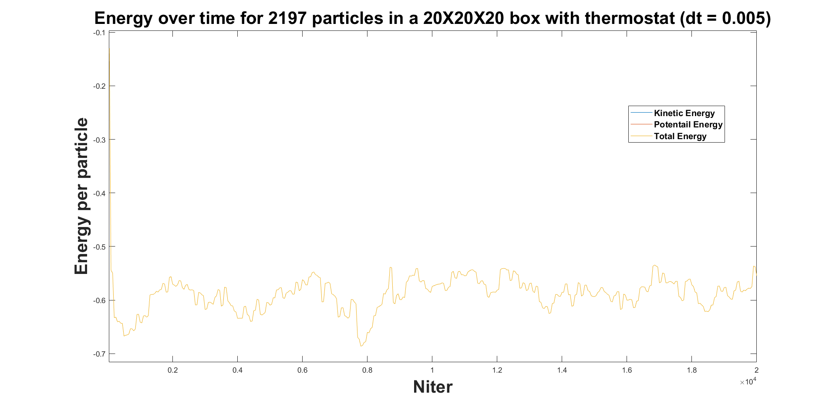

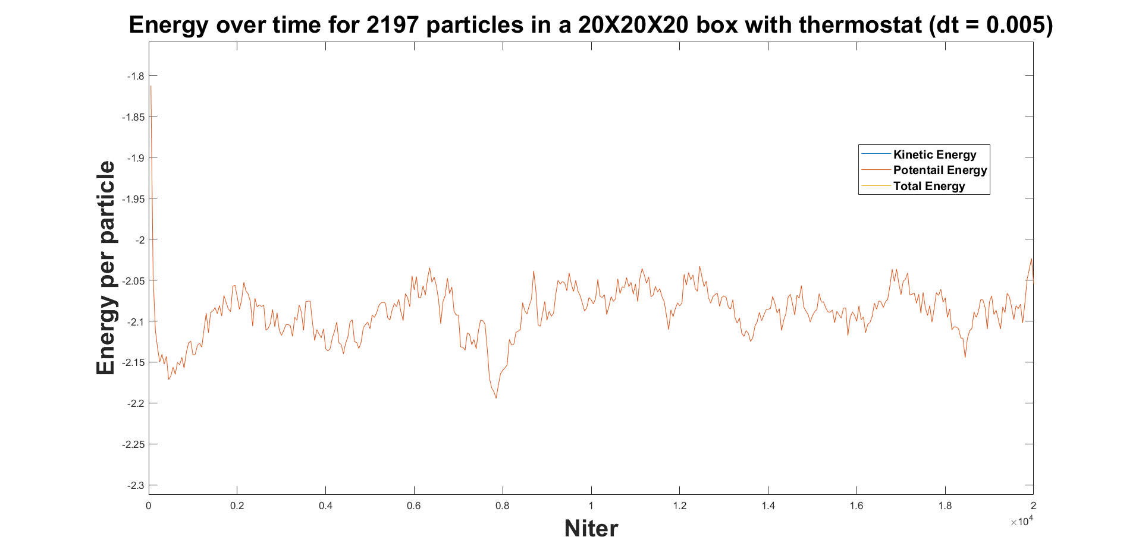

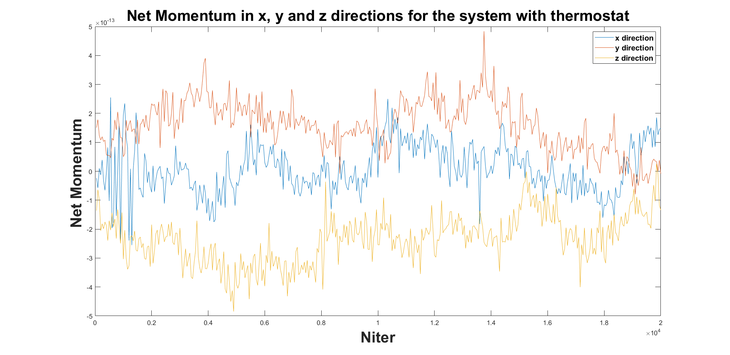

**Question 4.**

Parameters used: sigma = 1, epsilon = 1, KBT = 1, rcutoff = 2.5 sigma, rnearby = 4.5 sigma, thermostat ON, neighbour list updated every 40 iters. Sampling rate = 50 iters.

We see max number of neighbours lie between 86 and 103.

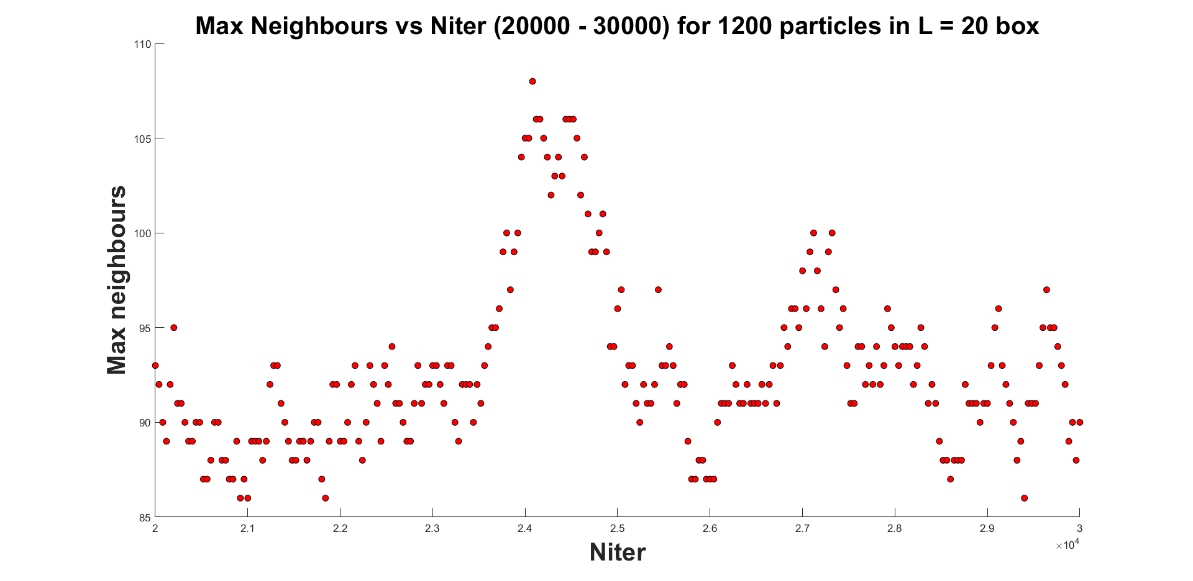

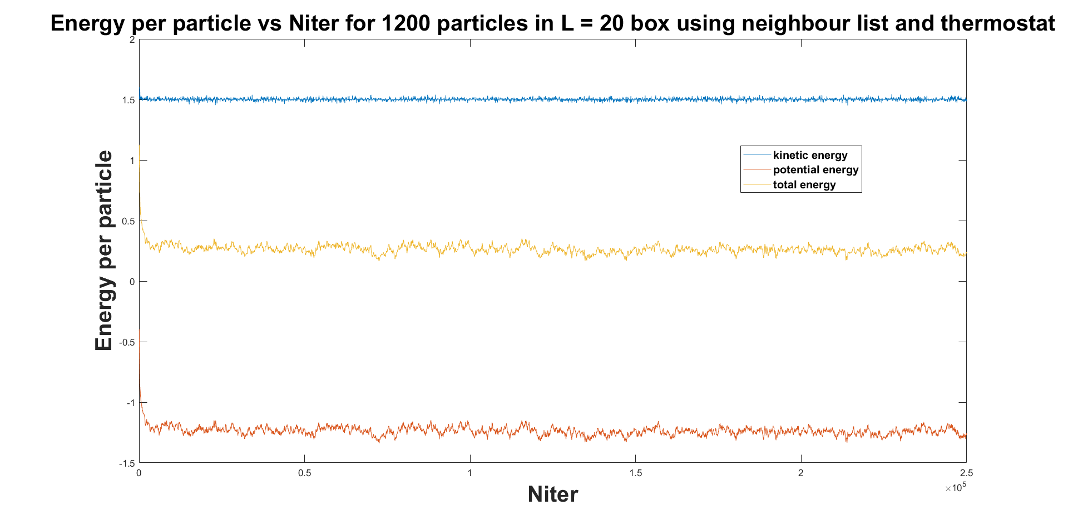

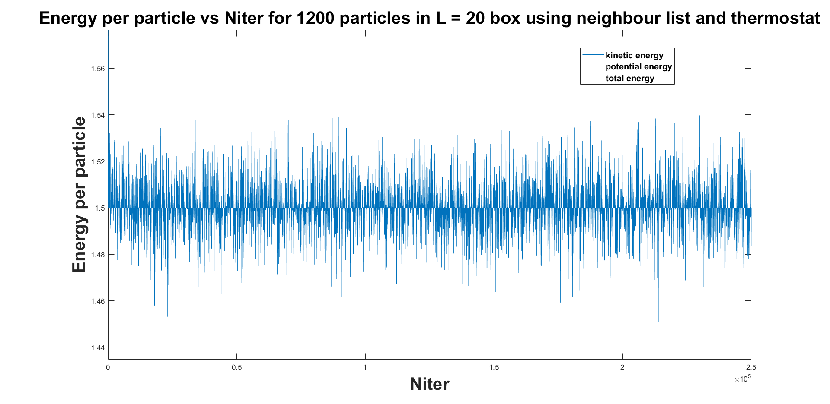

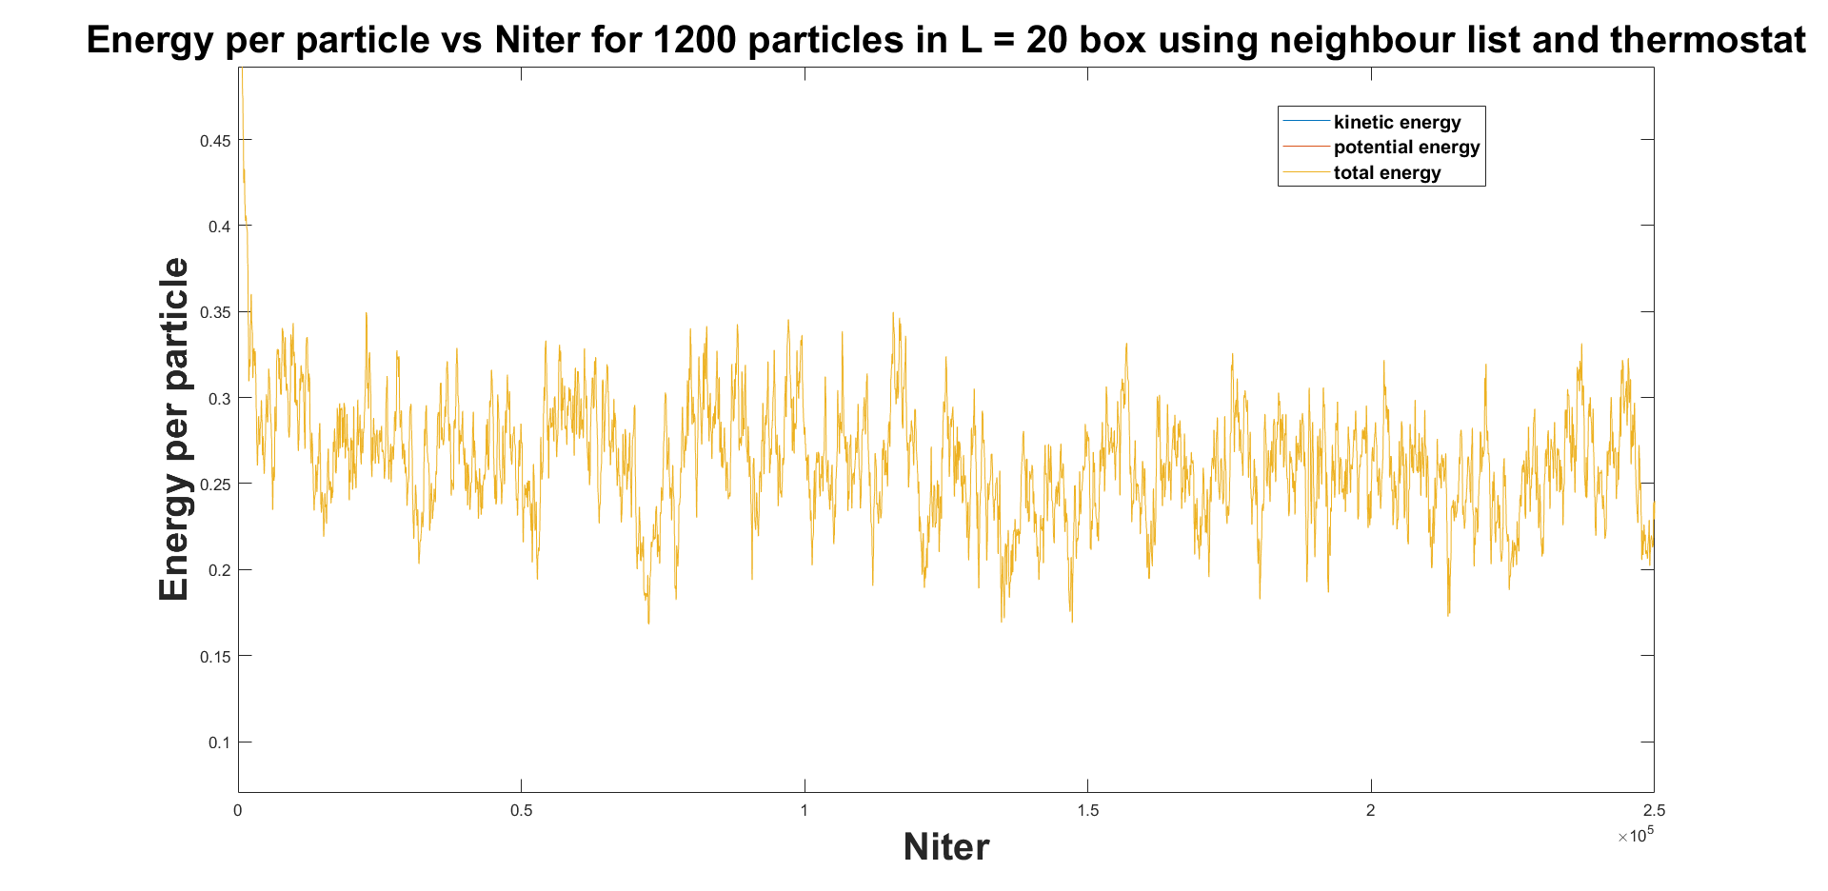

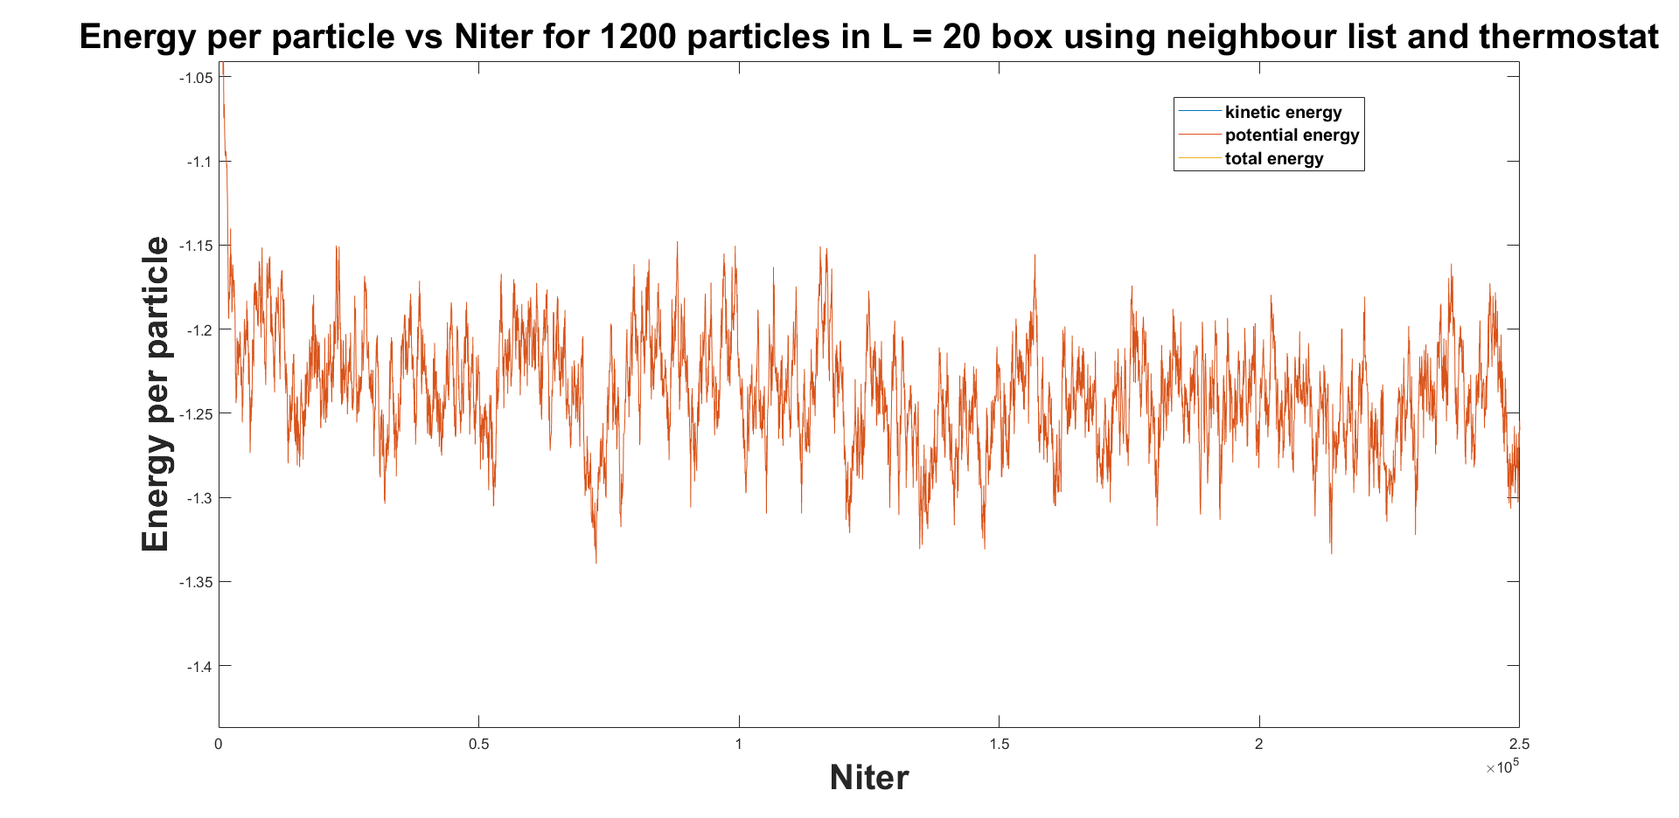

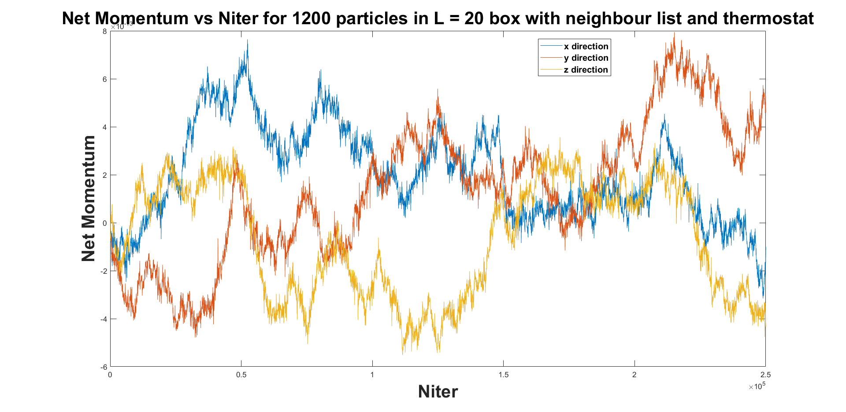

**Question 5.**

Parameters used: sigma = 1, epsilon = 1, KBT = 1, rcutoff = 2.5 sigma, rnearby = 4.5 sigma, thermostat ON, neighbour list updated every 40 iters. Sampling rate = 50 iters.

Max correlation happens at r = 1.15 and next highest at 2.15.

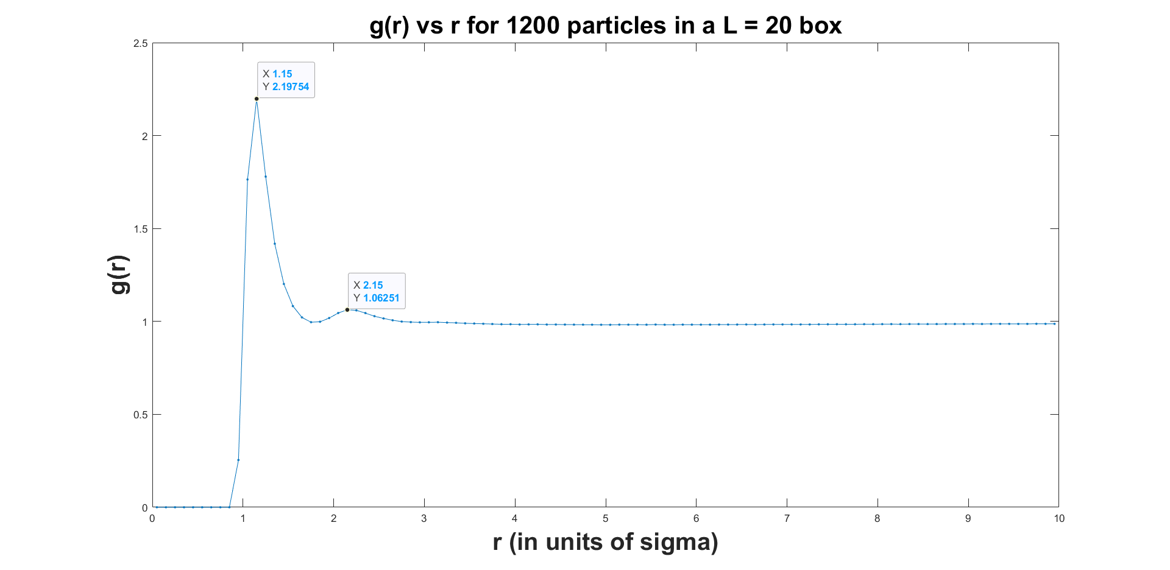

**Question 6.**

Parameters used: sigma = 1, epsilon = 1, KBT = 1, rcutoff = 2.5 sigma, rnearby = 4.5 sigma, thermostat ON, niter = 50000, neighbour list updated every 40 iters. Sampling rate = 100 iters.

We see max number of neighbours lie between 162 and 202. Max correlation happens at r = 1.15 and next highest at 2.15 and the next one at 3.15.

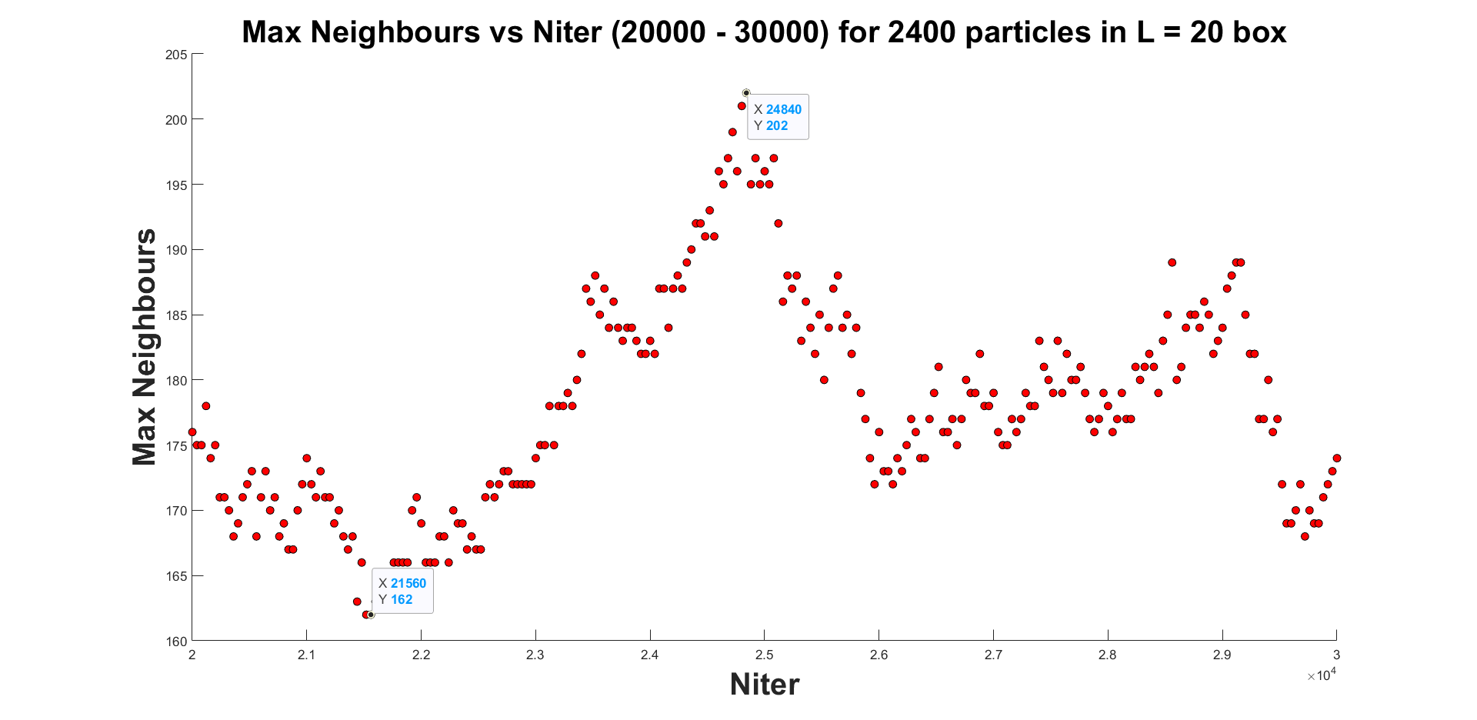

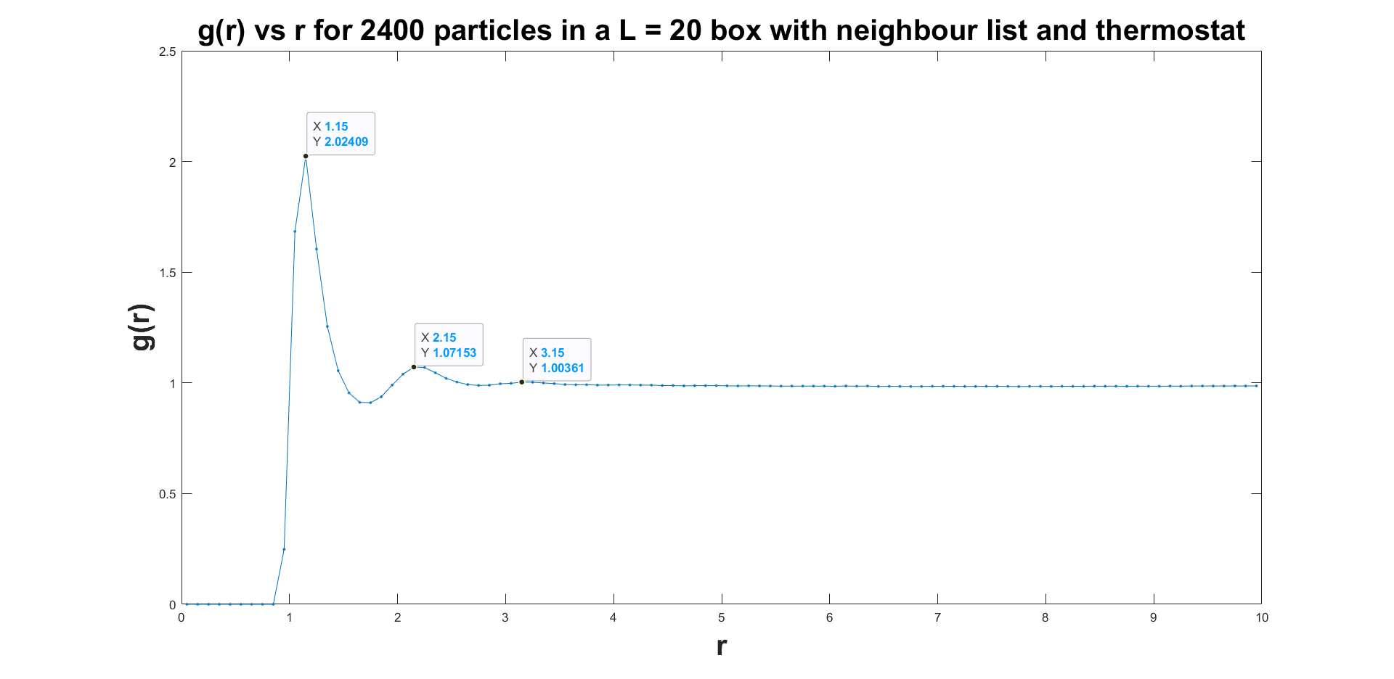

**Question 7.**

Parameters used: sigma = 1, epsilon = 1, KBT = 1, rcutoff = 2.5 sigma, rnearby = 4.5 sigma, thermostat ON, niter = 50000, neighbour list updated every 40 iters. Sampling rate = 100 iters.

We see max number of neighbours lie between 199 and 226. Max correlation happens at r = 1.15 and next highest at 2.15 and the next one at 3.25.

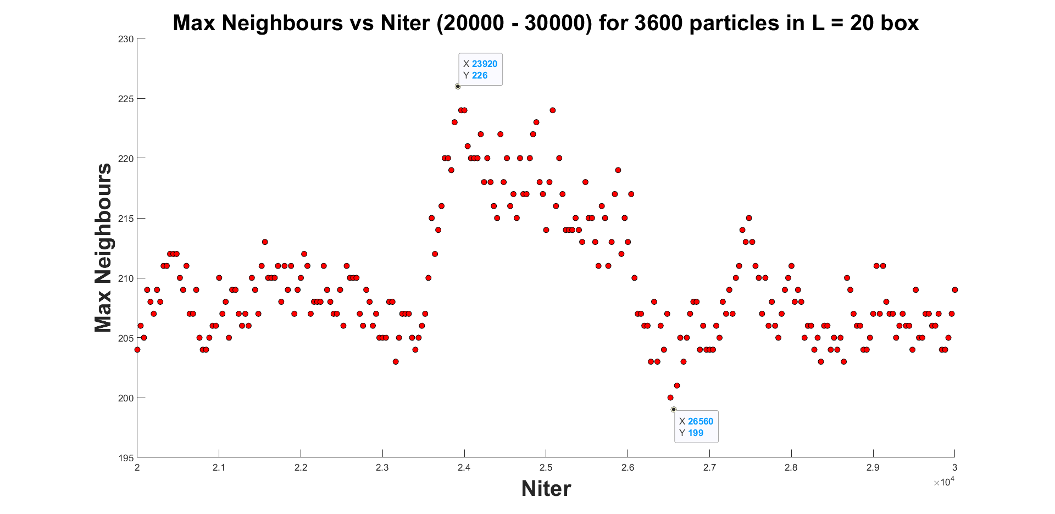

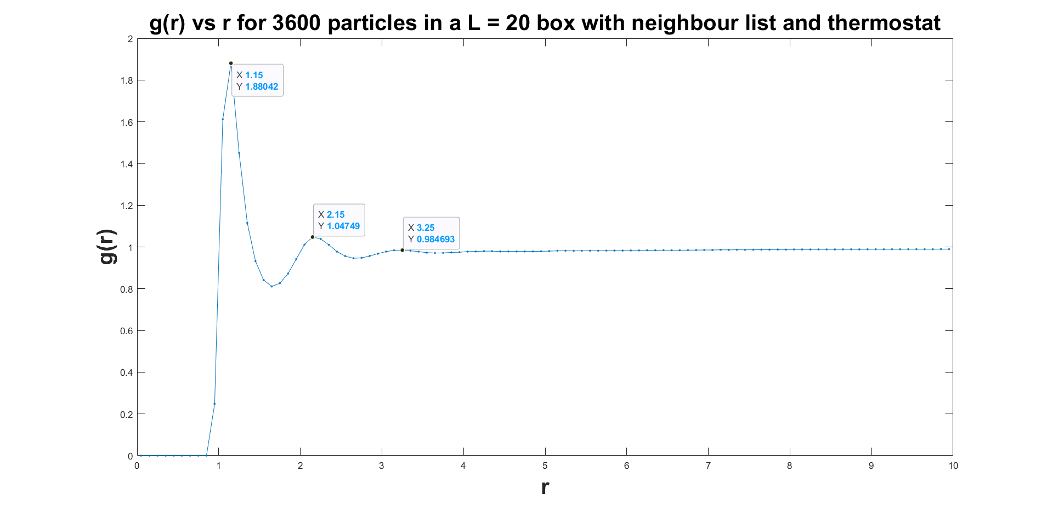

**Question 8.**

Parameters used: sigma = 1, epsilon = 1, KBT = 1, rcutoff = 2.5 sigma, rnearby = 4.5 sigma, thermostat ON, niter = 50000, neighbour list updated every 40 iters. Sampling rate = 100 iters.

We see the Maxwell Boltzmann speed distribution curve obtained from the simulation is in agreement with the theoretical curve.

