**Program 13: Demonstrate abstract base class implementation and usage.**

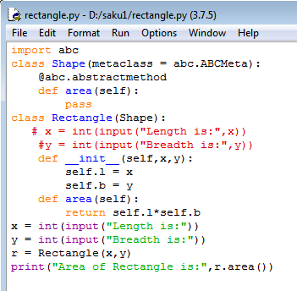

**Output:**

