**Program 11: Demonstrate create,add,remove,union,and intersection operations on a set.**

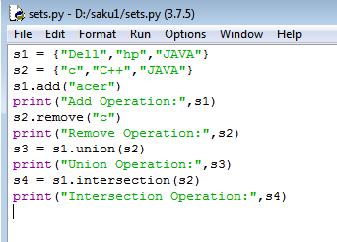

**Output:**

