**Program 12: Demonstrate create,concatenation,membership and iteration operations on a tuple.**

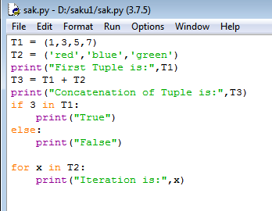

**Output:**

