**User's Guide for *Another Assimilation System for WRF-Chem* (AAS4WRF)**

A. L. Vara-Vela1, A. G. Muñoz2,3, A. Lomas4, M. E. Gavidia-Calderon1, S. Ibarra-Espinosa1, C. M. González5, and M. F. Andrade1

1Department of Atmospheric Sciences, Institute of Astronomy, Geophysics and Atmospheric Sciences, University of Sao Paulo, Sao Paulo, Brazil

2Atmospheric and Oceanic Sciences (AOS). Princeton University. Princeton, NJ. USA

3International Research Institute for Climate and Society (IRI). The Earth Institute. Columbia University. New York, NY. USA

4Centro de Investigación de Meteorología Aeronáutica (CIMA), DGAC, Quito, Ecuador

5Hydraulic Engineering and Environmental Research Group (GTAIHA), Universidad Nacional de Colombia Sede Manizales, Manizales, Colombia

**1. Overview**

Originally baptised as MLV due to its first developers (Muñoz-Lomas-Vara), the Another Assimilation System for WRF-Chem (AAS4WRF) is a mass-conserving emissions preprocessor developed by the Latin American Observatory (OLE2; Muñoz et al., 2010, 2012) in 2010. AAS4WRF is appropriate to scale emission rates from both surface and elevated sources in the proper WRF-Chem data file format, providing the users an alternative way to assimilate their emissions to WRF-Chem (Vara-Vela et al., 2016). Since it was successfully tested for the first time for the city of Lima, Peru in 2014 (managed by SENAMHI, the National Meteorological Service of the country), several studies on air quality modelling have applied this utility to convert their emissions to those required for WRF-Chem (Andrade et al., 2015; Hoshyaripour et al., 2016; Vara-Vela et al., 2016). In addition, some university groups and scientists in Bolivia, Peru, Venezuela, Brazil, Cuba and Colombia have also applied the AAS4WRF in order to conduct their experimental air quality simulations.

**2. Structure of input emissions**

AAS4WRF requires that the user provides a file containing the gridded hourly emissions (emissions.txt in this example). Each line of the file is required to have the following format:

id longitude latitude species_1 species_2…species_i species_(i+1)…species_36

where:

* id: grid point ID
* latitude : grid point latitude
* longitude: grid point longitude
* species_i: ith-species; 36 specifies the number of species in CBMZ-MOSAIC (remember to use the right units: mol km-2 hr-1 for gases and µg m-3 m s-1 for aerosols). Complete with columns of “0” if data is not available.

There are nx×ny×nt lines in the file emissions.txt, arranged in blocks of time (each with length of nx×ny) as follows: longitude and latitude are periodic 1D strictly monotonically increasing and decreasing arrays, respectively, that have their components equally spaced at dx (same horizontal resolution as the WRF grid). As geo-referenced data, we recommend to use any kind of GIS software to build their emission files (e.g., the emission file emissions.txt used in this example was built using Quantum GIS).

**3. Usage**

The AAS4WRF is a code written entirely in the NCAR Command Language (NCL, 2017), then the users only need to correctly build both NCL and NCAR Graphics, or install the available binaries for their platform. Prior to run AAS4WRF, the user must set up a namelist file called “namelist.emiss”. The workflow for using AAS4WRF is listed below.

1. Run GEOGRID, UNGRIB, METGRID, and REAL normally as a standard WRF-Chem simulation.
2. Enter the following information into the namelist.emiss:

|  |  |
| --- | --- |
| Variable Names | Description |
| &input_files |  |
| wrf_dir | string; full path and name of wrfinput_d01 |
| emiss_dir | string; full path and name of emissions.txt |
| &grid_points |  |
| nx | integer; number of longitude points in emissions.txt |
| ny | integer; number of latitude points in emissions.txt |
| nt | integer; number of time points in emissions.txt |
| hemi | integer; hemisphere: NH→1; SH→-1 |
| &time_control |  |
| sy | integer; start year |
| sm | integer; start month |
| sd | integer; start day |
| ey | integer; end year |
| em | integer; end month |
| ed | integer; end day |
| &species_control |  |
| so2 | integer; column number for so2 |
| ... |  |
| i | integer; column number for i |
| ... |  |
| ecc | integer; column number for ecc |

1. Run AAS4WRF by typing:

$ ncl AAS4WRF.ncl

* Input files: emissions.txt, wrfinput_d01 and namelist.emiss
* Output files: two different output files can be produced, depending on the choice for io_style_emisisons:

wrfchemi_00z_d01 and wrfchemi_12z_d01 for **io_style_emissions=1**

Set nt to 24 in namelist.emiss, and run AAS4WRF (although the file emissions.txt has more than 24 times, the code will only read the first nx×ny×24 lines). We recommend the user visualise the content of the output files to check that everything is working properly up to this point:

$ ncview wrfchemi_00z_d01 wrfchemi_12z_d01

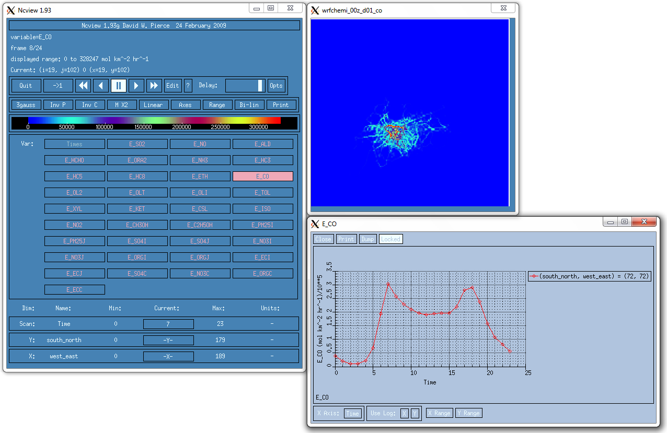

Fig. 1. Hourly CO emissions from 00 to 23 UTC (io_style_emissions=1) for the city of Sao Paulo, Brazil.

Or

wrfchemi_d01_<date/time> for **io_style_emissions=2**

Set nt to 168 (maximum number of times in this example) and run AAS4WRF. If a shorter period is desired, make sure the number of days in the section &time_control is fixed accordingly. This version of AAS4WRF only works with entire days (no fractional days are managed by this program at the moment).

$ ncview wrfchemi_d01_<date/time>

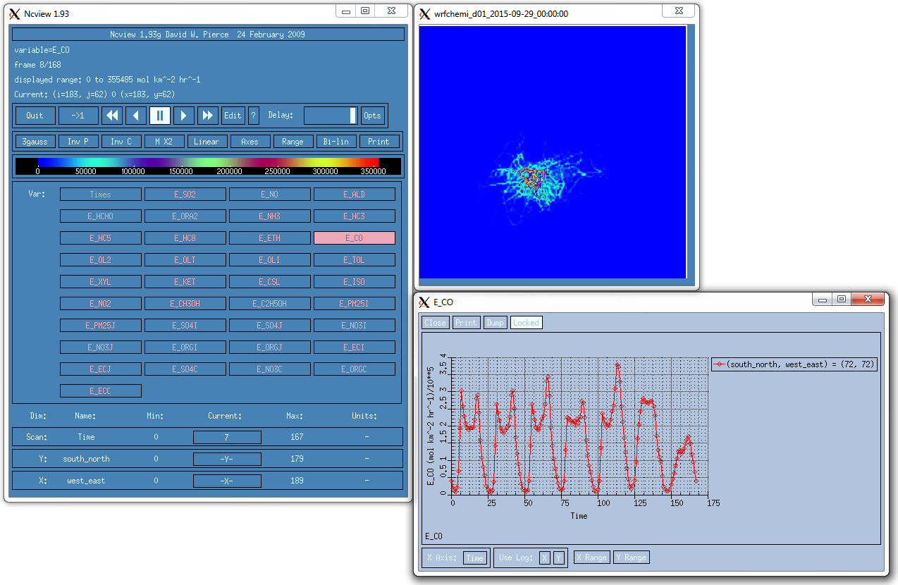

Fig. 2. Daily varying CO emissions (io_style_emissions=2) for the city of Sao Paulo, Brazil.

**4. References**

Andrade, M. F., Ynoue, R. Y., Freitas, E. D., Todesco, E., Vara-Vela, A., Ibarra, S., Martins, L. D., Martins, J. A., and Carvalho, V. S. B.: Air quality forecasting system for southeastern Brazil, Frontiers in Environmental Science, 3, 1-14, 2015.

Hoshyaripour, G., Brasseur, G., Andrade, M. F., Gavidia-Calderon, M., Bouarar, I., and Ynoue, R. Y.: Prediction of ground-level ozone concentration in Sao Paulo, Brazil: Deterministic versus statistic models, Atmospheric Environment, 145, 365-375, 2016.

Muñoz, A. G., López, P., Velásquez, R., Monterrey, L., León, G., Ruiz, F., Recalde, C., Cadena, J., Mejía, R., Paredes, M., Bazo, J., Reyes, C., Carrasco, G., Castellón, Y., Villarroel, C., Quintana, J., and Urdaneta, A.: An Environmental Watch System for the Andean Countries: El Observatorio Andino, Bull. Amer. Meteor. Soc., 91, 1645-1652, 2010.

Muñoz, A. G., Ruiz-Carrascal, D., Ramírez, P., León, G., Quintana, J., Bonilla, A., Torres, W., Pastén, M., and Sánchez, O.: Risk Management at the Latin American Observatory, in: Risk Management-Current Issues and Challenges, InTech Publications, doi:10.5772/50788, 533-556, 2012.

NCAR Command Language (version 6.4.0) [Software]. Boulder, Colorado: UCAR/NCAR/CISL/TDD <http://dx.doi.org/10.5065/D6WD3XH5>. 2017

Vara-Vela, A., Andrade, M. F., Kumar, P., Ynoue, R. Y., and Muñoz, A. G.: Impact of vehicular emissions on the formation of fine particles in the Sao Paulo Metropolitan Area: a numerical study with the WRF-Chem model, Atmos. Chem. Phys., 16, 777-797, 2016.