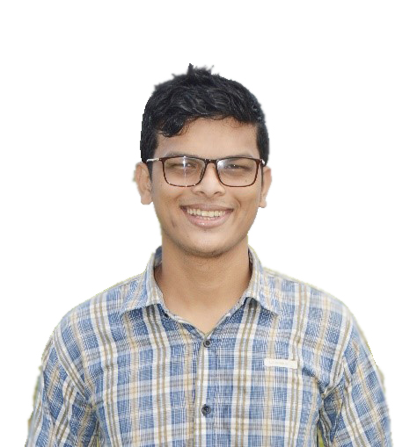**WAHIDUR RAHMAN**

**PERMANENT ADDRESS AND**

**MAILING ADDRESS: BANGLADESH**

49 Home Amborkhana, SYLHET-3100

|  |  |
| --- | --- |
| E-mail: wahidurrhn@googlemail.com | Github.com/WahidurRahman |

**Career objective:** To play a challenging and demanding role in an organization that has development and learning opportunities and make a substantial positive contribution to its success.

**Education: Secondary School Certificate**

**Sylhet Technical Gov. School & College.**

Group: Electrical engineering.

G.P.A: 3.62 (On a 5 point scale)

Year of passing: 2013

Board: Technical education board.

**Higher Secondary Certificate**

**Sylhet Technical Gov. School & College.**

Group: Electrical engineering.

G.P.A: 3.39 (On a 5 point scale)

Year of passing: 2016

Board: Technical education board.

**Bechelor of Science in C.S.E**

International University, Sylhet

Department: C.S.E (Hons)

***Dropout…***

|  |  |
| --- | --- |
| **Personal Qualities:** | * Excellent communication and presentation skill * Strong analytical and conceptual skill * Ability to work in a team * Creative approaches and enthusiasm to reach the goal * Self-starter, flexible, stress-resistant |

**Computer Knowledge:** Web Design, WordPress Customization, Internet Marketing,

HTML, CSS, Computer Hardware Skills, Photoshop, InDesign.

**Language Proficiency:** English, Bangla.

**Personal Details: Name:** Wahidur Rahman

**Father’s Name:** Md.

**Mother’s Name:** Ms.

**Date of Birth:** 06-01-1993

**Home District:** SYLHET - 3100

**Blood group:** O+

**Nationality:** Bangladeshi

**Marital Status:** Single

**Phone (Cell):** +8801818**********

**Permanent Address &**

**Mailing Address:** Amborkhana, Sylhet-3100, Bangladesh

I solemnly declare that all the information mentioned above is true.

Signature:

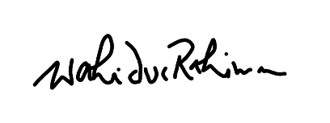

**Wahidur Rahman**

Date: 19-02-2020