NESTMATES
SHARED LIVING APP

Business Requirements
Document (BRD)
NestMates Team
29 allée le Corbusier  92000, Nanterre | Software Engineering – A4  contact@nestmates.app

1. Project Overview

1.1 Project Purpose
The purpose of "NestMates" is to centralize the organization of a shared flat (colocation) in a single web application. Today, flatmates juggle group chats, spreadsheets, paper notes and scattered emails to track who paid what, who does which chore, when events happen and where the lease or bills are stored. This fragmentation causes forgotten tasks, unclear debts and tension between flatmates. In addition, flatmates increasingly come from different countries and do not always share the same language. NestMates replaces these tools with five integrated modules: a shared calendar, shared expenses, a shared document space, a shared to-do list and a household chat that automatically translates messages between French and English. The whole application is available in French and English.

1.2 Project Objectives
The main objectives of the NestMates project are to:
- Reduce money-related conflicts by making every shared expense transparent and automatically computing who owes whom.
- Improve the distribution of household chores through assigned tasks.
- Give every flatmate instant access to important shared documents (lease, bills, inventory, insurance).
- Coordinate the life of the flat (guests, repairs, parties, rent due dates) in one shared calendar.
- Allow French-speaking and English-speaking flatmates to communicate easily through a group chat with automatic translation.
- Offer the whole application in French and English, according to each user's preference.
- Protect personal and financial data in compliance with the GDPR.

1.3 Business Goals
NestMates will achieve the following business goals:
- Financial Transparency: Every flatmate sees the same up-to-date balance, with no manual calculations.
- Time Savings: Less time spent reminding others, searching for documents or settling accounts.
- Better Shared Living: Fewer misunderstandings and a fairer distribution of chores and costs.
- Inclusive Communication: Language is no longer a barrier between flatmates who speak French or English.
- Single Point of Access: One account replaces several apps and group chats for household management.

1.4 Scope
NestMates will cover the following areas:
- Account and Household Management: Registering, logging in, creating a household, inviting flatmates by code and leaving a household.
- User Profile: Editing one's name, email and password, choosing the language of the application (French or English) and deleting one's account.
- Shared Calendar: Creating, editing and deleting household events visible to all members.
- Shared Expenses: Recording expenses, splitting them equally between the selected members and computing balances and settlements.
- Shared Documents: Uploading, viewing, downloading and deleting household files.
- Shared To-Do List: Creating tasks, assigning them to flatmates and setting due dates.
- Household Chat: Real-time group chat between the members of a household, with a typing indicator and automatic translation of messages between French and English.

2. Stakeholder Analysis

2.1 Key Stakeholders
- Flatmates (Household Members): The only users of the application. They speak French or English. They add expenses, events, tasks, documents and chat messages and consult the shared information. All members have the same rights and duties; the flatmate who creates the household has no special status.
- Landlord / Real-Estate Agency (indirect): Not a user, but the source of key documents (lease, inventory, rent receipts) stored in the application.

2.2 Stakeholder Needs
- Flatmates need a simple, fast interface usable on phone and computer, a clear view of what they owe or are owed, and a clear view of the tasks assigned to them.
- Flatmates moving in or out need to join or leave a household easily, without losing the history of shared expenses.
- Flatmates who do not speak the same language need to understand each other's messages without using an external translator, and to use the application in their own language.
- Landlord-related documents need to be stored securely and remain accessible to all current members.

3. Business Requirements

3.1 Functional Business Requirements
- Account and Household Management
  - Users must be able to register, log in, log out and reset their password.
  - A user must be able to create a household and invite flatmates via an invitation code.
  - Any member must be able to invite new flatmates. All members have the same rights, including the creator of the household.
  - A member must be able to leave the household voluntarily; departure is only allowed once their balance is settled (equal to zero).
  - No member can remove another member.
  - When the last member leaves, the household and all its data must be deleted.
- Shared Calendar
  - Members must be able to create, edit and delete events (title, date, time, description).
  - All members of the household must see the same calendar in a monthly view.
- Shared Expenses
  - Members must be able to record an expense (amount, payer, date, category, participants).
  - The expense is always split equally between the selected participants.
  - The system must automatically compute each member's balance and display who owes whom.
  - Members must be able to mark a reimbursement as settled and consult the expense history.
- Shared Documents
  - Members must be able to upload files (PDF, images).
  - Any member must be able to view, download and delete documents.
- Shared To-Do List
  - Members must be able to create tasks with a title, an assignee and a due date.
  - Members must be able to mark tasks as done.
- User Profile and Language
  - Users must be able to edit their name, email address and password in their profile.
  - Users must be able to choose the language of the application (French or English) in their profile; this choice applies to the whole interface and to the chat messages.
  - Users who do not belong to any household must be able to delete their account.
- Household Chat
  - Members must be able to send text messages to the other members of their household, received in real time.
  - Members must see when another member is typing a message (typing indicator).
  - Each message must be automatically translated between French and English and displayed in the language chosen by the reader in their profile.
  - Members must be able to consult the history of the household chat.

3.2 Non-Functional Business Requirements
- Usability
  - The interface must be intuitive enough for a new flatmate to add a first expense in under 2 minutes without help.
  - The application must be responsive (smartphone, tablet, desktop).
  - The whole application must be available in French and English.
- Performance
  - The system should support at least 200 concurrent users with a response time under 2 seconds for common actions.
  - A chat message, including its translation, should be delivered to the other members in less than 2 seconds.
- Scalability
  - The architecture must allow adding new modules (e.g. shopping list, online payment) without redesigning existing ones.
- Security
  - Passwords must be hashed (e.g. bcrypt) and sessions secured with tokens (e.g. JWT).
  - A user must only access the data of the households they belong to.
  - All communications must be encrypted using HTTPS (TLS).

3.3 Compliance Requirements
- The system must comply with the GDPR: consent at registration, right of access, rectification and deletion of personal data, and data minimization.
- Chat messages are sent to an external translation service (Google Cloud Translation); this processing must be stated in the privacy policy accepted at registration.
- Uploaded documents may contain personal data (names, addresses, bank details on bills) and must be stored with restricted access.

4. Functional Requirements Mapping

4.1 Mapping Business Requirements to Functional Requirements
- Account and Household Management is linked to the SRS Section 3.1.1.
- Shared Calendar is linked to the SRS Section 3.1.2.
- Shared Expenses is linked to the SRS Section 3.1.3.
- Shared Documents is linked to the SRS Section 3.1.4.
- Shared To-Do List is linked to the SRS Section 3.1.5.
- Household Chat is linked to the SRS Section 3.1.6.
- User Profile and Language is linked to the SRS Section 3.1.1.

4.2 Use Case Diagram
The use case diagram below shows the main use cases of NestMates. The application has a single actor, the Flatmate: every member of a household has the same rights, and there is no administrator role.
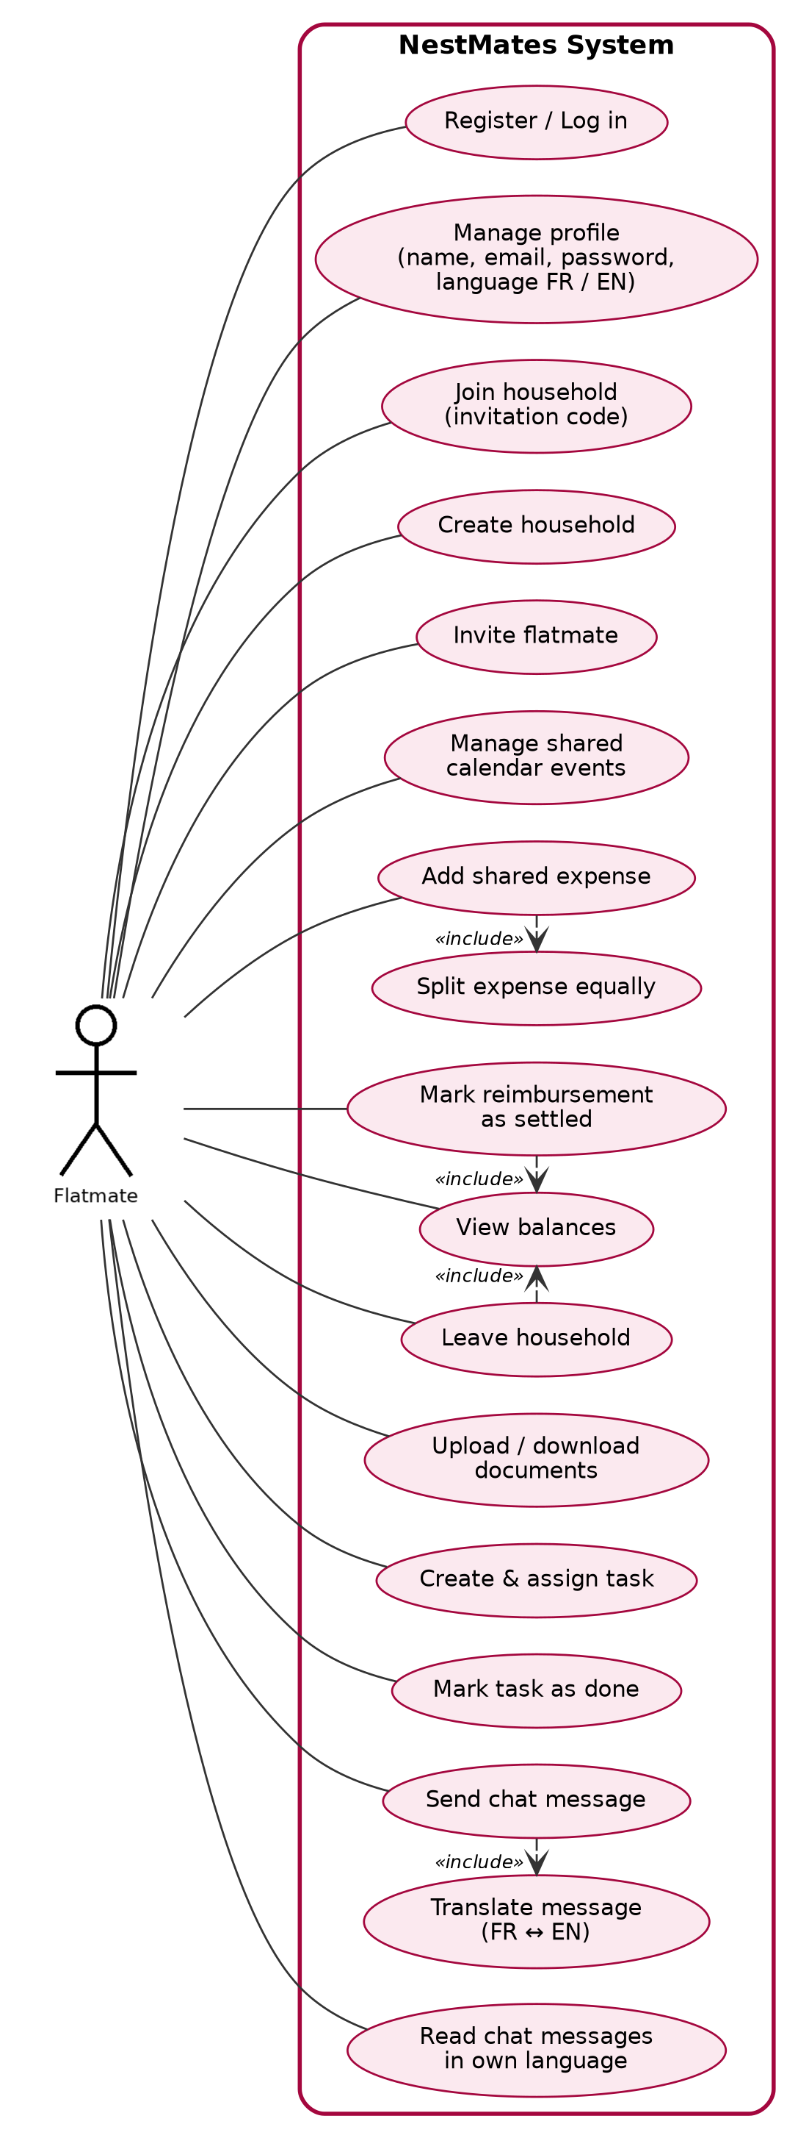
Figure 1 – NestMates use case diagram

5. Business Process Flow

5.1 Household Creation, Onboarding and Departure
- Process: A user registers, creates a household and shares an invitation code; any member can invite new flatmates, who register (or log in) and join the household. A member who moves out leaves the household once their balance is settled; when the last member leaves, the household is deleted.
- Inputs: User credentials (name, email, password), household name, invitation code, leave request.
- Outputs: New user accounts, an updated list of household members, or a deleted household.

5.2 Shared Expense and Settlement Process
- Process: A member records an expense and selects the participants; the system splits it equally, updates every balance and shows who owes whom; the debtor pays outside the application and the reimbursement is marked as settled.
- Inputs: Amount, payer, participants, date, category.
- Outputs: Updated balances, list of amounts owed between members, expense and settlement history.

5.3 Task Management Process
- Process: A member creates a task and assigns it to a flatmate with a due date; the assignee completes it and marks it as done.
- Inputs: Task title, assignee, due date.
- Outputs: Updated to-do list and task status.

5.4 Shared Document Management Process
- Process: A member uploads a file; all members can then view, download or delete it.
- Inputs: File (PDF or image), file name.
- Outputs: Stored document available to all household members.

5.5 Shared Calendar Process
- Process: A member creates an event with a date and time; the event appears in every member's calendar view; members can edit or delete it.
- Inputs: Event title, date, time, description.
- Outputs: Updated shared calendar visible to all household members.

5.6 Household Chat Process
- Process: A member writes a message while the other connected members see a typing indicator; when the message is sent, the system detects its language (French or English), translates it into the other language and delivers it in real time to every member, each one reading it in the language chosen in their profile.
- Inputs: Message text, sender, language preference of each member.
- Outputs: Message delivered to all members in their language and added to the chat history.
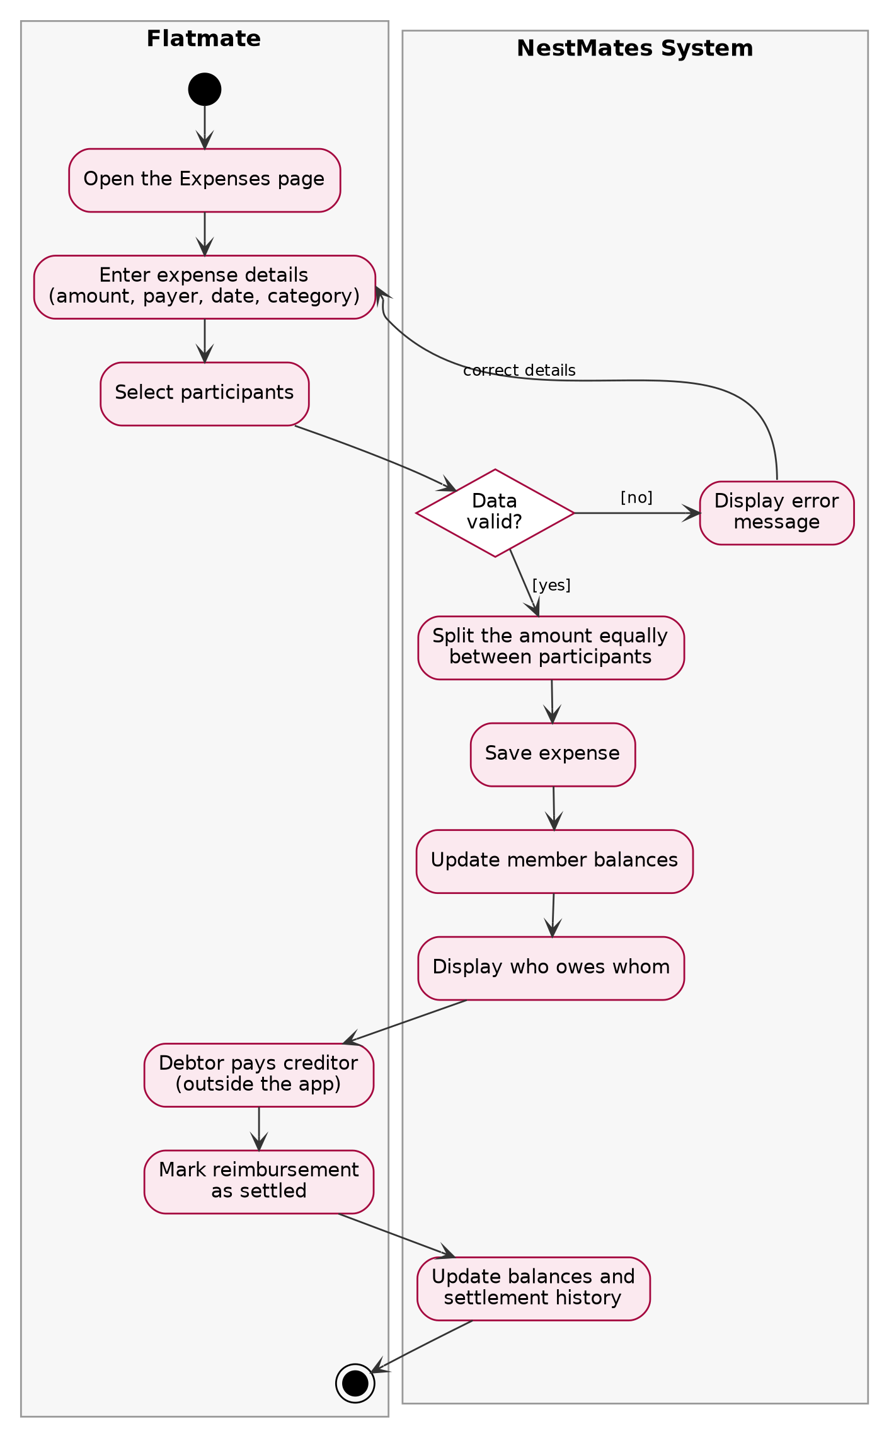
Figure 2 – Activity diagram of the shared expense and settlement process

6. Risks and Assumptions

6.1 Risks
- Data Privacy Risk: Leak of personal or financial data (bills, lease, bank details).
- Calculation Error Risk: An error in balance computation could create conflicts between flatmates.
- Low Adoption Risk: If only some flatmates use the application, data becomes incomplete.
- Storage Risk: Uploaded files could exceed storage capacity.
- Translation Quality Risk: Automatic translation can be inaccurate, especially with slang, abbreviations or very short messages.
- Third-Party Dependency Risk: If the translation service is unavailable or its quota is exceeded, messages cannot be translated.
- Inactive Member Risk: Since no member can remove another, a flatmate who moves out without leaving the household in the application remains a member.

6.2 Assumptions
- Each flatmate has a smartphone or computer with internet access.
- Flatmates agree to record shared expenses in the application rather than elsewhere.
- Reimbursements are paid outside the application (cash, bank transfer, payment apps).
- Flatmates leave the household in the application when they move out.
- A household typically has between 2 and 8 members.
- Flatmates speak French or English.

7. Implementation Strategy

7.1 Phased Implementation
- Sprint 1: Requirements and design documentation (BRD, SRS, SDD) and product backlog in Jira.
- Phase 1 – Foundations: Project setup, database and API conventions, French/English interface setup; Account and Household Management and User Profile.
- Phase 2 – Core modules: Shared Expenses with equal split and balances; Shared To-Do List.
- Phase 3 – Remaining modules: Shared Calendar and Shared Documents.
- Phase 4 – Household Chat: Real-time chat with typing indicator and automatic French–English translation; integration tests and deployment.

7.2 Training and Support
- Provide a short onboarding guide displayed at the first login of each user.
- Provide a help / FAQ page explaining how balances are computed.
- Track bug reports and improvements in Jira, handled by the project team.

8. Success Criteria
- Scope Delivery: 100% of the functional requirements are implemented and tested by the end of the project.
- User Satisfaction: At least 80% of test users are satisfied with the application (end-of-project survey).
- Ease of Use: A new user can create a household and add a first expense in under 5 minutes.
- Calculation Accuracy: 100% of balance-computation test cases pass.
- Translation Quality: At least 80% of test users consider the translated chat messages understandable.
- Adoption: In test households, at least 75% of shared expenses are recorded in the application.

9. Approval and Sign-off
This document is reviewed and approved by the following stakeholders:
- Product Owner / TD Instructor: Kenza RIAHI
- Scrum Master: Alexandre LARTIGUE
- Development Team: Alexandre LARTIGUE, Shayan KARIMI, Mahij GOSAI

