NESTMATES
SHARED LIVING APP

Software Design
Description (SDD)
NestMates Team
29 allée le Corbusier  92000, Nanterre | Software Engineering – A4  contact@nestmates.app

1. Introduction
Purpose. This document describes the software design of NestMates so that the developers can implement it, the testers can verify it, and the instructor can evaluate the technical choices. It explains how the requirements of the SRS will be realized.
Scope. NestMates is a responsive web application for managing a shared flat, available in French and English. It covers account and household management, a user profile with the choice of the application language, a shared calendar, shared expenses with automatic computation of debts, a shared document space, a shared to-do list and a real-time household chat with a typing indicator and automatic translation of messages between French and English. It does not include notifications, online payment or native mobile applications.
Audience. The development team (three developers), the Product Owner / TD instructor and future testers.
References. NestMates Business Requirements Document (BRD), NestMates Software Requirements Specification (SRS), IEEE 1016-2009 (Software Design Descriptions), ISO/IEC/IEEE 29148 (requirements), GDPR.

2. System Overview
NestMates is a single-page web application backed by a REST API and a real-time channel. Flatmates use their browser to create or join a household with an invitation code, record and settle shared expenses, manage a shared calendar, store household documents, share a to-do list and chat together. Chat messages are automatically translated between French and English, and each user reads the whole application, including the chat, in the language chosen in their profile. All members of a household have the same rights.
The system follows a classic three-tier architecture: a React frontend, a Node.js / Express backend organized in feature modules (a modular monolith) that also runs a Socket.IO server for real-time communication, and a MongoDB database hosted on MongoDB Atlas, which also stores the uploaded files through GridFS. The system relies on two external services: the Google Cloud Translation API for the chat, and an SMTP email provider for password reset emails.

3. Architectural Views

3.1 Context View
The system sits between its only type of human user, the flatmates, and two external systems: the Google Cloud Translation API and the email service. The landlord or real-estate agency does not interact with the system: flatmates upload the documents it provides.
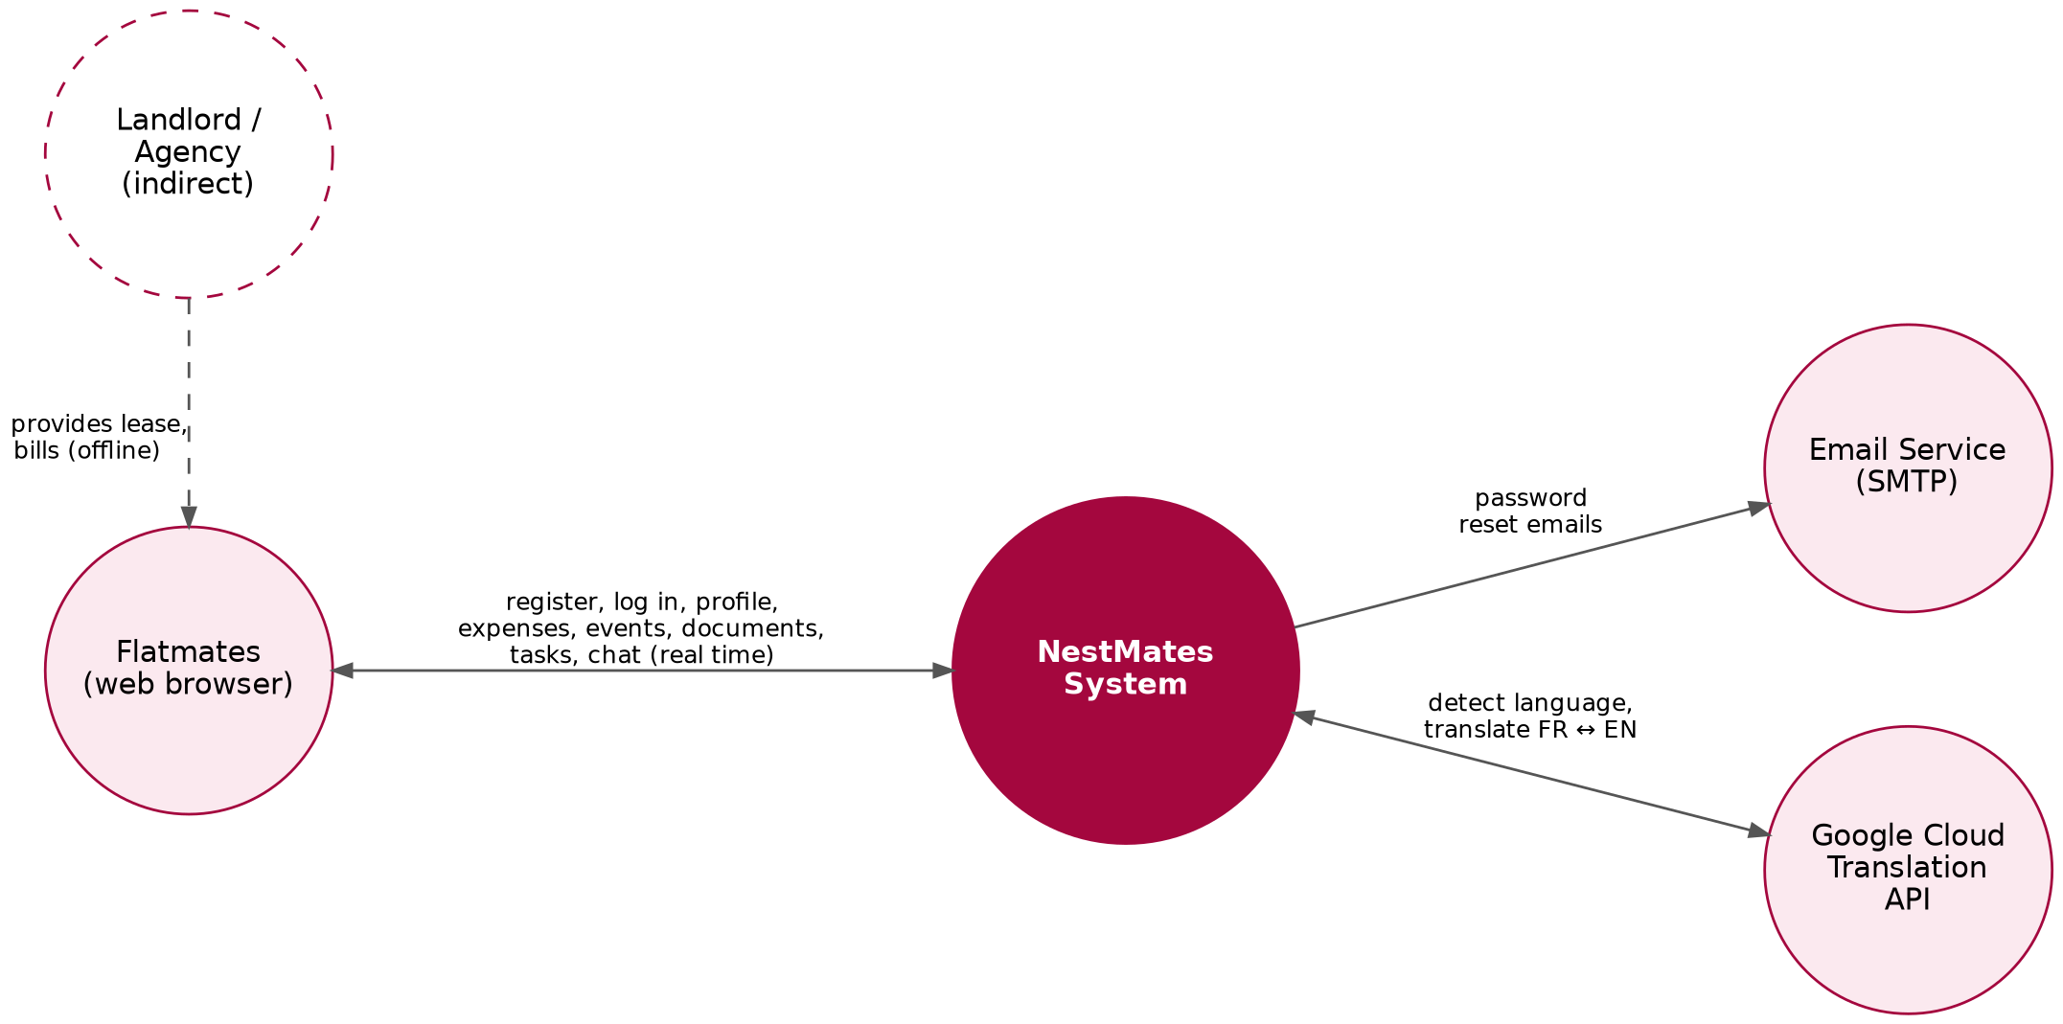
Figure 1 – Context diagram of NestMates
Primary interactions
- Flatmates ↔ NestMates: registration, login, profile and language, household creation and joining, expenses and settlements, events, documents, tasks, real-time chat.
- NestMates → Google Cloud Translation API: language detection and translation of chat messages between French and English (HTTPS).
- NestMates → Email Service: sending password reset links (SMTP over TLS).

3.2 Component View
Backend (Node.js / Express) – logical components and their responsibilities:
- AuthModule — registration, login, JWT issuing, password reset (token generation and email).
- UserModule — profile of the current user (name, email, password, application language) and account deletion.
- HouseholdModule — creation, invitation code, joining, leaving and cascade deletion of a household.
- ExpenseModule — expenses, equal split, settlements; relies on DebtService to compute debts and balances.
- CalendarModule — household events.
- DocumentModule — upload (Multer), storage in GridFS, streaming and deletion of files.
- TaskModule — tasks and their status.
- ChatModule — ChatGateway (Socket.IO server: authentication of connections, household rooms, typing and message events) and ChatService (validation, storage and history of messages).
- TranslationService — client of the Google Cloud Translation API: language detection and translation between French and English.
- Shared middlewares — authenticate (JWT), requireMembership (access control per household), validate (request schemas), errorHandler, security middlewares (Helmet, CORS, rate limiting).
- Database access — Mongoose models, one per collection (see Section 4).
Frontend (React) – logical components:
- Pages — Login, Register, ForgotPassword, ResetPassword, Onboarding (create or join), Expenses, Calendar, Documents, Tasks, Chat, Profile, HouseholdSettings.
- i18n — react-i18next with one file of texts per language (fr.json, en.json); the active language is the user's language after login, and the browser language (with a FR / EN switch) before login.
- socketClient — Socket.IO client opened after login with the JWT, used by the Chat page.
- AuthContext — stores the JWT and the current user, and protects private routes.
- apiClient — Axios instance that adds the JWT to every request and redirects to the login page on a 401 response.
- Layout — navigation menu (sidebar on desktop, bottom bar on mobile); after login, the user lands on the Expenses page.
Key dependencies
- Every module persists its data to MongoDB through Mongoose.
- All household routes go through authenticate then requireMembership.
- HouseholdModule depends on DebtService to check that a member's debts are zero before leaving.
- HouseholdModule depends on DocumentModule to delete GridFS files when a household is deleted.
- AuthModule depends on the Mailer (Nodemailer) for password reset emails, written in the user's language.
- ChatModule depends on TranslationService, and ChatGateway reuses the JWT verification of authenticate.
- HouseholdModule deletes the household's messages with the household, and disconnects a member from the household room when they leave.

3.3 Deployment View
- Frontend: React SPA built with Vite and served as static files by Vercel (CDN, HTTPS enforced).
- Backend: Node.js 20 / Express API and Socket.IO server deployed as a single Render Web Service in an EU region (Render supports WebSocket connections). The REST API is stateless (JWT).
- Data: MongoDB Atlas cluster in the eu-west-3 (Paris) region, storing both the collections and the uploaded files (GridFS). Encryption at rest and in transit is provided by Atlas; daily backups are enabled.
- Integrations: SMTP provider (e.g. Brevo) accessed through Nodemailer; Google Cloud Translation API (Basic edition) accessed through the official Node.js client with an API key restricted to this API.
- Ops: source code on GitHub; GitHub Actions runs the linter and tests on each push; Vercel and Render deploy automatically from the main branch. Secrets (JWT secret, database URI, SMTP credentials, translation API key) are stored as environment variables.

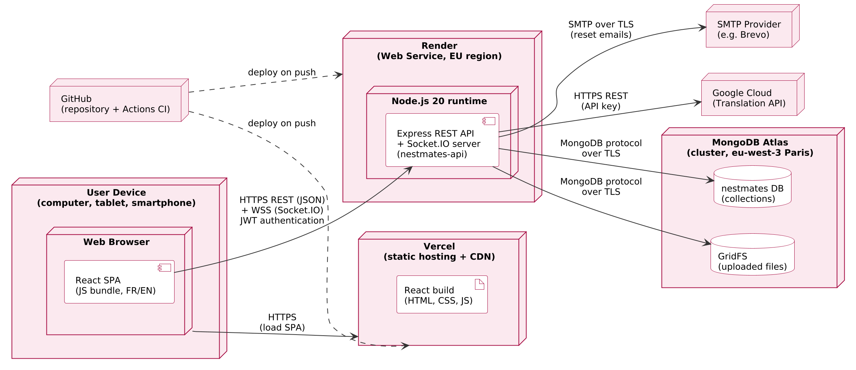
Figure 2 – Deployment diagram of NestMates

4. Data Design
NestMates uses MongoDB (document database) accessed through Mongoose. All amounts are stored as integers in cents (amountCents) to avoid floating-point rounding errors.
Core entities & relationships
- users(_id, name, email, passwordHash, householdId, language, privacyAcceptedAt, resetTokenHash, resetTokenExpiresAt, createdAt)
- households(_id, name, invitationCode, createdAt)
- expenses(_id, householdId, payerId, amountCents, date, category, description, shares[{userId, amountCents}], createdBy, createdAt)
- settlements(_id, householdId, fromUserId, toUserId, amountCents, createdBy, createdAt)
- events(_id, householdId, title, date, time, description, createdBy, createdAt)
- tasks(_id, householdId, title, assigneeId, dueDate, status, createdBy, completedAt)
- documents(_id, householdId, fileName, mimeType, size, gridFsFileId, uploadedBy, uploadedAt), with the file content stored in GridFS (fs.files / fs.chunks)
- messages(_id, householdId, senderId, originalText, sourceLang, translatedText, translatedLang, createdAt)
Household membership is stored on the user (householdId), which enforces the rule that a user belongs to at most one household. Expense shares are embedded in the expense document because they are always read and written together. Since only two languages are supported, each chat message is translated once, when it is sent, and stores its original text and its translation into the other language; the display language is chosen on the client according to the reader's language.
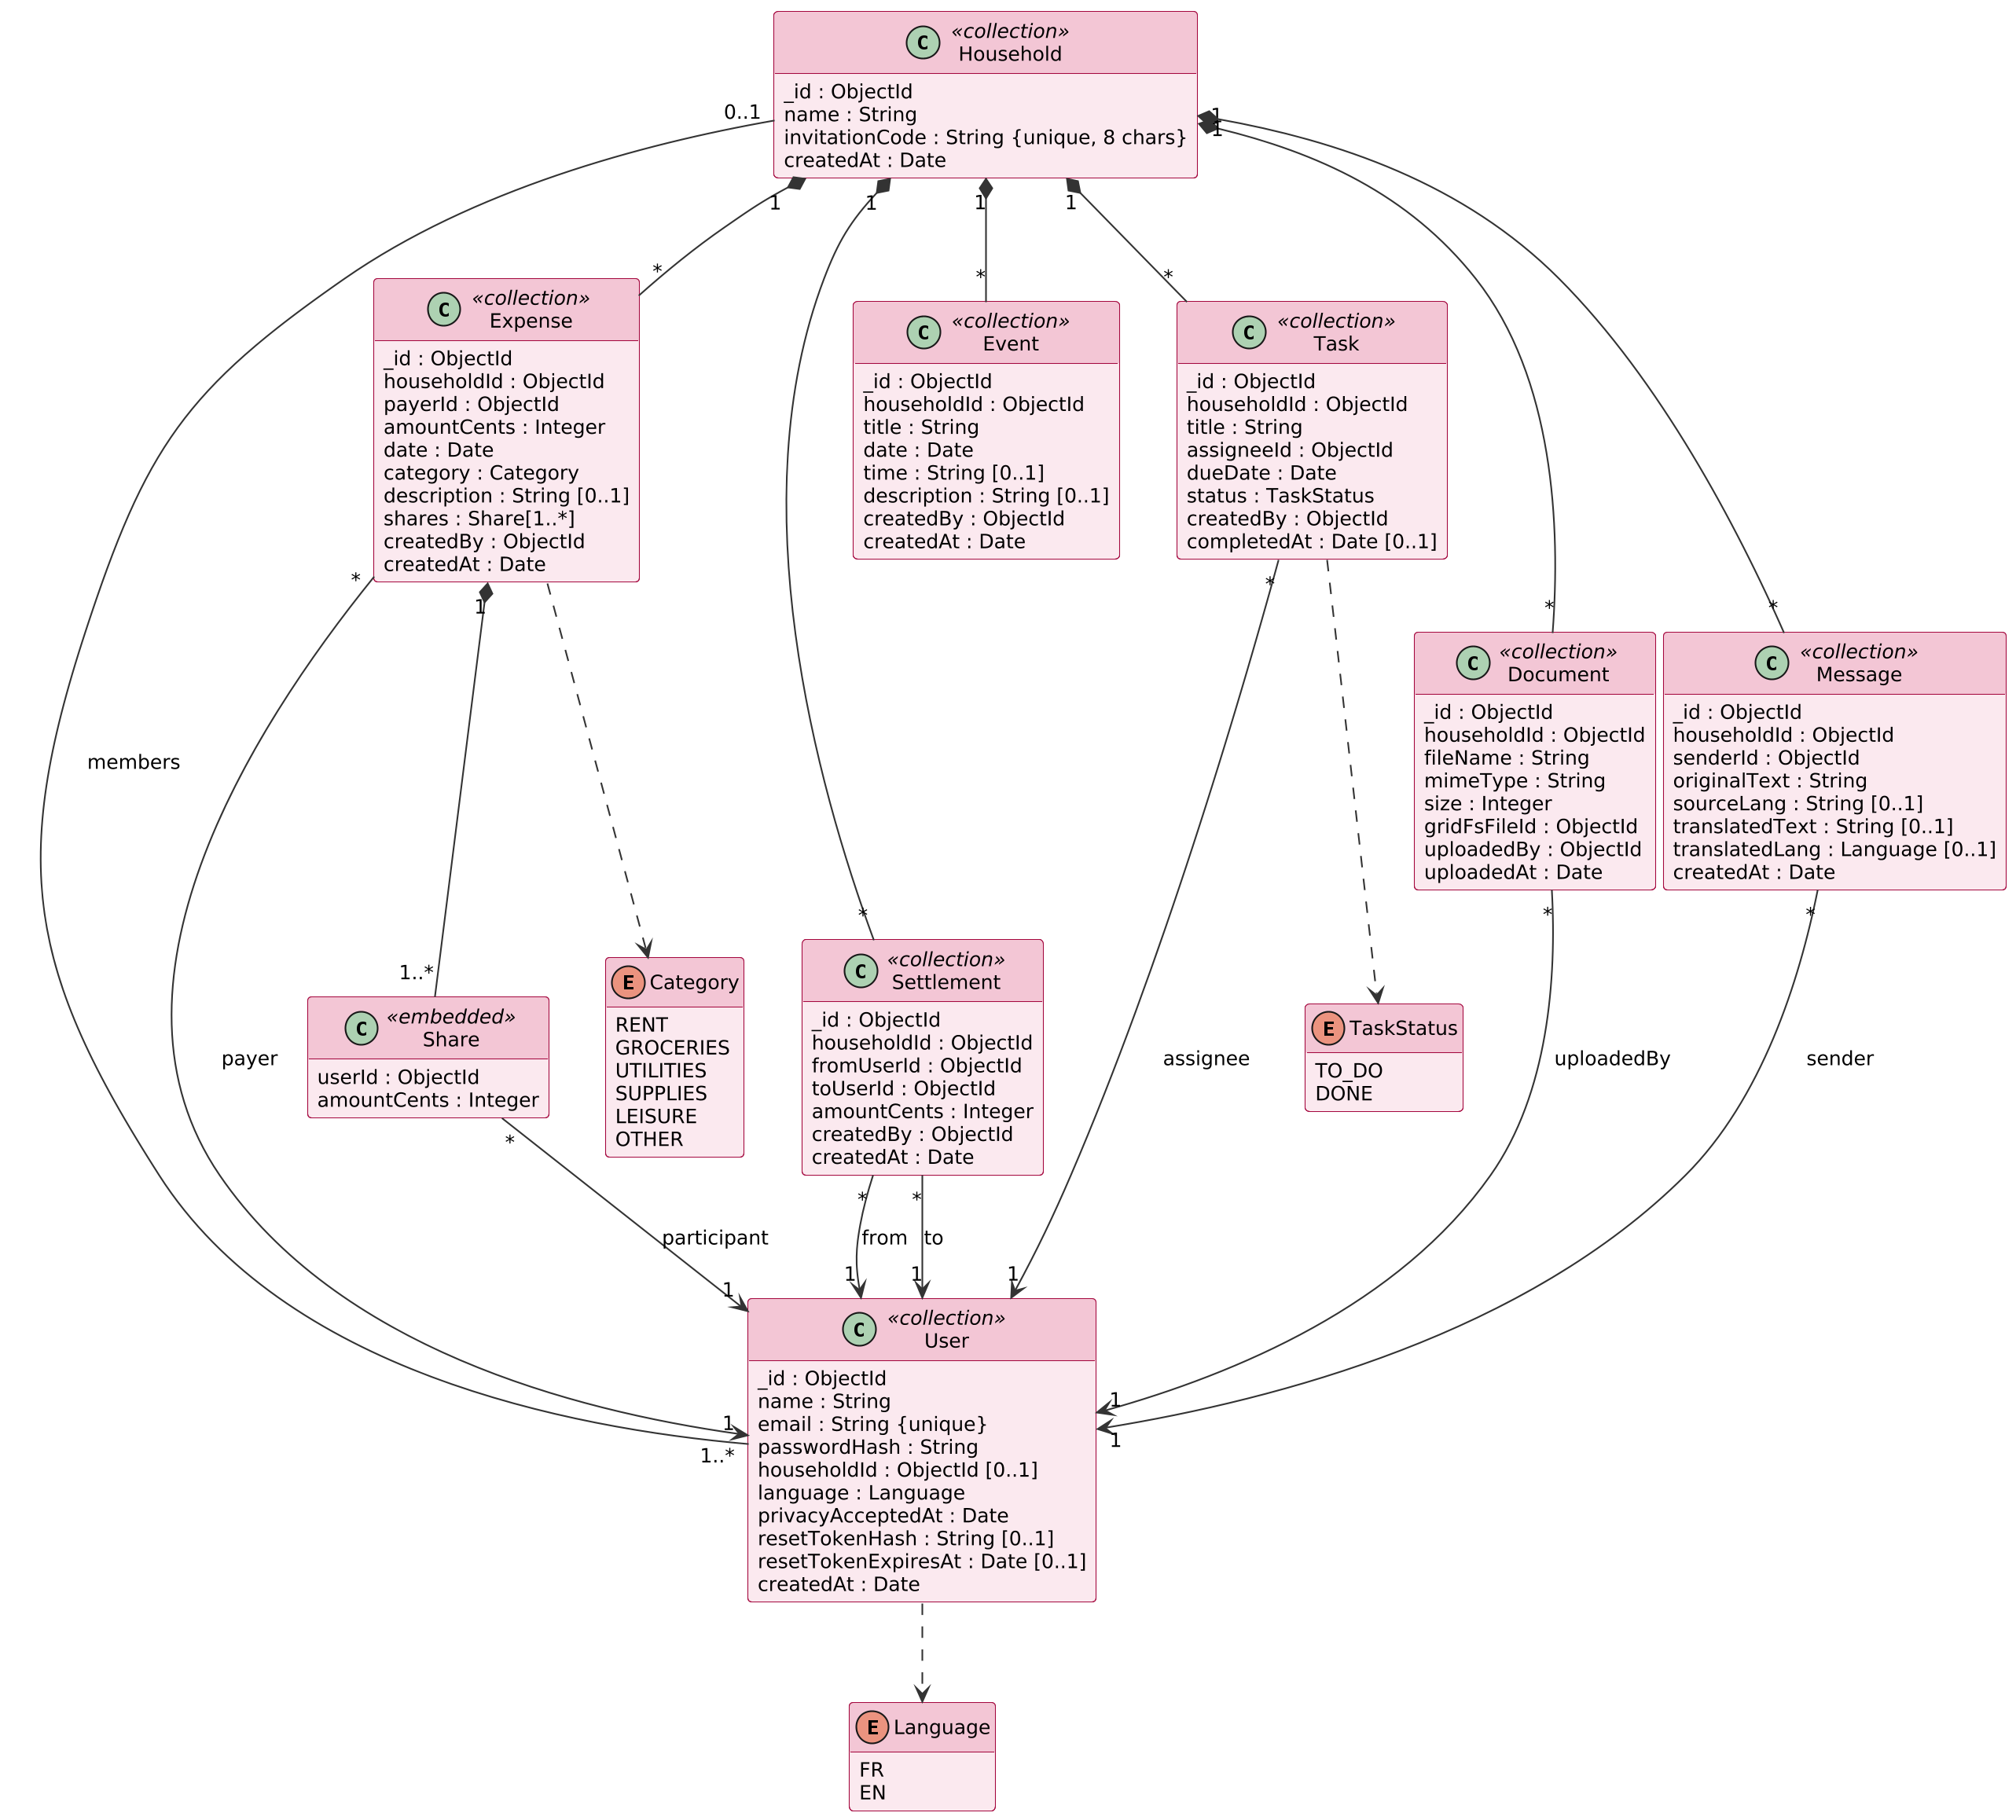
Figure 3 – Class diagram of the NestMates data model
Integrity rules
- users.email and households.invitationCode have unique indexes.
- users.language is either fr or en; messages.originalText contains 1 to 1,000 characters; translatedText and translatedLang are null when the message was not translated.
- Every household document has an index on householdId; expenses, settlements and messages also have a compound index on householdId and createdAt for the history.
- amountCents is a strictly positive integer, and the sum of the shares of an expense equals its amountCents.
- The payer, the participants, the assignee and the settlement members must belong to the household when the document is created.
- Leaving a household (householdId set to null) is only allowed when all the member's debts are zero; when the last member leaves, the household and all its documents (including messages and GridFS files) are deleted in a single MongoDB transaction.
- Past expenses and messages keep references to members who left or deleted their account; the interface displays them as "Former member".

5. Interface Design
External REST endpoints — base URL /api, JSON bodies, JWT required except for the authentication routes. {id} is the household identifier.
Method | Endpoint | Description / response
POST | /auth/register | Create an account {name, email, password, acceptPrivacy} → 201 + JWT
POST | /auth/login | Log in {email, password} → 200 + JWT
POST | /auth/forgot-password | Send a reset link {email} → 204
POST | /auth/reset-password | Set a new password {token, password} → 204
GET | /users/me | Current user (profile, language, household id)
PATCH | /users/me | Edit name, email or language {name, email, language}
PUT | /users/me/password | Change password {currentPassword, newPassword} → 204
DELETE | /users/me | Delete account → 204 (409 if in a household)
GET | /health | Health check → 200
POST | /households | Create a household {name} → 201 (409 if already in one)
POST | /households/join | Join {invitationCode} → 200 (404 invalid code)
GET | /households/{id} | Household, members and invitation code
POST | /households/{id}/leave | Leave → 204 (409 if debts not settled)
GET / POST | /households/{id}/expenses | List (paginated) / record an expense → 201
GET | /households/{id}/debts | Who owes whom and balances
GET / POST | /households/{id}/settlements | List / settle a debt {counterpartId} → 201
GET / POST | /households/{id}/events | List by month (?month=YYYY-MM) / create
PUT / DELETE | /households/{id}/events/{eventId} | Edit / delete an event
GET / POST | /households/{id}/documents | List / upload (multipart, field "file")
GET | /households/{id}/documents/{docId}/content | Stream the file (inline or attachment)
DELETE | /households/{id}/documents/{docId} | Delete a document and its GridFS file
GET / POST | /households/{id}/tasks | List (sorted by due date) / create
PATCH | /households/{id}/tasks/{taskId} | Mark as done {status: "DONE"}
GET | /households/{id}/messages | Chat history (?before=date&limit=50)
Real-time events (Socket.IO) — the client connects with auth: { token }; the server verifies the JWT and adds the socket to the room household:{id} of the user's household.
Event | Direction | Payload / behaviour
chat:send | Client → server | {text}; acknowledged with {message} or {error}
chat:message | Server → room | {message} with original text and translation
chat:typing | Client → server | Emitted at most every 2 s while the user types
chat:typing | Server → room (except sender) | {userId, name}; hidden by the client after 3 s
connect_error | Server → client | Invalid or expired JWT; the client redirects to login
Logging out is handled by the frontend, which deletes the stored JWT (the API is stateless).
Error format. All errors are returned as { "error": { "code", "message", "details" } } with the appropriate HTTP status (see Section 6.5).
UI surfaces
- Authentication pages: register, log in, forgot and reset password, with a FR / EN switch.
- Onboarding: create a household or join one with an invitation code.
- Expenses (landing page): "who owes whom" with "Mark as settled", balances, history, "Add expense" form.
- Calendar: monthly view (FullCalendar) with an event form.
- Documents: list with view, download and delete actions, upload button.
- Tasks: list sorted by due date with a "Done" checkbox and an "Add task" form.
- Chat: messages with sender, time and "Translated" label, typing indicator, text field and "Send" button.
- Profile: name, email, password, language selector (Français / English) and "Delete my account".
- Household settings: members, invitation code and "Leave household".

6. Detailed Design

6.1 Component Responsibilities (Selected)
- ExpenseService
  - Validates the payer and the participants against the household members.
  - Splits the amount with splitEqually and saves the expense with its shares.
  - Returns the created expense with the updated debts (via DebtService).
- DebtService
  - Computes the net debt between each pair of members and the balance of each member (algorithm in 6.2).
  - Provides getDebtsOf(userId) used by HouseholdService before a member leaves.
- SettlementService
  - Checks that the requester is one of the two members concerned.
  - Recomputes the current debt on the server and records a settlement for its full amount (the amount is never taken from the client).
- HouseholdService
  - Generates an 8-character invitation code (uppercase letters and digits, excluding ambiguous characters such as O/0 and I/1) and retries if it already exists.
  - Handles joining and leaving; deletes the household and all its data in a transaction when the last member leaves.
- DocumentService
  - Receives the file with Multer (memory storage, 10 MB limit, PDF/JPEG/PNG filter) and streams it into GridFS.
  - Streams files back only after the membership check; the frontend fetches them as a Blob and opens them with an object URL.
- ChatGateway
  - Verifies the JWT at connection, joins the socket to its household room and relays typing events to the other members of the room.
  - Receives chat:send, calls ChatService and broadcasts the saved message to the room; limits each user to 10 messages per 10 seconds.
- ChatService
  - Checks again that the sender is still a member of the household and validates the text (1 to 1,000 characters after trimming).
  - Calls TranslationService, saves the message and returns it; returns the history by pages of 50 messages.
- TranslationService
  - Detects the language and translates the message into the other language (algorithm in 6.2), with a timeout of 1.5 seconds.
  - Never blocks sending: on any error, timeout or unsupported language, it returns no translation and the message is kept in its original version.
- UserService
  - Updates the name, email (checked for uniqueness) and language; changes the password after checking the current one with bcrypt.
- AuthService
  - Hashes passwords with bcrypt (cost factor 12) and signs JWTs (HS256, 24-hour expiry).
  - Generates a random 32-byte reset token, stores only its SHA-256 hash with a 1-hour expiry, and emails the link; the response is the same whether or not the email exists.

6.2 Key Algorithms
Equal split (FR-EXP-03). The amount in cents is divided by the number of participants; the remaining cents are given one by one to the first participants (in the order of their identifiers), so that the sum of the shares always equals the amount.
function splitEqually(amountCents, participantIds) {
const ids = [...participantIds].sort();
const base = Math.floor(amountCents / ids.length);
let remainder = amountCents - base * ids.length;
return ids.map(userId => ({
userId,
amountCents: base + (remainder-- > 0 ? 1 : 0)
}));
}
// Example: 1000 cents between 3 members -> 334, 333, 333
Debts and balances (FR-EXP-04 to FR-EXP-06). For each pair of members, the service adds the shares owed by one to the other and subtracts the settlements between them:
- For each expense and each share whose participant is not the payer: owed[participant][payer] += share.
- For each settlement: owed[from][to] -= amount.
- For each pair (A, B): net = owed[A][B] − owed[B][A]. If net > 0, A owes net to B; if net < 0, B owes −net to A.
- The balance of a member is the total owed to them minus the total they owe.
Households have at most about 8 members, so this computation is done in memory from the household's expenses and settlements, which is fast enough and easy to unit test.
Chat translation (FR-CHT-03 to FR-CHT-05). Since only French and English are supported, one or two calls to the API are enough:
async function translateMessage(text) {
try {
// first call: translate to English and detect the language
const r1 = await translate(text, { to: 'en' });
const src = r1.detectedSourceLanguage;
if (src === 'fr')
return { sourceLang: 'fr', translatedLang: 'en',
translatedText: r1.text };
if (src === 'en') {
const r2 = await translate(text, { to: 'fr' });
return { sourceLang: 'en', translatedLang: 'fr',
translatedText: r2.text };
}
return { sourceLang: src, translatedText: null };
} catch (err) { // timeout, quota exceeded, unavailable
return { sourceLang: null, translatedText: null };
}
}
Display rule (client). A message is shown in its translation, with the "Translated" label, when translatedLang equals the reader's language; otherwise it is shown in its original version.

6.3 Sequence – "Record a Shared Expense" (UC1)
- The flatmate submits the "Add expense" form; the frontend converts the amount to cents.
- The frontend calls POST /api/households/{id}/expenses with the JWT.
- authenticate verifies the JWT; requireMembership checks that the user belongs to the household.
- ExpenseService validates the data against the household members and splits the amount equally.
- The expense is inserted; DebtService recomputes the debts and balances.
- The API returns 201 with the expense and the updated debts; the frontend refreshes the page.

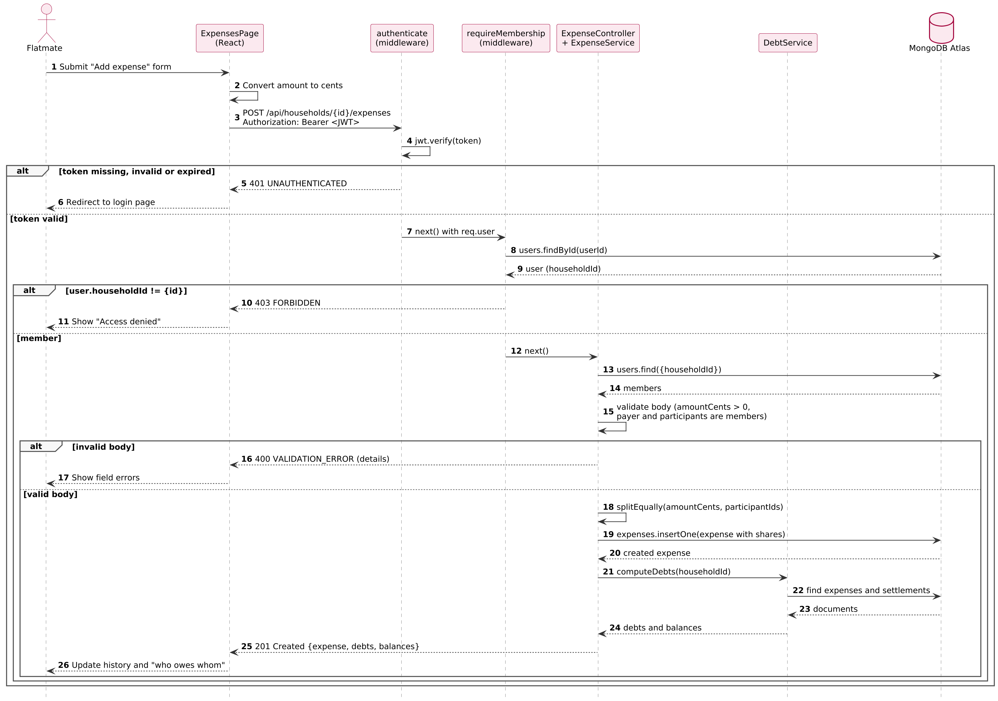
Figure 4 – Sequence diagram of recording a shared expense

6.4 Sequence – "Send a Chat Message" (UC4)
- While the sender types, the ChatPage emits chat:typing and the gateway relays it to the other members of the room.
- On "Send", the ChatPage emits chat:send with the text; ChatService checks the membership and validates the text.
- TranslationService detects the language and translates the message into the other language through the Google Cloud Translation API.
- The message is saved with its original text and its translation.
- The gateway broadcasts chat:message to the household room and acknowledges the sender.
- Each client displays the original or the translation according to the reader's language.

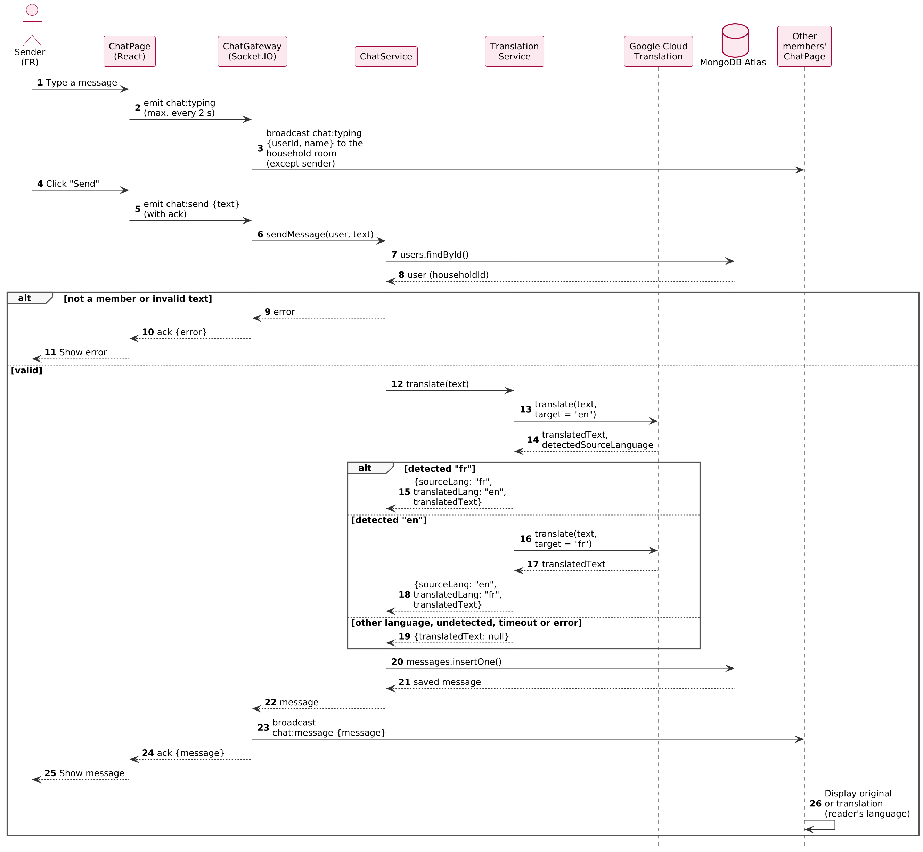
Figure 5 – Sequence diagram of sending a translated chat message

6.5 Error Handling & Recovery
- 400 VALIDATION_ERROR for invalid input, with a list of field errors displayed next to the form fields.
- 401 UNAUTHENTICATED for a missing, invalid or expired JWT; the frontend redirects to the login page.
- 403 FORBIDDEN when the user is not a member of the requested household.
- 404 NOT_FOUND for unknown resources or an invalid invitation code.
- 409 CONFLICT for business rule violations: email already used, user already in a household, leaving with unsettled debts, deleting an account while in a household.
- 413 / 415 for files that are too large or of an unsupported type.
- Socket.IO errors: an invalid JWT rejects the connection (connect_error); an invalid message or a non-member sender receives an error in the acknowledgement of chat:send; the client reconnects automatically after a network loss and reloads the latest messages.
- Translation failures never prevent sending: the message is saved without translation and the error is logged.
- 500 INTERNAL_ERROR from a global error handler that logs the error with a request ID and never exposes stack traces.
- Operations that modify several collections (leaving as the last member) use MongoDB transactions so that the data stays consistent if an error occurs.

7. Security & Compliance
- JWT authentication (HS256, 24 h expiry, secret in an environment variable); passwords hashed with bcrypt.
- Access control per household on every household route (requireMembership); no role-based access control, since all members have the same rights.
- HTTPS everywhere; Helmet for security headers (including a Content Security Policy); CORS restricted to the frontend domain; rate limiting on authentication routes.
- Socket.IO connections are authenticated with the JWT; a socket only joins the room of its user's household, membership is checked again for each message, and the sockets of a member who leaves are removed from the room.
- Chat messages are rate-limited, limited to 1,000 characters and displayed as plain text (React escapes them), which prevents script injection.
- The Google Cloud Translation API key is stored in an environment variable on the server, restricted to the Translation API and never sent to the browser.
- Server-side validation of every request and sanitization of MongoDB operators to prevent NoSQL injection.
- Documents are stored in GridFS, never exposed through a public URL, and served with the X-Content-Type-Options: nosniff header.
- GDPR: consent recorded at registration (privacyAcceptedAt), data minimization (name and email only), data hosted in the EU (Paris region), right of access and rectification (profile) and right to erasure (account deletion, household deletion when the last member leaves). The privacy policy states that chat messages are sent to Google Cloud Translation to be translated.

8. Performance, Scalability, Availability
- Indexes on householdId, email, invitationCode and createdAt keep common queries fast.
- The expense history is paginated (50 items per page); calendar events are loaded month by month.
- Debt computation is done in memory for a single household (at most a few hundred documents), well within the 2-second target.
- MongoDB Atlas can be upgraded to a larger cluster if needed.
- Chat messages are delivered through WebSockets without polling; the translation is limited to one or two API calls with a 1.5-second timeout, so that a message is displayed in less than 2 seconds (NFR-PERF-04). Typing events are relayed without any database access.
- With a single Render instance, Socket.IO rooms are kept in memory; running several instances would require the Socket.IO Redis adapter and sticky sessions.
- The free tier of Render puts the service to sleep after inactivity, which causes a slow first request; a paid instance should be used for the final demonstration (see Section 13).

9. Observability
- HTTP request logs with Morgan and application logs in JSON with a request ID.
- A GET /api/health endpoint used by Render to monitor the service.
- Translation errors, timeouts and quota warnings are logged; the number of translated characters is followed in the Google Cloud console.
- Logs and metrics available in the Render and MongoDB Atlas dashboards.

10. Internationalization & Accessibility
- The whole interface is available in French and English with react-i18next; every text is stored in fr.json and en.json, and no text is written directly in the components.
- The active language is the language field of the user profile (FR-ACC-15); at registration it is set to the browser language (French if it starts with "fr", English otherwise). Before login, the language follows the browser and can be switched with a FR / EN button.
- The API returns error codes (e.g. VALIDATION_ERROR) that the frontend translates; the backend only produces texts for the password reset email, available in both languages.
- Amounts (EUR) and dates are formatted with the browser's Intl API according to the active language (e.g. 1 234,50 € in French, €1,234.50 in English).
- Chat messages are displayed in the reader's language as described in Section 6.2.
- Accessibility target: WCAG 2.1 level AA basics, including labels on all form fields, keyboard navigation, sufficient color contrast and alternative texts; the typing indicator is announced with an ARIA live region.

11. Design Rationale
- React + Node.js / Express: required by the course, with a single language (JavaScript) for the whole stack.
- Modular monolith rather than microservices: simpler to develop, test and deploy for a three-person team, while keeping one module per feature as required by the SRS (NFR-MNT-03).
- MongoDB: flexible document model that fits the data well (shares embedded in expenses) and a free managed cluster with Atlas; GridFS avoids a separate file storage service and keeps files deleted with their household.
- Amounts in cents: exact arithmetic for the equal split and the debts.
- Pairwise debts computed on demand: no stored balance that could become inconsistent; always recomputed from the expenses and settlements.
- Socket.IO: rooms per household, acknowledgements, automatic reconnection and a fallback when WebSockets are blocked; required for the typing indicator, which cannot be done reasonably with polling.
- Google Cloud Translation API: chosen by the team for its translation quality, its automatic language detection and its free monthly quota.
- Translation at send time, stored with the message: each message is translated only once, the display is instant for every reader, and changing the language in the profile does not require any new API call.
- A single language setting in the profile: one clear place to change the language, applied consistently to the interface, the chat and the emails.
- Vercel + Render + Atlas: managed services with free tiers, automatic deployment from GitHub and HTTPS by default.

12. Assumptions & Constraints
- Web application only; native mobile applications are out of scope.
- A user belongs to at most one household; a household has between 2 and 8 members.
- The project is developed by three developers with free-tier cloud services.
- Only French and English are supported, for the interface and for the chat translation.
- A Google Cloud account with billing enabled is required to use the Translation API, even within the free quota.
- Reimbursements are paid outside the application.

13. Open Issues / Future Work
- Editing or deleting an expense entered by mistake.
- Handling of tasks assigned to a member who has left the household.
- Members who move out without leaving the household in the application.
- Storage of the JWT in the browser (localStorage) versus an HttpOnly cookie.
- Cold starts of the free Render instance.
- Editing or deleting chat messages, and unread message counters.
- Translation quality for slang and abbreviations; possible "show original" option.
- Scaling the Socket.IO server to several instances (Redis adapter).
- Possible future features: notifications, recurring tasks and events, custom splits, document folders, other languages.

