NESTMATES
SHARED LIVING APP

Software Requirements
Specification (SRS)
NestMates Team
29 allée le Corbusier  92000, Nanterre | Software Engineering – A4  contact@nestmates.app

1. Introduction

1.1 Purpose
The purpose of this document is to describe the functional and non-functional requirements of "NestMates", a web application for managing a shared flat (colocation). It translates the business needs defined in the NestMates Business Requirements Document (BRD) into precise, testable requirements. This document serves as a guideline for the developers, testers and other stakeholders to ensure that the system meets the needs of flatmates for sharing expenses, documents, events and chores.

1.2 Scope
NestMates allows flatmates to create a shared household and manage it together through five modules: a shared calendar, shared expenses with automatic balance computation, a shared document space, a shared to-do list and a household chat with automatic translation between French and English. All members of a household have the same rights. The whole application is available in French and English, according to the language chosen by each user in their profile.

1.3 Definitions, Acronyms, and Abbreviations
- Household: A shared flat registered in NestMates, grouping its members and their shared data.
- Flatmate / Member: A registered user who belongs to a household.
- Expense: An amount paid by one member on behalf of one or more participants.
- Share: The part of an expense owed by one participant.
- Debt: The net amount one member owes another, computed from expenses and settlements.
- Balance: The net position of a member in the household (positive: owed money; negative: owes money).
- Settlement: The record that a debt between two members has been paid back outside the application.
- Invitation Code: A unique code used to join a household.
- Profile: The page where a user manages their personal information and the language of the application.
- Application Language: The language (French or English) chosen by a user in their profile, used for the whole interface and for reading chat messages.
- Chat Message: A text message sent by a member to all the members of their household.
- Typing Indicator: A real-time signal showing that another member is typing a message.
- API: Application Programming Interface. REST: Representational State Transfer.
- JWT: JSON Web Token, used to authenticate API requests.
- WebSocket: A protocol allowing real-time, two-way communication between the browser and the server.
- GDPR: General Data Protection Regulation (EU 2016/679).

1.4 References
- NestMates Business Requirements Document (BRD).
- Google Cloud Translation API documentation.
- ISO/IEC/IEEE 29148:2018 – Systems and software engineering – Requirements engineering.
- ISO 9241-210 for Human-Centered Design Principles.
- Regulation (EU) 2016/679 – General Data Protection Regulation (GDPR).

1.5 Document Overview
This document is structured into the following sections: Introduction, General Description, Specific Requirements, Use Case Scenarios, Modeling Diagrams, External Interfaces and Other Requirements. Each section provides increasing levels of detail to facilitate the understanding and implementation of the system.

2. General Description

2.1 Product Perspective
NestMates is a new, standalone product. It replaces the combination of group chats, spreadsheets and paper notes currently used by flatmates. It follows a three-tier web architecture:
- Frontend: a single-page application developed with React, running in the user's browser.
- Backend: a REST API developed with Node.js and Express, handling authentication, business rules and data access.
- Data layer: a database storing users, households and shared data, and a file storage for uploaded documents.
The system uses two external services: the Google Cloud Translation API, to translate chat messages between French and English, and an email service, to send password reset links. Chat messages and typing indicators are exchanged in real time through a WebSocket connection.

2.2 Product Features
NestMates includes the following main features:
- Account and Household Management: Registration, login, password reset, creation of a household, invitation of flatmates, joining and leaving a household.
- User Profile: Modification of the name, email address and password, choice of the application language (French or English) and deletion of the account.
- Shared Calendar: Creation, modification and deletion of household events displayed in a monthly view.
- Shared Expenses: Recording of expenses split equally between participants, computation of balances and debts, and settlement of reimbursements.
- Shared Documents: Upload, consultation, download and deletion of household files.
- Shared To-Do List: Creation of tasks assigned to a flatmate with a due date, and marking tasks as done.
- Household Chat: Real-time group chat between the members of a household, with a typing indicator and automatic translation of messages between French and English.

2.3 User Characteristics
The application has a single type of user:
- Flatmate: A person living in a shared flat, typically a student or young professional, used to web and mobile applications. Every member of a household has the same rights and duties. Flatmates speak French or English and may not share the same language.

2.4 General Constraints
- The system must comply with data privacy regulations (GDPR).
- The backend must be developed with Node.js (Express) and the frontend with React.
- All communications must be secured with HTTPS.
- The application supports two languages only: French and English.
- Chat translation relies on the Google Cloud Translation API and is subject to its usage quotas.

2.5 Assumptions and Dependencies
- Users have a device (computer, tablet or smartphone) with a modern web browser and internet access.
- Users have basic digital literacy and a valid email address.
- A user belongs to at most one household at a time.
- A household typically has between 2 and 8 members.
- Flatmates leave the household in the application when they move out.
- Flatmates speak French or English.

3. Specific Requirements

3.1 Functional Requirements

3.1.1 Account and Household Management
- FR-ACC-01 – The system must allow a visitor to register with a name, an email address and a password. The email address must be unique and the password must contain at least 8 characters, including a letter and a digit.
- FR-ACC-02 – The system must require the visitor to accept the privacy policy before creating an account.
- FR-ACC-03 – The system must allow a registered user to log in with their email and password, and to log out.
- FR-ACC-04 – The system must allow a user to reset a forgotten password through a link sent by email, valid for 1 hour.
- FR-ACC-05 – The system must allow a user without a household to create one by entering a household name. The creator becomes its first member.
- FR-ACC-06 – The system must generate a unique 8-character invitation code for each household.
- FR-ACC-07 – Any member must be able to view and share the invitation code of their household.
- FR-ACC-08 – The system must allow a user without a household to join a household by entering a valid invitation code.
- FR-ACC-09 – All members of a household must have the same rights. No member can remove another member.
- FR-ACC-10 – The system must allow a member to leave the household only if all their debts are equal to zero. Otherwise, the system must refuse.
- FR-ACC-11 – When the last member leaves a household, the system must permanently delete the household and all its data (expenses, settlements, events, tasks and documents).
- FR-ACC-12 – The system must allow a user who does not belong to any household to delete their account and personal data from their profile.
- FR-ACC-13 – The system must allow a user to view and edit their name and email address in their profile. The new email address must be unique.
- FR-ACC-14 – The system must allow a user to change their password from their profile by entering their current password and a new password that respects the rules of FR-ACC-01.
- FR-ACC-15 – The system must allow a user to choose the application language (French or English) in their profile. This choice applies immediately to the whole interface (texts, error messages, dates and amounts), to the display of chat messages and to the emails sent to the user.
- FR-ACC-16 – At registration, the application language must be set by default to the browser language (French if the browser language is French, English otherwise). Before logging in, the visitor must be able to switch the language of the authentication pages between French and English.

3.1.2 Shared Calendar
- FR-CAL-01 – The system must allow a member to create an event with a title (required), a date (required), a time (optional) and a description (optional).
- FR-CAL-02 – The system must allow any member to edit or delete an event of their household.
- FR-CAL-03 – The system must display the household events in a monthly calendar view, identical for all members.
- FR-CAL-04 – The system must allow the user to navigate to the previous and next months, and to open an event to see its details.

3.1.3 Shared Expenses
- FR-EXP-01 – The system must allow a member to record an expense with an amount, a payer, a date, a category, an optional description and one or more participants.
- FR-EXP-02 – The amount must be strictly positive with at most two decimals. The payer and the participants must be members of the household.
- FR-EXP-03 – The system must split the amount equally between the participants. Shares are rounded to the cent, and any remaining cents are distributed one by one among the participants so that the sum of the shares equals the amount.
- FR-EXP-04 – For each expense, each participant other than the payer owes their share to the payer.
- FR-EXP-05 – The system must compute the net debt between each pair of members from all expenses and settlements, and display the list of "who owes whom" with the amounts.
- FR-EXP-06 – The system must display the balance of each member (total owed to them minus total they owe).
- FR-EXP-07 – The system must allow either of the two members concerned to mark a debt as settled. The system then records a settlement for the full amount of the debt and updates the balances.
- FR-EXP-08 – The system must display the history of expenses and settlements, sorted from the most recent.

3.1.4 Shared Documents
- FR-DOC-01 – The system must allow a member to upload a file in PDF, JPEG or PNG format, with a maximum size of 10 MB.
- FR-DOC-02 – The system must reject files of another format or exceeding the maximum size, with an explicit error message.
- FR-DOC-03 – The system must display the list of household documents with their name, type, size, uploader and upload date.
- FR-DOC-04 – The system must allow any member to view a document in the browser and to download it.
- FR-DOC-05 – The system must allow any member to delete a document, after a confirmation.
- FR-DOC-06 – Documents must only be accessible to members of the household they belong to.

3.1.5 Shared To-Do List
- FR-TSK-01 – The system must allow a member to create a task with a title (required), an assignee chosen among the members (required) and a due date (required).
- FR-TSK-02 – The system must display the household tasks with their title, assignee, due date and status (To do or Done), sorted by due date.
- FR-TSK-03 – The system must allow any member to mark a task as done.

3.1.6 Household Chat
- FR-CHT-01 – The system must allow a member to send a text message (1 to 1,000 characters) to all the members of their household.
- FR-CHT-02 – New messages must appear in real time for the connected members, without reloading the page.
- FR-CHT-03 – The system must detect the language of each message and, if it is French or English, automatically translate it into the other language when it is sent.
- FR-CHT-04 – Each message must be displayed in the application language of the reader: in its original version if it was written in that language, or in its translated version otherwise.
- FR-CHT-05 – A message written in another language, or whose language cannot be detected (e.g. an emoji or a very short message), must be displayed in its original version to all members.
- FR-CHT-06 – Translated messages must be marked with a "Translated" label.
- FR-CHT-07 – If the translation service is unavailable, the message must still be sent and displayed in its original version.
- FR-CHT-08 – While a member is typing a message, the other connected members must see a typing indicator ("<name> is typing…"). It disappears after 3 seconds without typing or when the message is sent.
- FR-CHT-09 – The system must display the chat history with the sender's name and the time of each message, from the oldest to the most recent; older messages are loaded by pages of 50.
- FR-CHT-10 – Messages must only be accessible to the members of the household; a new member can read the whole history of the household. Messages are deleted with the household.

3.2 Non-Functional Requirements

3.2.1 Performance
- NFR-PERF-01 – The system should support at least 200 concurrent users.
- NFR-PERF-02 – The response time of common actions (display a page, add an expense, create a task) should not exceed 2 seconds.
- NFR-PERF-03 – The upload of a 10 MB file should complete in less than 10 seconds on a standard broadband connection.
- NFR-PERF-04 – A chat message, including its translation, should be displayed to the other connected members in less than 2 seconds.

3.2.2 Security
- NFR-SEC-01 – Passwords must be hashed with bcrypt and never stored or transmitted in clear text.
- NFR-SEC-02 – API requests must be authenticated with a JWT that expires after 24 hours.
- NFR-SEC-03 – Every API request on household data must check that the user is a member of that household (access control per household).
- NFR-SEC-04 – All communications must be encrypted using HTTPS (TLS).
- NFR-SEC-05 – User inputs must be validated on the server side to prevent injection attacks.
- NFR-SEC-06 – WebSocket connections must be authenticated with the JWT, and a user must only receive the messages and typing indicators of their own household.
- NFR-SEC-07 – The translation API key must be stored on the server only and never exposed to the browser.

3.2.3 Usability
- NFR-USA-01 – A new user must be able to add a first expense in under 2 minutes without help.
- NFR-USA-02 – The interface must be responsive and usable on smartphone, tablet and desktop screens.
- NFR-USA-03 – Error messages must be explicit and indicate how to correct the problem.
- NFR-USA-04 – The whole interface must be available in French and English, with no text left untranslated.

3.2.4 Maintainability
- NFR-MNT-01 – Source code must be documented, versioned with Git and adhere to consistent coding conventions.
- NFR-MNT-02 – The balance computation and the equal split must be covered by unit tests.
- NFR-MNT-03 – The architecture must allow adding new modules without redesigning existing ones.

4. Use Case Scenarios

4.1 Use Case 1: Recording a Shared Expense
Actors: Flatmate, System
Description: A member records an expense they paid for some flatmates. The system splits it equally, saves it and updates the debts of the household.
Preconditions: The flatmate is logged in and is a member of a household.
Steps:
- Flatmate opens the Expenses page.
- Flatmate clicks "Add expense".
- Flatmate enters the amount, payer, date, category and optional description.
- Flatmate selects the participants.
- Flatmate confirms.
- System validates the data.
- System splits the amount equally between the participants and saves the expense.
- System updates the debts and displays the expense in the history and the updated "who owes whom" list.
Alternative flows:
- Invalid data (step 6): the system displays the errors and the flatmate corrects the form.
- Not a member / expired session: the system refuses the request and redirects to the login page.
Diagram:
- Sequence Diagram (Section 5.2): interaction between the flatmate, the frontend, the API and the database.

4.2 Use Case 2: Leaving a Household
Actors: Flatmate, System
Description: A member who moves out leaves the household in the application.
Preconditions: The flatmate is logged in and is a member of a household.
Steps:
- Flatmate opens the household settings.
- Flatmate clicks "Leave household".
- System checks that all debts of the flatmate are equal to zero.
- System asks for confirmation.
- Flatmate confirms.
- System removes the flatmate from the household. If they were the last member, the system deletes the household and all its data.
Alternative flows:
- Debts not settled (step 3): the system refuses and displays the amounts still to be settled.
Diagram:
- State Machine Diagram (Section 5.3): lifecycle of a user's membership.

4.3 Use Case 3: Joining a Household
Actors: Flatmate, System
Description: A user joins the household of their flatmates using an invitation code.
Preconditions: The user is logged in and does not belong to any household.
Steps:
- User enters the invitation code on the "Join a household" page.
- System checks that the code is valid.
- System displays the name of the household and asks for confirmation.
- User confirms.
- System adds the user to the household and displays the expenses page.
Alternative flows:
- Invalid code (step 2): the system displays an error message.
- User already in a household: the system asks the user to leave their current household first.
Diagram:
- Use Case Diagram (BRD, Section 4.2).

4.4 Use Case 4: Sending a Chat Message
Actors: Flatmate, System, Google Cloud Translation API
Description: A member sends a message in the household chat. The system translates it and delivers it in real time to the other members, each one reading it in their own language.
Preconditions: The flatmate is logged in, is a member of a household and is on the Chat page.
Steps:
- Flatmate types a message; the other connected members see the typing indicator.
- Flatmate sends the message.
- System checks that the flatmate is still a member of the household.
- System detects the language of the message.
- System translates the message into the other language (French or English) and saves both versions.
- System delivers the message in real time to all connected members.
- Each member sees the message in the language chosen in their profile, with a "Translated" label when applicable.
Alternative flows:
- Language not detected or other than French/English (step 4): the message is saved and displayed in its original version.
- Translation service unavailable (step 5): the message is saved and displayed in its original version.
- Empty message or more than 1,000 characters (step 2): the system refuses the message.
Diagram:
- Sequence Diagram (SDD, Section 6.4).

5. Modeling Diagrams

5.1 Class Diagram
The class diagram below shows the main entities of NestMates and their relationships. A household groups its members and owns all the shared data; each expense is divided into shares, one per participant; each chat message keeps its original text and its translation.
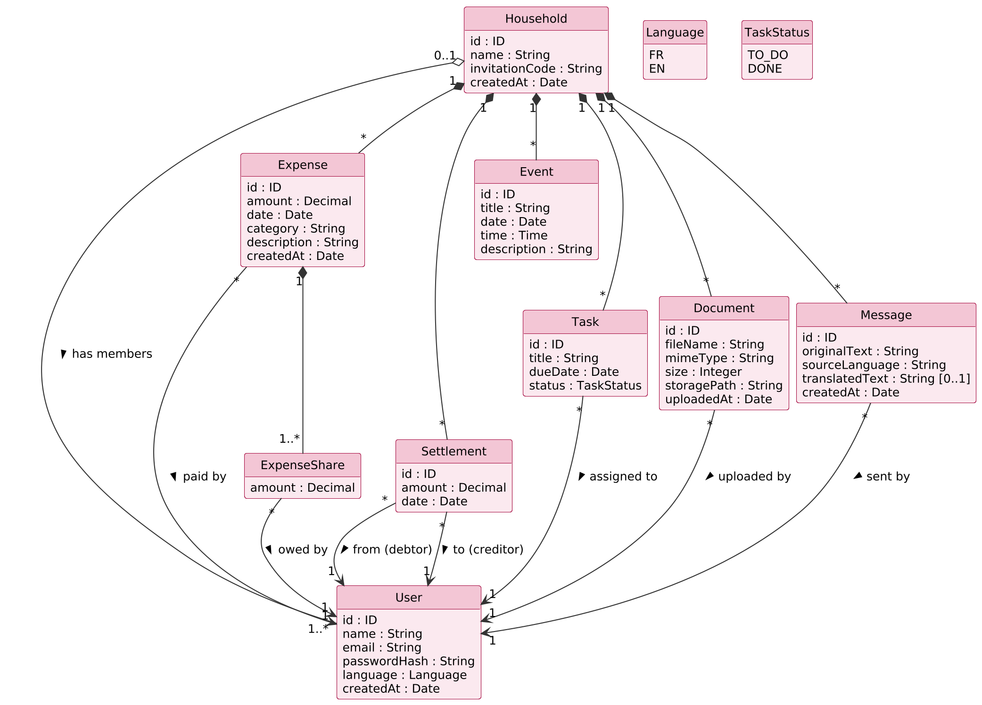
Figure 1 – NestMates class diagram

5.2 Sequence Diagram
The sequence diagram below details the recording of a shared expense (Use Case 1), including the authorization and validation checks performed by the API.
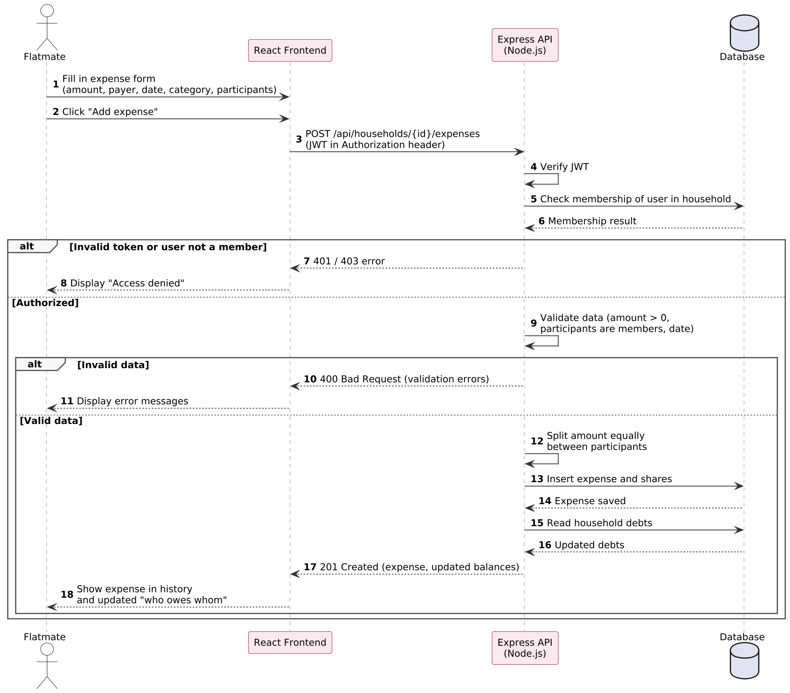
Figure 2 – Sequence diagram of recording a shared expense

5.3 State Machine Diagram
The state machine diagram below shows the lifecycle of a user with respect to a household. Leaving is only possible from the Balanced state, which enforces requirement FR-ACC-10.
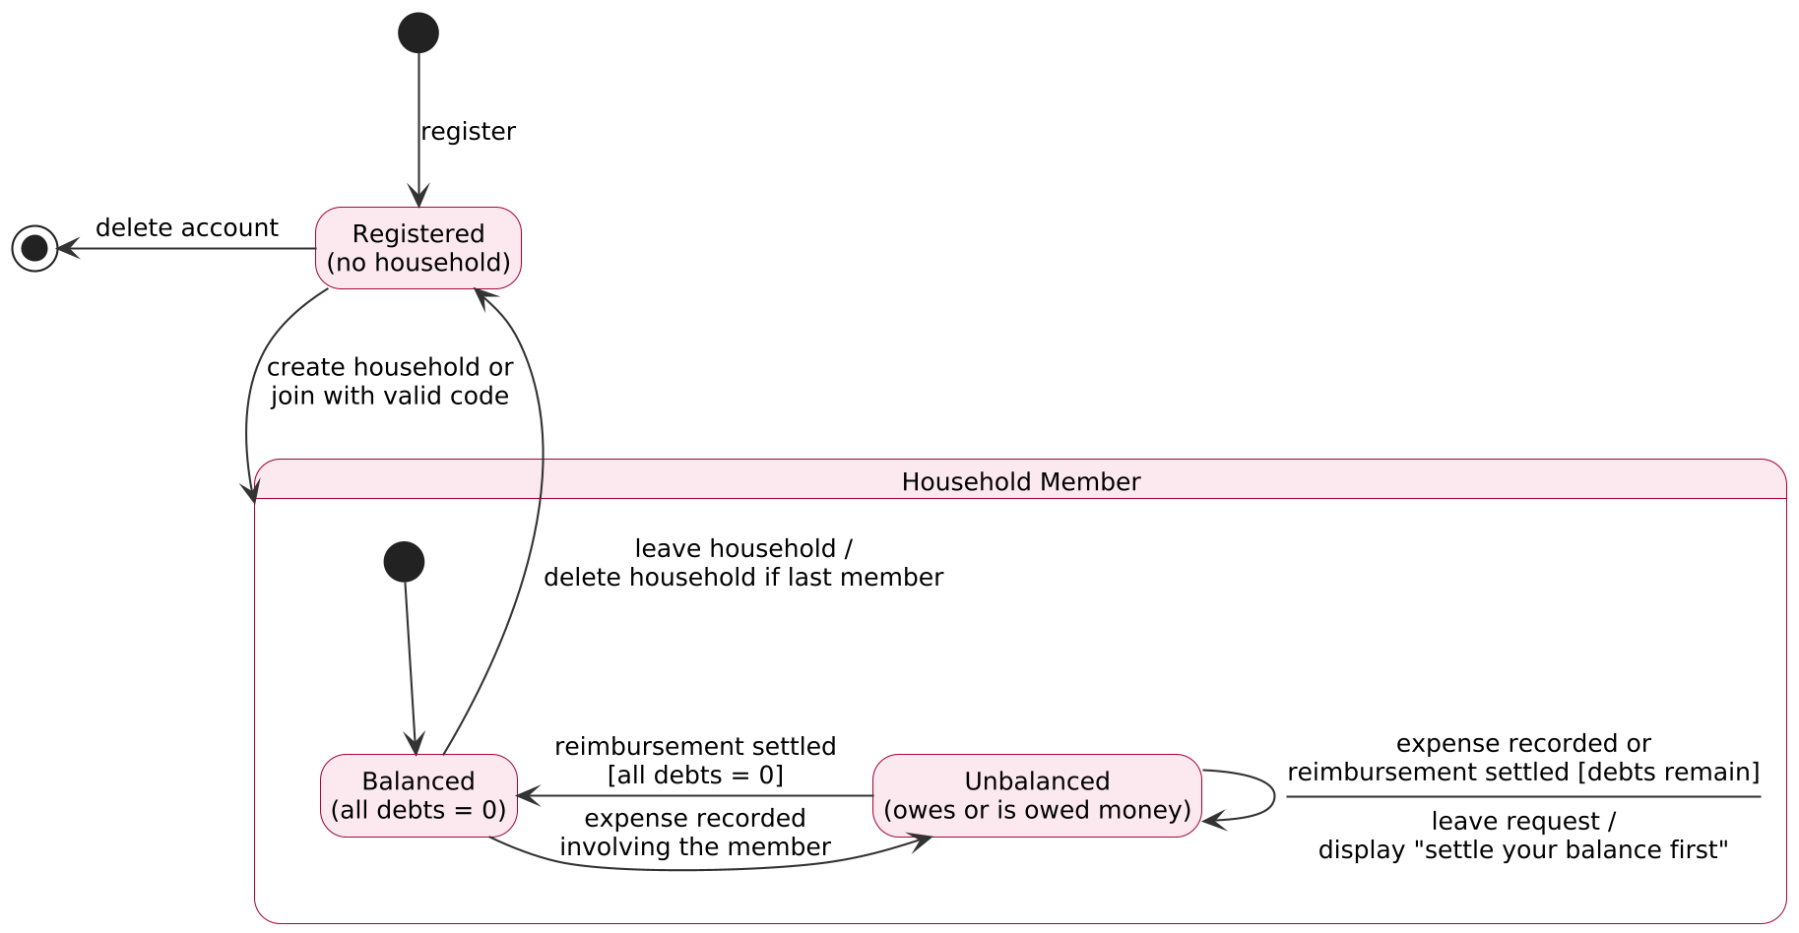
Figure 3 – State machine diagram of a user's household membership

6. External Interfaces

6.1 User Interface
- Authentication Pages: Allow visitors to register, log in and reset their password.
- Onboarding Page: Allows a user without a household to create one or join one with an invitation code.
- Module Pages: One page per module (Expenses, Calendar, Documents, To-Do List, Chat), accessible from a navigation menu. After logging in, the user lands on the Expenses page.
- Profile Page: Allows the user to edit their name, email and password, choose the application language (French or English) and delete their account.
- Household Settings: Displays the members, the invitation code and allows the user to leave the household.
Example Wireframe Screens:
- Login Screen: Contains fields for email and password, a "Log in" button, a "Forgot password?" link, a link to the registration page and a FR / EN language switch.
- Expenses Page: Displays the "who owes whom" list with a "Mark as settled" button, the history of expenses and settlements, and an "Add expense" button opening a form.
- Calendar Page: Displays a monthly calendar with the events and an "Add event" button.
- Documents Page: Displays the list of documents with view, download and delete actions, and an "Upload" button.
- To-Do List Page: Displays the tasks with their assignee, due date and status, a "Done" checkbox and an "Add task" button.
- Chat Page: Displays the messages with the sender's name, the time and a "Translated" label when applicable, the typing indicator above the input field, and a text field with a "Send" button.
- Profile Page: Contains the name, email and password fields, a language selector (Français / English) and a "Delete my account" button.

6.2 Hardware Interfaces
- The system does not require any specific hardware. It must run on any device with a modern web browser (computer, tablet or smartphone).

6.3 Software Interfaces
- The React frontend communicates with the Node.js / Express backend through a RESTful API exchanging JSON data.
- The backend stores data in the database management system MongoDB.
- The backend uses an SMTP email service to send password reset links, in the language of the user.
- The backend uses the Google Cloud Translation API (REST) to detect the language of chat messages and translate them between French and English.

6.4 Communication Interfaces
- The system must use the HTTPS protocol for secure communications between the server and clients.
- The JWT must be sent in the Authorization header of every authenticated request.
- Chat messages and typing indicators must be exchanged through a secure WebSocket connection (WSS) using Socket.IO, authenticated with the JWT at connection time.

7. Other Requirements

7.1 Security and Privacy
- The system must comply with the GDPR: consent at registration, right of access, rectification and deletion of personal data, and data minimization (only name and email are collected).
- Uploaded documents may contain personal data and must never be accessible through a public URL.
- Chat messages are sent to the Google Cloud Translation API to be translated; this processing must be stated in the privacy policy accepted at registration.

7.2 Compatibility
- The system should be compatible with the latest two versions of Google Chrome, Mozilla Firefox, Safari and Microsoft Edge.

7.3 Maintainability
- NestMates should be modular (one module per feature on both frontend and backend) to facilitate adding new features without impacting existing ones.

8. Appendices

Appendix A: Traceability Matrix
The table below links each business requirement of the BRD to the functional requirements of this document.
BRD Business Requirement | SRS Section | Functional Requirements
Account and Household Management | 3.1.1 | FR-ACC-01 to FR-ACC-12
User Profile and Language | 3.1.1 | FR-ACC-12 to FR-ACC-16
Shared Calendar | 3.1.2 | FR-CAL-01 to FR-CAL-04
Shared Expenses | 3.1.3 | FR-EXP-01 to FR-EXP-08
Shared Documents | 3.1.4 | FR-DOC-01 to FR-DOC-06
Shared To-Do List | 3.1.5 | FR-TSK-01 to FR-TSK-03
Household Chat | 3.1.6 | FR-CHT-01 to FR-CHT-10

Appendix B: Main API Endpoints
Preliminary list of REST endpoints; the complete API documentation will be provided in the SDD.
Method | Endpoint | Description
POST | /api/auth/register | Create an account
POST | /api/auth/login | Log in and obtain a JWT
GET / PATCH | /api/users/me | View / edit profile and language
PUT | /api/users/me/password | Change password
DELETE | /api/users/me | Delete account
POST | /api/households | Create a household
POST | /api/households/join | Join a household with a code
POST | /api/households/{id}/leave | Leave the household
GET / POST | /api/households/{id}/expenses | List / record expenses
GET | /api/households/{id}/debts | Get who owes whom
POST | /api/households/{id}/settlements | Mark a debt as settled
GET / POST | /api/households/{id}/events | List / create events
GET / POST | /api/households/{id}/documents | List / upload documents
GET / POST | /api/households/{id}/tasks | List / create tasks
GET | /api/households/{id}/messages | Chat history (sending uses Socket.IO)

