POSTMAN TOOL DEMO

Name : Guhan Balaaji V K

Reg no : 2403917710421022

Project Title : TCE Turf Booking System

GET METHOD:

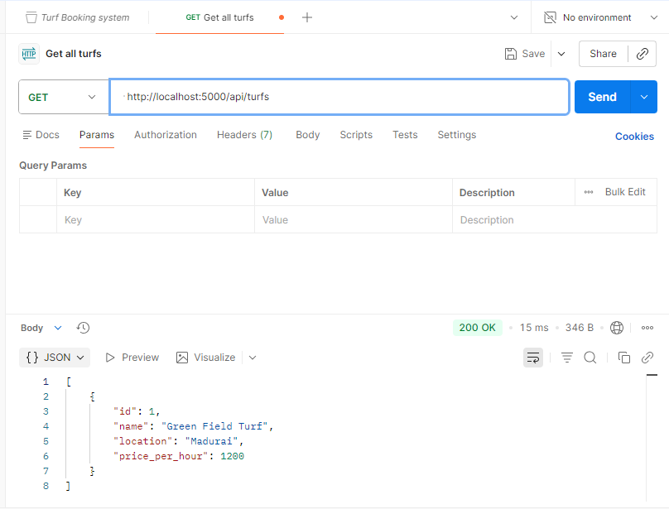

POST METHOD:
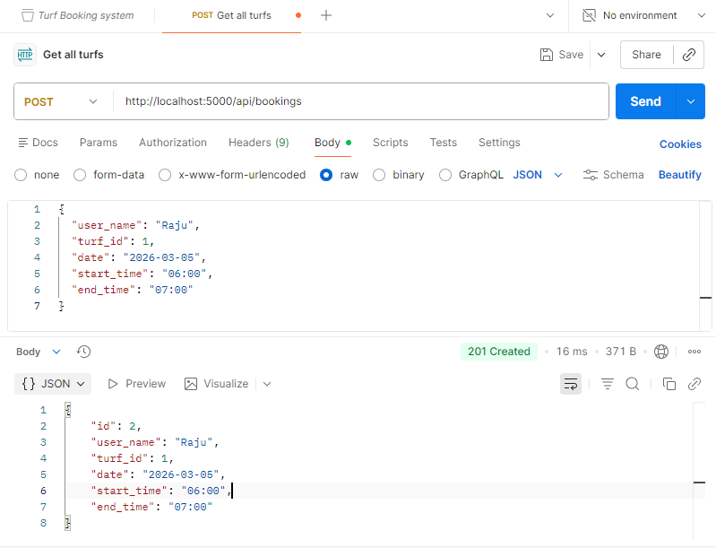

PUT METHOD:
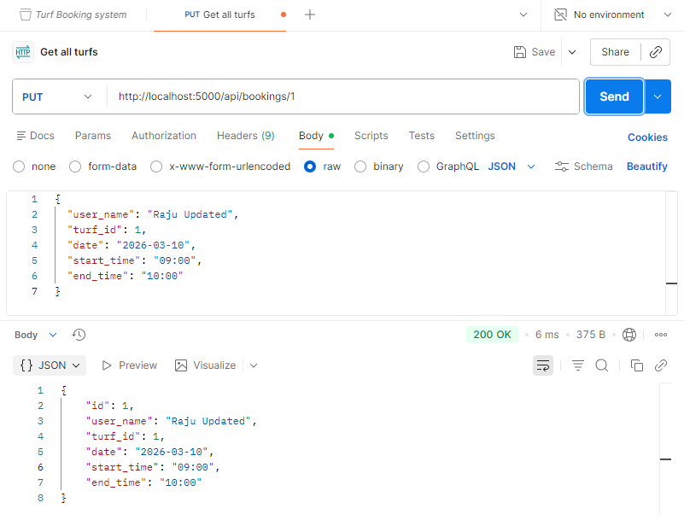
PATCH METHOD:
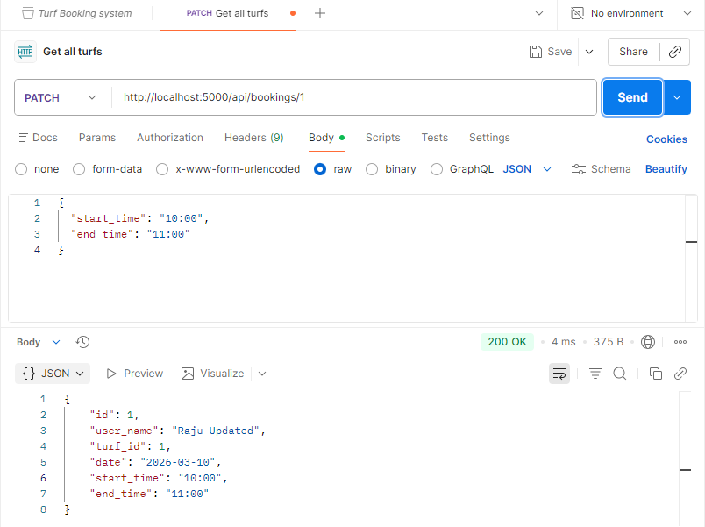

DELETE METHOD:

