POSTMAN TOOL DEMO

Name: Guhan Balaaji V K

Reg no:2403917710421022

GET METHOD:

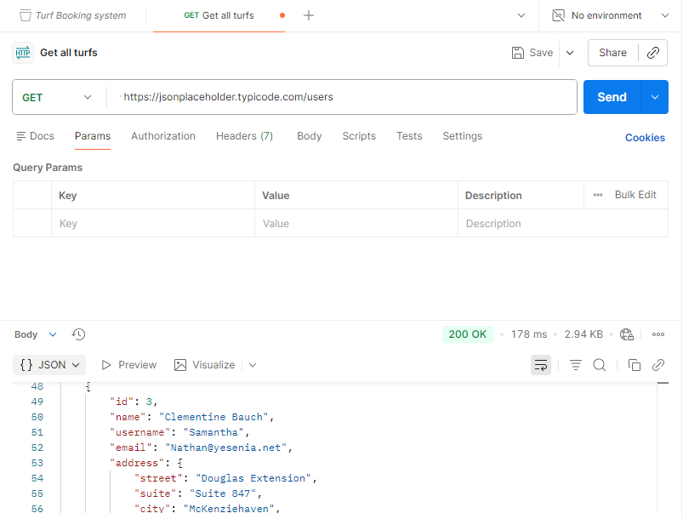

POST METHOD:

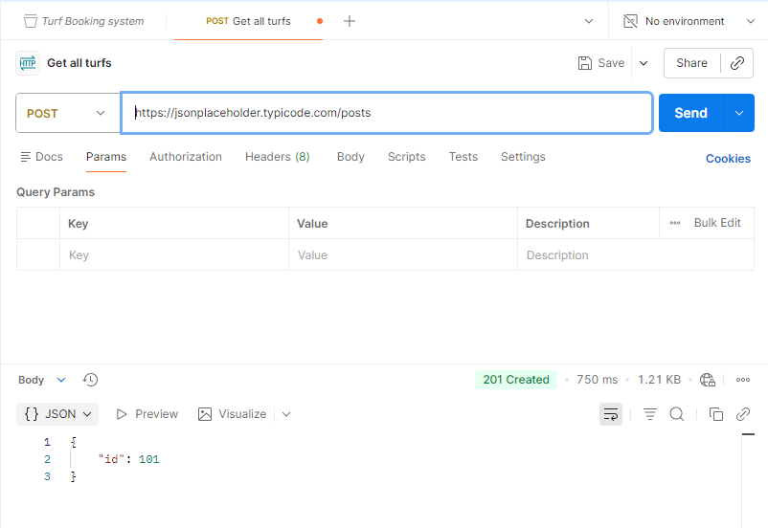

PUT METHOD:

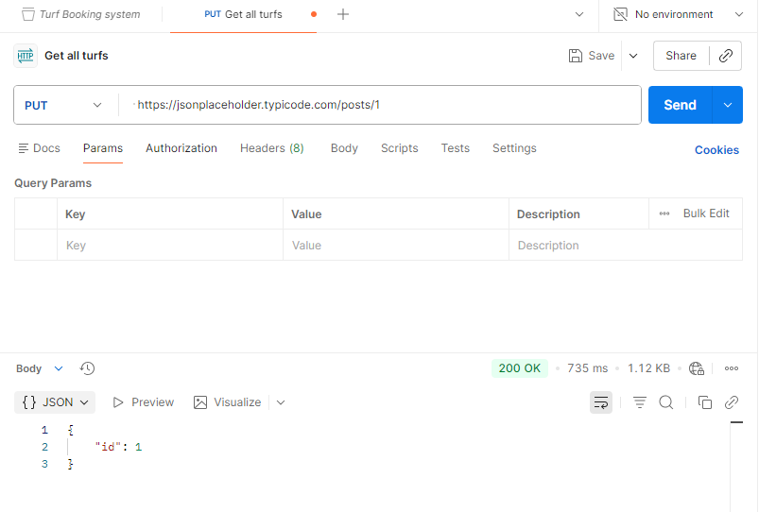
PATCH METHOD:

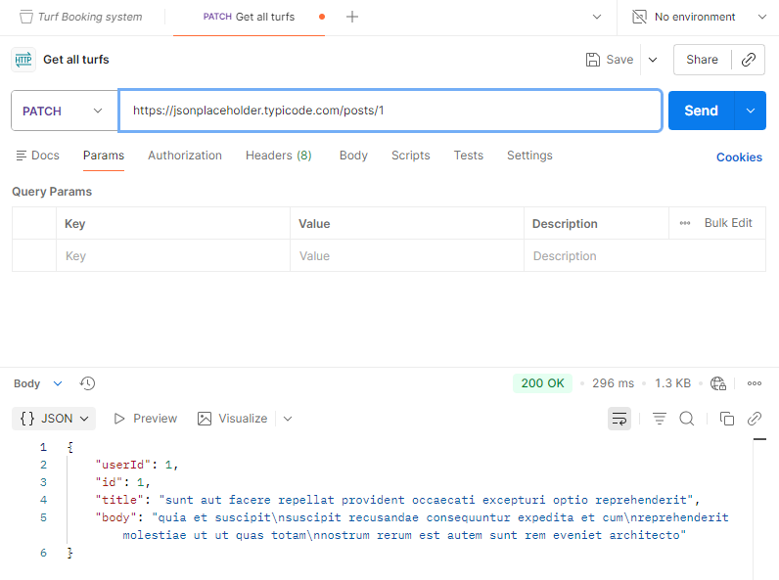

DELETE METHOD:

