**Experiment 8: MANUFACTURING LAB**

**COMPUTER NUMERICAL (CNC) MILLING**

**BACKGROUND:** Numerical control (NC) (also computer numerical control (CNC)) is the automated control of machining tools (drills, boring tools, lathes) by means of a computer. An NC machine alters a blank piece of material (metal, plastic, wood, ceramic, or composite) to meet precise specifications by following programmed instructions and without a manual operator.

NC machines combine a motorized maneuverable tool and often a motorized maneuverable platform, which are both controlled by a computer core, according to specific input instructions. Instructions are delivered to an NC machine in the form of graphical computer-aided design (CAD) files, which are transformed into a sequential program of machine control instructions, and then executed.

NC is a major advance in machining, and is a vast improvement over non-computer type machining that requires manual control, by hand wheels or levers, or mechanical control by fabricated pattern guides (cams). In modern CNC systems, the design of a mechanical part and its manufacturing program is highly automated. The part's mechanical dimensions are defined using CAD software, and then translated into manufacturing directives by computer-aided manufacturing (CAM) software. The resulting directives are transformed (by "post processor" software) into the specific commands necessary for a particular machine to produce the component, and then are loaded into the CNC machine.

Since any particular component might require the use of a number of different tools – drills, saws, etc. – modern machines often combine multiple tools into a single "cell". In other installations, a number of different machines are used with an external controller and human or robotic operators that move the component from machine to machine. In either case, the series of steps needed to produce any part is highly automated and produces a part that closely matches the original CAD.

**Positioning Control System:** In numerical control systems, the position of the tool is defined by a set of instructions called the part program.

Positioning control is handled by means of either an open loop or a closed loop system. In an open loop system, communication takes place in one direction only: from the controller to the motor. In a closed loop system, feedback is provided to the controller so that it can correct for errors in position, velocity, and acceleration, which can arise due to variations in load or temperature. Open loop systems are generally cheaper but less accurate. Stepper motors can be used in both types of systems, while servo motors can only be used in closed systems.

**Cartesian Coordinates:** The G & M code positions are all based on a three dimensional Cartesian coordinate system. This system is a typical plane often seen in maths when graphing. This system is required to map out the machine tool paths and any other kind of actions that need to happen in a specific coordinate. Absolute coordinates are what is generally used more commonly for machines and represent the (0, 0, 0) point on the plane. This point is set on the stock material in order to give a starting point or "home position" before starting the actual machining.

**M-CODES:** [Code Miscellaneous Functions (M-Code)]. M-codes are miscellaneous machine commands that do not command axis motion. The format for an M-code is the letter M followed by two to three digits; for example:

[M02 End of Program]

[M03 Start Spindle - Clockwise]

[M04 Start Spindle - Counter Clockwise]

[M05 Stop Spindle]

[M06 Tool Change]

[M07 Coolant on mist coolant]

[M08 Flood coolant on]

[M09 Coolant off]

[M10 Chuck open]

[M11 Chuck close]

[M13 BOTH M03&M08 Spindle clockwise rotation & flood coolant]

[M14 BOTH M04&M08 Spindle counter clockwise rotation & flood coolant]

[M16 Special tool call]

[M19 Spindle orientate]

[M29 DNC mode]

[M30 Program reset & rewind]

[M38 Door open]

[M39 Door close]

[M40 Spindle gear at middle]

[M41 Low gear select]

[M42 High gear select]

[M53 Retract Spindle] (Raises tool spindle above current position to allow operator to do whatever they would need to do)

[M68 Hydraulic chuck close]

[M69 Hydraulic chuck open]

[M78 Tailstock advancing]

[M79 Tailstock reversing]

M-codes are essential in **ALL** CNC programs to ensure a functioning line of code. All complete CNC programs have an M-code in both the first and last line of code.

**G-CODES:** are used to command specific movements of the machine, such as machine moves or drilling functions. The format for a G-code is the letter G followed by two to three digits; for example G01. G-codes differ slightly between a mill and lathe application, for example:

[G00 Rapid Motion Positioning]

[G01 Linear Interpolation Motion]

[G02 Interpolation Motion-Clockwise]

[G03 Circular Interpolation Motion-Counter Clockwise]

[G04 Dwell (Group 00) Mill]

[G10 Set offsets (Group 00) Mill]

[G12 Circular Pocketing-Clockwise]

[G13 Circular Pocketing-Counter Clockwise]

**AIM OF STUDY:** Write simple CNC milling program and simulate the toolpath.

**LABORATORY EQUIPMENT:** A desk-top CNC Milling machine C=501 from Lyrics Electronics. The C-501 is for processing of plastics, hardwood and soft metal products. The system includes a rotating three tooth mill cutter operated by a spindle DC motor. The spindle speed range of the system is 0-3000rpm. The table can be moved in X, Y and Z directions.

**Lab Work Result:**

M3S2500

G0Z3

G10

G1Z-1

G02I-58J-58R42C270E180

G1X58

G02I-58J58R42C180E90

G1Y58

G02I58J58R42C90E0

G1X-58

G02I58J-58R42C0E270

G1Y-58

G0Z3

G0X0Y100

G1Z-1F300

G1X21Y21

G1X100Y0

G1X21Y-21

G1X0Y-100

G1X-21Y-21

G1X-100Y0

G1X-21Y21

G1X0Y100

G0Z3

M4

Having the correct speeds and feeds in the program provides for a more efficient and smoother product run. Incorrect speeds and feeds will cause damage to the tool, machine spindle and even the product. The quickest and simplest way to find these numbers would be to use a calculator that can be found online. A formula can also be used to calculate the proper feeds for a material.

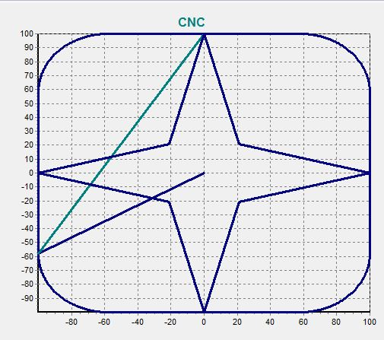

**OBSERVATIONS:**

1. I observed that the G-program can be started from a different coordinates and at the end, give you the same desired pattern.

**PRECAUTIONS:**

**CONCLUSION**