**Adobe Photoshop V/S Adobe Lightroom V/S Adobe Illustrator**

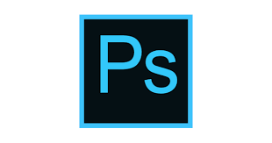**Adobe Photoshop**

* Adobe Photoshop was created initially for the purpose of editing of photos as the name suggests. The functionality of the program expanded and its now it is far more capable and is being used by designers, architects, publishers, photographers, and any other professionals.
* Photoshop is used for other purposes such as designing, pixel-level editing, graphic designing, animation. The basic photo editing is difficult to perform as compared to Lightroom. Lightroom is much smarter than a normal photo editor.
* It saves the edited photos automatically at every stage.
* It helps to apply a change (edit) to a bunch of photos easily.
* Photos can be organized, imported and exported in form of a folder or a catalog, so no hassle as in photoshop in which photos have to be imported one by one.
* Photoshop has retouching feature which allows you to remove blemishes, get rid of stray hairs, reduce bags under eyes, whiten teeth, remove garbage, or perform any other change to a specific part of an image. This feature is lacked in Lightroom.
* It allows the advanced manipulation of photos, editing them layer by layer, and allows you to record those steps so that process may be applied anywhere. This feature is very helpful in industries.

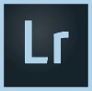 **Adobe Lightroom**

* Adobe Lightroom is specially designed with a purpose to edit photos directly served by the camera in the RAW format. It is a highly organized application which includes many functions in order to organize and edit photos efficiently. It is much more affordable software than adobe photoshop in terms of cost and much easier to learn.
* As like Photoshop, Lightroom is an easy and affordable piece then photoshop and the workflow is efficient as compared to photoshop. Lightroom can be split into different working modes where one (Library) allows you to import images, sort them into categories, assign labels etc. Another is Develop, which allows you to process the images, such as adjusting exposure, contrast, saturation etc. and several other modes.
* Lightroom is non destructive i.e. it does not make any change to the original photos while you edit the photos rather it makes copies - which further makes easier to work without fear of loss while in case of Photoshop, if the file is accidentally rewritten to original file, then it is impossible to recover the original file back.
* Lightroom presets(same as actions in photoshop) can be applied to a bunch of photos at once as compared to photoshop.

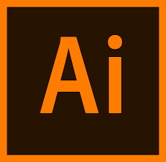 **Adobe Illustrator**

* Adobe Illustrator is an Adobe program much similar to photoshop but works on the concept of vectors rather than pixels. It helps to create very smooth lines and curves the application of which can be applied to create and edit vector-based work such as graphics and logos. For Example, you can resize any image to any size you want without disturbing the clarity and the resolution of the image.
* While illustrator uses vector-based graphics, on the other hand, photoshop uses raster-based graphics. Vector graphics involve mathematical expressions, so they are very precise and accurate and thus used for scaling pictures to any desired size without losing the quality. This is a drawback of photoshop.
* As I have explained the main functioning of illustrator, it is quite clear that what is the difference between Adobe Lightroom and Adobe Photoshop. Therefore, no need to explain.