Typography :

Typography is the process of organising, editing and improving the appearance of a piece of font to enhance the readability and ease the process of viewing.

It basically aims to grab the attention of audience to the content and feel the essence of the topic not just by write up, but also the way in which font is customized and represented.

It incorporates several elements of text assembling and designing and displaying. An appealing text is only produced by a perfect combination of these elements.

Typography has its wide applications in presentations, poster design, graffiti design, comic or magazine design, newspapers, logos, advertisements, display boards, standee’s, banners etc. and many more.

**Making an effective presentation:**

## # CHOICE OF FONT

There are some basic properties of font which should be kept in mind while choosing or customizing the font for some content. These may be depicted in a single picture as shown below: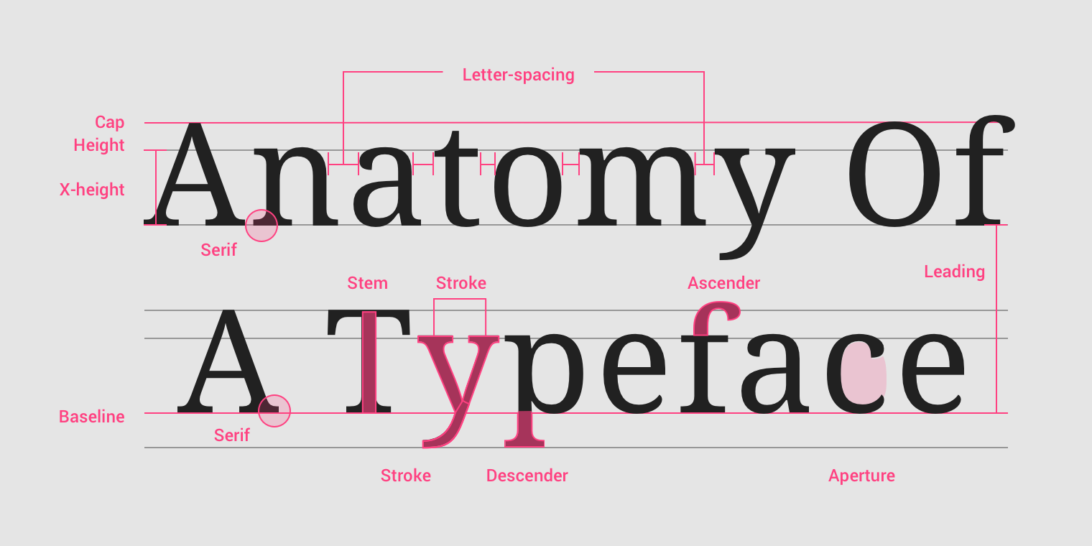

The font should be optimized and its elements be modified such that a perfect combination can be produced which suits the job of text for example – heading, subheading, paragraph etc.

* For good readability, the minimum size of font should be 24, with 36-44 for headings.
* Most commonly used font family is Sans Serif with styles such as Helvetica, Garamond, Future, Gill Sans and Rockwell as these are legible at all sizes and most common in body text.
* Large text always draws attention. So, always enlarge that part in your slide which is most important, but not necessarily the headings.

# LEGIBILITY OF FONT

Legibility refers to the ease of readability of font to the viewers. The several elements of legibility may be: Contrast, Background colour, Text Colour, Colour Scheme used and the number of lines per slide.

Text should be legible enough to meet the **WCAG** (Web Content Accessibility Guidelines) standards i.e. - 4.5.1 colour contrast between text and background for normal text, and 3:1 to large text.

* Colour combination in a slide should be such that they may be contrasting for a better appearance.
* Choice of colours in a slide should me made wisely so as to enhance and depict the mood of topic.
* Light in the area plays an important role on the visibility of your slides.



Light in Room Slide Background Colour Virtual Difference in the Shades of grey

* Also see the difference in the shades of grey in the above figure. Actually, they are same. This phenomenon is called Simultaneous contrast basically due to the difference in BG colour of slides.

**Other Uses:**

* Designing Logos



Similarly, used in designing areas.