

**Indian Institute of Information Technology,**

**Allahabad**

**Human Activity Recognition System**

Under the supervision of

**Dr. Rajat Kumar Singh**

Department of Electronics and Communication Engineering,

Indian Institute of Information Technology- Allahabad.

Mail : [**rajatsingh@iiita.ac.in**](mailto:rajatsingh@iiita.ac.in)

**Manan Mittal - IEC2018056**

**Likith Kumar Vidupulapati - IEC2018064**

**Rayan Kejriwal - IEC2018080**

**Table of Contents**

**HUMAN ACTIVITY RECOGNITION SYSTEM**

1. Abstract . . . . . . . . . . . . . . . . . . . . . . . . . . . . . . . . . . 3

2. Introduction . . . . . . . . . . . . . . . . . . . . . . . . . . . . . . . . 3

3. Methodology . . . . . . . . . . . . . . . . . . . . . . . . . . . . . . . 4

4. Hardware Implementation . . . . . . . . . . . . . . . . . . . . . . . . . 4

4.1 Collection of data . . . . . . . . . . . . . . . . . . . . . . . . . 4

4.2 Data transmission . . . . . . . . . . . . . . . . . . . . . . . . . 4

4.3 Components used . . . . . . . . . . . . . . . . . . . . . . . . . 5

5. Software Implementation. . . . . . . . . . . . . . . . . . . . . . . . . . 7

5.1 Filtration of data . . . . . . . . . . . . . . . . . . . . . . . . . . 7

5.2 Feature engineering . . . . . . . . . . . . . . . . . . . . . . . . 8

5.3 Features obtained. . . . . . . . . . . . . . . . . . . . . . . . . . 9

5.4 Methods calculated. . . . . . . . . . . . . . . . . . . . . . . . . 10

6. Observation . . . . . . . . . . . . . . . . . . . . . . . . . . . . . . . . . 10

6.1 Dimensionality reduction . . . . . . . . . . . . . . . . . . . . . 10

6.2 Feature importance. . . . . . . . . . . . . . . . . . . . . . . . . 12

6.3 Neural network accuracy. . . . . . . . . . . . . . . . . . . . . . 12

7. Output results . . . . . . . . . . . . . . . . . . . . . . . . . . . . . . . 13

8. Conclusion. . . . . . . . . . . . . . . . . . . . . . . . . . . . . . . . . 14

9. Challenges faced and Future Work . . . . . . . . . . . . . . . . . . . . . 15

10. References . . . . . . . . . . . . . . . . . . . . . . . . . . . . . . . . . 15

**1. Abstract**

In recent days the awareness of health and wellness care has become one of the important aspects in the modern world with the evolution of technology and many modern methods. The main objective of our project is to make a device and train a model for human activity recognition(HAR) based on a motion sensor to analyze different daily activities of an individual and classify into one of these i.e., walking, sitting, laying, standing, walking down or walking up the stairs. Our model uses 5 different passive learning methods to classify the activities performed by an individual, a) logistic regression b) support vector machine(SVMs) c) k-nearest neighbor algo d) random forest algo e) artificial neural networks. Finally, we compare the accuracies of our algorithms, use the ensemble approach on our best predictors and deploy in a real time device.

**2. Introduction**

In recent times, the health and wellness of an individual have become one of the most prominent factors with the evolution of various advanced technologies and more advanced methods which can track daily human activities so accurately. It is a significant computational task to provide the information regarding different human activities precisely and find the patterns. The modern advancements in Human Activity Recognition systems have countless applications in the modern world in various domains which include health and medical care (elder care, rehabilitation centers, diabetes and cognitive disorders), virtual reality, entertainment, advanced security etc., By using such human activity recognition systems a huge number of resources can be saved. These systems can monitor all the time and report any abnormal behavior without the help of any caretaker. So, in this project we use a motion sensor to get the data from different people performing different activities i.e., walking, sitting, laying, standing, walking down or walking up the stairs. We filter this data for any noise and then to differentiate different signals. We apply dimensionality reduction to extract different features from the sensory data. Then we train the model with this data using different learning methods to classify the activities accurately. We find the learning method with the most accuracy and test it on the test data.

**3. Methodology** 

**4. Hardware Implementation**

**4.1 Collection of data**

The user is made to perform an activity among the six activities we want to analyse. It is tracked by using our hardware which is based on a MPU-6050 chip. The MPU-6050 chip is a Motion Tracking device. This device is a combination of a tri-axial gyroscope and a tri-axial accelerometer. Our objective of using this chip is to get information of the targeted object in the scope of 6 axis based motion discussion by means of its GyroScope and Accelerometer sensors. This information will serve as raw data for our time series model to be able to classify performed human activity in 6 different classes.

**4.2 Data Transmission**

Wifi Module (ESP8266) interfaced with Arduino Nano is used for data transmission.Arduino Nano acts as the main controller for directing our other components. It communicates with the MPU6050 chip to gather the required data and transmits it through the wifi module. The ESp8266 is a module used to communicate between our microcontroller and any other web based interface using its WiFI functionality. For this project we have chosen Firebase to act as a web server.

**4.3 Components Used**

MPU6050

Arduino Nano

ESP8266-01

Wearable Band

Resistors,Switches,Battery,Connecting Wires,Jumping Cables.

**4.3 Circuit Diagram**

**4.3.1 MPU6050-Arduino Nano Interface**

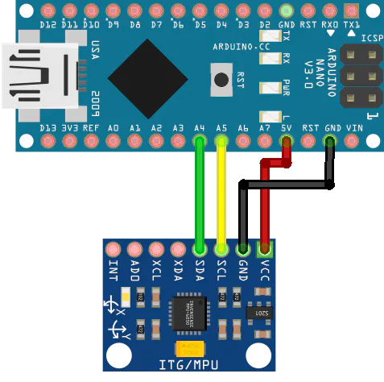

Arduino Nano MPU6050

5v ----------------------------------------------------------------------------------- Vcc

Gnd ----------------------------------------------------------------------------------- Gnd

A5 ----------------------------------------------------------------------------------- SCL

A4 ----------------------------------------------------------------------------------- SDA

**4.3.2 ESP8266-Arduino Nano Interface**

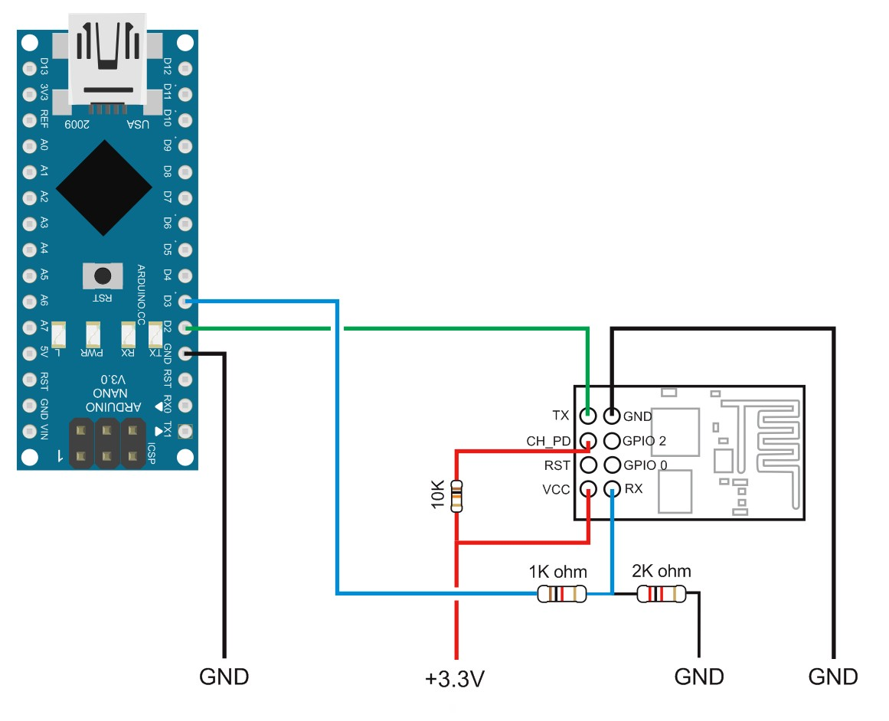

Note: Since Rx(of ESP8266) accepts the maximum voltage of 3.6V whereas output voltage from Tx(of Arduino Nano) is around 5V so a resistor circuit must be placed in between of the connection as to divide up the voltage so that the chip doesn't get damaged. It is better for the ESP8266 to draw voltage from an eternal stable source since Arduino Nano isn't able to provide the current required constantly.

Arduino Nano MPU6050

3.3 ----------------------------------------------------------------------------------- 3.3

3.3 ----------------------------------------------------------------------------------- En

Gnd ----------------------------------------------------------------------------------- Gnd

Tx ----------------------------------------------------------------------------------- Rx

Rx ----------------------------------------------------------------------------------- Tx

**4.3.3 Wearable Band Circuit**

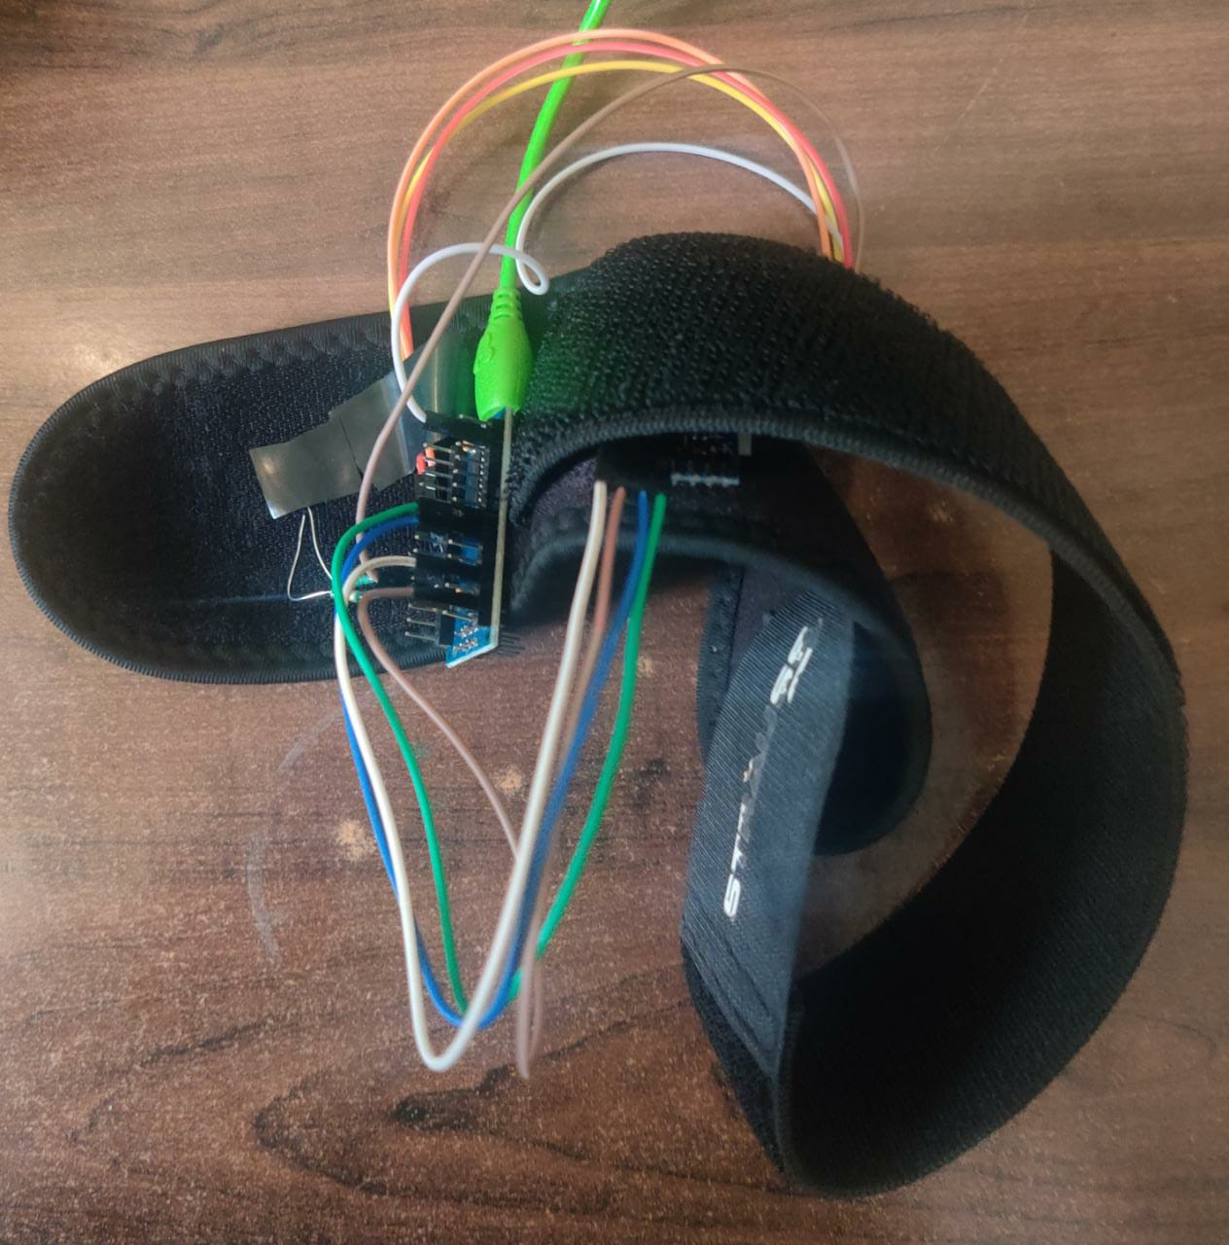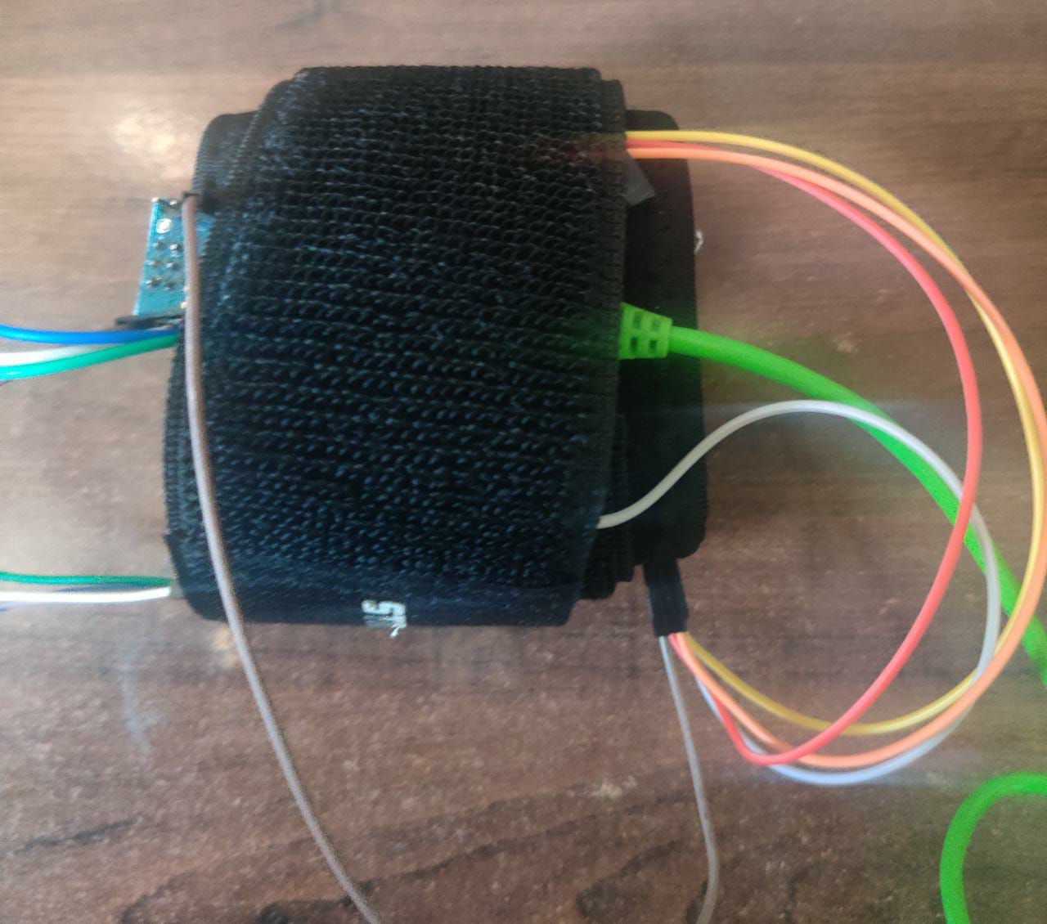

**5. Software Implementation**

**5.1 Filtration of Data**

After taking the input from the hardware, a sensor signal of acceleration is produced, which has two main components a) body motion components b) gravitational components. To analyse the data those components have to be separated. The components of gravitational signal mostly consist of low frequency components, hence a low pass filter butterworth of cutoff frequency of 0.3Hz is used so as to derive those components from sensor acceleration signal. To remove the noise we use another butterworth low pass filter of cut off frequency 20 Hz. This data is then used for feature extraction and normalization.The time domain signals (prefix 't' to denote time) are sampled at a frequency of 50 Hz. Then we are using a 3rd order low pass Butterworth filter with a cutoff frequency of 20 Hz to remove noise along with a median filter which is available in scipy.signals library.

The acceleration signal was then divided into 2 different components - body acceleration signals and gravity acceleration signals along all the three axises. It is carried out by using a different low pass Butterworth filter with a cutoff frequency of 0.3 Hz.

**5.2 Feature Engineering**

The idea is to engineer as many features as possible and then apply dimensionality reduction techniques later to preserve only the most important features which are highly predictive and very uncorrelated with each other so as to maintain a perfect balance of bias and variance in our model.

We Specifically get 9 features after filtration > tGyro-XYZ + tBodyAcc-XYZ + tGravityAcc-XYZ

**5.2.1 Deriving Jerk Signals**

tGyro-XYZ (angular velocity of the body) and tBodyAcc-XYZ ( linear acceleration of the body) are differentiated wrt time to calculate the Jerk (Impulse) signals in all three directions each. (tBodyAccJerk-XYZ and tBodyGyroJerk-XYZ)

**5.2.2 Euclidean Norm**

||L_2|| is carried out on our signals viz. >

tBodyAcc, tGravityAcc, tBodyAccJerk, tBodyGyro, tBodyGyroJerk to obtain their respective euclidean norms (magnitudes).

**5.2.3 Fast Fourier Transform (FFT)**

FFT is applied to these signals to correspondingly derive new respectively set as - fBodyGyro-XYZ fBodyAccJerkMag fBodyGyroMag fBodyGyroJerkMag fBodyAcc-XYZ fBodyAccJerk-XYZ

Although we had previously tried using FFT to engineer new features in the frequency domain, it turns out that those frequencies were purely complex numbers and hence cannot be utilized further on performing methods like mean,max, min,standard deviation to obtain more features.

**5.3 Features obtained**

We use the notation ‘XYZ’ to denote the X, Y and Z directions of 3-axial signals

**5.3.1 Time Domain Signals**

tBodyAcc-XYZ

tBodyGyroMag

tBodyAccJerk-XYZ

tBodyGyro-XYZ

tGravityAccMag

tBodyAccJerkMag

tBodyAccMag

tBodyGyroJerkMag

tGravityAcc-XYZ

tBodyGyroJerk-XYZ

**5.3.2 Frequency Domain Signals**

fBodyAcc-XYZ

fBodyGyro-XYZ

fBodyAccJerkMag

fBodyGyroJerkMag

fBodyAccJerk-XYZ

fBodyAccMag

fBodyGyroMag

**5.4 Methods Calculated**

**5.4.1 For Time Domain**

mean() is the mean value

std() is the Standard deviation

mad() is the absolute median deviation

iqr() is the Interquartile range

energy() denotes the energy measure which is obtained as Sum of the squares divided by the number of values.

max() gives the largest value in array

min() gives the Smallest value in array

**5.4.2 For Frequency Domain**

Frequency domain has some extra parameters

skewness() gives skewness of the frequency domain signal

kurtosis() gives the kurtosis of the frequency domain signal

maxInds() gives the index of the frequency component which is of the largest magnitude

meanFreq() gives the weighted average of the frequency components so as to obtain a mean frequency

**6. Observation**

These observations were made while training our data model on test data

**6.1 Dimensionality Reduction and EDA:**

Final number of features after feature engineering have been reduced to 240 feature vectors from 561. For this, the feature selection was made from the above mentioned approaches viz. T-SNE and Random Forest Most Important Features. We also tried using PCA, but we found out that the model accuracy became way too low as we lost some of the most important features during PCA dimension reduction, hence we discarded that approach.

**6.1.1 Balancing of Data :**

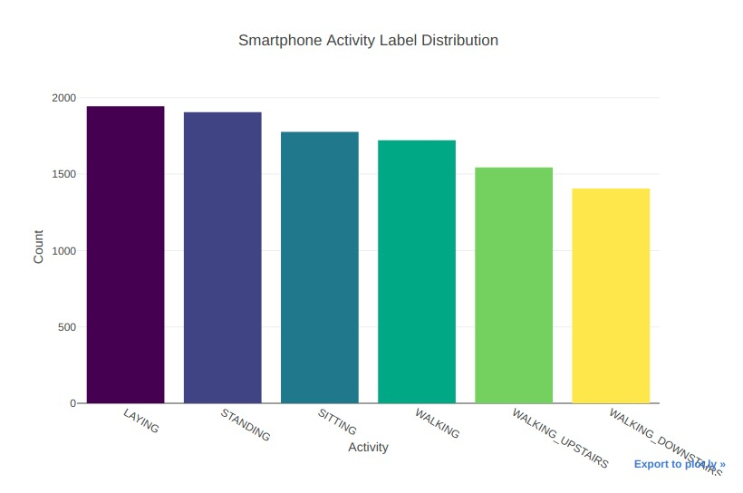

**6.1.2 Activity Visualization**

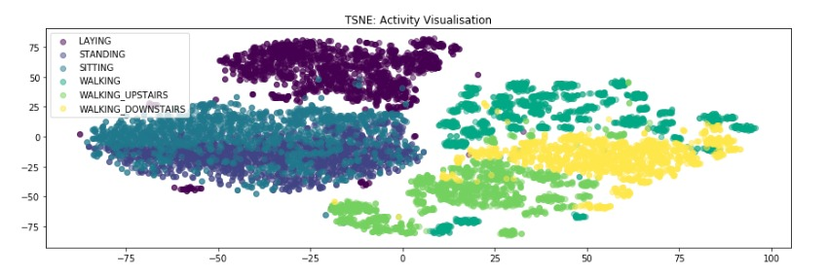

Inference : In this Plot, you can clearly see the activities are mostly separable.

**6.2 Feature Importance**

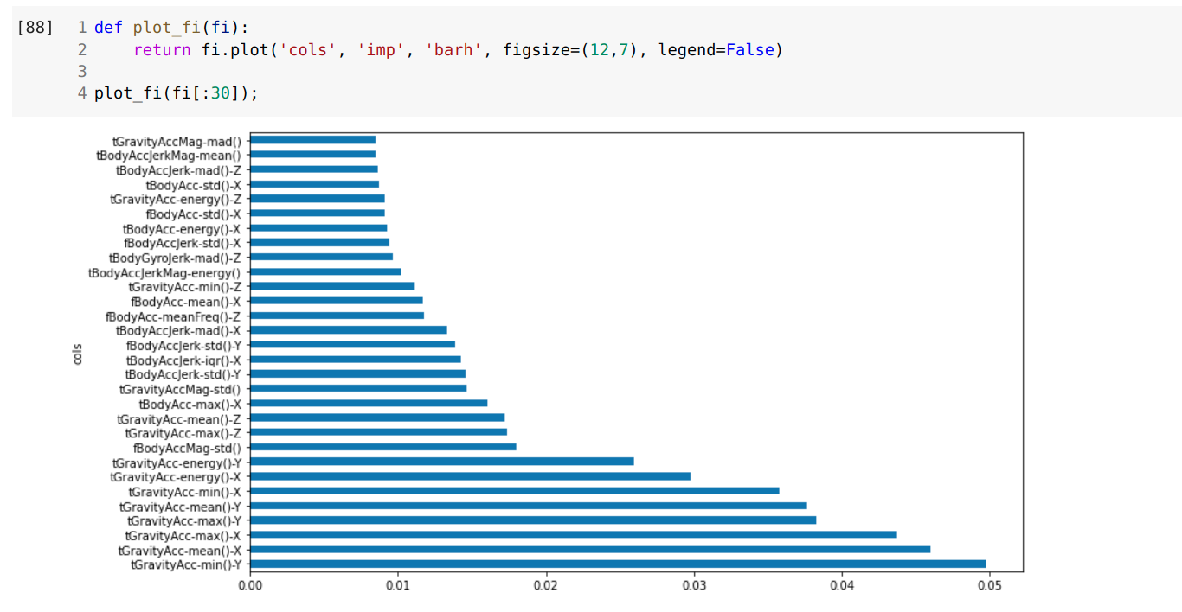

**6.3 Neural Network Accuracy :**

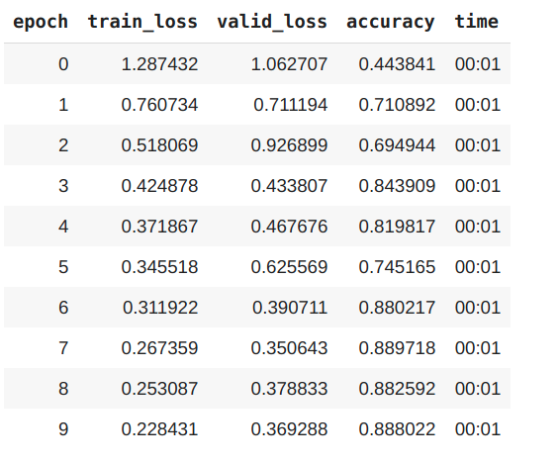

**6.4 Other Algorithms : SVM, Logistic Regression, KNN, Random Forest**

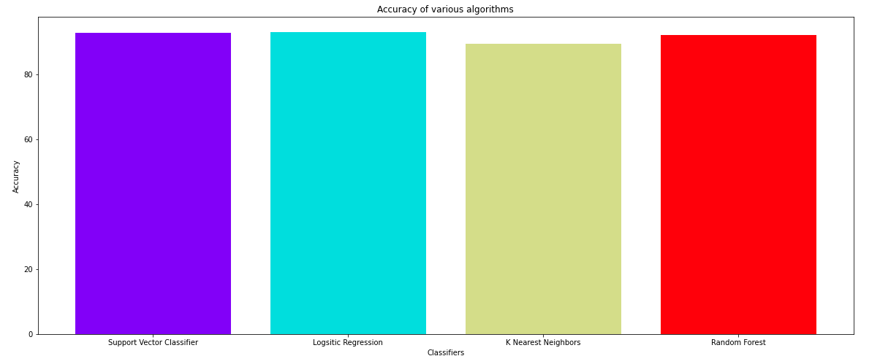

|  |  |
| --- | --- |
| **Model** | **Accuracy on Validation Set** |
| SVM Classifier | 92.67051238547675% |
| Logistic Regression | 93.07770614183916% |
| KNN Classifier | 89.44689514760775% |
| Random Forest Classifier | 92.05972175093315% |

**7. Output Results :**

Each of the float variables represent a class

from [0.0,6.0] in

0.0 - LAYING

1.0 -SITTING

2.0 - STANDING

3.0 -WALKING

4.0 -WALKING_DOWNSTAIRS

5.0 -WALKING_UPSTAIRS

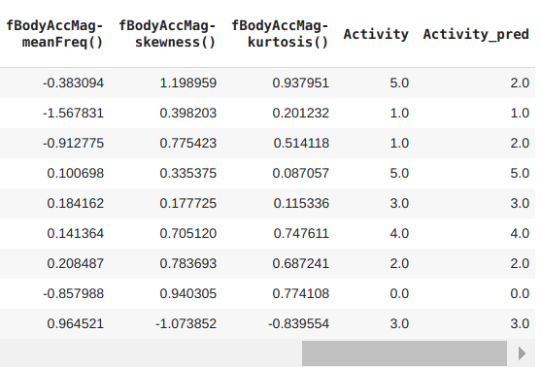

Sample Result Screenshot of Walking (Ground Truth) :

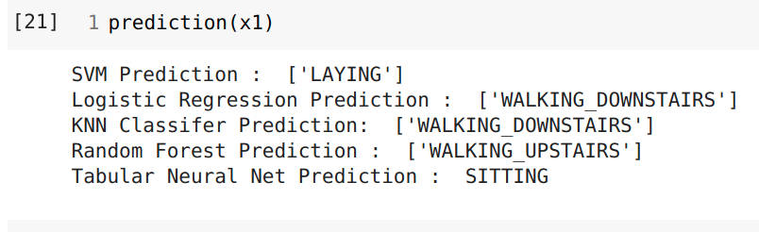

**8. Conclusion**

We have successfully implemented an automated human activity recognition system using MPU6050 sensor data based on optimal attribute selection, digital discrete signal processing and machine learning techniques. The real time model predicts the Human Activity based on a Wearable Sensor Motion Variables (3- (X,Y,Z) acceleration and 3- (X,Y,Z) Angular Velocity) which are used to classify the Human Activity in one of the classes as mentioned above.

**9. Challenges Faced and Future Work**

The future work mainly consists of researching and implementing the advanced noise reduction techniques and signal processing part which we found to be challenging and which can have a major impact on the model’s accuracy as the signals are very sensitive to the motion of the sensor due to which noise occurs.

**10. References**

[1]M. Cornacchia, K. Ozcan, Y. Zheng, and S. Velipasalar, ‘‘A survey on activity detection and classification using wearable sensors,’’ IEEE Sensors J., vol. 17, no. 2, pp. 386–403, Jan. 2017.

[2] Mannini, A., Sabatini, A.M.: Machine learning methods for classifying human physical activity from on-body accelerometers. Sensors 10(2) (2010) 11541175

[3] Anguita, Davide, Alessandro Ghio, Luca Oneto, Xavier Parra, and Jorge L. Reyes-Ortiz. Human Activity Recognition on Smartphones using a Multiclass Hardware-Friendly Support Vector Machine. Vitoria-Gasteiz, Spain: International Workshop.

[4] Jorge Luis Reyes-Ortiz, Alessandro Ghio, Xavier Parra-Llanas, Davide Anguita, Joan Cabestany, Andreu Català. Human Activity and Motion Disorder Recognition: Towards Smarter Interactive Cognitive Environments. 21th European Symposium on Artificial Neural Networks, Computational Intelligence and Machine Learning, ESANN 2013. Bruges, Belgium 24-26 April 2