Step 1: Create the room.
Create the room, just like normal, in SOI. For the purposes of this documentation, we'll call the room “timewarp”.
Notes: The background and color options in the SOI controls will be over-ridden. Don't worry too much about what they say, but make sure that it is something readable. These are the colors that will be used when the room is in AUTO mode.
Then go to the FTP File Controls for the room.
Here we will create the two files that the room needs.
Where it says 'Create File:' enter the name 'timewarp.js' and click 'Edit.' Cut and paste the section below into the edit window. Be sure to click “Save” when done. **PRO NOTE: If the file already exists, it will actually EDIT that file rather than create a new one. We'll be using this feature a lot later on.*
-------------------------------START-CUT HERE-----------------------------------------------------------------
var console;
(function () {
"use strict";

var config = {
// These are the items to change to configure how the room works.

// Accepted values:
// "time" - The room works like a timewarp room with 24 hour days.
// "multiloc" -- The room works like the old multiloc rooms.
mode: "multiloc",

///////////////////////////////////////////////////
// Valid for mode: "time"
///////////////////////////////////////////////////

// May the player save his current time selection?
// true - If the player changes the time, the system will remember his change.
// false - The room always loads to SOI's current time.
canSaveTime: true,

// May the player even HAVE the option to change the time?
// true - The player gets the list of times.
// false - the list of times does not even appear.
canChangeTime: true,

///////////////////////////////////////////////////
// Valid for mode: "multiloc"
///////////////////////////////////////////////////

views: []

};

var canUseLocalStorage = true;

var storage = (function () {
// This code comes from Mozilla.
// Its a limited version of localStorage, but it works well enough for
// my purposes.
// Syntax is very limited. No big deal.

var o = {
getItem: function (sKey) {
if (!sKey || !this.hasOwnProperty(sKey)) {
return null;
}
return unescape(document.cookie.replace(new RegExp("(?:^|.*;\\s*)" + escape(sKey).replace(/[\-\.\+\*]/g, "\\$&") + "\\s*\\=\\s*((?:[^;](?!;))*[^;]?).*"), "$1"));
},
key: function (nKeyId) {
return unescape(document.cookie.replace(/\s*\=(?:.(?!;))*$/, "").split(/\s*\=(?:[^;](?!;))*[^;]?;\s*/)[nKeyId]);
},
setItem: function (sKey, sValue) {
if (!sKey) {
return;
}
document.cookie = escape(sKey) + "=" + escape(sValue) + "; expires=Tue, 19 Jan 2038 03:14:07 GMT; path=/";
this.length = document.cookie.match(/\=/g).length;
},
length: 0,
removeItem: function (sKey) {
if (!sKey || !this.hasOwnProperty(sKey)) {
return;
}
document.cookie = escape(sKey) + "=; expires=Thu, 01 Jan 1970 00:00:00 GMT; path=/";
this.length--;
},
hasOwnProperty: function (sKey) {
return (new RegExp("(?:^|;\\s*)" + escape(sKey).replace(/[\-\.\+\*]/g, "\\$&") + "\\s*\\=")).test(document.cookie);
}
};
o.length = (document.cookie.match(/\=/g) || o).length;

return o;
}());

function featureTest() {
function err(s) {

var submitButton = document.getElementsByName("vqvaj")[0];
var td = submitButton;
while (td.tagName.toLowerCase() != "td") {
td = td.parentNode;
}

var strong = document.createElement("strong");
strong.appendChild(document.createTextNode("Unable to enjoy this room due to missing browser feature: "));
strong.appendChild(document.createTextNode(s));

td.appendChild(strong);
throw s;
}

// This is an ugly, nasty, brute-force feature test.
// UGHH

try {
var t1 = " ".trim(" ");
} catch (e) {
err("String.trim");
}

try {
var t2 = document.querySelectorAll(".modalDialog")
} catch (e) {
err("document.querySelectorAll");
}

try {

// We actually TRY the localStorage rather than just checking for its existence.
// In some browsers, if cookies are disabled, localStorage appears, but one gets an
// access denied.
//
// In addition, localStorage may be full and throws an error.

var key = "SESSION_STORAGE_TEST";
var n1 = Math.random();
localStorage.setItem(key, n1);
var n2 = +localStorage.getItem(key);
localStorage.removeItem(key);
if (n1 !== n2) {
canUseLocalStorage = false;
}
} catch (e) {
canUseLocalStorage = false;
}

if (!canUseLocalStorage) {
var key = "SESSION_STORAGE_TEST";
var n1 = Math.random();
storage.setItem(key, n1);
var n2 = +storage.getItem(key);
storage.removeItem(key);
if (n1 !== n2) {
err("localStorage or cookies");
}
}

}

function addEventHandler(elem, eventType, handler) {
if (elem.addEventListener)
elem.addEventListener(eventType, handler, false);
else if (elem.attachEvent)
elem.attachEvent('on' + eventType, handler);
}

function dummy() { };

function walkTheDOM(node, func) {
func(node);
node = node.firstChild;
while (node) {
walkTheDOM(node, func);
node = node.nextSibling;
}
}

var PREFKEY;

function mainTimeWarp() {

featureTest();

var HAS_POINTER_EVENTS = (function () {
// FRIGGING IE10 doesn't know pointer events.
// So, we'll hide and unhide the div instead.
// Nowhere near as pretty, but it works.

//return false;
var a = document.createElement("x");
a.style.cssText = "pointer-events:auto";
return a.style.pointerEvents === "auto"
}
());

var $$findButton = document.getElementsByName("vqvak")[0];
var currentView;

config.canSaveView = false;
if ((config.mode === "multiloc") || (config.mode === "time" && config.canSaveTime)) {
config.canSaveView = true;
}

var PLAYERNAME = document.getElementsByName("vqxus")[0].value;
var ROOMNAME = document.getElementsByName("vqxro")[0].value;
PREFKEY = "ATHELON_TIMEWARP_" + PLAYERNAME + "_" + ROOMNAME;

var playerPrefs = getPlayerPrefs();

function getPlayerPrefs() {
var data;
if (canUseLocalStorage) {
data = localStorage.getItem(PREFKEY);
} else {
data = storage.getItem(PREFKEY);
}

if (!data) {
return {};
}
return JSON.parse(data);
}

function setPlayerPrefs() {
var data = JSON.stringify(playerPrefs);
if (canUseLocalStorage) {
localStorage.setItem(PREFKEY, data);
} else {
storage.setItem(PREFKEY, data);
}
}

if (!console) {
console = {
log: dummy,
info: dummy,
trace: dummy,
error: dummy
};
}

function hourToString(h) {
var hs = h;
if (hs < 10) {
hs = "0" + h;
}
return "" + hs;
}

function loopNodeList(list, f) {
var l = list.length;
for (var i = 0; i < l; i++) {
f(list[i]);
}
}

function getSoiViewName() {
// Start at the Find button and work our way up to the proper td
var el = $$findButton;
while (el.tagName.toLowerCase() !== 'td') {
el = el.parentNode;
}

// Ok, we have the right time element.
// Now, walk through the text elements and look for the time sig

var hour = null;

var hourRegex = /\[(\d{1,2}):\d{2}\]/; //[12:12]

walkTheDOM(el, function (node) {
if (node.nodeType === 3) {
var txt = node.nodeValue.trim();
var m = txt.match(hourRegex);

if (m) {
hour = +m[1];
}

}
});

if (hour === null) {
throw "Unable to locate SOI time for determine the hour";
}
return hourToString(hour);
}

function timeWarpOne(el, view) {
// Nope, don't want to show it.
el.style.display = "none";

function addElement(ourEl) {
var span;
// It is a text node, lets wrap it up in a SPAN
if (ourEl.nodeType === 3) {
span = document.createElement("span");
span.appendChild(ourEl);
ourEl = span;
}

ourEl.setAttribute("data-time-virtual", true);
el.parentNode.appendChild(ourEl);
}

var viewsToShow = el.getAttribute("data-time-views");
if (!viewsToShow) {
console.error("There were no views available for element");
console.error(el);
return;
}

viewsToShow = viewsToShow.split(",");

for (var i = 0; i < viewsToShow.length; i++) {
var h = viewsToShow[i];
if (h === view) {

var html = el.innerHTML;
html = html.trim();

// Create an element just to hold our template
var testDiv = document.createElement("div");

// Let the browser convert it to HTML
testDiv.innerHTML = html;
while (testDiv.firstChild) {
addElement(testDiv.firstChild);
}
}
}
}

function createTimeChangeControls() {
var views = getViewsForTime();
createChangeControls(views, "Change Time");
}

function getViewList() {
function getViewListMulti() {
var viewList = [];

for (var i = 0; i < config.views.length; i++) {
var view = config.views[i];
var o = {
key: view[0],
value: view[1]
};

viewList.push(o);
}
return viewList;
}

function getViewListForTime() {
var viewList = getViewsForTime();
return viewList;
}

if (config.mode === "time") {
return getViewListForTime();
} else {
return getViewListMulti();
}
}

function createMultilocChangeControls() {
var viewList = getViewList();
createChangeControls(viewList, "Change View");
}

function closeChangeControls() {
if (!HAS_POINTER_EVENTS) {
document.getElementById("chooseViewModal").style.display = "none";
}
window.location.hash = "close";
}

function createChangeControls(views, defaultDropdownTitle) {
var messageText;

var button = document.createElement("button");
button.type = "button";
button.appendChild(document.createTextNode(defaultDropdownTitle));
$$findButton.parentNode.insertBefore(button, $$findButton.nextSibling);

addEventHandler(button, "click", function () {
var container = document.getElementById("chooseViewModal");
if (!HAS_POINTER_EVENTS) {
container.style.display = "";
}

window.location.hash = "chooseViewModal";
}, 1);

var containerDiv = document.getElementById("chooseViewModelViews");

if (config.mode === "time") {
if (config.canSaveTime) {
messageText = "This room allows you to change time.";
} else {
messageText = "This room follows SOI time. You may see these views, but not change to them.";
}

var el = document.createElement("div");
el.className = "message";
el.appendChild(document.createTextNode(messageText));
containerDiv.appendChild(el);
}

function makeEntry(str, val) {
var button = document.createElement("button");
button.type = "button";
button.setAttribute("data-view", val);
button.appendChild(document.createTextNode(str));
containerDiv.appendChild(button);

addEventHandler(button, "click", rerun);
}

for (var i = 0; i < views.length; i++) {
makeEntry(views[i].value, views[i].key);
}

function rerun() {
var view = this.getAttribute("data-view");
if (view !== "") {

if (config.canSaveView) {
playerPrefs.lastView = view;
setPlayerPrefs();
}
runTimeWarp(view);

window.setTimeout(function () {
// If the images are loaded, this will put the screen in the right place.
// That *should* be the case more often than not.
closeChangeControls();
window.location.hash = "chatmark";
}, 1);

}
return false;
}
}

function runTimeWarp(hour) {
//console.log("Running Timewarp as of hour: " + hour + " (SOI time)");

// Remove anything filled in by templates already.
var els = document.querySelectorAll("[data-time-virtual]");
loopNodeList(els, function (el) {
el.parentElement.removeChild(el);
});

// Process Text Nodes
var text = document.querySelectorAll("[data-time-type='text']");
loopNodeList(text, function (el) {
timeWarpOne(el, hour);
});

currentView = hour;
document.body.setAttribute("data-time-hour", "" + hour);
}

function runSoiCurrentTime() {
var soiViewName = getSoiViewName();
runTimeWarp(soiViewName);
}

function getViewsForTime() {
var v = [{
"key": "00",
"value": "Midnight"
}, {
"key": "01",
"value": "1 AM"
}, {
"key": "02",
"value": "2 AM"
}, {
"key": "03",
"value": "3 AM"
}, {
"key": "04",
"value": "4 AM"
}, {
"key": "05",
"value": "5 AM"
}, {
"key": "06",
"value": "6 AM"
}, {
"key": "07",
"value": "7 AM"
}, {
"key": "08",
"value": "8 AM"
}, {
"key": "09",
"value": "9 AM"
}, {
"key": "10",
"value": "10 AM"
}, {
"key": "11",
"value": "11 AM"
}, {
"key": "12",
"value": "Noon"
}, {
"key": "13",
"value": "1 PM"
}, {
"key": "14",
"value": "2 PM"
}, {
"key": "15",
"value": "3 PM"
}, {
"key": "16",
"value": "4 PM"
}, {
"key": "17",
"value": "5 PM"
}, {
"key": "18",
"value": "6 PM"
}, {
"key": "19",
"value": "7 PM"
}, {
"key": "20",
"value": "8 PM"
}, {
"key": "21",
"value": "9 PM"
}, {
"key": "22",
"value": "10 PM"
}, {
"key": "23",
"value": "11 PM"
}];

return v;
}

function hijackFormSubmit() {
var submitButton = document.getElementsByName("vqvaj")[0];
var textArea = document.getElementsByName("vqxsp")[0];
var form;

if (submitButton) {
form = submitButton.form;
addEventHandler(form, "submit", function () {

var views = getViewList();
var currentViewName = "**UNKNOWN**";

for (var i = 0; i < views.length; i++) {
var view = views[i];
if (view.key === playerPrefs.lastView) {
currentViewName = view.value;
}
}

if (config.canSaveTime) {
// Only display the new time if the player can save the time.
var txt = textArea.value;
if (txt.trim() !== "") {
textArea.value = "<section class='viewMessage'>" + currentViewName + "</section>" + textArea.value;
}
}
});
}
}

function createSelectWindow() {
var a = [];
a[a.length] = '<div id="chooseViewModal" class="modalDialog">';
a[a.length] = '<div>';
a[a.length] = '<a href="#close" title="Close" class="modalDialogClose">X</a>';

if (config.mode === "time") {
a[a.length] = '<h2>Choose Time</h2>';
}

if (config.mode === "multiloc") {
a[a.length] = '<h2>Choose View</h2>';
}

a[a.length] = '<div id="chooseViewModelViews"></div>';
a[a.length] = '</div>';
a[a.length] = '</div>';
var div = document.createElement("div");
div.innerHTML = a.join("");
document.body.appendChild(div);

var close = document.querySelector(".modalDialogClose");
addEventHandler(close, "click", closeChangeControls);
}

function DeCrapifyIE10() {
var els = document.querySelectorAll(".modalDialog");
loopNodeList(els, function (el) {
el.style.display = "none";
});
}

function runInitTimeWarp() {
hijackFormSubmit();
createSelectWindow();

if (!HAS_POINTER_EVENTS) {
DeCrapifyIE10();
}

if (config.mode === "time") {
if (!config.canSaveTime) {
playerPrefs.lastView = null;
runSoiCurrentTime();
} else {
if (playerPrefs.lastView) {
runTimeWarp(playerPrefs.lastView);
} else {
runSoiCurrentTime();
}
}

if (config.canChangeTime) {
createTimeChangeControls();
}
}

if (config.mode === "multiloc") {
if (playerPrefs.lastView) {
runTimeWarp(playerPrefs.lastView);
} else {
runTimeWarp(config.views[0][0]);
}
createMultilocChangeControls();
}

}

// Set up some things to make decorating the room easier
(function () {
var toBox = document.getElementsByName("vqxto")[0];
var chatBox = toBox;
while (chatBox.nodeName.toLowerCase() !== "table") {
chatBox = chatBox.parentNode;
}

chatBox.setAttribute("data-time-style", "chat-box ");
}());

runInitTimeWarp();
}

addEventHandler(window, "load", mainTimeWarp);
}());

------------------------------END--CUT HERE-------------------------------------------------------------------

Where it says 'Create File:' enter the name 'timewarp.css' and click 'Edit.' Cut and paste the section below into the edit window. Be sure to click “Save” when done. *Again, if the file exists, this will edit the existing file.*

-------------------------------START-CUT HERE-----------------------------------------------------------------

/* The stuff that goes here is true for every view, unless it is over-written later by another entry */
body {
background: #323232;
color: white;
}

/* The color that the 'view message' part of the post is printed in */
.viewMessage {
background: black;
color: white;
font-size: xx-small;
}

/* unvisited link */
a:link {
color: #A0A0A0;
}

/* visited link */
a:visited {
color: #FFFFFF;
}

/* mouse over link */
a:hover {
color: #FF00FF;
}

/* selected link */
a:active {
color: #FF00FF;
}

.modalDialog {
position: fixed;
font-family: Arial, Helvetica, sans-serif;
top: 0;
right: 0;
bottom: 0;
left: 0;
background: rgba(0,0,0,0.8);
z-index: 99999;
opacity: 0;
-webkit-transition: opacity 400ms ease-in;
-moz-transition: opacity 400ms ease-in;
transition: opacity 400ms ease-in;
pointer-events: none;
}

.modalDialog:target {
opacity: 1;
pointer-events: auto;
}

.modalDialog > div {
width: 400px;
position: relative;
margin: 10% auto;
padding: 5px 20px 13px 20px;
border-radius: 10px;
background: #fff;
background: -moz-linear-gradient(#fff, #999);
background: -webkit-linear-gradient(#fff, #999);
background: -o-linear-gradient(#fff, #999);
color: #000;
}

.modalDialogClose {
background: #606061;
color: #FFFFFF;
line-height: 25px;
position: absolute;
right: -12px;
text-align: center;
top: -10px;
width: 24px;
text-decoration: none;
font-weight: bold;
-webkit-border-radius: 12px;
-moz-border-radius: 12px;
border-radius: 12px;
-moz-box-shadow: 1px 1px 3px #000;
-webkit-box-shadow: 1px 1px 3px #000;
box-shadow: 1px 1px 3px #000;
}

.modalDialogClose {
background: #00d9ff;
}

#chooseViewModelViews.message {
font-weight: bold;
}

#chooseViewModelViews button {
/* Change this number to put more, or fewer, view buttons on the popup. */
width: 33%;
}

------------------------------END--CUT HERE-------------------------------------------------------------------

Once these two files have been created, you'll need to return to the room controls and put a link to them inside the “Text for Top Level of Room” section.
<link rel="stylesheet" type="text/css" href="http://76.188.44.119/fakesoi/rooms/timewarp/timewarp.css?demo1">
<script type="text/javascript" src="http://76.188.44.119/fakesoi/rooms/timewarp/timewarp.js?demo1"></script>

You'll need to change the highlighted section to point to the location of the files you just created.
A note of explanation is needed about the weird-looking ?demo1 at end of the URL. If you've spent any time building rooms at SOI, you may have noticed that it takes SOI forever and a day to realize that files have been changed. This aggressive caching helps SOI performance, but makes development much harder. That 'queryString', as it is properly called, lets us request a new copy of the file as it changes. We'll be updating that number from ?demo1 to ?demo2 and beyond as this tutorial continues.
At this point, return to the room and test to see that things have worked properly.
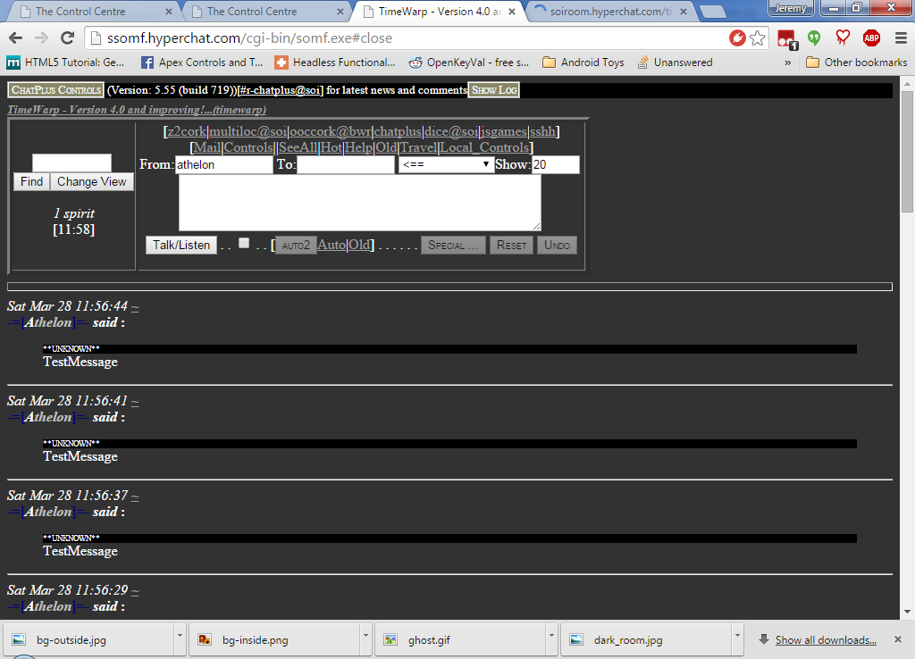
If you click on the 'Change View' button, you'll see the following empty popup:
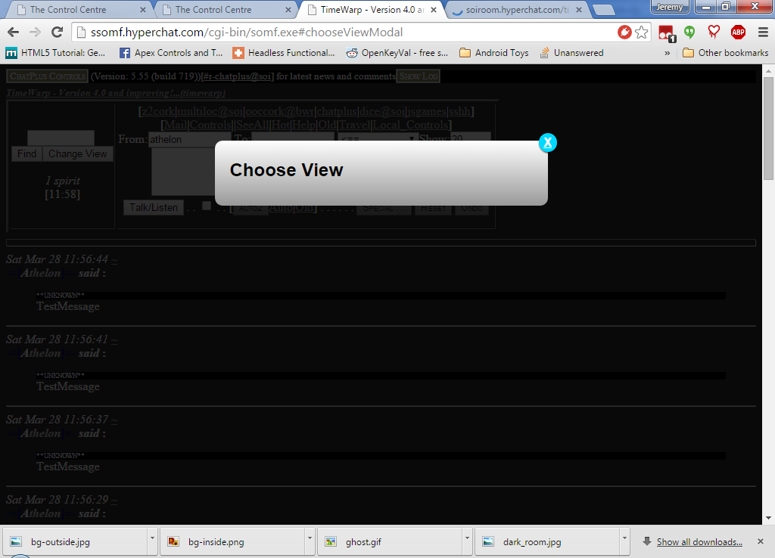
Ok, there are no views defined yet – no worries, we'll take care of that in the next section.

Step 2: Configuring Views.

In this example, we are going to make a small haunted cabin with three views:
- Outside the Cabin
- Inside the Cabin
- In the Dark Closet

So first, we'll just create the views. We'll populate things later.
Return to FTP Files and edit the timewarp.js file.
Hint: Remember, you can just type 'timewarp.js' where it says 'Create File' and hit 'Enter'
The only part of the file we'll be editing right now is near the very top of the file:
var config = {
// These are the items to change to configure how the room works.

// Accepted values:
// "time" - The room works like a timewarp room with 24 hour days.
// "multiloc" -- The room works like the old multiloc rooms.
mode: "multiloc",

///////////////////////////////////////////////////
// Valid for mode: "time"
///////////////////////////////////////////////////

// May the player save his current time selection?
// true - If the player changes the time, the system will remember his change.
// false - The room always loads to SOI's current time.
canSaveTime: true,

// May the player even HAVE the option to change the time?
// true - The player gets the list of times.
// false - the list of times does not even appear.
canChangeTime: true,

///////////////////////////////////////////////////
// Valid for mode: "multiloc"
///////////////////////////////////////////////////

views: [
["outside", "Outside the Cabin"],
["inside", "Inside the Cabin"],
["closet", "In the Dark Closet"]
]

};

Save the file.
Be sure to return to the Room Controls and update the version number of your CSS and JavaScript file. (True, we didn't edit the CSS, but during this demo I'll be keeping the two numbers in sync just for sanity.)
<link rel="stylesheet" type="text/css" href="http://76.188.44.119/fakesoi/rooms/timewarp/timewarp.css?demo2">
<script type="text/javascript" src="http://76.188.44.119/fakesoi/rooms/timewarp/timewarp.js?demo2"></script>

Returning to the room now and clicking on the 'Change View' button gives us this:
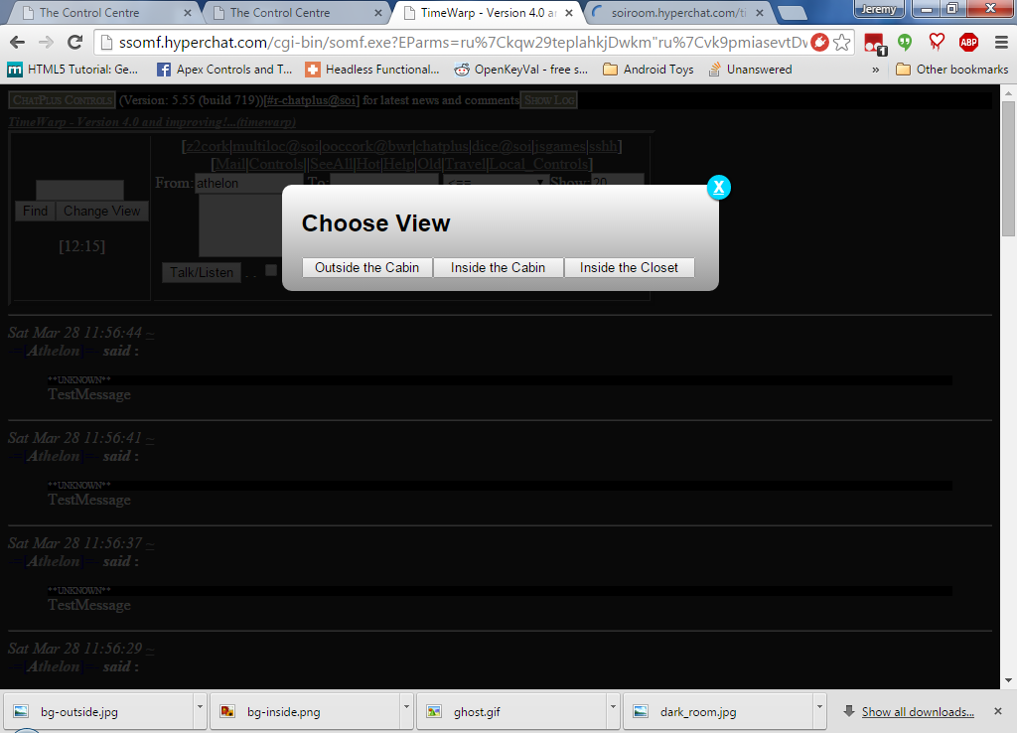
Great. We've now got our views defined, but the room looks a little empty. We'll need to populate it now with some information that never changes, and we'll put in some things that do change.
First we'll just put some informational text at the top of the screen to say which view we are in. This will be short code, but will give me a chance to explain some important concepts of how this code works.
<!-- Remember, these lines don't get changed. They need to stay pointed at YOUR files -->
<link rel="stylesheet" type="text/css" href="http://soiroom.hyperchat.com/timewarp/timewarp.css?demo2">
<script type="text/javascript" src="http://soiroom.hyperchat.com/timewarp/timewarp.js?demo2"></script>

<p>
Current view:
<span>
<script type="text/html" data-time-type="text" data-time-views="outside">
outside
</script>

<script type="text/html" data-time-type="text" data-time-views="inside">
inside
</script>

<script type="text/html" data-time-type="text" data-time-views="closet">
closet
</script>
</span>.
</p>

The screen shot:
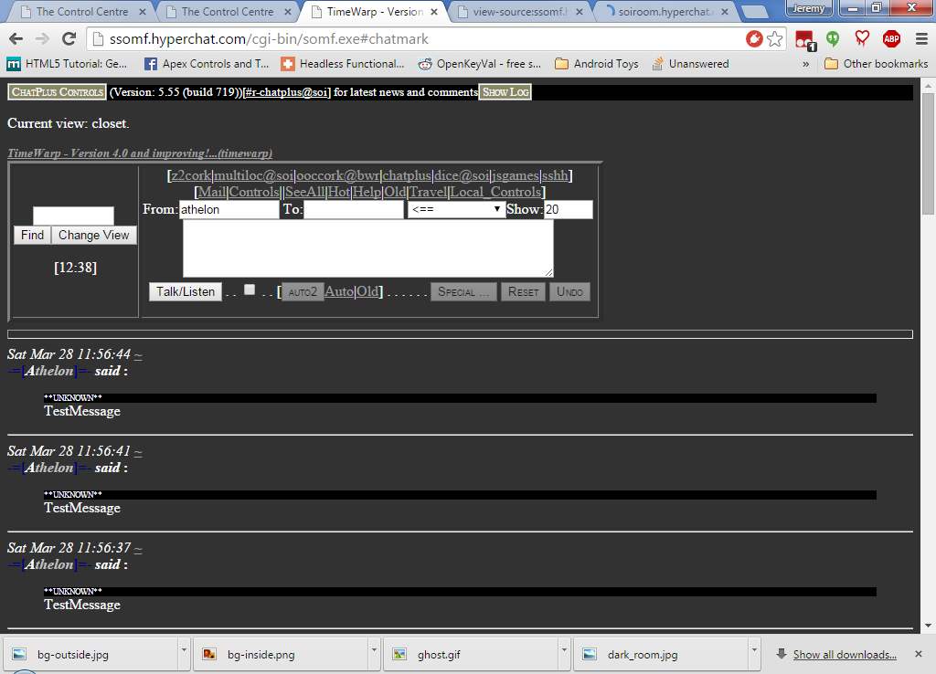
Now I'm going to repeat that code and highlight certain sections of it and attempt to explain each section.
<!-- Remember, these lines don't get changed. They need to stay pointed at YOUR files -->
<link rel="stylesheet" type="text/css" href="http://soiroom.hyperchat.com/timewarp/timewarp.css?demo2">
<script type="text/javascript" src="http://soiroom.hyperchat.com/timewarp/timewarp.js?demo2"></script>

<p>
Current view:
<span>
<script type="text/html" data-time-type="text" data-time-views="outside">
outside
</script>

<script type="text/html" data-time-type="text" data-time-views="inside">
inside
</script>

<script type="text/html" data-time-type="text" data-time-views="closet">
closet
</script>
</span>.
</p>

Boiler Plate – Discussed before
The regular HTML that we all know and love.
The <span>...</span> element serves as a container for our view-specific code. It gives the TimeWarp code a place to put things when it goes to draw (render) the view-specific information. You can use any of the standard containers or even (<p>...</p>, <div>...</div>, <center>...</center> or even <i>...</i> if you wish. For the most predictable results, the container should only have <script> … </script> elements inside of it.

Now I'll break down one of the templates themselves, since they are the very heart and soul the TimeWarp code. There are only two parts of this template that needs to be changed. The rest is required boilerplate.
<script type="text/html" data-time-type="text" data-time-views="inside">
inside
</script>

The yellow section indicates the view names that this template is intended for. It is possible to have more than one name, separated by commas.
The blue section is what will show when the view is active. This can contain anything that would normally go on a page, either as HTML or plain text. The HTML can include images as well.
We'll put this together in a slightly more complex example that shows our location, some narrative text, and a picture for each view. Just for added fun, we'll include a ghost that only shows up inside.
<!-- Remember, these lines don't get changed. They need to stay pointed at YOUR files -->
<link rel="stylesheet" type="text/css" href="http://soiroom.hyperchat.com/timewarp/timewarp.css?demo2">
<script type="text/javascript" src="http://soiroom.hyperchat.com/timewarp/timewarp.js?demo2"></script>

<p>
Current view:
<span>
<script type="text/html" data-time-type="text" data-time-views="outside">
outside
</script>

<script type="text/html" data-time-type="text" data-time-views="inside">
inside
</script>

<script type="text/html" data-time-type="text" data-time-views="closet">
closet
</script>
</span>.
</p>

<div style="float: left;"><!-- Have to have a wrapper -->
<script type="text/html" data-time-type="text" data-time-views="outside">
<img src="http://76.188.44.119:8080/fakesoi/rooms/timewarp/CabinFullSized/cabin-outside.jpg" alt="">
</script>

<script type="text/html" data-time-type="text" data-time-views="inside">
<img src="http://76.188.44.119:8080/fakesoi/rooms/timewarp/CabinFullSized/cabin-inside.jpg" alt="">
</script>

<script type="text/html" data-time-type="text" data-time-views="closet">
<img src="http://76.188.44.119:8080/fakesoi/rooms/timewarp/CabinFullSized/cabin-closet.jpg" alt="">
</script>
</div> <!-- End of wrapper -->

<div><!-- Have to have a wrapper -->
<script type="text/html" data-time-type="text" data-time-views="outside">
<p>
Outside the cabin of one Mr Athelon DeGeek. Here, outside the cabin,
everything appears safe and normal. If you haven't been inside the cabin yet,
save yourself and go somewhere else. If you have escaped from the cabin,
don't tempt fate -- again.
</p>
</script>

<script type="text/html" data-time-type="text" data-time-views="inside">
<p>
Inside the cabin, the <i>Spirit List</i> is never quite right. There may be no
chatters, or there may be ten. Either way, the count is wrong, for in this cabin
lurks a spirit that never posts, but sometimes shimmers about for reasons only it
-- formerly he or she -- knows.
</p>
</script>

<script type="text/html" data-time-type="text" data-time-views="closet">
<p>
Neither day, nor night, matters here in the closet. This small room, isolated from the rest of the
cabin, eats light. The <i>Spirit</i> is strongest here. If the door could talk,
it would explain why the words "HELP ME" have been carved with fingernails in the ancient
wood.
</p>
</script>

<script type="text/html" data-time-type="text" data-time-views="inside,closet">
<img height="100" src="http://76.188.44.119:8080/fakesoi/rooms/timewarp/CabinFullSized/ghost.gif" alt="">
</script>

</div> <!-- End of wrapper -->

<div style="clear: both"></div> <!-- Stop the floating -->

