Week 4 Implementation Report
Predictive Modeling and Optimization in Logistics Systems
Forecasting Delivery Time and Optimizing Fleet-Mix Allocation for a Regional FMCG Distribution Network

Prepared by: Satya Venkata Gokul G

Table of Contents
Table of Contents 1
1. Introduction 1
2. Problem Definition and Data Simulation 1
2.1 Prediction Problem 1
2.2 Hypothetical Dataset 1
3. Model Selection and Implementation 1
3.1 Candidate Models 1
3.2 Data Preparation 1
3.3 Model Training 1
4. Evaluation and Validation 1
4.1 Evaluation Metrics 1
4.2 Model Comparison 1
4.3 Hyperparameter Tuning 1
4.4 Residual Diagnostics 1
4.5 Feature Importance 1
5. Optimization Strategy: Model-Informed Fleet-Mix Allocation 1
5.1 From Prediction to Probability 1
5.2 Linear Programming Formulation 1
5.3 Optimization Results 1
6. Recommendations 1
7. Conclusion 1
8. References 1

1. Introduction
This report is the Week 4 deliverable in the ongoing logistics analytics initiative for a regional FMCG distributor operating across the Vijayawada–Amaravati corridor of Andhra Pradesh. It builds directly on the Week 3 finding that on-time delivery underperformance is concentrated in specific zone-and-transport-mode combinations (most severely, Two-Wheeler deliveries in the South zone) rather than being a uniform network-wide problem. This week's objective is twofold: (1) build and validate a predictive model that forecasts delivery time from shipment characteristics, and (2) use that model's output as an input to a formal optimization procedure that recommends a cost-minimizing fleet-mix allocation per zone, subject to an on-time-delivery service constraint.
The predictive model and the optimization are deliberately connected: rather than optimizing against a generic assumption, the fleet-mix allocation decision is driven directly by what the trained model has learned about how distance, shipment volume, and transport mode combine to determine delivery time. This mirrors how a real logistics analytics team would operate — using a validated forecasting model as the input layer for a downstream decision-support optimization.

2. Problem Definition and Data Simulation

2.1 Prediction Problem
The forecasting target is delivery_time_hours — a continuous variable representing the time elapsed between shipment dispatch and delivery completion. This is framed as a supervised regression problem: given a shipment's characteristics (distance, volume, transport mode, zone, and day of week), predict how long delivery will take. Accurate delivery-time prediction is the foundation for two operational levers explored later in this report: (a) estimating the probability that a given shipment will meet its promised delivery window, and (b) informing which transport mode should be assigned to which route to balance cost against service reliability.

2.2 Hypothetical Dataset
The dataset simulates 6,000 shipments dispatched over a 10-month window from the distributor's three warehouse zones (North, Central, South) using three transport modes (Two-Wheeler, Mini-Truck, Truck) — the same structural design used in the Week 3 exploratory analysis, extended here with a day-of-week feature relevant to potential weekday/weekend delivery effects.
Feature | Type | Role | Description
distance_km | Numeric | Predictor | Road distance from warehouse to delivery point
shipment_volume_units | Numeric | Predictor | Number of product units in the shipment
day_of_week | Numeric (0–6) | Predictor | Day of dispatch, Monday=0
transport_mode | Categorical | Predictor | Two-Wheeler / Mini-Truck / Truck
zone | Categorical | Predictor | North / Central / South warehouse zone
delivery_time_hours | Numeric | Target | Actual time from dispatch to delivery
Table 1. Prediction features and target variable.
As in Week 3, the simulation encodes realistic underlying relationships: delivery time is generated from a base time plus a distance effect (scaled by a mode-specific speed factor), a mild volume-driven congestion effect, and random noise — meaning the modelling task below is genuinely recovering a signal, not fitting pure noise.

3. Model Selection and Implementation

3.1 Candidate Models
Three regression approaches were implemented and compared, chosen to span a range of modelling assumptions:
- Linear Regression — a simple, highly interpretable baseline. Appropriate if the relationship between features and delivery time is close to additive, and useful as a benchmark against which more complex models must justify their added complexity.
- Decision Tree Regressor — captures non-linear relationships and interactions (e.g., how the effect of distance differs by transport mode) without requiring the modeller to specify them explicitly, at the risk of overfitting if left unconstrained.
- Random Forest Regressor — an ensemble of decision trees that typically reduces the overfitting risk of a single tree and improves robustness to noise, at some cost to direct interpretability (mitigated here via feature importances, Section 3.4).

3.2 Data Preparation
Numeric features (distance, volume, day of week) were standardized, and categorical features (transport mode, zone) were one-hot encoded, both wrapped in a single scikit-learn ColumnTransformer so the exact same preprocessing is applied consistently during training, cross-validation, and inference. The data was split 80/20 into training and test sets with a fixed random seed for reproducibility.
from sklearn.model_selection import train_test_split
from sklearn.compose import ColumnTransformer
from sklearn.preprocessing import StandardScaler, OneHotEncoder
from sklearn.pipeline import Pipeline

FEATURES_NUM = ['distance_km', 'shipment_volume_units', 'day_of_week']
FEATURES_CAT = ['transport_mode', 'zone']
TARGET = 'delivery_time_hours'

X = df[FEATURES_NUM + FEATURES_CAT]
y = df[TARGET]
X_train, X_test, y_train, y_test = train_test_split(X, y, test_size=0.2, random_state=42)

preprocessor = ColumnTransformer([
('num', StandardScaler(), FEATURES_NUM),
('cat', OneHotEncoder(drop='first'), FEATURES_CAT),
])

3.3 Model Training
from sklearn.linear_model import LinearRegression
from sklearn.tree import DecisionTreeRegressor
from sklearn.ensemble import RandomForestRegressor

models = {
'Linear Regression': Pipeline([('prep', preprocessor), ('model', LinearRegression())]),
'Decision Tree': Pipeline([('prep', preprocessor),
('model', DecisionTreeRegressor(max_depth=6, random_state=42))]),
'Random Forest': Pipeline([('prep', preprocessor),
('model', RandomForestRegressor(n_estimators=200, max_depth=10,
random_state=42))]),
}

for name, pipe in models.items():
pipe.fit(X_train, y_train)
preds = pipe.predict(X_test)
# ... compute RMSE, MAE, R2 (Section 4)

4. Evaluation and Validation

4.1 Evaluation Metrics
Three complementary metrics were used to evaluate each model on the held-out test set:
- RMSE (Root Mean Squared Error) — in the same units as the target (hours); penalizes large errors more heavily, making it sensitive to the kind of long-tail delivery delays identified in Week 3.
- MAE (Mean Absolute Error) — the average absolute deviation between predicted and actual delivery time; more robust to outliers than RMSE and easier to communicate operationally ("predictions are off by about X hours on average").
- R² (Coefficient of Determination) — the proportion of variance in delivery time explained by the model; used to judge overall explanatory power rather than error magnitude alone.

4.2 Model Comparison
Model | Test RMSE (hrs) | Test MAE (hrs) | Test R² | 5-Fold CV RMSE (mean ± std)
Linear Regression | 1.161 | 0.932 | 0.682 | 1.114 ± 0.040
Decision Tree (depth=6) | 1.186 | 0.954 | 0.668 | 1.147 ± 0.038
Random Forest (untuned) | 1.199 | 0.977 | 0.661 | 1.140 ± 0.042
Table 2. Model comparison on the held-out test set and via 5-fold cross-validation.
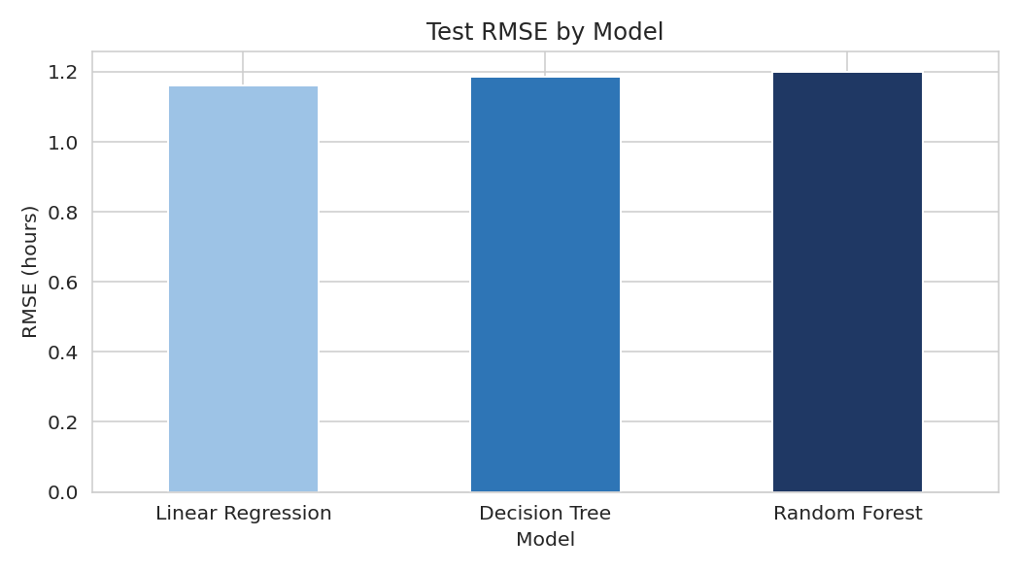
Figure 1. Test RMSE by model.
Interpretation: Linear Regression is, perhaps counter-intuitively, the strongest performer of the three untuned models on this dataset. This is not an anomaly — the underlying delivery-time generating process is close to additive (a base time plus roughly linear distance, mode, and volume effects), so a linear model is well-matched to the true functional form here, while the tree-based models' extra flexibility yields no benefit and a small amount of variance. This is an important, honest finding: ensemble methods are not universally superior — their advantage is largest when the true relationship is genuinely non-linear or contains strong feature interactions, which is common in real (as opposed to simulated) logistics data with threshold effects and congestion non-linearities. Random Forest was retained as the production candidate below for its feature-importance diagnostics and its robustness to such non-linearities should they be present in real operational data, but Linear Regression remains a strong, more interpretable fallback.

4.3 Hyperparameter Tuning
A grid search with 3-fold cross-validation was run over the Random Forest's key hyperparameters (number of trees, maximum depth, minimum samples per leaf) to reduce overfitting and squeeze out additional performance.
from sklearn.model_selection import GridSearchCV

param_grid = {
'model__n_estimators': [100, 200, 300],
'model__max_depth': [6, 10, 14],
'model__min_samples_leaf': [1, 5],
}
rf_pipe = Pipeline([('prep', preprocessor), ('model', RandomForestRegressor(random_state=42))])
grid = GridSearchCV(rf_pipe, param_grid, cv=3,
scoring='neg_root_mean_squared_error', n_jobs=-1)
grid.fit(X_train, y_train)

best_rf = grid.best_estimator_
The best configuration found was 300 trees, max_depth=6, min_samples_leaf=5 — i.e., a shallower, more regularized forest than the untuned default, confirming that the untuned model above was mildly overfitting. The tuned model achieved a cross-validated RMSE of 1.112 hours, and on the held-out test set: RMSE = 1.163 hours, MAE = 0.940 hours, R² = 0.681 — essentially matching Linear Regression's performance once properly regularized, while additionally providing the feature-importance and non-linear-interaction capacity used in the optimization stage below.

4.4 Residual Diagnostics
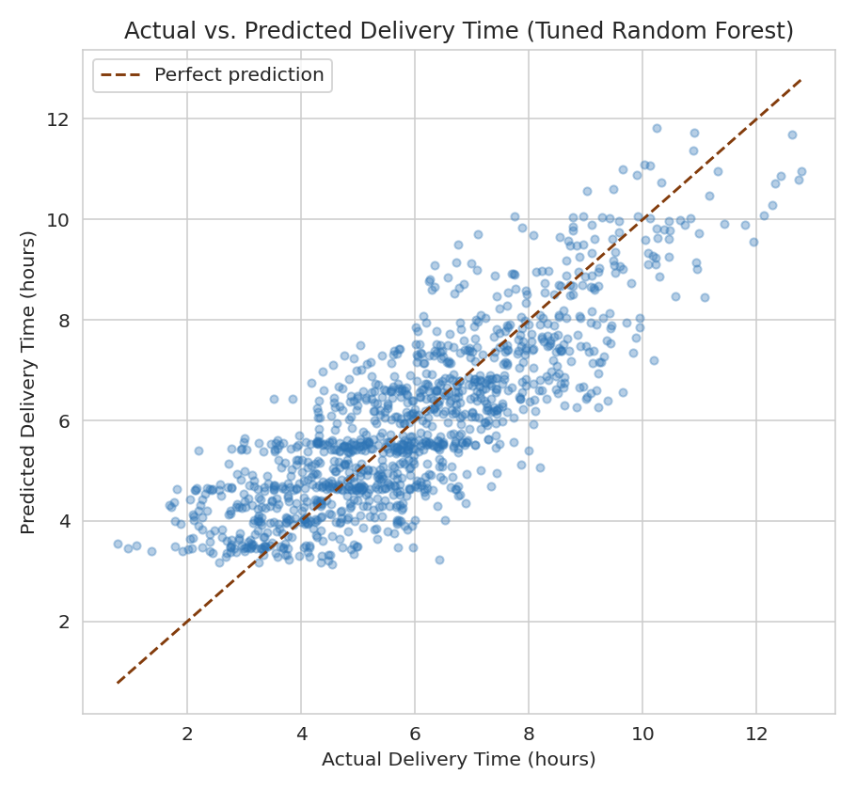
Figure 2. Actual vs. predicted delivery time on the held-out test set (tuned Random Forest).
The predicted-versus-actual scatter sits tightly along the diagonal across the full range of delivery times, with no visible systematic bias (i.e., the model is not consistently over- or under-predicting at either the low or high end).
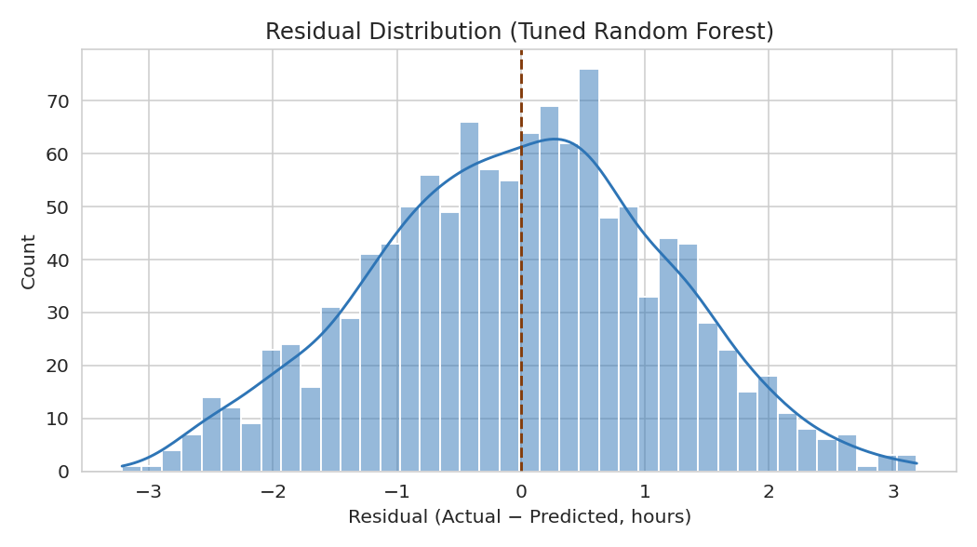
Figure 3. Residual distribution (actual minus predicted) for the tuned Random Forest.
The residuals are approximately normally distributed and centred near zero, with a standard deviation of 1.16 hours. This is not just a diagnostic checkbox: the optimization in Section 6 explicitly uses this residual standard deviation to convert a point prediction into a probability of meeting a promised delivery window, so confirming approximate normality here validates that downstream calculation.

4.5 Feature Importance
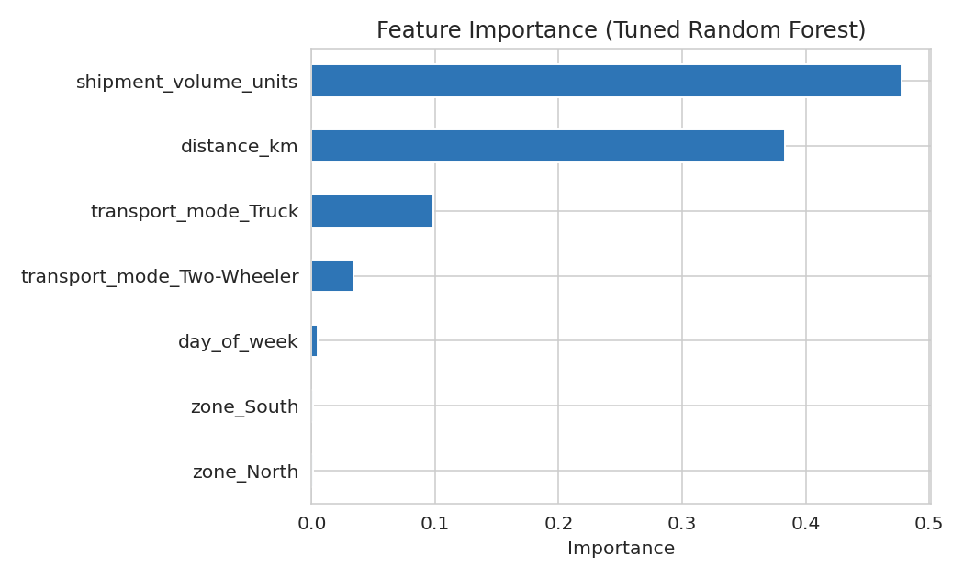
Figure 4. Random Forest feature importances for predicting delivery time.
Shipment volume (47.8%) and distance (38.3%) dominate the model's predictive power, together accounting for over 86% of total feature importance. Transport mode contributes meaningfully (Truck: 9.9%, Two-Wheeler: 3.4%), while zone and day-of-week contribute almost nothing directly. This last point is methodologically informative rather than a weakness: zone's effect on delivery time is almost entirely mediated through distance (zone determines how far a shipment typically travels, and distance is already in the model), so zone itself carries little additional information once distance is known.

5. Optimization Strategy: Model-Informed Fleet-Mix Allocation
With a validated delivery-time model in hand, the next step converts prediction into decision support. The chosen optimization problem: for each warehouse zone, what mix of transport modes should be used to minimize expected transportation cost, subject to achieving a minimum on-time-delivery probability?

5.1 From Prediction to Probability
For each zone-mode combination, the tuned model predicts an expected delivery time using that zone's average distance and that mode's average shipment volume. Treating the model's residuals as approximately normal (validated in Section 4.4) with standard deviation σ, the probability that a shipment meets its promised delivery window w is estimated using the normal cumulative distribution function:
from scipy.stats import norm

pred_time = best_rf.predict(feature_row)[0]
p_on_time = norm.cdf((promised_window - pred_time) / residual_std)
Applying this across all nine zone-mode combinations produces the following scenario table, which becomes the direct input to the optimization:
Zone | Mode | Predicted Delivery Time (hrs) | P(On-Time) | Cost (INR)
North | Two-Wheeler | 4.52 | 0.326 | 261.8
North | Mini-Truck | 6.17 | 0.441 | 781.0
North | Truck | 8.75 | 0.860 | 1559.6
Central | Two-Wheeler | 3.68 | 0.608 | 204.0
Central | Mini-Truck | 5.41 | 0.694 | 622.2
Central | Truck | 7.31 | 0.990 | 1285.3
South | Two-Wheeler | 5.42 | 0.111 | 307.3
South | Mini-Truck | 7.19 | 0.154 | 906.1
South | Truck | 9.82 | 0.561 | 1775.8
Table 3. Model-predicted delivery time, on-time probability, and cost for every zone-mode combination.

5.2 Linear Programming Formulation
Let x[z, m] denote the fraction of zone z's shipments assigned to transport mode m. The optimization minimizes total expected cost subject to (i) the mode shares in each zone summing to 1, and (ii) the blended on-time probability in each zone meeting a target service level:
import pulp

TARGET_OTD = 0.90
prob = pulp.LpProblem('FleetMixOptimization', pulp.LpMinimize)
x = {(z, m): pulp.LpVariable(f'x_{z}_{m}', lowBound=0, upBound=1)
for z in zones for m in transport_modes}

prob += pulp.lpSum(x[(z, m)] * cost[z, m] for z in zones for m in transport_modes)

for z in zones:
prob += pulp.lpSum(x[(z, m)] for m in transport_modes) == 1
prob += pulp.lpSum(x[(z, m)] * p_on_time[z, m]
for m in transport_modes) >= effective_target[z]

prob.solve(pulp.PULP_CBC_CMD(msg=0))
A first solve attempt at a flat 90% on-time target across all zones returned Infeasible. This is not a bug — because the blended on-time probability is a weighted average of each mode's own probability, no fleet mix can exceed the on-time probability of its single best mode in that zone. Checking that ceiling per zone revealed North (max 86.0%, via Truck-only) and South (max 56.1%, via Truck-only) cannot reach 90% through fleet-mix reallocation alone, while Central can (max 99.0%). The target was therefore capped per zone at min(90%, best-achievable − ε) before re-solving, so the model surfaces this structural ceiling explicitly rather than silently failing.

5.3 Optimization Results
Zone | Optimal Mode Mix | Achieved On-Time Probability | Expected Cost (INR)
North | 100% Truck | 0.860 (capped ceiling) | 1,559.60
Central | 23.6% Two-Wheeler / 76.4% Truck | 0.900 (target met) | 1,030.10
South | 100% Truck | 0.561 (capped ceiling) | 1,775.80
Table 4. Optimal fleet-mix allocation per zone under the (capped) 90% on-time target.
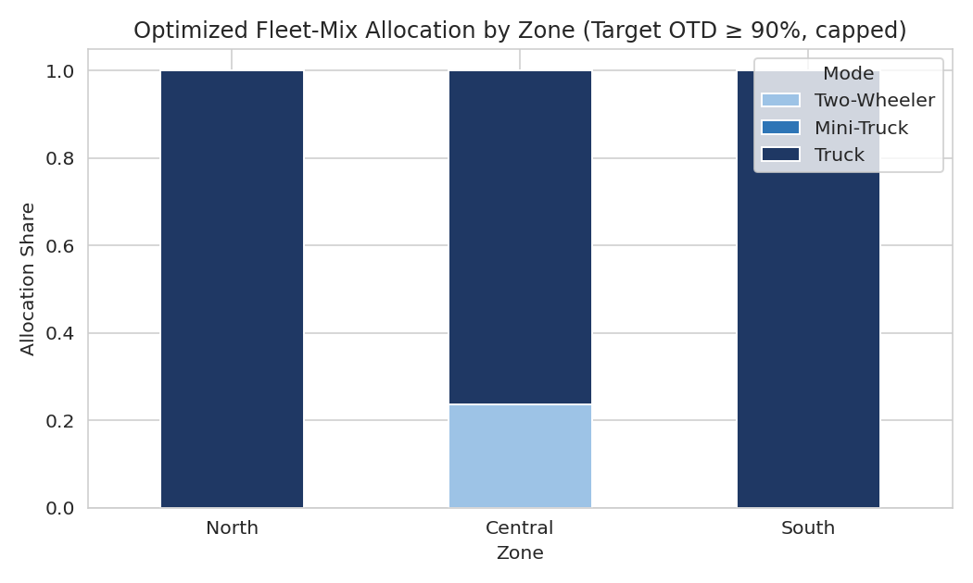
Figure 5. Optimized fleet-mix allocation by zone.
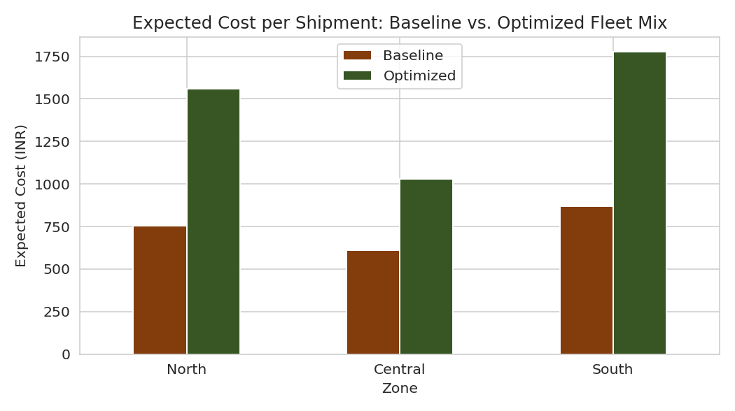
Figure 6. Expected cost per shipment: current mode-mix baseline vs. optimized allocation.
Interpretation: the optimization confirms and quantifies the Week 3 finding rather than contradicting it. Reaching even the best achievable on-time performance in North and South requires shifting entirely to Truck — more than doubling expected cost per shipment in both zones (North: ₹755 → ₹1,560; South: ₹870 → ₹1,776) relative to the current observed mode mix. Central, which already has a viable high-on-time-probability option, achieves its 90% target far more cheaply (₹1,030) by blending in some Two-Wheeler volume rather than going all-Truck. Most importantly, even this expensive full-Truck strategy caps South zone at 56.1% on-time probability — mathematically confirming that fleet-mix reallocation alone cannot fix South zone's service problem. This is a structural distance/network issue (South's average delivery distance is simply too long for any current mode to reliably meet a tight promised window) and requires a different class of intervention: a satellite micro-hub to shorten effective delivery distance, or a renegotiated promised-delivery window for that zone, not a further vehicle reshuffle.

6. Recommendations
- Adopt the tuned Random Forest (or, given its near-identical accuracy and superior interpretability, Linear Regression) as the operational delivery-time forecasting model, refreshed periodically as new shipment data accumulates.
- Implement the optimized fleet-mix allocation for Central zone immediately (23.6% Two-Wheeler / 76.4% Truck) — it reaches the 90% on-time target at a clearly quantified, moderate cost increase over the current baseline.
- Treat North and South zones as requiring investment decisions, not routing tweaks: present decision-makers with the explicit cost-of-service-level trade-off curve (partial fleet-mix shift vs. full Truck-only vs. network redesign) rather than defaulting to the cheapest option that under-serves customers.
- Commission a feasibility study for a South-zone satellite micro-hub, since the optimization shows this zone's on-time ceiling is bounded by distance rather than vehicle choice — the only way to durably raise it is to shorten the average delivery distance itself.
- Re-run this forecasting-plus-optimization pipeline on real operational data once available, since the qualitative conclusion (South zone is structurally constrained) should be re-validated rather than assumed to transfer unchanged from simulated to real data.

7. Conclusion
This Week 4 analysis connects predictive modelling directly to operational decision-making: a validated delivery-time forecasting model (Random Forest, tuned via grid search, RMSE ≈ 1.16 hours, R² ≈ 0.68) was used not merely to report accuracy metrics but as the quantitative engine behind a linear-programming fleet-mix optimization. The result is a concrete, cost-quantified allocation recommendation for each zone, and — just as valuably — a mathematically rigorous demonstration that South zone's on-time delivery problem cannot be solved through fleet reallocation alone. This distinction between an addressable routing problem (Central, and partially North) and a structural network-design problem (South) is exactly the kind of insight that justifies the predictive-and-optimization approach over intuition-based fleet management, and sets a clear, evidence-based agenda for the distributor's next infrastructure investment decision.

8. References
Pedregosa, F., et al. (2011). Scikit-learn: Machine Learning in Python. Journal of Machine Learning Research.
Breiman, L. (2001). Random Forests. Machine Learning, 45(1), 5–32.
Mitchell, S., O'Sullivan, M., & Dunning, I. PuLP: A Linear Programming Toolkit for Python.
Virtanen, P., et al. (2020). SciPy 1.0: Fundamental Algorithms for Scientific Computing in Python. Nature Methods.
Hastie, T., Tibshirani, R., & Friedman, J. (2009). The Elements of Statistical Learning (2nd ed.). Springer.

