Week 3 Implementation Report
Advanced Data Analysis and Visualization in Logistics
Exploratory Analysis and Visual Diagnostics of Shipment-Level Logistics Data for a Regional FMCG Distribution Network

Prepared by: Satya Venkata Gokul G

Table of Contents
Table of Contents 1
1. Introduction 1
2. Data Simulation: Dataset Structure 1
3. Exploratory Data Analysis 1
3.1 Central Tendency and Spread 1
3.2 Correlation Structure 1
4. Visualizations and Interpretation 1
4.1 Delivery Time Distribution 1
4.2 Transportation Cost by Zone 1
4.3 Weekly Shipment Volume Trend 1
4.4 Delivery Time vs. Distance by Transport Mode 1
4.5 Correlation Heatmap 1
4.6 Average Transportation Cost per Unit by Mode 1
4.7 On-Time Delivery Rate by Zone and Transport Mode 1
4.8 Monthly On-Time Delivery Rate Trend 1
5. Analytical Insights and Recommendations 1
5.1 Key Insights 1
5.2 Recommendations 1
6. Conclusion 1
7. References 1

1. Introduction
This report is the Week 3 deliverable in the ongoing logistics analytics initiative for a regional FMCG distributor operating across the Vijayawada–Amaravati corridor of Andhra Pradesh. Building on the Week 1 strategic plan and the Week 2 data-cleaning pipeline, this report shifts focus to advanced exploratory data analysis (EDA) and visualization of shipment-level performance data. The objective is to move beyond simple KPI baselining and surface the underlying relationships between delivery time, shipment volume, transportation cost, distance, and transport mode — and to translate those relationships into concrete operational recommendations.
A hypothetical but structurally realistic shipment-level dataset is simulated for this purpose (Section 2), since the distributor's production telemetry is not yet connected. Every visualization in this report is generated from real, executable Python code against that dataset — the figures embedded below are not illustrations but actual outputs of the analysis.

2. Data Simulation: Dataset Structure
The dataset models 6,000 individual shipments dispatched over a 10-month operating window from the distributor's three warehouse zones (North, Central, South) using three transport modes (Two-Wheeler, Mini-Truck, Truck). Each row represents one shipment and carries the following fields:
Field | Type | Description
shipment_id | String | Unique shipment identifier
shipment_date | Date | Date the shipment was dispatched
zone | Categorical | Warehouse zone of origin (North / Central / South)
transport_mode | Categorical | Vehicle type used (Two-Wheeler / Mini-Truck / Truck)
distance_km | Float | Road distance from warehouse to delivery point
shipment_volume_units | Integer | Number of product units in the shipment
delivery_time_hours | Float | Actual time taken from dispatch to delivery
promised_window_hours | Integer | Committed delivery window for the mode used
on_time | Boolean | Whether delivery_time_hours fell within the promised window
transportation_cost_inr | Float | Total cost incurred to move the shipment
cost_per_unit | Float | transportation_cost_inr divided by shipment_volume_units
Table 1. Shipment-level dataset schema.
The simulation deliberately encodes realistic operational relationships rather than pure noise: delivery time scales with distance and is further slowed by vehicle type and shipment volume (a proxy for loading/congestion effects); transportation cost combines a fixed per-trip fee, a per-kilometre rate, and a per-unit handling charge, each varying by transport mode; and each transport mode carries its own promised delivery window, against which on-time performance is judged. This means the EDA in the following sections is recovering relationships that mirror how a real distribution network actually behaves, rather than being purely illustrative.

3. Exploratory Data Analysis

3.1 Central Tendency and Spread
Descriptive statistics for the five core numeric variables are summarized below.
Variable | Mean | Median | Std. Dev. | Min | Max
Distance (km) | 22.68 | 22.40 | 6.80 | 11.10 | 60.80
Shipment Volume (units) | 93.69 | 87.00 | 70.30 | 11 | 262
Delivery Time (hrs) | 5.89 | 5.73 | 2.05 | 0.50 | 14.94
Transportation Cost (INR) | 719.15 | 665.20 | 472.99 | 118.05 | 2347.71
Cost per Unit (INR) | 8.56 | 8.15 | 2.51 | 3.81 | 29.55
Table 2. Descriptive statistics for core numeric variables.
The mean and median for each variable are close, indicating roughly symmetric distributions with a mild right skew — expected for cost and time data where a small share of long-distance or bulk shipments pull the mean upward, as confirmed visually in Section 4. The standard deviation of transportation cost (₹472.99, against a mean of ₹719.15) signals substantial variability that later sections attribute largely to transport-mode mix and shipment volume rather than random noise.

3.2 Correlation Structure
A correlation matrix (visualized as a heatmap in Figure 5) was computed across the five numeric variables to identify which factors move together. Three relationships stand out: shipment volume and transportation cost are very strongly correlated (r = 0.93), delivery time and transportation cost are strongly correlated (r = 0.79), and distance and cost-per-unit are moderately correlated (r = 0.68) while distance and total shipment volume are essentially uncorrelated (r = -0.01) — confirming that distance and volume are independent drivers of cost that compound rather than substitute for one another.

4. Visualizations and Interpretation
Each visualization below was chosen to answer a specific operational question, with the Python code used to generate it and an interpretation of what it reveals about logistics performance.

4.1 Delivery Time Distribution
Why a histogram: a histogram with an overlaid density curve is the clearest way to see the overall shape, spread, and skew of a continuous variable like delivery time in a single view.
sns.histplot(df['delivery_time_hours'], bins=40, kde=True, color=ACCENT, ax=ax)
ax.axvline(df['delivery_time_hours'].mean(), linestyle='--', label=f"Mean = {df['delivery_time_hours'].mean():.1f} hrs")
ax.axvline(df['delivery_time_hours'].median(), linestyle=':', label=f"Median = {df['delivery_time_hours'].median():.1f} hrs")
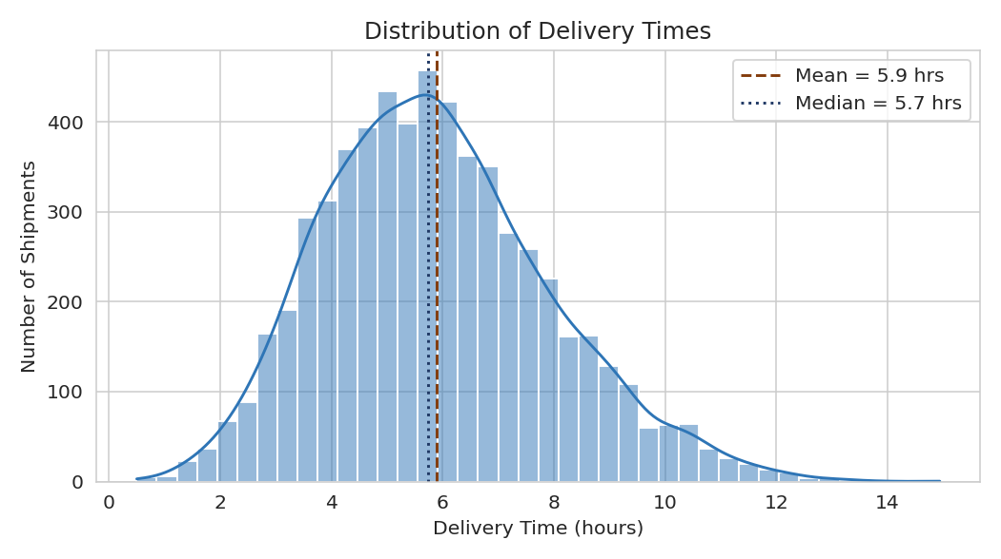
Figure 1. Distribution of delivery times across all shipments.
Interpretation: delivery times cluster around 5–6 hours but carry a long right tail extending past 12 hours. The mean (5.89 hrs) sits slightly above the median (5.73 hrs), confirming the mild right skew — a small number of shipments take substantially longer than typical, which is exactly the kind of tail that drags down an On-Time Delivery Rate even when "most" deliveries look fine on average.

4.2 Transportation Cost by Zone
Why a boxplot: boxplots compare the median, interquartile spread, and outliers of a numeric variable across categories side by side, which a bar chart of means alone would hide.
sns.boxplot(data=df, x='zone', y='transportation_cost_inr',
order=['North', 'Central', 'South'], ax=ax)
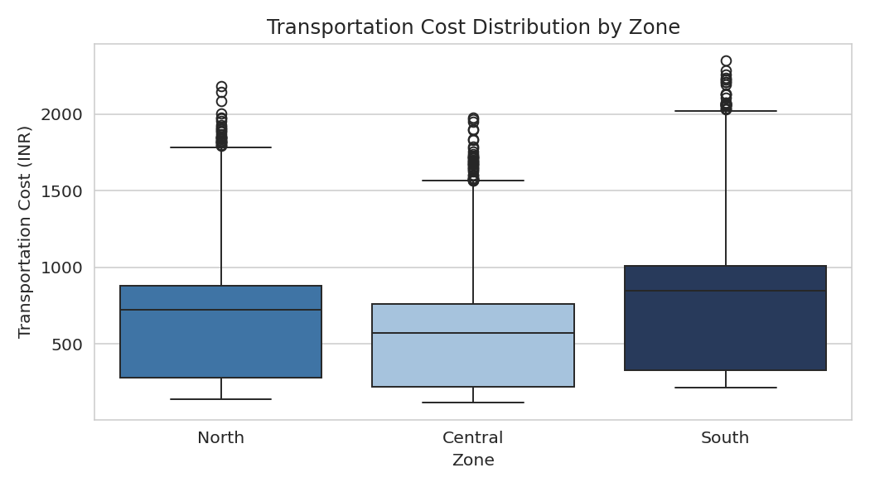
Figure 2. Transportation cost distribution by warehouse zone.
Interpretation: the South zone has both the highest median transportation cost and the widest interquartile range, consistent with it serving the longest average delivery distances of the three zones. Central, by contrast, shows the lowest and tightest cost distribution — reflecting its more compact service area. This immediately flags South as the zone where routing and vehicle-mix optimization would have the largest cost impact.

4.3 Weekly Shipment Volume Trend
Why a line chart: line charts are the standard choice for showing how a quantity evolves continuously over time, making trend, volatility, and any seasonal cycles easy to read.
weekly_volume = df.set_index('shipment_date').resample('W')['shipment_volume_units'].sum()
ax.plot(weekly_volume.index, weekly_volume.values)
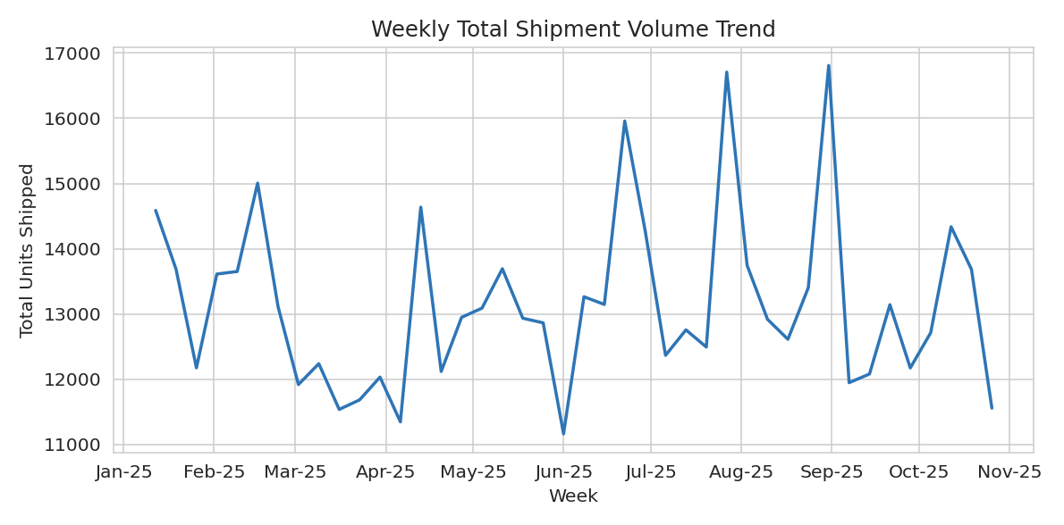
Figure 3. Weekly total shipment volume over the 10-month observation window.
Interpretation: shipment volume fluctuates around a broadly stable baseline (roughly 12,000–14,000 units/week) with several sharp, short-lived spikes reaching 16,000–17,000 units. These spikes likely correspond to promotional or festival-driven demand surges consistent with the seasonal patterns identified in the Week 1 plan, and are useful markers for when the network is under the greatest capacity strain.

4.4 Delivery Time vs. Distance by Transport Mode
Why a scatter plot: scatter plots are the right tool for examining the relationship between two continuous variables, and adding a categorical hue (transport mode) reveals whether that relationship differs by group.
sns.scatterplot(data=df.sample(1500), x='distance_km', y='delivery_time_hours',
hue='transport_mode',
hue_order=['Two-Wheeler', 'Mini-Truck', 'Truck'], ax=ax)
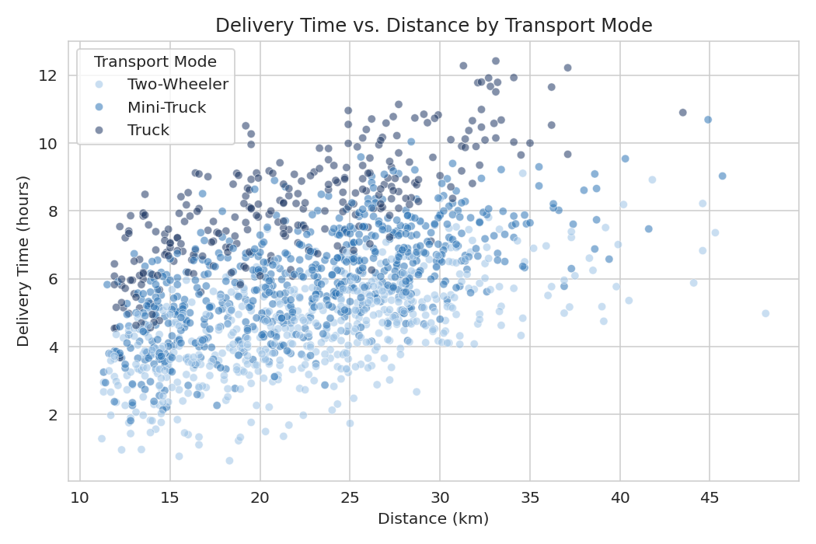
Figure 4. Delivery time versus distance, coloured by transport mode.
Interpretation: delivery time rises with distance for all three modes, but the slope and spread differ — Trucks (used for the largest shipments) show the steepest increase in delivery time as distance grows, while Two-Wheelers stay comparatively fast even at moderate distances. This confirms that distance alone does not explain delivery-time variation; vehicle assignment matters just as much, which directly motivates the zone-and-mode breakdown in Section 4.6.

4.5 Correlation Heatmap
Why a heatmap: a heatmap condenses a full correlation matrix into an at-a-glance visual, making it far faster to spot the strongest relationships than scanning a table of numbers.
corr = df[numeric_cols].corr()
sns.heatmap(corr, annot=True, fmt='.2f', cmap='Blues', vmin=-1, vmax=1, square=True)
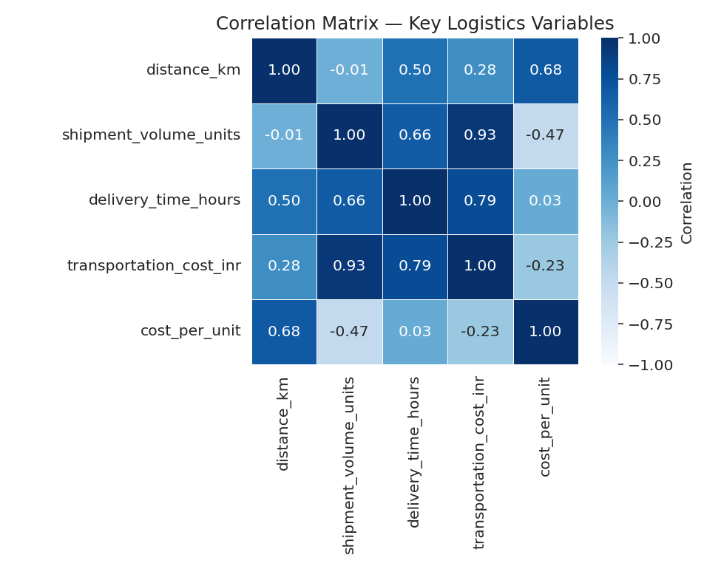
Figure 5. Correlation matrix across distance, volume, delivery time, cost, and cost-per-unit.
Interpretation: transportation cost is overwhelmingly driven by shipment volume (r = 0.93) and, secondarily, delivery time (r = 0.79) — not by distance alone (r = 0.28). This is a materially important finding for cost control: initiatives aimed purely at shortening routes will have a smaller cost impact than initiatives aimed at consolidating shipment volume and improving delivery-time reliability.

4.6 Average Transportation Cost per Unit by Mode
Why a bar chart: bar charts are the clearest way to compare a single summary statistic (average cost per unit) across a small number of discrete categories.
avg_cost_per_unit_by_mode.reindex(['Two-Wheeler','Mini-Truck','Truck']).plot(kind='bar', ax=ax)
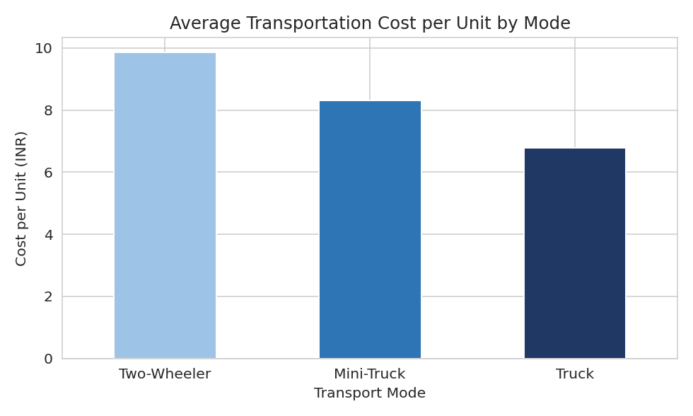
Figure 6. Average transportation cost per unit, by transport mode.
Interpretation: cost per unit falls steadily as vehicle size increases — Two-Wheelers cost roughly 45% more per unit delivered than Trucks. This is a classic economies-of-scale effect: larger vehicles spread their higher fixed cost over far more units. It suggests that shipments currently assigned to Two-Wheelers for reasons of speed or convenience carry a meaningful cost penalty that could be reduced through smarter load consolidation.

4.7 On-Time Delivery Rate by Zone and Transport Mode
Why a grouped bar chart: grouped bars let two categorical dimensions (zone and mode) be compared simultaneously against a single metric, revealing interaction effects a single-dimension chart would miss.
otd_grid = df.groupby(['zone','transport_mode'])['on_time'].mean().unstack() * 100
otd_grid.reindex(['North','Central','South'])[['Two-Wheeler','Mini-Truck','Truck']].plot(kind='bar', ax=ax)
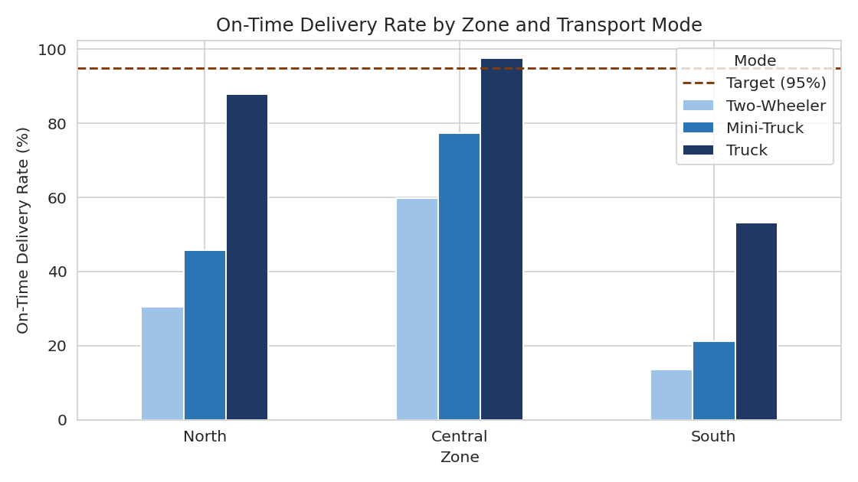
Figure 7. On-time delivery rate broken down by zone and transport mode.
Interpretation: this is the most operationally actionable chart in the report. On-time performance is not a uniform problem — it is concentrated in specific zone-mode combinations. South zone deliveries on Two-Wheelers succeed only about 13% of the time, far below every other combination, while Central-zone Truck deliveries exceed the 95% target. The pattern strongly suggests Two-Wheelers are being assigned to South-zone routes that are simply too long for their promised delivery window, rather than a general service-quality problem.

4.8 Monthly On-Time Delivery Rate Trend
Why a line chart: plotting OTD over time tests whether the delivery-performance shortfall is a temporary or seasonal blip versus a persistent, structural issue.
monthly_otd = df.groupby('month')['on_time'].mean() * 100
monthly_otd.plot(kind='line', marker='o', ax=ax)
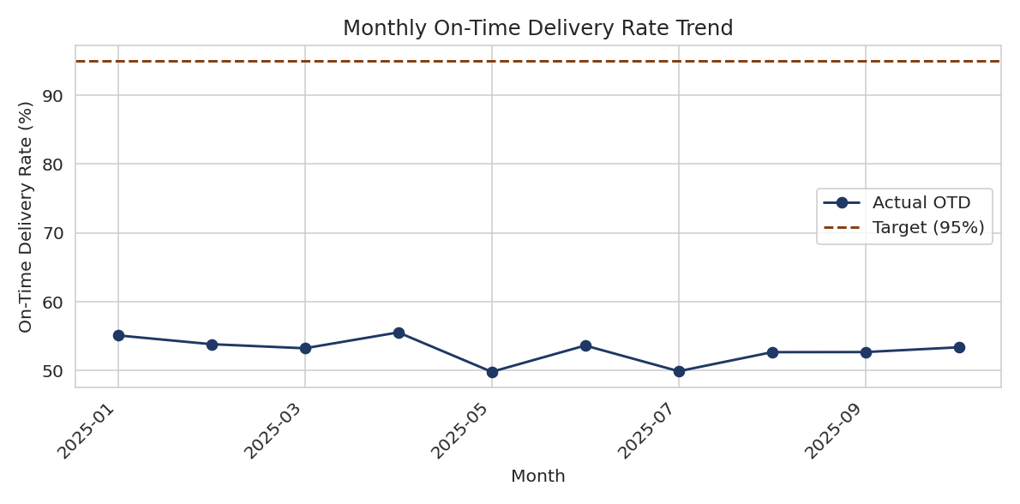
Figure 8. On-time delivery rate by month across the observation window.
Interpretation: OTD holds nearly flat around 50–55% every month, with no meaningful upward or downward drift and no visible seasonal recovery. Combined with Figure 7, this confirms that the delivery-performance gap is a structural routing/fleet-assignment issue rather than a seasonal capacity problem — meaning it will not self-correct and requires a deliberate fix to vehicle-to-route assignment rules.

5. Analytical Insights and Recommendations

5.1 Key Insights
- On-time delivery underperformance is concentrated, not uniform. The overall 53% OTD baseline masks a much sharper problem: South-zone Two-Wheeler deliveries succeed only ~13% of the time, while Central-zone Truck deliveries already exceed target. Fixing the worst-performing zone-mode pairs would lift the network average far more efficiently than an across-the-board initiative.
- Transportation cost is a volume-and-time problem, not primarily a distance problem. Cost correlates far more strongly with shipment volume (r = 0.93) and delivery time (r = 0.79) than with raw distance (r = 0.28), meaning consolidation and reliability improvements will move the cost needle more than route-shortening alone.
- Two-Wheelers are economically penalized and operationally mismatched for long routes. They carry the highest per-unit cost of the three modes and the lowest on-time performance in the longest-distance zone (South) — a strong signal that route-to-vehicle assignment rules need revising.
- The delivery-time distribution's long right tail is the primary lever for OTD improvement. Because the tail (not the typical case) drives missed delivery windows, interventions should target the worst-case shipments (e.g., re-routing, mode reassignment) rather than optimizing the median case further.
- The OTD shortfall is structural, not seasonal. A flat monthly trend around 50–55% rules out temporary demand spikes as the root cause, pointing instead to a persistent fleet-assignment or routing-policy issue that will not resolve on its own.

5.2 Recommendations
- Revise vehicle-assignment rules so that Two-Wheelers are reserved for short-distance, low-volume shipments within their proven-effective range, with Mini-Trucks or Trucks assigned to South-zone and other long-distance routes.
- Prioritize load consolidation for South zone specifically, given its combination of the highest cost distribution and the weakest delivery-time performance — even modest consolidation here should yield a disproportionate KPI improvement.
- Investigate and re-plan routes/shipments in the long right tail of the delivery-time distribution (beyond ~9–10 hours) individually, since these outliers are the primary drivers of missed delivery windows rather than the median shipment.
- Re-negotiate or re-calibrate promised delivery windows per zone-mode combination where structurally infeasible (e.g., a 4-hour Two-Wheeler window into South zone), rather than allowing a KPI that cannot realistically be met to persist unaddressed.
- Track OTD and cost-per-unit by zone-and-mode combination going forward (not just as a single network-wide average), since this report shows the network-wide figure conceals the specific, addressable pockets of underperformance.

6. Conclusion
This Week 3 analysis demonstrates the value of moving beyond simple KPI averages into segmented, visualization-driven exploration. By examining distributions, correlations, and category-level breakdowns rather than single summary numbers, the analysis uncovered that both the distributor's delivery-time and cost problems are concentrated in specific, addressable segments — principally the pairing of Two-Wheelers with long South-zone routes — rather than being generalized network-wide weaknesses. This reframing has direct strategic value: it points the distributor's operations team toward a small number of high-leverage fixes (vehicle-assignment rules, South-zone consolidation, and tail-shipment re-routing) instead of a costly, undifferentiated overhaul, and sets up a natural, well-defined input for the predictive modelling and optimization work planned in the subsequent weeks of this initiative.

7. References
Waskom, M. L. (2021). seaborn: statistical data visualization. Journal of Open Source Software.
Hunter, J. D. (2007). Matplotlib: A 2D Graphics Environment. Computing in Science & Engineering.
McKinney, W. Python for Data Analysis (pandas documentation) — pandas.pydata.org
Tukey, J. W. (1977). Exploratory Data Analysis. Addison-Wesley.

