SIMS Bulk Import Guide



The SIMS Bulk Import tool is a freeware tool designed by Matt Smith, it allows the bulk import from a wide range of file formats including .txt, .csv, .xml and .xls directly into the Capita SIMS .net MIS system. It uses the SIMS Business Objects to achieve these wish means it should be “safe” to use in the live environment without invalidating support agreements with Capita.

It does not come with any guarantees or warranties and support is a on a “honour” bases. It is therefore recommend that SIMS Support Teams test the product before recommending it to schools they support. For example you understand that you could import the same email address for every pupil, staff and contact record in SIMS .net – assuming you foolish enough to create a file with the same email address for every person and then try and import it.

The application is not designed to generate data, only import existing data from another system that has been exported. For example, you have exported a list of users and their email addresses from Google Apps and you want to import that data into SIMS .net.

Contents
Licensing 3
Support 4
Requirements 5
Installing 6
Getting Started 11
FAQs 17

Licensing

At the moment the software is considered freeware, you use it at your own risk. You must also hold a valid SIMS .net license and have a support agreement in place, ie you must pay annual maintenance to Capita.

The SIMS Bulk Import tool allows users to use to use the tool regardless of a license key being entered, however there are the following restrictions

- Users are unable to actual import data into SIMS .net. For example, they can select a file to import, the tool will search the SIMS system and match students, however when the user clicks the final import, they will receive a prompt saying they are not licensed to do so.
- In demo mode, only email addresses are able to be imported into the Green Abbey School training database, UDF will be ignored. If you wish to import UDF into your Green Abbey School training database, please request a license key for the school code.

SIMS Support Teams can request license keys via:
http://www.matt40k.co.uk/apps/simsbulkimport/licensing

Support Teams can either request a key for individual schools or for an entire LA code. License keys are based on the DfE number.

Support

Support is limited, you get what you pay for after all. A forum area will be setup in EduGeek. Please be aware this is a publicly accessible website, user identity is not verified, which has it's positives and negatives.

The Log file can be accessed via Help > Logs

Under no circumstances should any personal data be published. Please ensure any log files are free of any data. SIMS Bulk Import tool should not log such information however it should still be inspected before transmission to a third party. It is highly recommended that the license key, DfE code and any other similar data is also removed to give the user anonymity.

Requirements

You require administrator rights in order to install the application. You also require administrator rights to change parameters such as the license key via the application.

You are required to have the SIMS .net client installed and working. This is because it uses Capita SIMS Business Objects

Microsoft .NET Framework 4.0 (Full)

10MB free hard disc space

Installing

Download the latest tool from: http://www.matt40k.co.uk/apps/simsbulkimport/download/

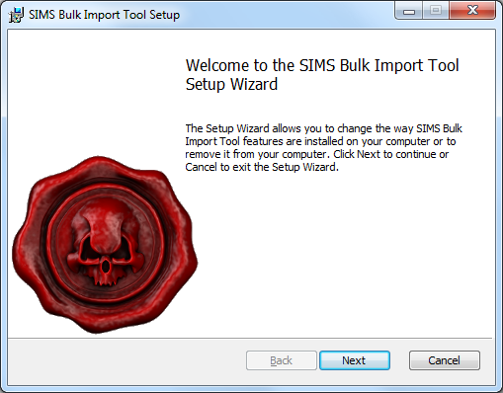
Click Next
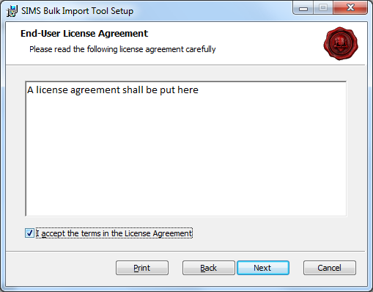
License agreement is currently missing from installer, check the I accept... then click Next

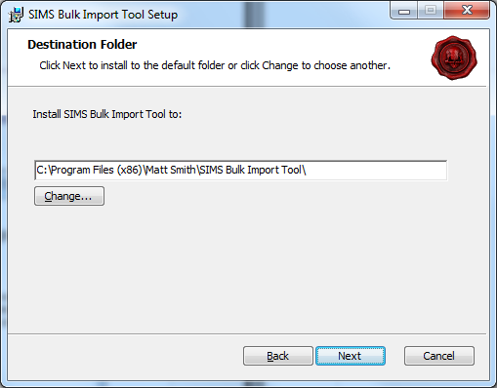
You then get the opportunity to change the install path, it doesn't matter where it installs. Personally, leave it, click Next

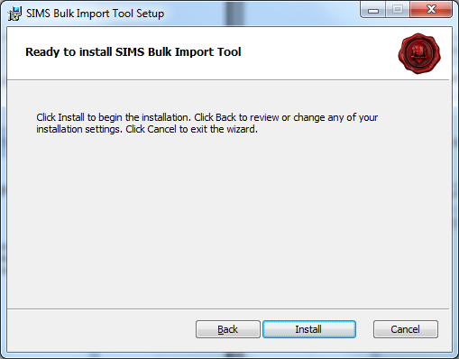
Click Install
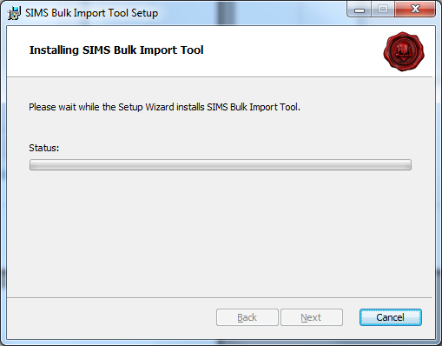
The installer will then install, you will get a UAC prompt on Windows 7\2008 machines asking you to confirm you wish to give the installer elevated rights, click yes so it can install the program.

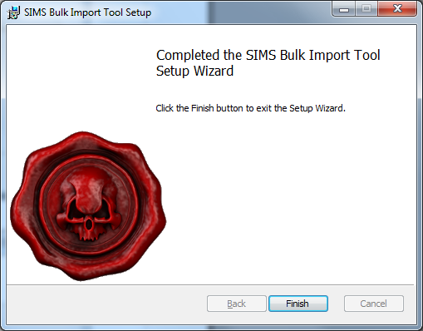
Once the installer completes, click Finish

Getting Started
When you first login you will be prompted with the following message:

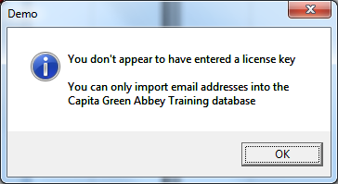
Currently you are unable to set the license key via the installer, you must enter the license key via the application. You can do this by click OK to close the popup. Then clicking Help > License

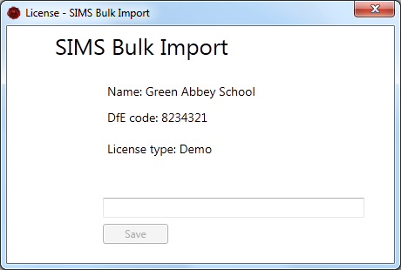
You can then enter your license key into the box and clicking Save.

Please refer to the licensing section of the guide for more information regarding requesting a license.
Once you have entered your license, you can then actually import data into SIMS .net.

To get started lets import something into Pupils - File > New > Pupil

When you first do this, it will need to create a connection to the SIMS .net database and you'll see:

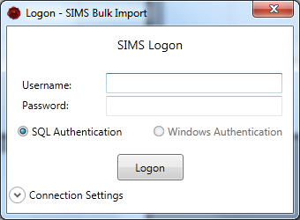
Currently only SIMS SQL logins are supported :(

Enter your Username and Password then click Logon, if you have multiple database it's worth checking the connection settings.

Click the Connection Settings to see the details that SIMS Bulk Import will use

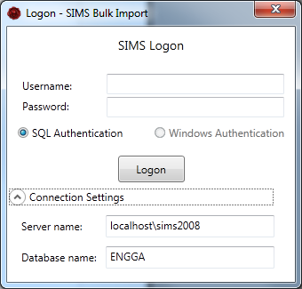
Once you're connected you see that the bottom status bar on the main window has updated with it's connection status – like below

Once you've connected to the database, you need to select the file you wish to import

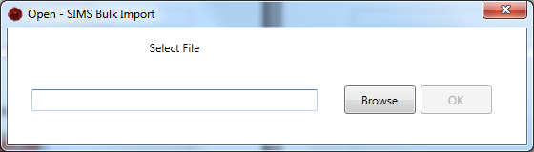
You can do this by either type the address or using the Browse button. Once you've found it, click OK

Once you've selected the file, the tool will then process the file, this normally involves copying the file to your temporary directory so it can process it.

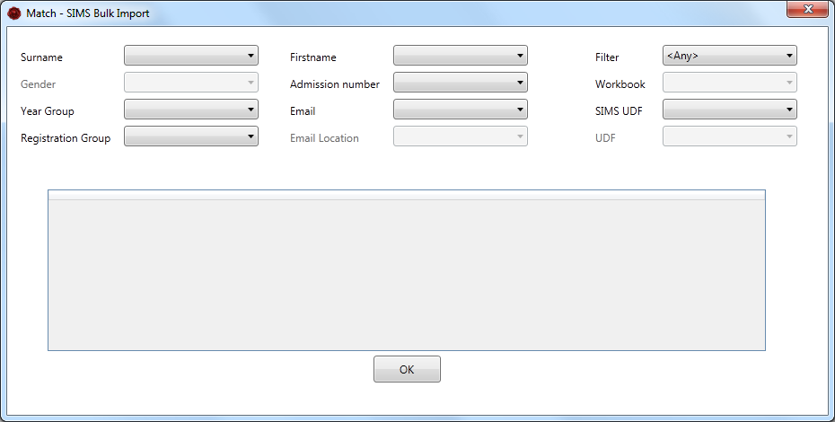
Once it's finished processing it, it will then give you the matching screen, this is where we match the fields from our file with the fields in SIMS .net.

As you match the fields the preview table will update. Please note this will only display the first 5 rows of data, this is due to performance issues.

If you require to import UDFs, it will list the UDFs that are already setup in SIMS .net, once you've selected which UDF you wish to import into, you then have to match that UDF to a field in your import file like you've just done, the field below UDF will update with the name of the UDF you selected and this should be used to match the chosen UDF field with the import file field.

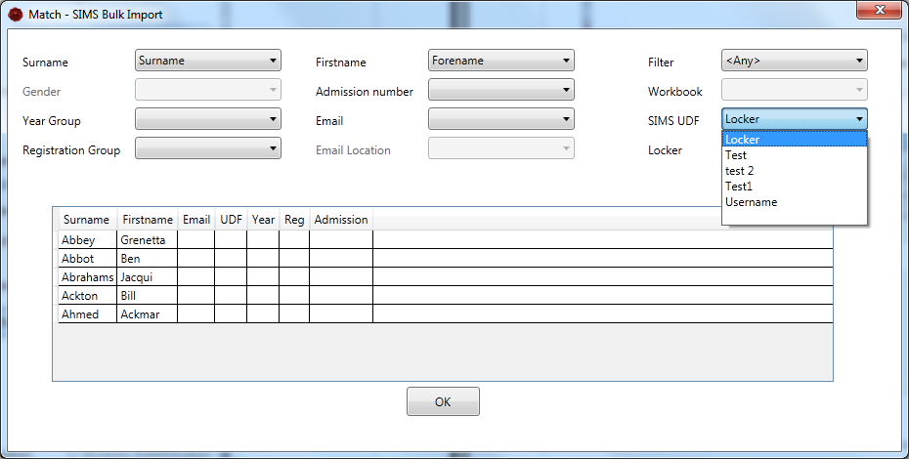
Once you are happy with the matching click OK.

The tool will then query the SIMS database and try and find the student in the SIMS .net database. If the database returns multiple students, it currently, does not allow you to select the correct student and you will not be able to import the data for that student. The tool will pull in additional or missing data that was not included in the import file, this should be used an as a opportunity to verify the data is correct and the tool has matched to the correct student.

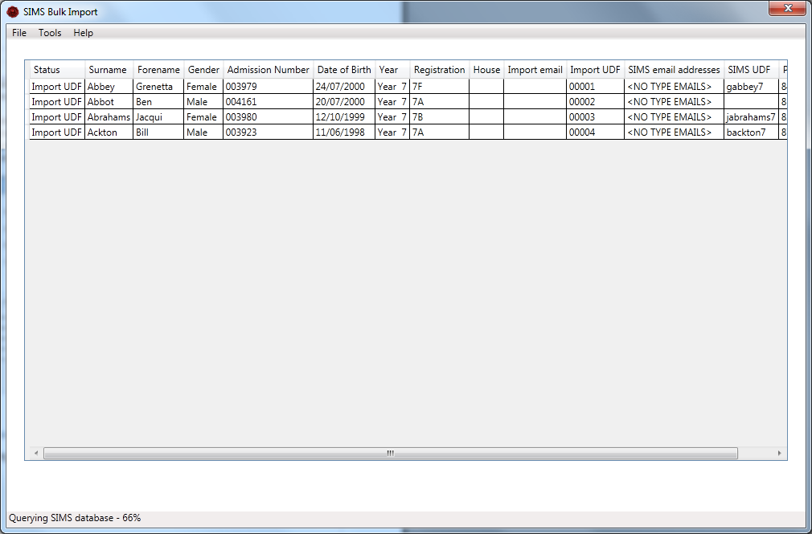
The status column will detail the action that the tool will perform when you click the Import button. Such as Import UDF and\or email (address), any other status will be ignored.

The import button will only appear once the tool has finished querying the SIMS database.

If you are unable to match students, it is recommended that you check within SIMS .net, as the same search routine is used. For example, the firstname may be spelt differently, it might be worth using admission number

Caution:
If you use admission number and you are providing this service to a number of schools, all though the admission number is unique, it is only unique for that school. Ensure you have the correct file for the correct school.

Once the import is complete the report will open.

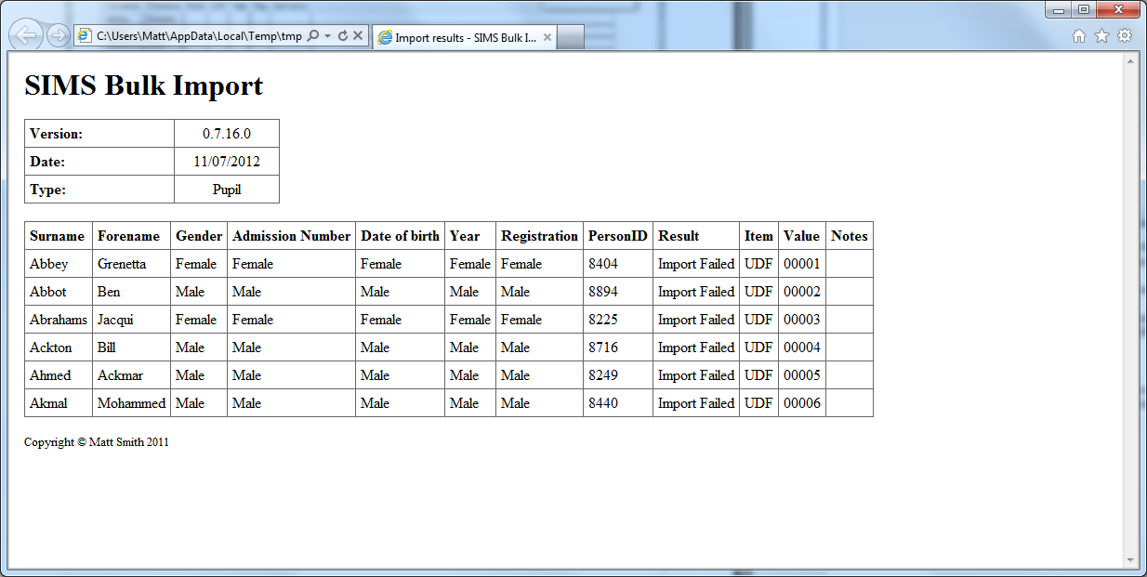

FAQs

Q. How does the system check for updates? Can this be turned off?

A. Every time the application is launched it will check for updates, I've not enabled the option from the tool to turn this off at this stage as they is likely to be a number of important updates that are required.
You can however manually turn it off by editing the SIMSBulkImport.exe.config and changing the following line:
<add key="AutoUpdate" value="True" />
to:
<add key="AutoUpdate" value="False" />

Q. Can I install the tool silently? For example for CentraStage deployment?

A. Yes, you can use the standard msiexec /i <msiname>.msi licensekey={licensekey} /qn /l* output.txt
replacing {LICENSEKEY} with your actual license key

For Example:
msiexec simsbulkimport.msi licensekey=demo /qn /l* output.txt
type output.txt

Q. I'm having trouble updating the license key

A. You can do it by editing the SIMSBulkImport.exe.config located in the SIMS Bulk Import Tool application directory

Add the following line below <appSettings>, replacing {LICENSEKEY} with your license key

<add key="LicenseKey" value="{LICENSEKEY}" />

Q. Can you custom the application (branding)

A. Yes, I can produce a custom build which includes your support telephone number, logo and name. I can also customize the result reports as well

Q. How are the SIMS connection details detected?

A. It uses the connect.ini, it looks in the following locations in this order:

- Application directory (same location as the SIMS Bulk Import Tool
- In the SIMS Application directory as set in the SIMS.ini
- In the c:\program files\sims\sims .net
- In the c:\program files (x86)\sims\sims .net

Redirects are supported but not recommended. If you manually change the connection details a temporary connect.ini will be generated and used.

