SIMS Bulk Import Guide
http://simsbulkimport.codeplex.com/



The SIMS Bulk Import tool is a freeware tool designed by Matt Smith, it allows the bulk import from a wide range of file formats including .txt, .csv, .xml and .xls directly into the Capita SIMS .net MIS system. It uses the SIMS Business Objects to achieve these wish means it should be “safe” to use in the live environment without invalidating support agreements with Capita.

It does not come with any guarantees or warranties and support is a on a “honour” bases. It is therefore recommend that SIMS Support Teams test the product before recommending it to schools they support. For example you understand that you could import the same email address for every pupil, staff and contact record in SIMS .net – assuming you foolish enough to create a file with the same email address for every person and then try and import it.

The application is not designed to generate data, only import existing data from another system that has been exported. For example, you have exported a list of users and their email addresses from Google Apps and you want to import that data into SIMS .net.

Content
Licensing 2
Support 3
Requirements 4
Installing 5
Getting Started 9
FAQs 14

Licensing
SIMS Bulk Import is licensed under the Microsoft Reciprocal License (Ms-RL). For more information please visit: http://simsbulkimport.codeplex.com/license

Previous licensing restrictions have been removed and you no longer require a (free) license key

Support

In the unfortunate event that you have a problem we recommend that you check that you are running the latest stable release by visiting the site - http://www.edugeek.net/forums/sims-bulk-import/

Problems can be raised via CodePlex by visiting http://simsbulkimport.codeplex.com/workitem/list/basic. You are required to register on CodePlex in order to log an issue. You are able to logon with a CodePlex account or use your Microsoft Account which you can use on other Microsoft sites such as Licensing and Outlook.

Under no circumstances should any personal data be published. Please ensure any log files are free of any data. SIMS Bulk Import tool should not log such information however it should still be inspected before transmission to a third party. It is highly recommended that DfE code and any other similar data is also removed to give the user anonymity.

A dedicated forum has also been setup on Edugeek which under Forums > EduGeek Projects > Projects > SIMS Bulk Import - http://www.edugeek.net/forums/sims-bulk-import/

Requirements

You require administrator rights in order to install the application. You also require administrator rights to change parameters such as the license key via the application.

You are required to have the SIMS .net client installed and working. This is because it uses Capita SIMS Business Objects

Microsoft .NET Framework 4.0 (Full)

10MB free hard disc space

Installing

Download the latest tool from: http://simsbulkimport.codeplex.com/

Getting Started
Once you have entered your license, you can then actually import data into SIMS .net.

To get started lets import something into Pupils - File > New > Pupil

When you first do this, it will need to create a connection to the SIMS .net database and you'll see:

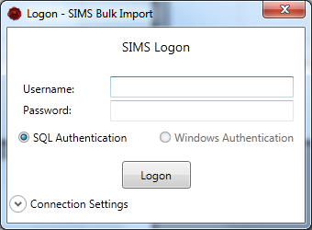
Currently only SIMS SQL logins are supported :(

Enter your Username and Password then click Logon, if you have multiple database it's worth checking the connection settings.

Click the Connection Settings to see the details that SIMS Bulk Import will use

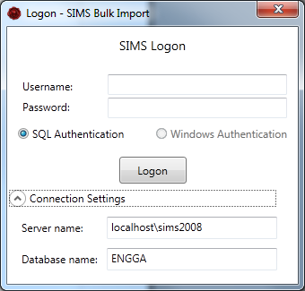
Once you're connected you see that the bottom status bar on the main window has updated with it's connection status

Once you've connected to the database, you need to select the file you wish to import

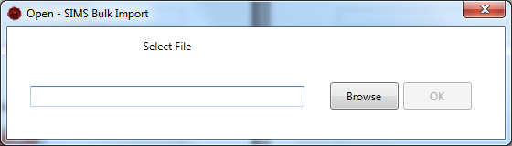
You can do this by either type the address or using the Browse button. Once you've found it, click OK

Once you've selected the file, the tool will then process the file, this normally involves copying the file to your temporary directory so it can process it.

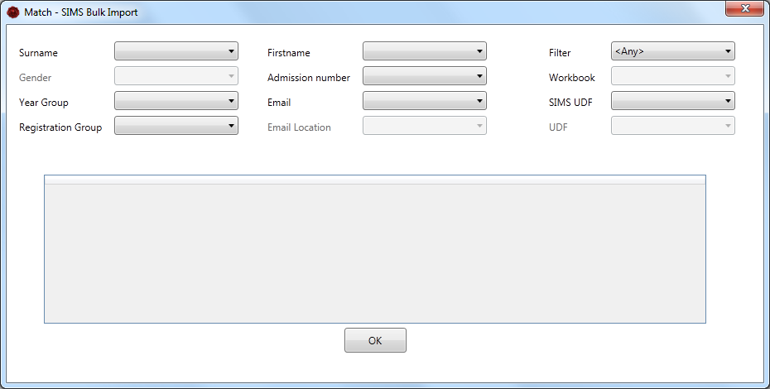
Once it's finished processing it, it will then give you the matching screen, this is where we match the fields from our file with the fields in SIMS .net.

As you match the fields the preview table will update. Please note this will only display the first 5 rows of data, this is due to performance issues.

If you require to import UDFs, it will list the UDFs that are already setup in SIMS .net, once you've selected which UDF you wish to import into, you then have to match that UDF to a field in your import file like you've just done, the field below UDF will update with the name of the UDF you selected and this should be used to match the chosen UDF field with the import file field.

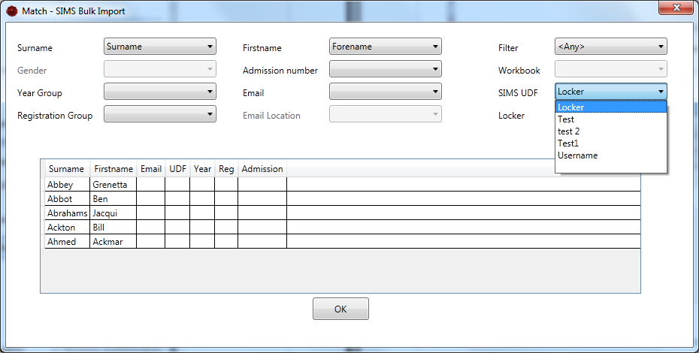
Once you are happy with the matching click OK.

The tool will then query the SIMS database and try and find the student in the SIMS .net database. If the database returns multiple students, it currently, does not allow you to select the correct student and you will not be able to import the data for that student. The tool will pull in additional or missing data that was not included in the import file, this should be used an as a opportunity to verify the data is correct and the tool has matched to the correct student.

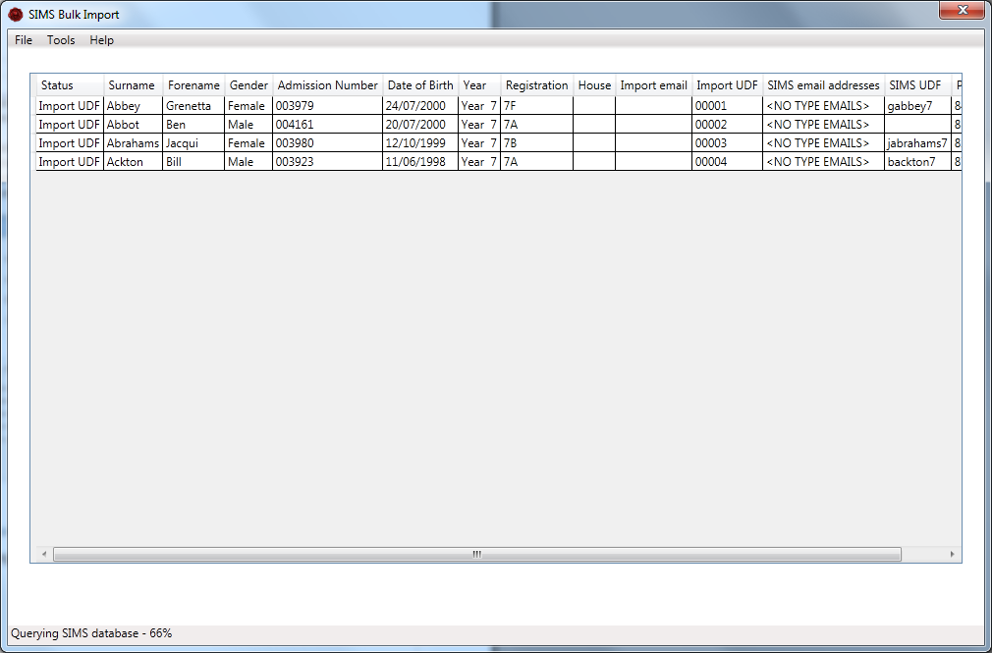
The status column will detail the action that the tool will perform when you click the Import button. Such as Import UDF and\or email (address), any other status will be ignored.

The import button will only appear once the tool has finished querying the SIMS database.

If you are unable to match students, it is recommended that you check within SIMS .net, as the same search routine is used. For example, the firstname may be spelt differently, it might be worth using admission number

Caution:
If you use admission number and you are providing this service to a number of schools, all though the admission number is unique, it is only unique for that school. Ensure you have the correct file for the correct school.

Once the import is complete the report will open.

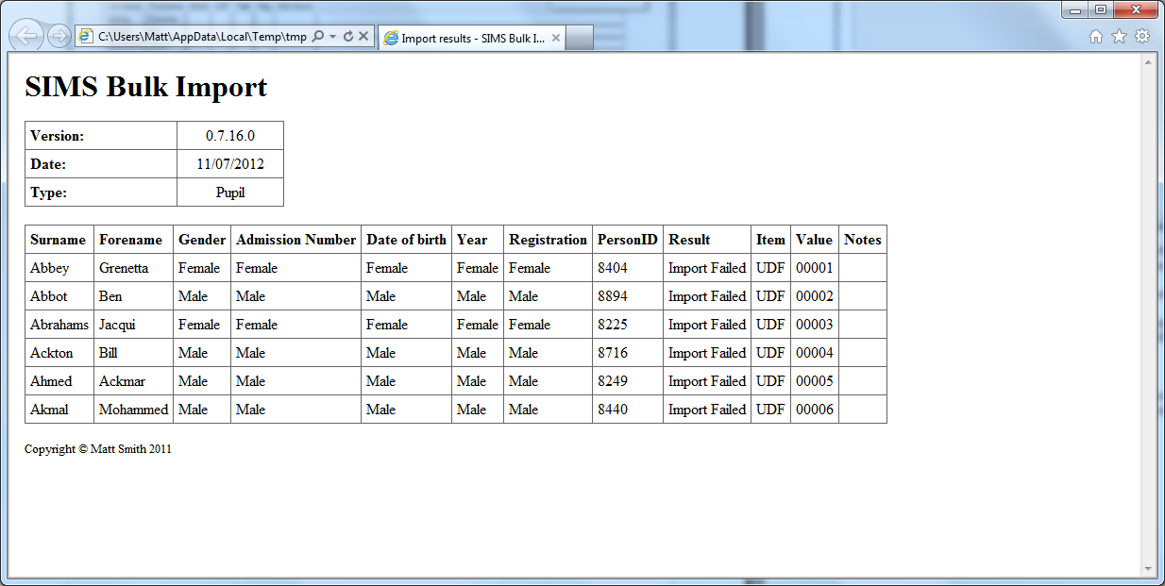

FAQs

Q. How does the system check for updates? Can this be turned off?

A. It currently uses ClickOnce which will check for updates every time it runs. It cannot be turned off.

Q. How are the SIMS connection details detected?

A. It uses the connect.ini, it looks in the following locations in this order:

- Application directory (same location as the SIMS Bulk Import Tool
- In the SIMS Application directory as set in the SIMS.ini
- In the c:\program files\sims\sims .net
- In the c:\program files (x86)\sims\sims .net

Redirects are supported but not recommended. If you manually change the connection details a temporary connect.ini will be generated and used.

