AZUBI AFRICA CAPSTONE PROJECT

Student Study Planner

Phase 5: Intern Presentation — Project Showcase

Status
Phase 5 Complete ✅

Date
June 11, 2026

Live URL
studentstudyplannerxyz.xyz

Infrastructure Flow
CloudFront → ALB → EC2

Phase 5: Intern Presentation — Project Showcase
Challenge: Present the completed cloud project, explain architectural decisions, and demo the live deployment.

Deliverables Checklist
Deliverable | Status
GitHub repo with all source code | ✅ Done
Completed Trello board (screenshot) | ✅ Done
Architecture diagram | ✅ Done
Live HTTPS URL (CloudFront) | ✅ Done
README with setup guide | ✅ Done
Presentation slides (this deck) | ✅ Done
Recorded demo video (optional) | ⬜ Optional

1 — Problem Statement

What Problem Does the App Solve?
Students often struggle to stay organised across multiple subjects, assignments, and deadlines. Paper planners are easily lost; general-purpose apps lack the academic context students actually need.
Student Study Planner is a purpose-built productivity tool that lets students:
- Create and manage study tasks — title, subject category, priority, and due date
- Track session progress — a live progress bar shows percentage of tasks completed
- Filter and search tasks — by status (All / Active / Completed) or keyword
- Stay motivated — a daily motivational quote refreshes on each visit
- Work offline — all state is persisted in localStorage; no back-end required
The application is completely free to use and runs in any modern browser.
Live URL: 🌐 https://www.studentstudyplannerxyz.xyz/

2 — Architecture Walkthrough

Full Traffic Flow: CloudFront → ALB → EC2
Student's Browser │ │ HTTPS — https://www.studentstudyplannerxyz.xyz/ ▼ ┌────────────────────────────────────────────────────┐ │ Namecheap DNS │ │ ALIAS @ → dk24845v6mvo0.cloudfront.net │ │ CNAME www → dk24845v6mvo0.cloudfront.net │ └────────────────────────┬───────────────────────────┘ │ ▼ HTTPS (TLS 1.2+) ┌────────────────────────────────────────────────────┐ │ AWS CloudFront Distribution │ │ Domain: dk24845v6mvo0.cloudfront.net │ │ Alt Names: studentstudyplannerxyz.xyz │ │ www.studentstudyplannerxyz.xyz │ │ Certificate: ACM (us-east-1) — auto-renewed │ │ Viewer Policy: Redirect HTTP → HTTPS │ │ Origin Policy: HTTPS Only │ │ Global edge caching across 400+ PoPs │ └────────────────────────┬───────────────────────────┘ │ HTTPS → ALB origin ▼ ┌────────────────────────────────────────────────────┐ │ Application Load Balancer (study-planner-alb) │ │ DNS: study-planner-alb-1113325153. │ │ us-east-1.elb.amazonaws.com │ │ Listener: HTTP : 80 → forward capstone-web-tg │ │ Health Check: GET /health.html → 200 OK │ └────────────────────────┬───────────────────────────┘ │ HTTP : 80 ▼ ┌────────────────────────────────────────────────────┐ │ Auto Scaling Group (capstone-web-asg) │ │ Desired: 1 | Min: 1 | Max: 3 │ │ Launch Template: capstone-web-lt (t3.micro) │ │ AMI: Capstone-WebServer-AMI │ │ │ │ ├── EC2: Capstone-WebServer (i-039e2bea39a5ec163)│ │ │ Nginx serving /var/www/study-planner │ │ └── EC2: ASG clone instance(s) (auto-registered) │ └────────────────────────────────────────────────────┘ S3 Bucket (static assets — Azubi logo, images) capstone-static-assets-azubi-610356897914-us-east-1-an

Component Reference
Component | Service | Key Detail
DNS | Namecheap (custom domain) | ALIAS + CNAME → CloudFront
CDN | AWS CloudFront | 400+ global edge locations
TLS/SSL | AWS Certificate Manager (ACM) | DNS-validated, auto-renewed
Load Balancer | AWS Application Load Balancer | Internet-facing, us-east-1
Compute | AWS EC2  t3.micro | Amazon Linux 2023, Nginx
Scaling | AWS Auto Scaling Group | 1–3 instances, ELB health check
Static Assets | AWS S3 | Public bucket, HTTPS served
CI/CD | GitHub Actions | appleboy/ssh-action  , push-to-deploy
Monitoring | AWS CloudWatch | Alarms + Logs, 7-day retention
Cost Control | AWS Budgets | Zero Spend alert ($0.01 threshold)

3 — Security Decisions

How Is the Deployment Secured End-to-End?

Identity & Access Management (IAM)
- Principle of Least Privilege — no AdministratorAccess was granted. Six scoped AWS-managed policies cover only the services used: EC2, S3, ACM, CloudFront, ELB, and IAM Read-only.
- Group-based permissions — all users belong to CloudCapstoneTeam. Changes to permissions cascade to all team members automatically.
- Individual access keys — each of the five team members has isolated programmatic credentials.
- No credentials in source control — access keys are stored only in local ~/.aws/credentials files.

Transport Security
- HTTPS enforced end-to-end — CloudFront is configured to Redirect HTTP → HTTPS; the ALB origin is set to HTTPS Only.
- TLS 1.2+ — CloudFront negotiates TLS 1.2 minimum with browsers.
- ACM certificate — public certificate for studentstudyplannerxyz.xyz is DNS-validated and auto-renewed by AWS. Zero manual certificate rotation.

Network Security
- EC2 Security Group — inbound rules allow HTTP (80) and HTTPS (443) only. SSH (22) is restricted and is not exposed publicly.
- SSH key authentication — the EC2 instance uses an RSA key pair (eddie-key.pem); password authentication is disabled.
- GitHub Actions SSH secrets — EC2 host, username, and private key are stored as GitHub repository secrets (EC2_HOST, EC2_USER, EC2_SSH_KEY). Secrets are never printed in logs.

CI/CD Security
- No plaintext credentials — the deploy.yml workflow references only encrypted secrets.
- Scoped deployment script — the deploy script does the minimum required: git pull, cp, chown, nginx -t, systemctl reload nginx. No shell escaping or arbitrary code paths.

Observability & Cost Safety
- CloudWatch Alarms — EC2-High-CPU (>80% for 15 min) and ALB-High-5XX (>5% 5xx error rate) trigger SNS email alerts.
- CloudWatch Logs — Nginx access and error logs streamed to AWS with 7-day retention.
- AWS Budgets — Free-Tier-Monitor sends an email alert on any spend above $0.01, preventing surprise charges.

4 — CI/CD Demo

GitHub Actions Pipeline
Every git push to the main branch triggers an automated deployment to the EC2 instance — no manual SSH or file copying required.

Workflow File (.github/workflows/deploy.yml)
name: Deploy to EC2 on: push: branches: - main jobs: deploy: runs-on: ubuntu-latest steps: - name: SSH into EC2 and deploy uses: appleboy/ssh-action@v1.0.0 with: host: ${{ secrets.EC2_HOST }} username: ${{ secrets.EC2_USER }} key: ${{ secrets.EC2_SSH_KEY }} script: | set -e cd /home/ec2-user/aws-capstone-project git pull origin main sudo cp -r app/* /var/www/study-planner/ sudo chown -R nginx:nginx /var/www/study-planner sudo nginx -t sudo systemctl reload nginx echo "Deployment complete."

Deployment Flow
Developer pushes to main │ ▼ GitHub Actions runner (ubuntu-latest) │ ▼ SSH via appleboy/ssh-action (encrypted GitHub secret) EC2 Instance (3.237.34.20) │ ├── git pull origin main ← pulls latest code ├── cp app/* → /var/www/study-planner/ ├── chown nginx:nginx ← sets correct file ownership ├── nginx -t ← validates config before reload └── systemctl reload nginx ← zero-downtime reload │ ▼ Live site updated ✅

How to Trigger a Live Demo
- Make any change to a file in the app/ directory.
- Commit and push to main:git add app/index.html git commit -m "demo: update heading text" git push origin main
- Navigate to GitHub → Actions tab and watch the workflow run in real time.
- Refresh https://www.studentstudyplannerxyz.xyz/ to see the change live.

Bugs Fixed During Setup
Bug | Root Cause | Fix Applied
Workflow parse error | on:  and  jobs:  had 3 leading spaces — invalid YAML | Fixed to column-0 top-level alignment
Deploy path not found | Used placeholder  your-app-folder  that did not exist | Changed to  /home/ec2-user/aws-capstone-project
Wrong server commands | Used  npm install  +  pm2 restart  (Node.js) on a static Nginx site | Replaced with  cp  ,  chown  ,  nginx -t  ,  systemctl reload nginx

5 — Trello Board Review

Kanban Workflow
The AWS Capstone Project Trello board used four columns throughout the project:
Column | Purpose
Backlog | All planned tasks not yet started
In Progress | Actively being worked on by a team member
Review | Completed work awaiting peer review
Done | Accepted and merged

Sprint History by Phase
Phase | Sprint Focus | Key Cards Completed
Phase 1 | Setup & Foundation | IAM users, CLI config, GitHub repo, Trello board, EC2 + S3 provisioning, ACM cert request
Phase 2 | App Deployment | Nginx install, SCP deploy, ALB + Target Group, S3 static assets sync, Auto Scaling Group
Phase 3 | CDN & HTTPS | CloudFront distribution, ACM attachment, HTTP→HTTPS redirect, custom domain DNS
Phase 4 | CI/CD & Monitoring | GitHub Actions workflow, Git on EC2, CloudWatch Alarms, CloudWatch Logs, AWS Budgets, DNS go-live
Phase 5 | Presentation | Trello review, peer code review, presentation document

All Tasks Complete ✅
Every card across all five phases has been moved to the Done column. The board represents a complete sprint history of the project from initial AWS account setup through production go-live.

6 — Live Demo

Application Access
URL | Status
https://studentstudyplannerxyz.xyz | ✅ Live — 200 OK via CloudFront
https://www.studentstudyplannerxyz.xyz | ✅ Live — 200 OK via CloudFront

Demo Script (Step-by-Step)
- Openhttps://www.studentstudyplannerxyz.xyz in a browser.
- Verify HTTPS — padlock icon confirms TLS is active (ACM certificate).
- Add a task — enter a task name, select subject, priority, and due date → click Add Task.
- Complete a task — check the checkbox to mark it done and watch the progress bar update.
- Filter tasks — switch between All / Active / Completed using the filter buttons.
- Inspect CloudFront headers — open DevTools → Network → reload → click on the document:Via: 1.1 xxxx.cloudfront.net (CloudFront) X-Cache: Hit from cloudfront ← content served from edge Server: nginx/1.30.2 ← origin server identity
- Verify CI/CD — show the GitHub Actions tab with successful workflow runs.

7 — Challenges Faced

Blockers Encountered and How They Were Resolved
# | Challenge | Root Cause | Resolution
1 | GitHub Actions workflow failed to parse | on:  and  jobs:  were indented with 3 spaces — YAML requires top-level keys at column 0 | Corrected indentation; workflow parsed successfully on next push
2 | Deploy script ran  npm install  /  pm2  — commands not found on EC2 | Starter template assumed a Node.js app, not a static Nginx site | Replaced with  git pull  ,  cp  ,  chown  ,  nginx -t  ,  systemctl reload nginx
3 | CloudFront returned 502 Bad Gateway | ALB origin was configured with HTTP; CloudFront was set to HTTPS Only | Corrected the origin protocol to match the ALB listener (HTTP) and ensured the ALB forwarded to the correct target group
4 | CloudFront X-Cache showed "Miss" on every request | Cache behaviour had TTL set to 0 / CachingDisabled policy was applied | Verified caching policy; understood that dynamic ALB content intentionally bypasses cache for freshness
5 | Domain apex (  studentstudyplannerxyz.xyz  ) was not resolving | Namecheap does not natively support ALIAS records for the apex; initial CNAME failed | Added an ALIAS record (  @  → CloudFront domain) in Namecheap Advanced DNS; propagated within 5 minutes
6 | EC2 instance lacked Git;  git pull  failed during first CI/CD run | Amazon Linux 2023 does not include Git by default | Ran  sudo dnf install -y git  and cloned the repo manually; subsequent CI/CD runs pulled successfully
7 | ACM certificate stayed "Pending validation" | DNS CNAME validation record was not yet added to the domain registrar | Added the ACM-generated CNAME to Namecheap DNS; certificate status changed to "Issued" within minutes

8 — Lessons Learned

What Worked Well
- Layered AWS architecture — separating concerns (CloudFront → ALB → EC2) gave us independent control over caching, load balancing, and compute without coupling any layer to another.
- ACM for TLS — zero-configuration certificate renewal removed the operational burden of managing SSL certificates manually.
- GitHub Actions for CI/CD — once the YAML indentation bug was fixed, push-to-deploy was seamless. The team could merge PRs and see live changes within ~30 seconds.
- CloudWatch Logs + Alarms — having observability from day one meant we could investigate the CloudFront caching issue with real log data rather than guessing.
- Free Tier discipline — using AWS Budgets with a $0.01 alert gave confidence to experiment without fear of unexpected bills.

What We'd Do Differently Next Time
Area | Current Approach | Improved Approach
Infrastructure provisioning | Manual AWS Console clicks | Infrastructure as Code — AWS CloudFormation or Terraform for reproducible, version-controlled infrastructure
Secrets management | GitHub repository secrets (flat key-value) | AWS Secrets Manager or AWS Parameter Store for rotation and auditing
HTTPS end-to-end | CloudFront → ALB via HTTPS, ALB → EC2 via HTTP | Add ACM certificate to ALB HTTPS listener; use HTTPS internally as well
Database / persistence | localStorage  only (client-side) | Add Amazon RDS (PostgreSQL) or DynamoDB for shared, server-side persistence
Monitoring | CloudWatch CPU + 5xx alarms only | Add custom application metrics (task creation rate, error rate) and a CloudWatch Dashboard
Deployment rollback | No rollback mechanism | Use blue/green deployments via ALB weighted target groups or AWS CodeDeploy
Load testing | Not performed | Add k6 or AWS Distributed Load Testing to validate ASG scale-out behaviour

Architecture Diagram (Final State — All Phases)
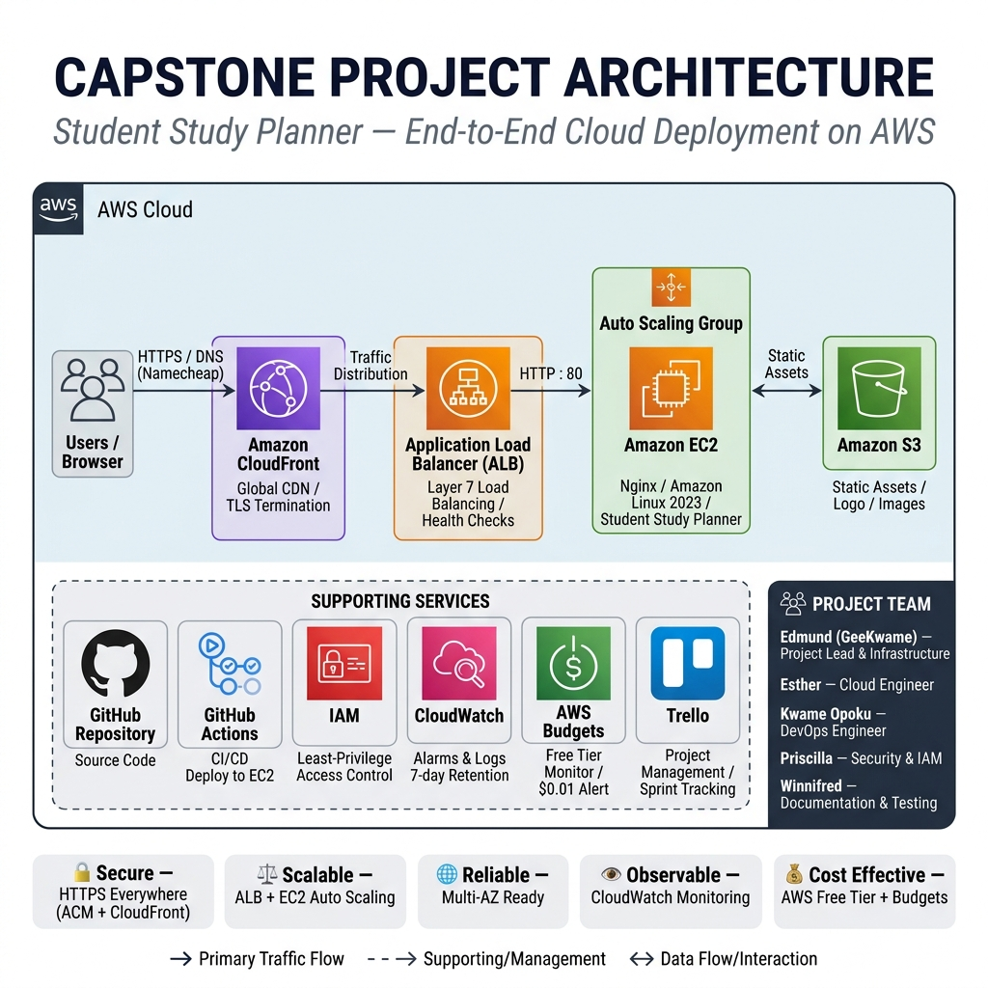
┌─────────────────────────────────────────────────────────────────┐ │ INTERNET │ └──────────────────────────────┬──────────────────────────────────┘ │ HTTPS ▼ Namecheap DNS (ALIAS @ + CNAME www → CloudFront) │ ▼ ┌─────────────────────────────────┐ │ AWS CloudFront CDN │ │ dk24845v6mvo0.cloudfront.net │ │ ACM Certificate (TLS 1.2+) │ │ HTTP → HTTPS redirect │ │ Global edge caching │ └────────────────┬────────────────┘ │ HTTPS ▼ ┌─────────────────────────────────┐ │ Application Load Balancer │ │ study-planner-alb │ │ HTTP : 80 listener │ │ Health check: /health.html │ └────────────────┬────────────────┘ │ HTTP : 80 ▼ ┌─────────────────────────────────┐ │ Auto Scaling Group │ │ capstone-web-asg (1–3) │ │ │ │ ┌───────────────────────────┐ │ │ │ EC2: Capstone-WebServer │ │ │ │ t3.micro, Amazon Linux │ │ │ │ Nginx → /var/www/ │ │ │ │ study-planner │ │ │ └───────────────────────────┘ │ └─────────────────────────────────┘ ┌─────────────────────────────────┐ │ S3 Bucket (static assets) │ │ capstone-static-assets-azubi.. │ └─────────────────────────────────┘ CI/CD Pipeline: Developer → git push → GitHub Actions → SSH → EC2 → Nginx reload Monitoring: CloudWatch Alarms (EC2 CPU, ALB 5xx) → SNS → Email CloudWatch Logs (Nginx access + error) — 7-day retention AWS Budgets (Free-Tier-Monitor) → Email on any spend > $0.01

Repository & Links
Resource | Link
GitHub Repository | GeekKwame/aws-capstone-project
Live Application | https://www.studentstudyplannerxyz.xyz/
Phase 1 Docs | docs/phase1/README.md
Phase 2 Docs | docs/phase2/README.md
Phase 3 Docs | docs/phase3/README.md
Phase 4 Docs | docs/phase4/README.md

Team
Name | GitHub | AWS IAM User | Role
Edmund (GeekKwame) | GeekKwame | Edmund | Repository owner, infrastructure lead
Esther | — | Esther | Team member
Kwame Opoku | OwassJnr | Kwame | Team member
Priscilla | cilla-sys | Priscilla | Team member
Winnifred | winnhans-devops | Winnifred | Team member

Last updated: June 11, 2026 — Phase 5 complete. All phases documented, all deliverables submitted.

