Phase 4 Report
CI/CD Pipeline, Monitoring & Cost Management
Student Study Planner — AWS Capstone Project
June 2026

Phase 4 Overview
Challenge: Automate deployments and set up observability within Free Tier limits.

Activities Summary
Activity | Status
Create GitHub Actions CI/CD workflow | ✅ Done
Install Git on EC2 and clone repository | ✅ Done
Set up SSH deploy script for EC2 + Nginx reload | ✅ Done
Configure CloudWatch Alarms (CPU > 80%, ALB 5xx > 5%) | ✅ Done
Install & configure CloudWatch Logs Agent (7-day retention) | ✅ Done
Create AWS Budgets Free-Tier alert | ✅ Done
Update Trello board | ⏳ Pending
Peer code review via GitHub Pull Requests | ⏳ Pending

Task 1 — GitHub Actions CI/CD Workflow
A GitHub Actions workflow was created at .github/workflows/deploy.yml to automatically deploy application code to the EC2 instance on every push to the main branch.

Workflow File (deploy.yml)
name: Deploy to EC2

on:
push:
branches:
- main

jobs:
deploy:
runs-on: ubuntu-latest
steps:
- name: SSH into EC2 and deploy
uses: appleboy/ssh-action@v1.0.0
with:
host: ${{ secrets.EC2_HOST }}
username: ${{ secrets.EC2_USER }}
key: ${{ secrets.EC2_SSH_KEY }}
script: |
set -e
cd /home/ec2-user/aws-capstone-project
git pull origin main
sudo cp -r app/* /var/www/study-planner/
sudo chown -R nginx:nginx /var/www/study-planner
sudo nginx -t
sudo systemctl reload nginx
echo "Deployment complete."

deploy.yml on GitHub
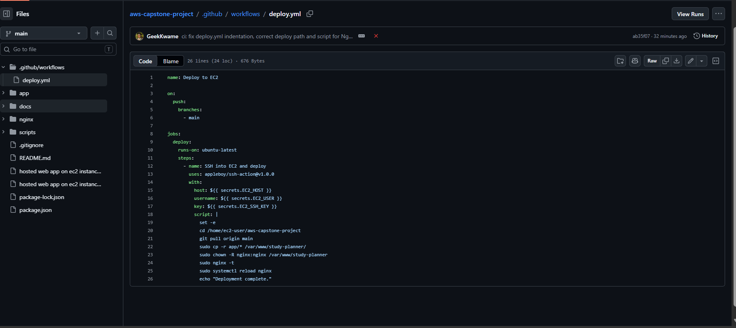
Figure: deploy.yml file as viewed on GitHub.

GitHub Actions Workflow Runs
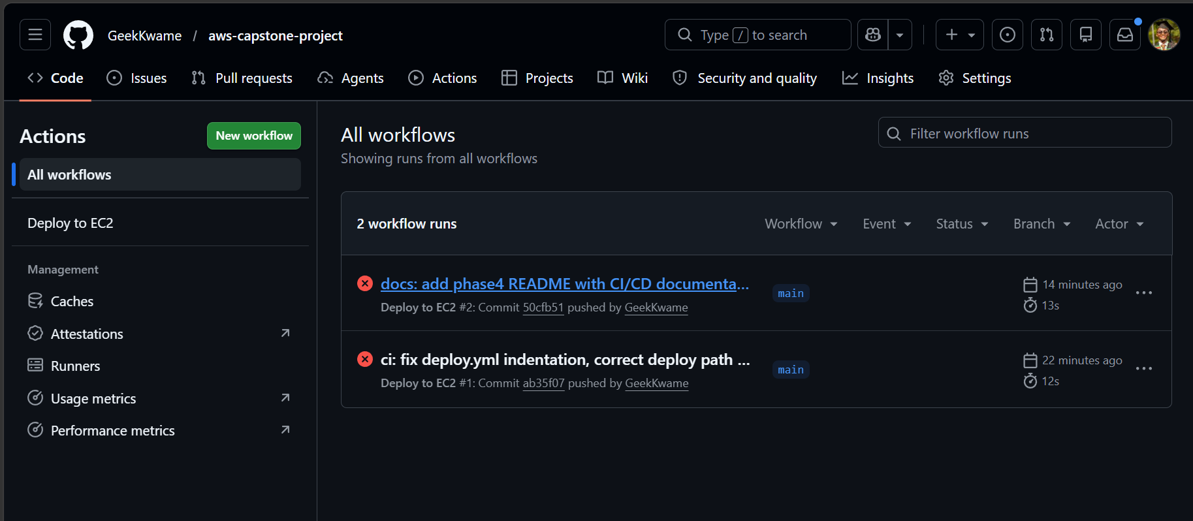
Figure: GitHub Actions tab showing the workflow.
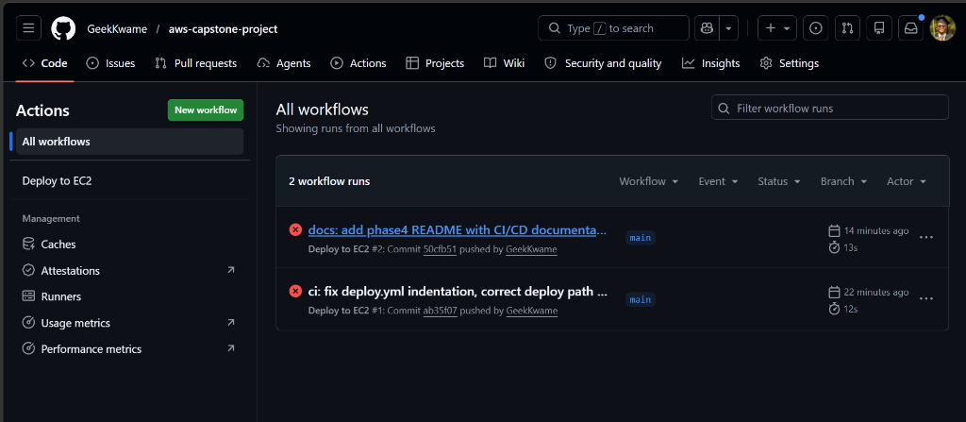
Figure: List of workflow runs triggered by pushes to main.

GitHub Repository Secrets
Three repository secrets are required for the workflow to SSH into EC2:
Secret Name | Description
EC2_HOST | EC2 Public IP — 3.237.34.20
EC2_USER | SSH username — ec2-user
EC2_SSH_KEY | Full contents of the SSH private key (.pem)

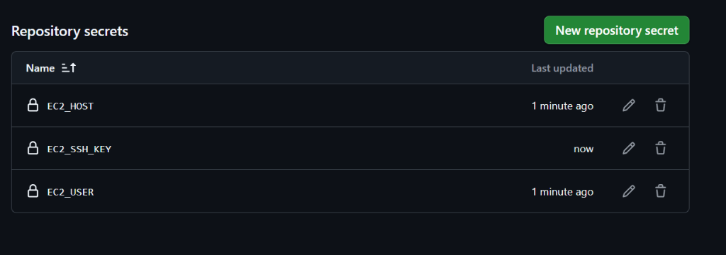
Figure: EC2_HOST, EC2_USER, and EC2_SSH_KEY configured as Actions secrets.

Bugs Fixed in Original deploy.yml
Bug | Fix Applied
on: and jobs: had 3 leading spaces — invalid YAML | Fixed to column-0 alignment
Deploy path 'your-app-folder' was a placeholder | Changed to /home/ec2-user/aws-capstone-project
npm install + pm2 restart — wrong for static Nginx site | Replaced with cp, chown, nginx -t, systemctl reload

Task 2 — Git Installation & Repository Clone on EC2
Git was not pre-installed on the Amazon Linux 2023 instance. It was installed and the GitHub repository was cloned to enable git pull during CI/CD deployments.

Commands Run on EC2
# Install Git
sudo dnf install -y git
git --version # git version 2.50.1

# Clone the repository
git clone https://github.com/GeekKwame/aws-capstone-project.git \
/home/ec2-user/aws-capstone-project

Verification
--- Repo app files ---
css health.html index.html js

--- Nginx web root ---
css health.html index.html js
Both directories match, confirming the deploy script will copy the correct files on future pushes.

Task 3 — CloudWatch Alarms
CloudWatch Alarms were set up to monitor infrastructure health and alert the team via email when the EC2 instance is under heavy load or the ALB starts returning HTTP 5xx errors.

1. EC2 CPU Utilization Alarm (EC2-High-CPU)
Property | Value
Metric | EC2 > Per-Instance Metrics > CPUUtilization
Threshold | Greater than 80%
Evaluation Period | 3 consecutive periods of 5 minutes
SNS Topic | ec2-cpu-alert
Alarm Name | EC2-High-CPU

Configuration Steps
- Navigated to CloudWatch → Alarms → Create Alarm.
- Clicked Select metric → EC2 → Per-Instance Metrics → selected CPUUtilization.
- Set threshold type to Static, value to 80.
- Set evaluation periods to 3 out of 3.
- Created new SNS topic ec2-cpu-alert and subscribed the team email.
- Clicked Create alarm and confirmed the email subscription.

Screenshots
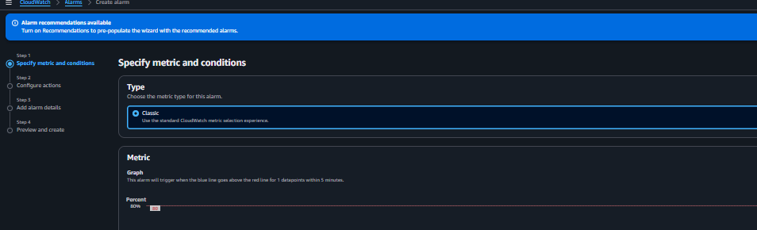
Figure: Selecting the CPUUtilization metric for the EC2 instance.
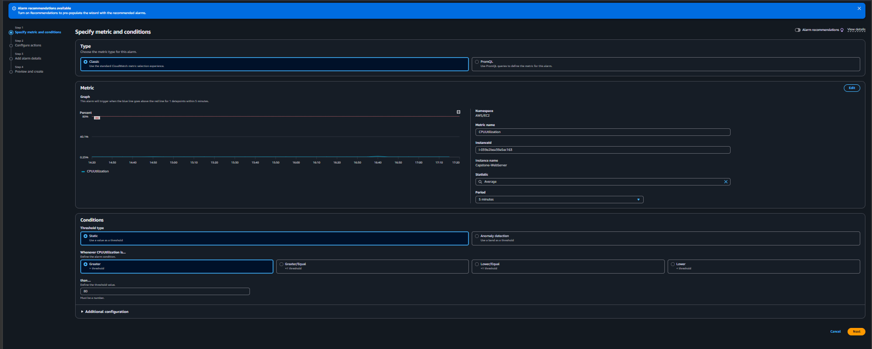
Figure: Setting the alarm threshold to >80% for 3 consecutive 5-min periods.
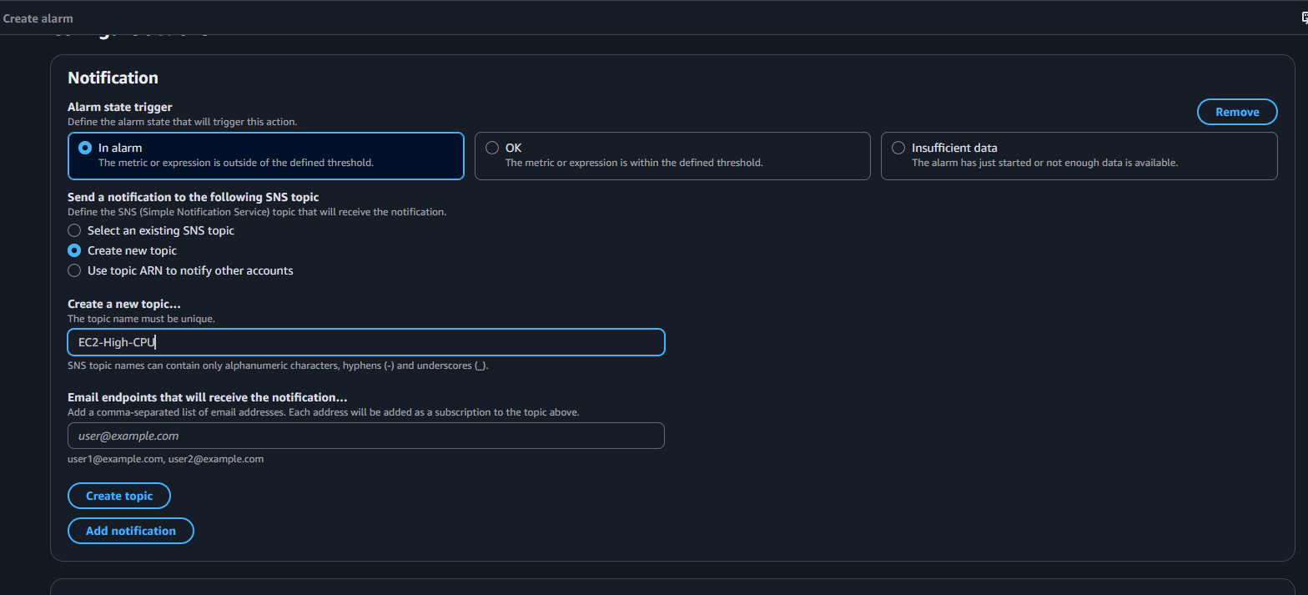
Figure: Configuring SNS email notifications.
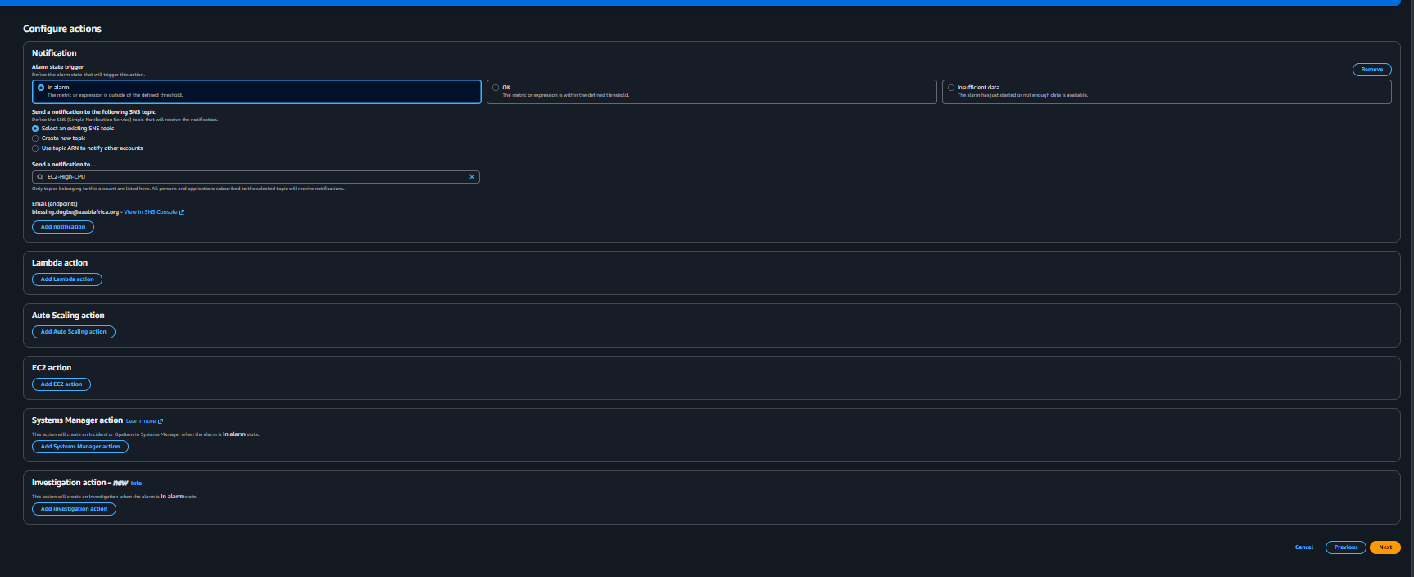
Figure: EC2-High-CPU alarm created and listed in the CloudWatch dashboard.

2. ALB 5xx Error Rate Alarm (ALB-High-5XX)
Property | Value
Metric | ApplicationELB > Per AppELB Metrics
Math Expression | e1/m1*100 (HTTPCode_ELB_5XX_Count / RequestCount × 100)
Threshold | Greater than 5%
SNS Topic | ec2-cpu-alert (existing)
Alarm Name | ALB-High-5XX

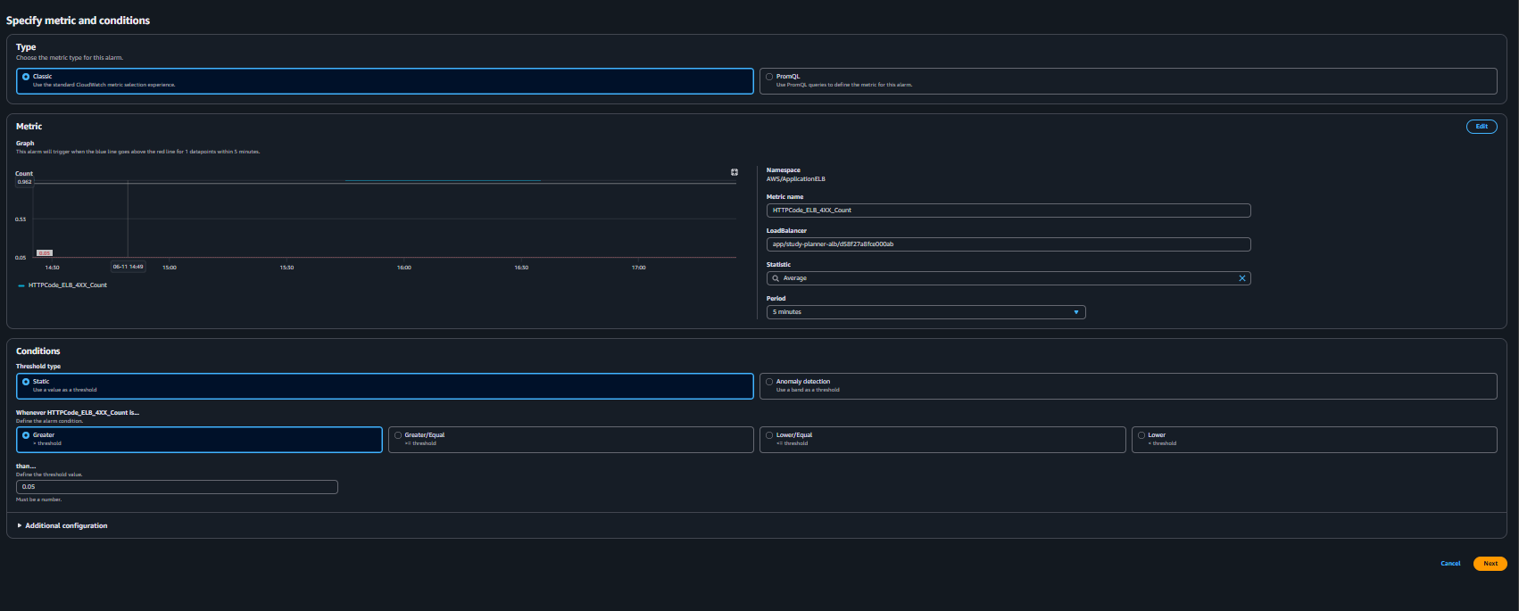
Figure: Math expression alarm setup for calculating ALB 5xx error percentage.

Task 4 — CloudWatch Logs Agent
The Amazon CloudWatch Logs Agent was installed and configured on the EC2 instance to stream Nginx logs to AWS CloudWatch with a 7-day retention policy.

Installation
sudo yum install amazon-cloudwatch-agent -y
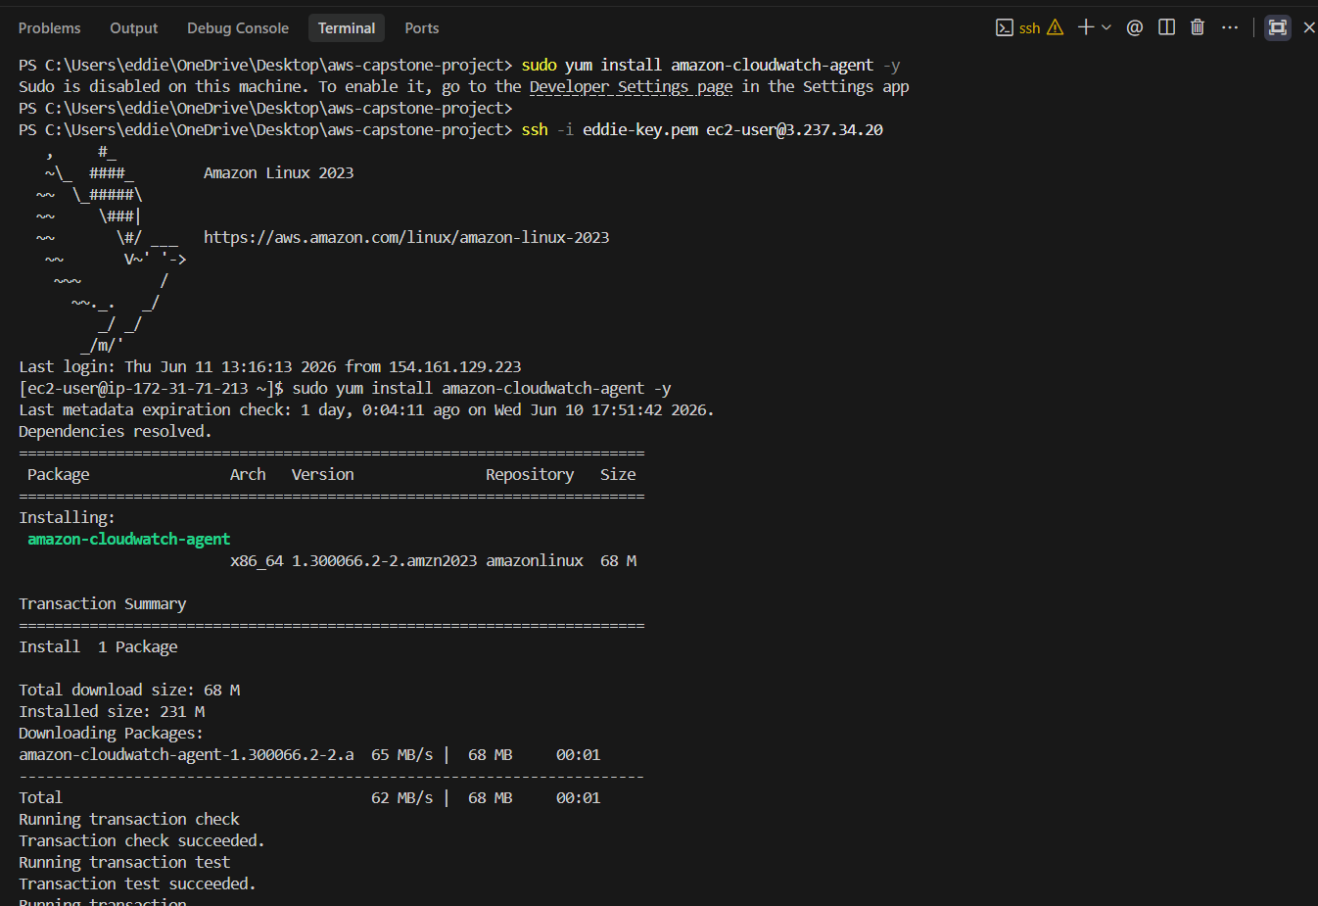
Figure: CloudWatch Agent installed on EC2 (version 1.300066.2-2).

Configuration File
Config file written to: /opt/aws/amazon-cloudwatch-agent/etc/amazon-cloudwatch-agent.json
{"logs":{"logs_collected":{"files":{"collect_list":[
{"file_path":"/var/log/nginx/access.log",
"log_group_name":"study-planner-nginx",
"log_stream_name":"{instance_id}",
"retention_in_days":7},
{"file_path":"/var/log/nginx/error.log",
"log_group_name":"study-planner-nginx-errors",
"log_stream_name":"{instance_id}",
"retention_in_days":7}
]}}}}
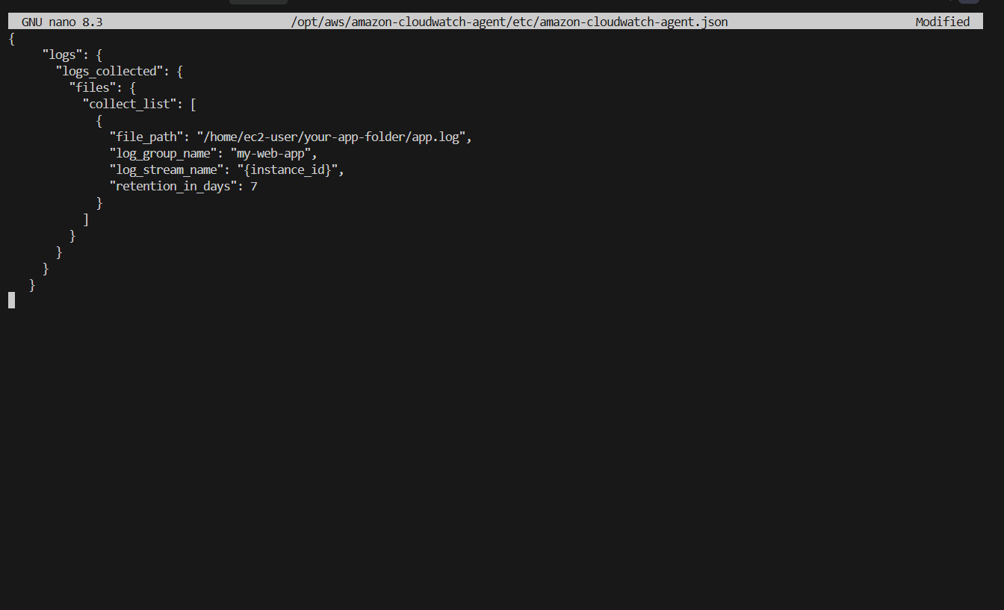
Figure: Agent JSON config open in nano on EC2 — log paths, group, stream, and 7-day retention.

Starting the Agent
sudo /opt/aws/amazon-cloudwatch-agent/bin/amazon-cloudwatch-agent-ctl \
-a fetch-config -m ec2 \
-c file:/opt/aws/amazon-cloudwatch-agent/etc/amazon-cloudwatch-agent.json -s
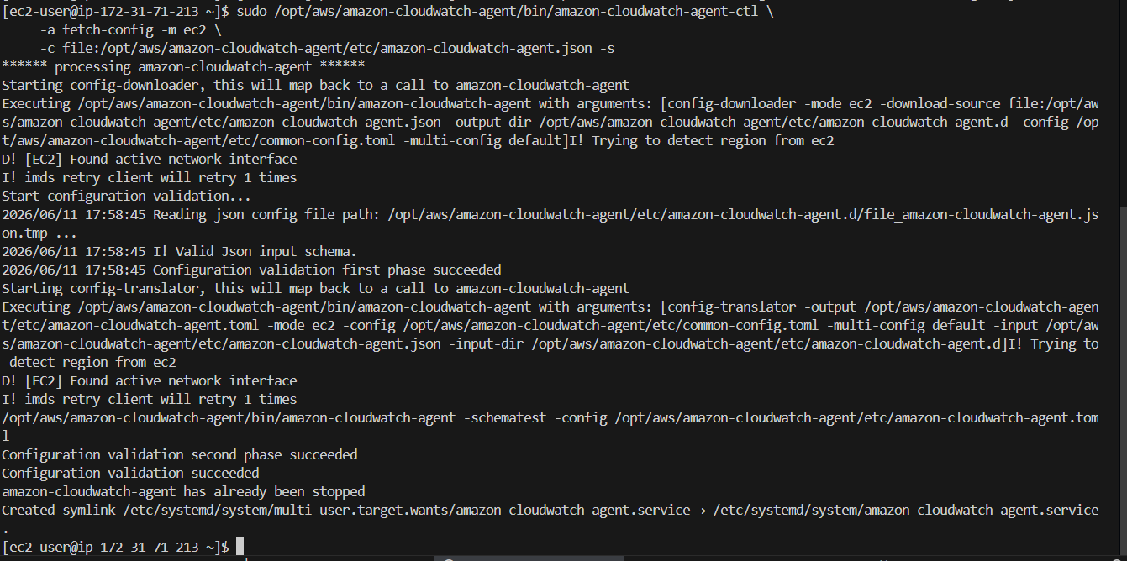
Figure: Configuration validation succeeded and CloudWatch Agent service started.

Summary
Property | Value
Log Group (access) | study-planner-nginx
Log Group (errors) | study-planner-nginx-errors
Log Stream | {instance_id} (auto-resolved per instance)
Retention | 7 days

Task 5 — AWS Budgets
An AWS Budget alert was created to monitor monthly spending and send an email notification the moment any cost above $0.01 is incurred, protecting the team from unexpected Free Tier overages.

Configuration Steps
- Navigated to AWS Console → Billing → Budgets → Create budget.
- Selected the Zero spend budget template (alerts on any spend above $0.01).
- Named the budget: Free-Tier-Monitor.
- Added the team lead email address as a notification recipient.
- Clicked Create budget.

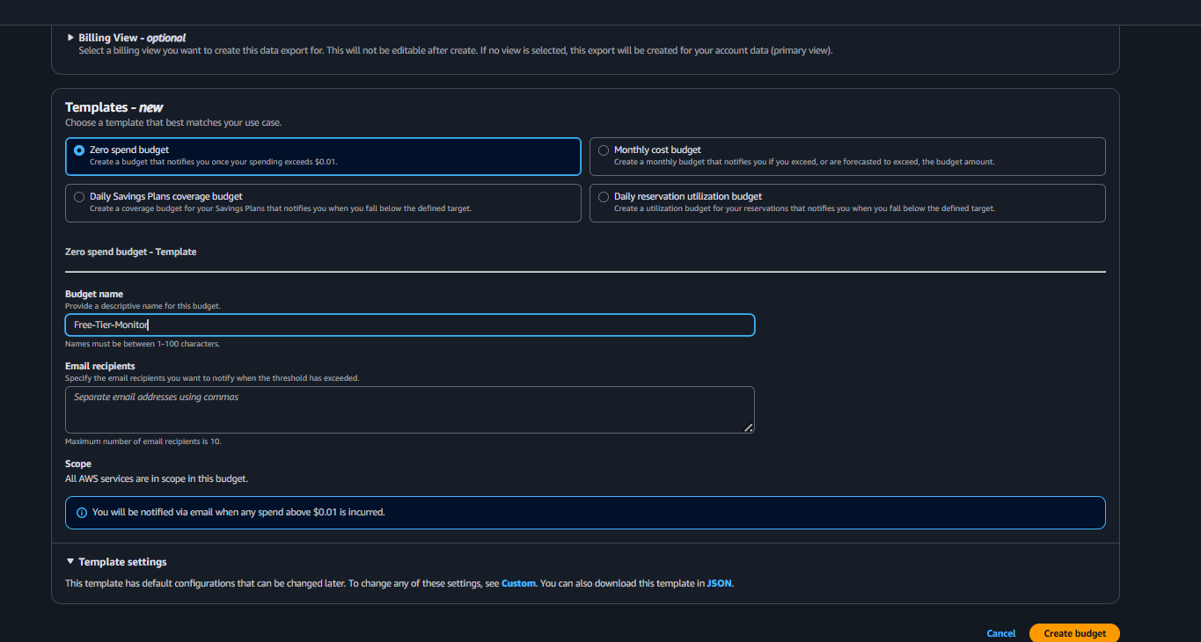
Figure: Zero spend budget template selected and named 'Free-Tier-Monitor'.
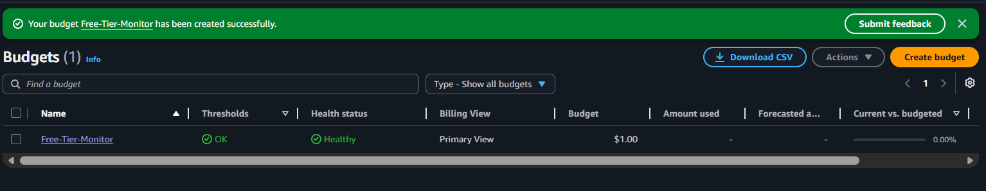
Figure: Free-Tier-Monitor budget active — Status: Healthy, 0.00% used.

Budget Summary
Property | Value
Budget Name | Free-Tier-Monitor
Budget Type | Zero spend budget
Alert Threshold | Any spend > $0.01
Notification | Email to team lead
Status | Active & Healthy

Last updated: June 11, 2026 — Phase 4: CI/CD pipeline live, CloudWatch Alarms & Logs configured, AWS Budget active.

