IAM USERS SETUP - The Principle of Least Privilege

Instead of assigning the blanket and risky AdministratorAccess policy to our team members, we adhered strictly to the Principle of Least Privilege. We granularly selected six explicit AWS-managed policies required to successfully execute our scope of work. This completely blocks unauthorized actions (such as altering billing info or launching expensive, non-Free Tier database clusters) while giving our developers full power to build out our specific stack: compute, load balancing, content delivery, certificate management, and storage assets.

AmazonEC2FullAccess: Allows the team to provision, modify, and manage our t3.micro instances and configure local firewall security groups.
AmazonS3FullAccess: Grants the ability to create and manage the storage bucket containing our web application's static media assets.
AWSCertificateManagerFullAccess: Required to safely request, validate, and track our SSL/TLS public certificates for end-to-end HTTPS encryption.
CloudFrontFullAccess: Grants permissions to spin up and configure our edge content delivery network (CDN) cache distribution.
ElasticLoadBalancingFullAccess: Essential for configuring our Application Load Balancer (ALB), Target Groups, and traffic routing listeners.
IAMReadOnlyAccess: Gives team members visibility into the identity configurations without allowing them to modify core root account structures or permissions

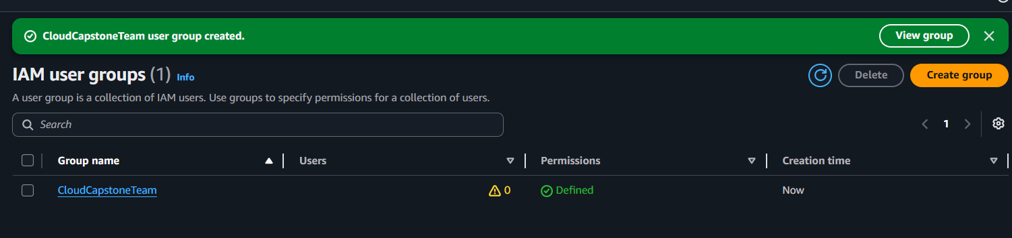

To ensure scalability and clean access management, we avoided mapping individual policies directly to individual users. Instead, we created a centralized IAM User Group called CloudCapstoneTeam. By establishing this architectural bucket, any permission modifications we make instantly cascade to all developers inside the group, ensuring identical environments and zero configuration drift across our 5-person team.
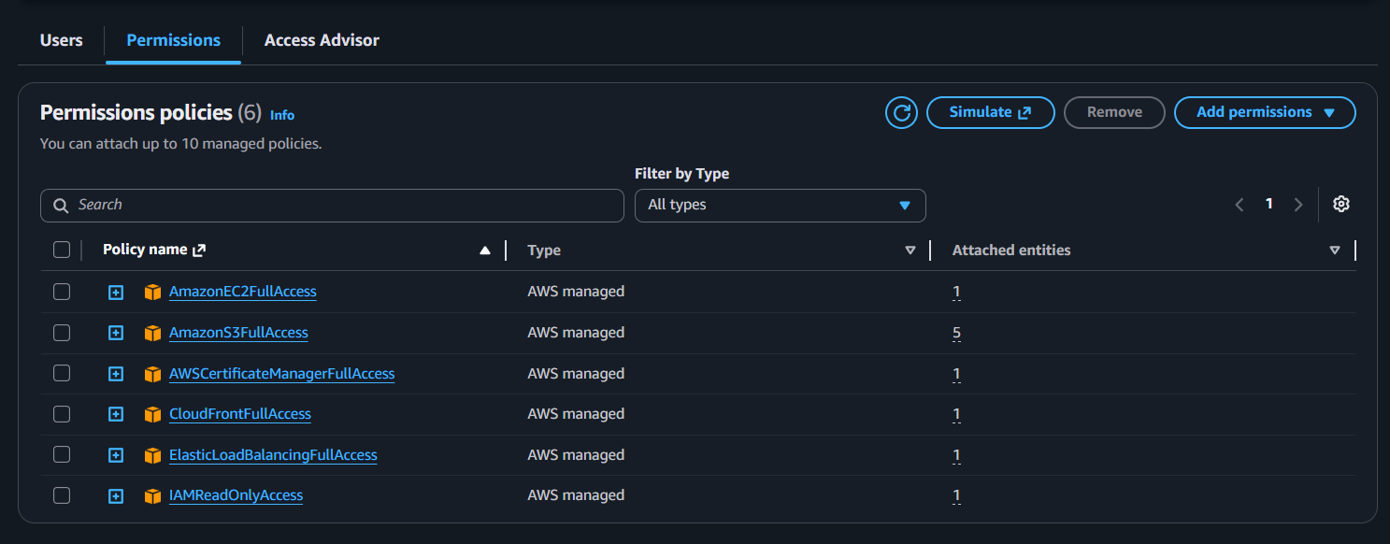
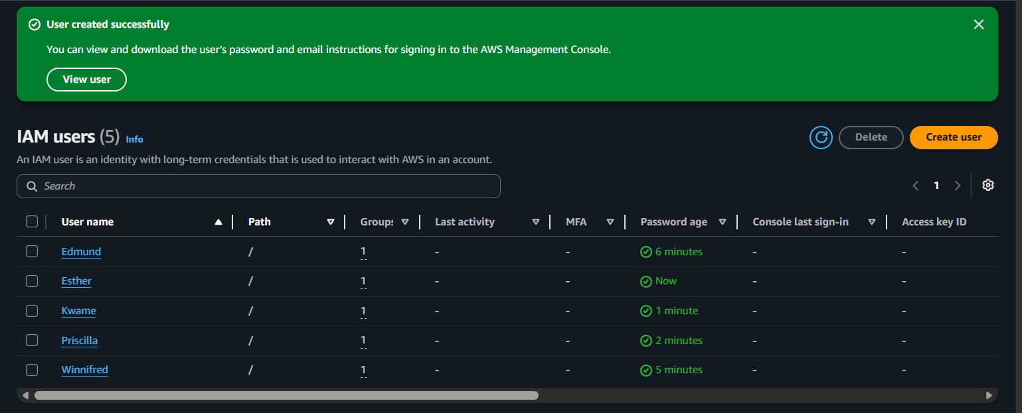

Sharing a single set of deployment keys is an anti-pattern in cloud architecture. To solve this, we provisioned five distinct, isolated IAM user accounts. By doing this, we guarantee total operational accountability. Every infrastructure change, code push, or deployment trigger is tied to a specific username. If an error occurs, our team can cleanly track changes using AWS CloudTrail to understand exactly who initiated the action and when

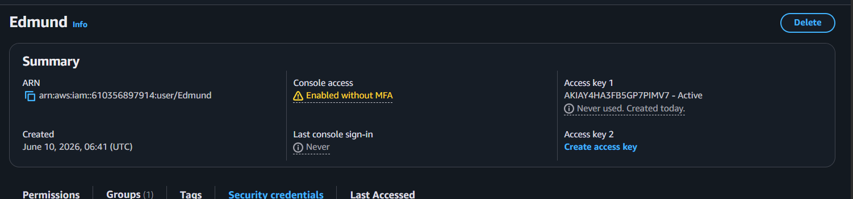

To ensure all local workstations are standard and ready for active deployment, we verified our primary toolchains via the terminal command line interface. This baseline check ensures that our orchestration, automation, and version control tools are natively available within our OS environment before executing any infrastructure changes."
- aws --version Execution: Confirms that the AWS Command Line Interface (aws-cli/2.35.0) is properly installed and globally accessible over Python 3.14.5 on a Windows 11 AMD64 machine. This tool is crucial for executing programmatic cloud commands, configuring our custom named profiles, and verifying user identity endpoints.
- git --version Execution: Confirms that Git version 2.54.0.windows.1 is successfully configured. This establishes our tracking baseline, allowing our 5-person team to pull code repositories, initialize feature branches, and safely manage our development workflows before merging into production branches.
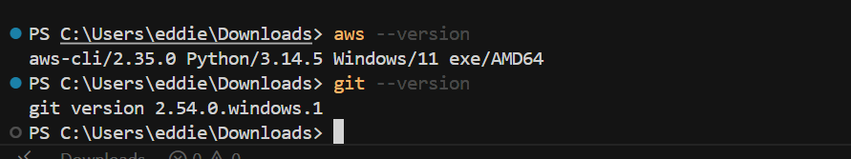

To bridge our local machines with our cloud infrastructure safely, we decoupled Console Access from Programmatic Access. We generated individual, secure access key pairs for our developers to inject into their local IDE environments. As proven by our terminal output execution of aws sts get-caller-identity --profile cloud-project, the AWS Security Token Service (STS) explicitly registers our active terminal session directly to the user Edmund within account 610356897914."
"This validates that our local AWS CLI named profiles are correctly configured, isolated from other credentials on our machines, and fully ready to securely pass automation commands directly to our environment.
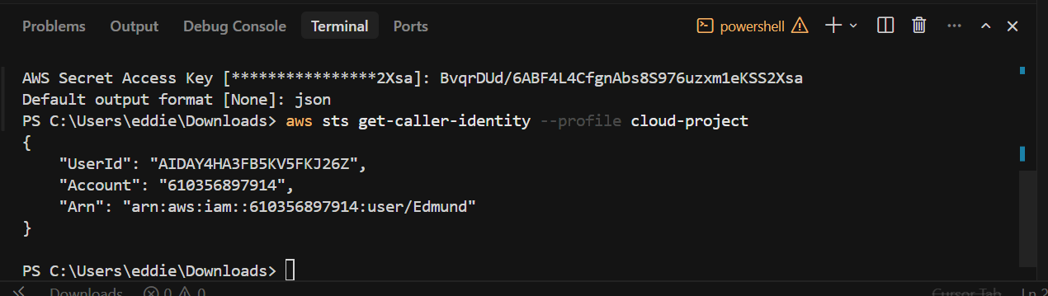

GitHub Repository and Branching Setup
- The Repository Overview: This screenshot shows your public repository named aws-capstone-project. It is properly initialized with an initial commit containing a root README.md file.
- Branch Management: You have successfully configured your local and remote workflows to support the required branching strategy. The screen shows the three distinct core branches: main (the default production branch), develop (the team integration branch), and a feature branch for isolated task development.
- Collaborator Access: You have invited and configured your core team members—ADuah26, cilla-sys, Kwame Opoku, and Winn—as project collaborators with proper repository access, ensuring everyone can safely push branches and open Pull Requests.

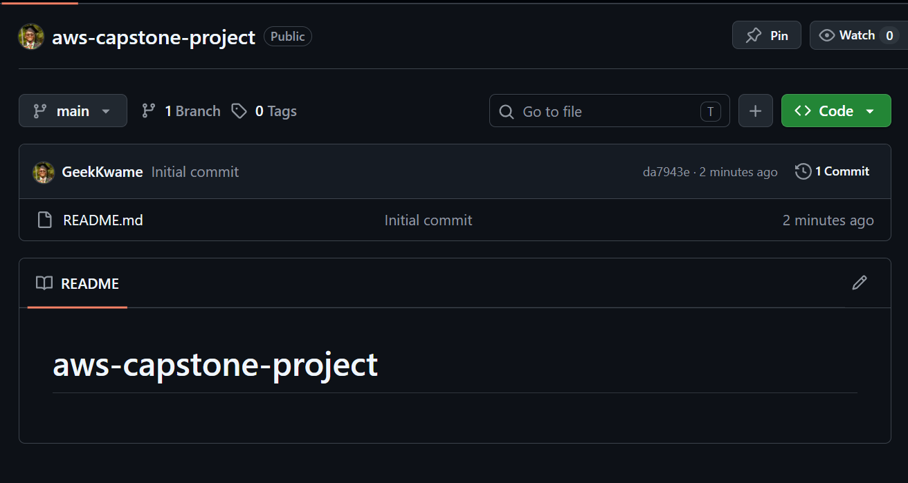

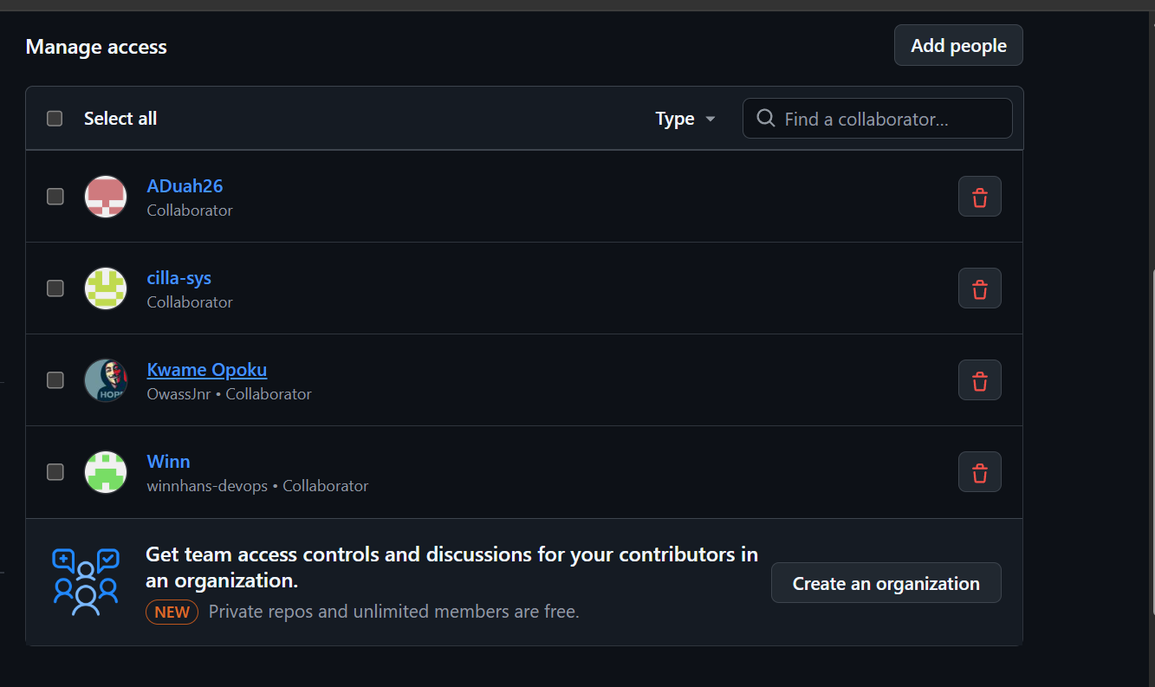

Trello Project Management Board
- The Workflow Framework: This shows your sprint planning workspace tailored for the team. The board contains the four mandatory progress tracking columns: Backlog, In Progress, Review, and Done.
- Task Delegation & Backlog: Your team has fully populated the board and added all members. The first set of tasks (like Create IAM Users and Install AWS CLI) are already sitting in the Done column. Meanwhile, the remaining core infra tasks (like launching the EC2 instance, configuring security groups, and creating the S3 bucket) are cleanly organized in the Backlog, ready to be pulled into production.
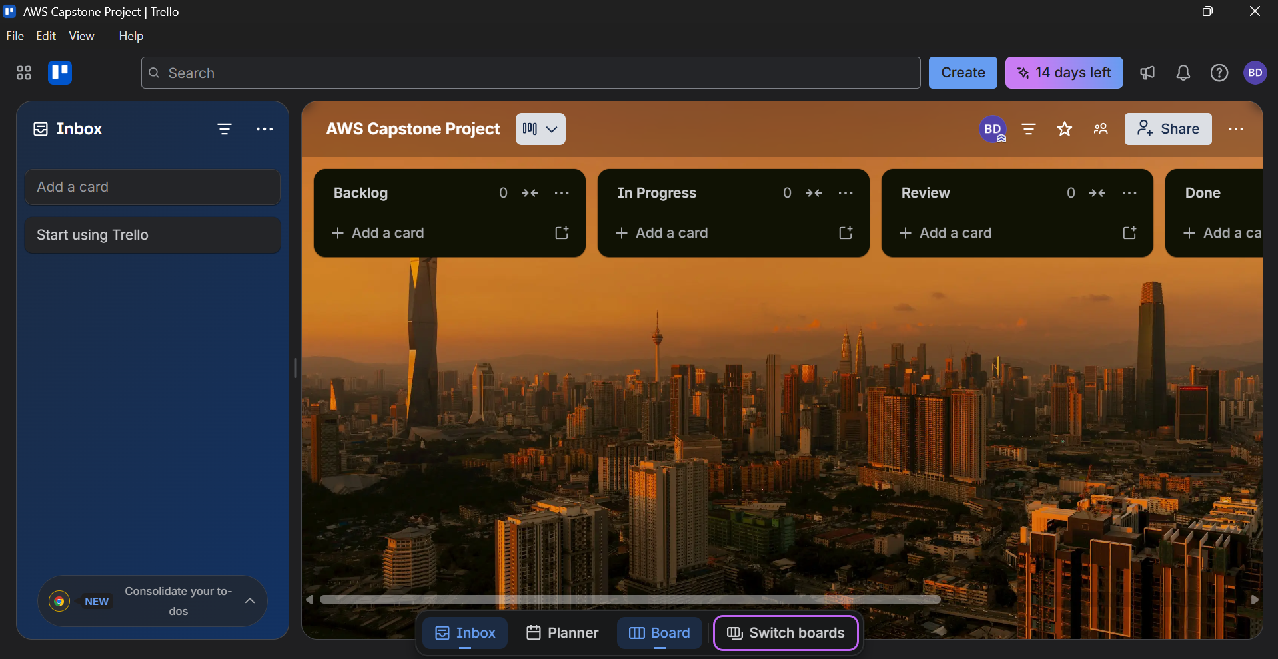
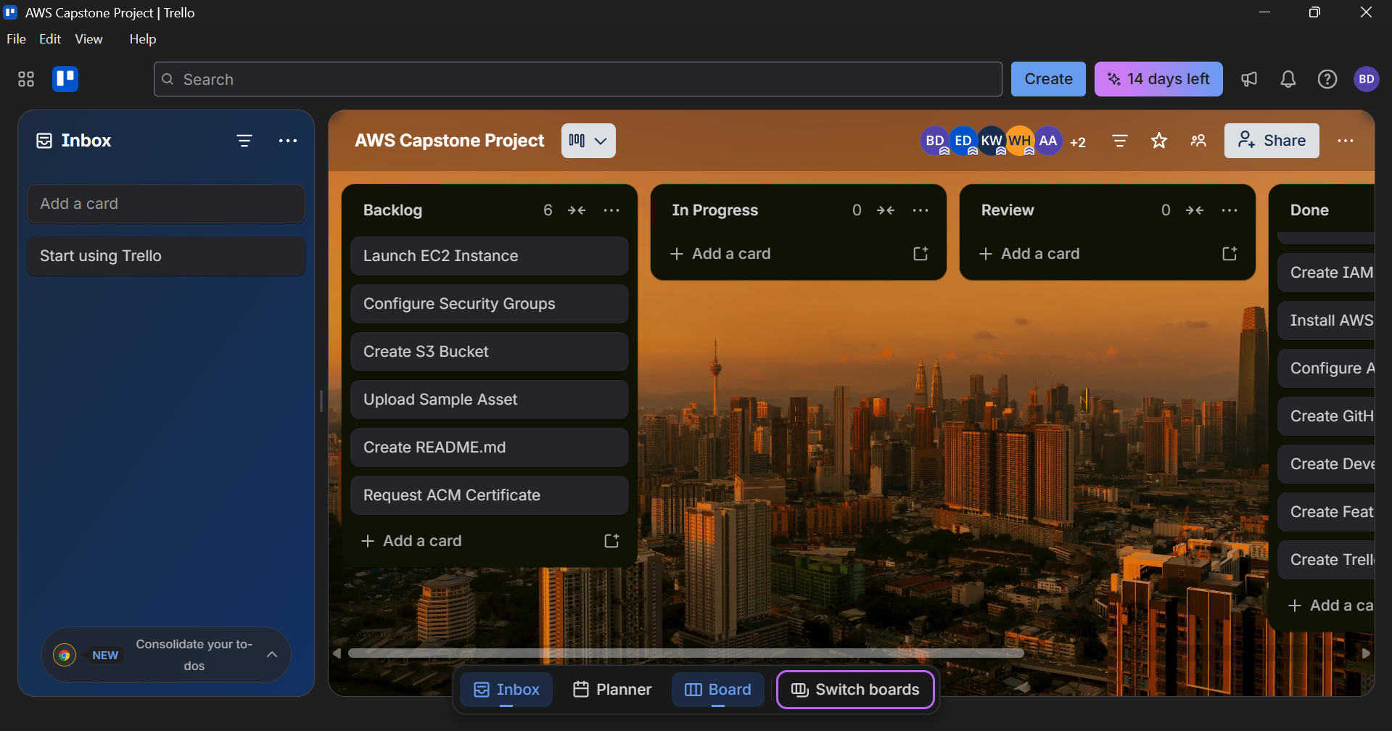

EC2 instance and S3 bucket

AWS Compute & Storage Infrastructure
- Active EC2 Web Server: This is our EC2 dashboard showing our compute layer. We have a running instance named Capstone-WebServer... utilizing the standard Free Tier t3.micro instance type. It is fully initialized in the us-east-1f availability zone with a public IPv4 address (3.237.34.20) assigned and ready to host your web server software.
- S3 Bucket Configuration: This captures the initial creation screen for your object storage. You've chosen a standard General purpose bucket type set to use the standard regional namespace. The bucket is globally uniquely named capstone-static-assets-azubi-61035689714-us-east-1-an.
- Static Asset Verification: The final screenshot confirms your storage layer is working perfectly. You have successfully uploaded your first test static asset—an image named Azubi.png—into the root of the bucket using the Standard storage class, verifying that your upload permissions are working flawlessly.

