On Windows Setup screen press Shift+f10 to get to CMD prompt, type in explorer. Navigate to your USB drive and right click Hash.cmd run as administrator. Make sure that Comphash.CSV does not already exist on the drive and if it does, delete it.
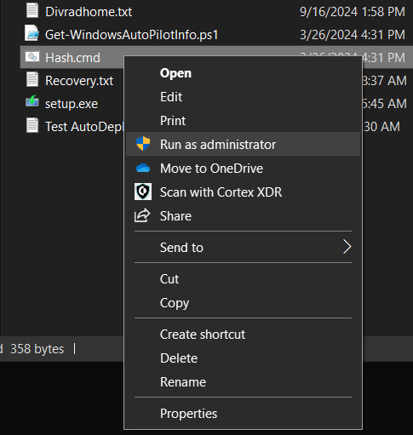
Once it runs it will look like this. Press any key (might have to press a key 30seconds after it says “gathering” to prompt for the response)
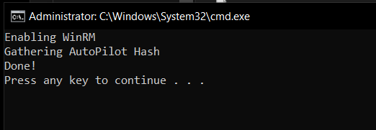
Once Done, it will generate a CSV file that you will use to upload to Intune
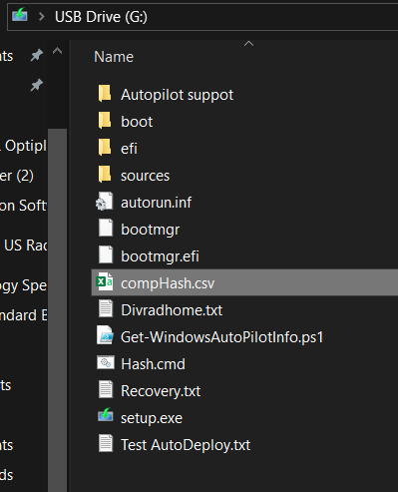
Log into Intune using your FT Certs using the below link within a Chrome incognito window (has to be done on another PC) https://intune.microsoft.com/?ref=AdminCenter#home
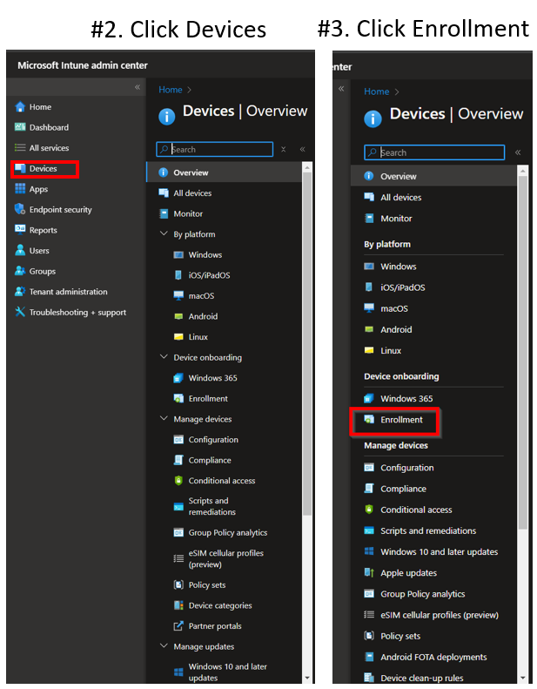
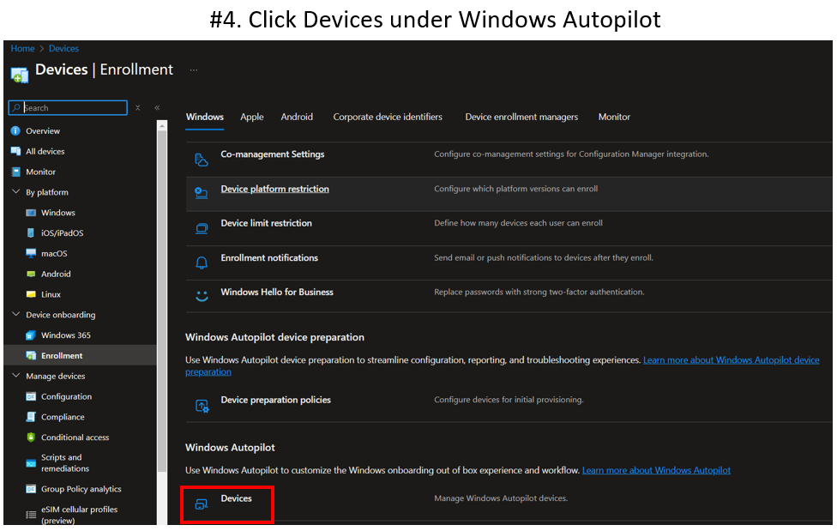
Select “Import”
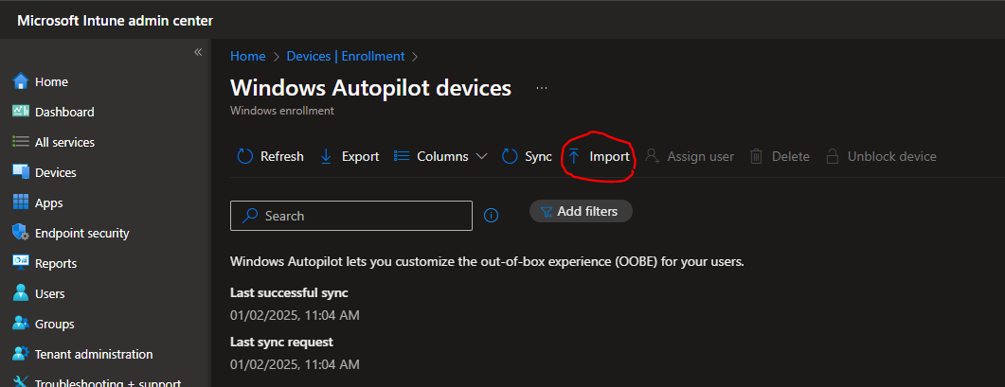
Select the path to the USB drive with the comphash and select comphash.csv
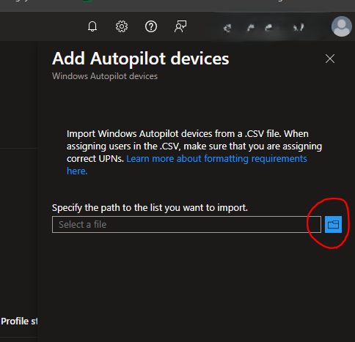
Select Import
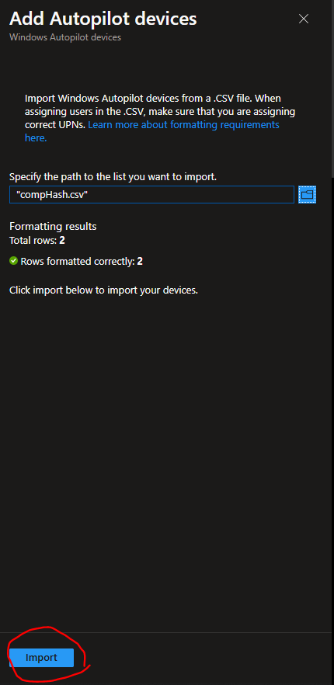
You will see at the top through the notifications what is happening
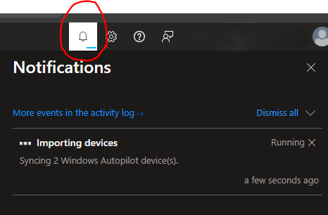
Once this says it has imported successfully, proceed to the next step
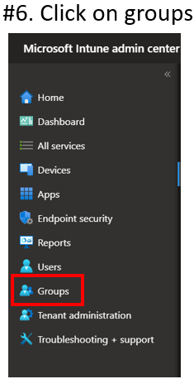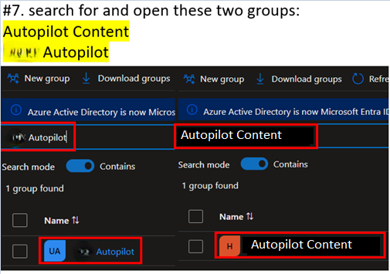
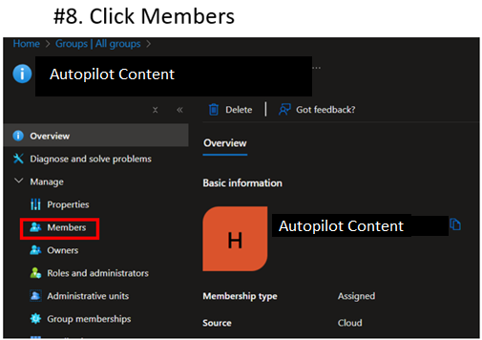
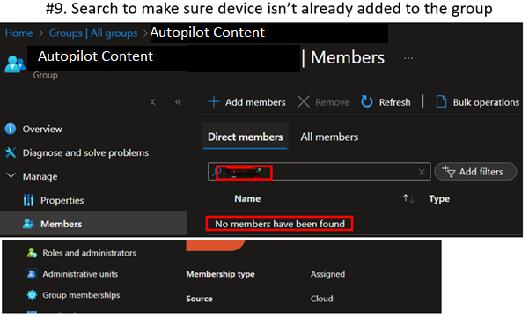
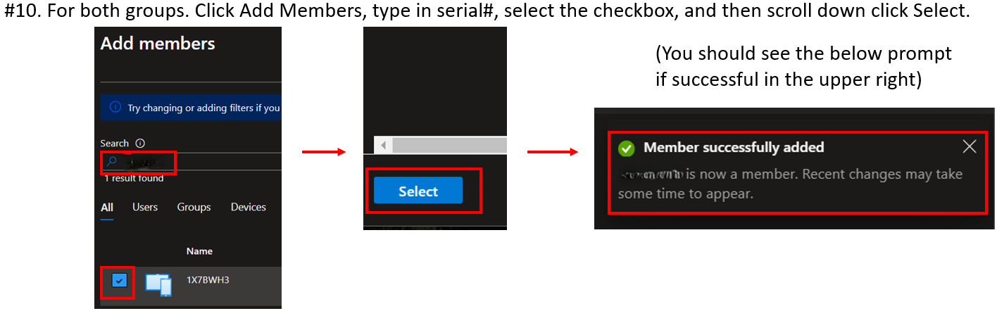

Go back to the machine with the first time sign on and sign in using the intune autopilot credentials. (Retrieve from Intune Admin if you don’t have elevated rights profile)
UN: xxxxxxx
PW: xxxxxxx
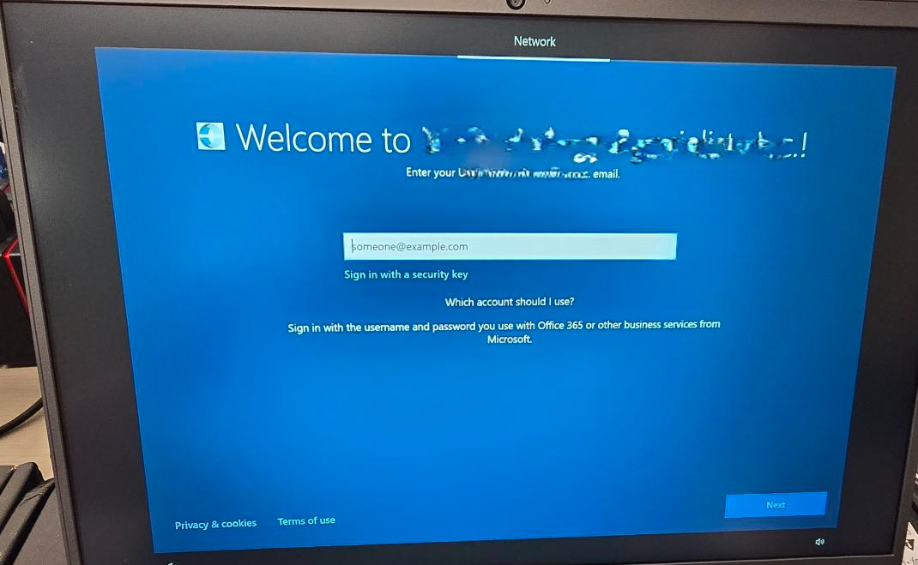
After logging in, device setup will begin:
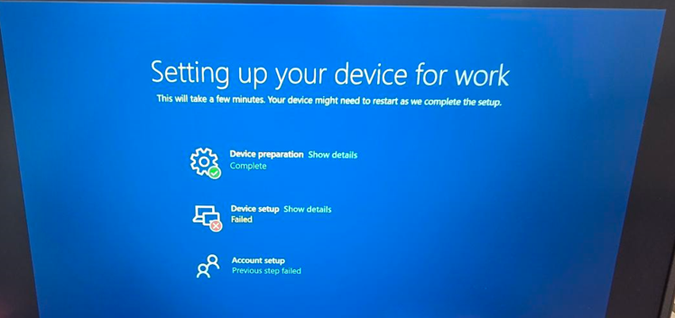
You may encounter the below error, click Continue Anyway and sign in with the local admin certs.
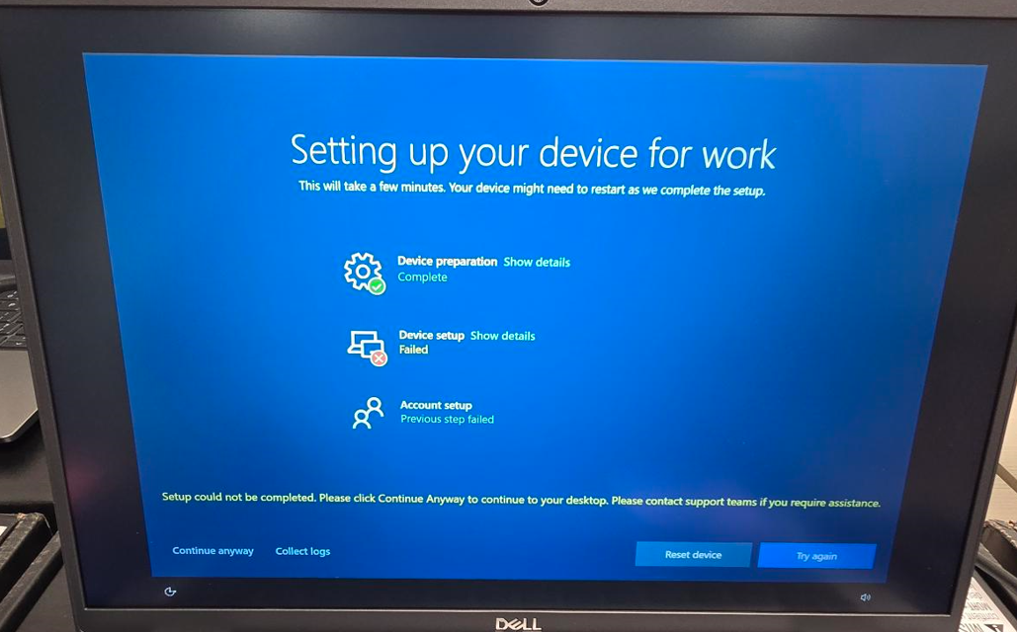
When windows is done installing you will be presented with sign in screen. Click on “Other User” and Sign in with the local admin credentials. Once done, you may want to sign in do the autopilotagen account so it can finish anything that was missed on initial intune install (it will pull them from intune, you can provoke this by going to company portal and click the sync button within its settings)

