Guide to Connect UniFi Access Points to a Cloud Controller

Prerequisites
- UniFi Cloud Controller (e.g., hosted on Ubiquiti's cloud, AWS, or a remote VM)
- Access point powered on and connected to a network with internet access
- Access to the Cloud Controller's public IP or hostname
- Default or factory-reset UniFi AP

Step 1: Power and Connect the AP
- Connect the AP to a PoE switch or injector.
- Ensure the network has DHCP and internet access.

Step 2: Identify the AP
- Option 1: SSH into the AP
- - Use a network scanner (e.g., Advanced IP Scanner or nmap) to find the AP’s IP.
- - SSH into the AP: ssh ubnt@<AP-IP> (default password: ubnt)
- Option 2: Use UniFi Mobile App (Optional)
- - The app can detect new APs on the same local network and adopt them if cloud access is configured.

Step 3: Point the AP to the Cloud Controller
- Once in the AP via SSH, run the following command:
  - set-inform http://<Cloud-Controller-IP-or-FQDN>:8080/inform
  - example: set-inform http://xxxxxxxx-xxxx-xxxx-xxxx-xxxxxxxxxxxx.unifi-hosting.ui.com:8080/inform

Step 4: Adopt the AP in the Cloud Controller
- Log into your Cloud Controller.
- Open Google Chrome - https://xxxxxxxx-xxxx-xxxx-xxxx-xxxxxxxxxxxx.unifi-hosting.ui.com/network/default/dashboard
- Go to Devices.
- You should see the new AP listed as 'Pending Adoption'.
- Click Adopt.

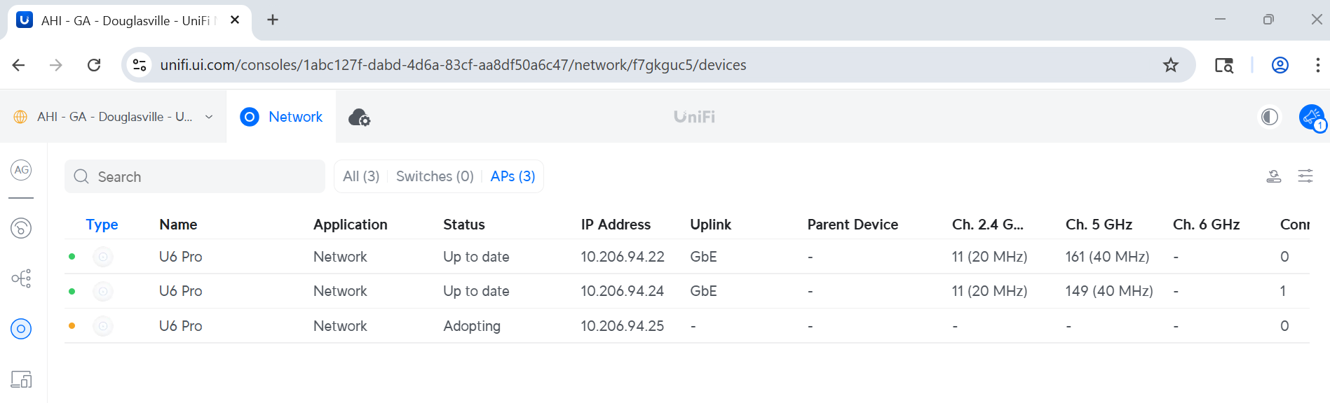

Troubleshooting Tips
- Make sure ports 8080 (inform), 443 (web), and 3478 (STUN) are open inbound on the controller.
- Confirm APs can reach the controller’s hostname or IP.
- Factory-reset AP with: syswrapper.sh restore-default
- Press and hold reset pin on AP until flashing white and blue
- Then Unplug network cable to the AP
- Delete from Cloud control then reconnect with Putty and then Adapt

