

Project title

VisionGuard: Integrated Assistive Driving Interface for Visual & Cognitive Support
Project Plan
Spring 2026

Project Phase: FYP1
Team Number:
Adviser: Dr. Zied Bouida
Team Members:
ID | Name
211615 | Anfal Almesbah
221147 | Fatemah Alenezi
211645 | Shahad Alsarraf
211507 | Eidah Marzoq

​

Revised: 10/04/2026
Contents
Abstract 5
1 Introductory Materials 6
1.1 Acknowledgement 6
1.2 Problem Statement 6
1.3 Operating Environment 7
1.4 Intended Users and Uses 7
1.4.1 Intended Users 8
1.4.2 Intended Uses 8
1.5 Assumptions and Limitations 8
1.5.1 Assumptions 8
1.5.2 Limitations 9
1.6 Expected End Product and Other Deliverables 9
1.6.1 Expected End Product 9
1.6.2 Deliverables 10
2 Proposed Approach and Statement of Work 10
2.1 Objective of the Task 10
2.2 Functional Requirements 10
2.3 Constraints Considerations 10
2.4 Previous Work and Literature 11
2.5 Proposed Design 12
2.6 Technology Considerations 12
2.7 Safety Considerations 12
2.8 Task Approach 12
2.9 Possible Risks and Risk Management 12
2.10 Project Proposed Milestones and Evaluation Criteria 12
2.11 Project Tracking Procedures 12
2.12 Expected Results and Validation 13
2.13 Test Plan 13
3 Project Timeline, Estimated Resources, and Challenges 14
3.1 Project Timeline 14
3.2 Feasibility Assessment 14
3.3 Personnel Effort Requirements 14
3.4 Other Resource Requirements 14
3.5 Financial Requirements 14
4 Closure Materials 15
4.1 Conclusion 15
4.2 References 15

List of Figures
Figure 1: Proposed System Architecture 16
Figure 2: Proposed system Workflow 17
Figure 3: NVIDIA Jetson 18
Figure 4: Camera module 19
Figure 5: FYP1 Planning Phase Gantt Chart (20 January – 27 April 2026) 31
Figure 6: FYP2 Implementation Phase Gantt Chart (20 September – 25 December 2026) 32

List of Tables
Table 1: Project milestones 25
Table 2: Test plan 28
Table 3: FYP1 Planning Phase Timeline (20 January – 27 April 2026) 31
Table 4: FYP2 Implementation Phase Timeline (20 September – 25 December 2026) 32
Table 5: Personnel Effort Requirements 33
Table 6: Estimated Financial Budget (KWD) 35

Abstract
VisionGuard is a real-time assistive driving system designed to help drivers understand what is happening on the road more easily. The system uses a camera mounted inside the vehicle to capture live footage of the road ahead. This footage is processed using deep learning models to detect traffic lights and road signs, and the results are shown to the driver through a simple on-board display. The project uses YOLOv8, a fast and accurate object detection model, which will be trained on two well-known public datasets: the GTSRB dataset for road sign recognition, and the LISA Traffic Light Dataset for traffic light detection. After training, the models will be optimized and deployed on an NVIDIA Jetson Orin Nano embedded platform to support real-time inference directly inside the vehicle.
This document presents the full project plan for FYP1, which covers the planning and design phase of the project. It includes the system design, dataset selection, model training approach, project timeline, resource requirements, and test plan. The second phase (FYP2) will focus on building, integrating, and testing the complete system.

Introductory Materials

Acknowledgement
We would like to express our sincere thanks and appreciation to our project supervisor Dr. Zied for his continuous support in providing us with technical guidance and feedback, and for our constructive discussions with him throughout the development of this project. We would also like to thank the Kuwait College of Science and Technology (KCST) for providing us with the academic environment, facilities, and structured framework needed to complete this work.

Problem Statement
Driving is an activity based on perception, where a driver continuously has to interpret traffic lights and road signs in an ever-changing environment. The integration of Advanced Driver Assistance Systems (ADAS) within modern vehicles provides some assistance to drivers however, the majority of the available solutions developed to date provide a greater focus on overall vehicle safety rather than specifically focusing on perceptual assistance. In general, the state of a traffic signal is primarily determined by the colour of the light, while a road sign is generally determined by the speed at which it can be visually recognized. Drivers who experience Colour Vision Deficiency (CVD) or who have difficulty paying attention may have difficulty distinguishing signal states or detecting critical road signs, especially when faced with glare, low-light conditions, blurred motion or partially hidden visibility of traffic signals or road signs.
While advances in deep learning have provided the ability to perform reliable real-time object detection, most implementations of this technology are focused on an autonomous vehicle pipeline in contrast to embedded, assistive systems that provide perceptual enhancement to human drivers. Additionally, limited integration exists between localized traffic detection, low-latency edge inference, and simple presentations of information that are suitable for perceptual assistance. There is therefore a need for an AI-driven embedded driving support system that can detect traffic lights and road signs, on edge hardware in real time, and present visual information through intuitive and clear cues, in order to assist drivers to be more aware of their surroundings, without taking over control of the driver's ability to operate their vehicle.

Operating Environment
The proposed VisionGuard system is intended to operate within a real-world driving environment where traffic lights and road signs must be detected under varying lighting and weather conditions. The system is designed for installation inside a vehicle as a dashboard-mounted embedded unit equipped with a forward-facing camera. It must function reliably in dynamic road scenarios, including daytime and nighttime driving, partial occlusion, and moderate motion conditions. Since the system acts as an assistive interface rather than an autonomous controller, it operates independently without interfering with the vehicle’s core control mechanisms.
The system will run on NVIDIA Jetson class hardware, an embedded computing platform capable of supporting real-time deep learning inference and an edge device equipped with GPU acceleration. The software environment will include a trained object detection model for traffic lights and road signs, implemented using deep learning frameworks compatible with edge deployment. The system will process live video input locally without reliance on cloud connectivity to ensure low latency and operational stability. Visual or auditory alerts will be generated through an in-vehicle display interface designed to provide clear perception cues to the driver.

Intended Users and Uses
The VisionGuard is designed to help drivers, who require additional assistance with seeing things visually as they are driving. More and more, driving is done in very complex visual environments, so pausing for long periods of time to interpret visually based symbols and signs (traffic lights & signs) when driving will soon be an out-dated practice.
The purpose of the VisionGuard system is to add an additional layer (perception) of support to a driver's ability to see the world around them, without interfering with or taking away the driver's ability to control the vehicle. The VisionGuard system will help create situational awareness by using real-time AI detection of traffic lights and road signs to transform the visual symbols into simplified visual cues, thereby allowing for the driver to more easily see critical driving information (traffic lights & road signs).

Intended Users
- Drivers who have colour vision deficiency (CVD) and have difficulty distinguishing between the colours of traffic lights.
- Drivers who have slight distraction-based visual or attention-based challenges that require additional visually-based cues when driving a vehicle.
- Elderly drivers would benefit from additional signals and signs being visually reinforced.
- All drivers need enhanced visual perception when driving in complex visual traffic environments.

Intended Uses
- To detect and identify traffic lights in real time ('red,' 'green,' 'yellow').
- To detect and recognize road signs in real-time when driving a vehicle.
- To transform detected traffic lights into simplified visual ('shape') representations.
- To provide in-vehicle assistive alerts by displaying them on an in-vehicle display interface.
- To create greater situational awareness for the driver while retaining total control of the vehicle.

Assumptions and Limitations

Assumptions
The assumptions related to the design and development of the VisionGuard system are as follows:
- The system will be installed within a vehicle in a stable position that allows the camera to see the road ahead clearly.
- The computing unit is connected to a stable power supply from the vehicle.
- The driving environment will contain all standard traffic control devices and all are expected to follow the basic rules of traffic.
- The trained deep learning models will be trained with a data set that accurately reflects the real world.
- The camera is expected to have enough resolution and frame rate to enable real-time object detection.
- The driver of the vehicle will be able to retain complete control of the vehicle when using the system in assistive mode and that the system will not interfere with the control of the vehicle in any way.

Limitations
While VisionGuard is designed to provide real-time assistive detection, several limitations are expected:
- The system may be affected by conditions such as glare, heavy rain, fog, or limited visibility at nighttime.
- The training data set will also affect accuracy of detection. Any traffic signs that are not in the training data set may cause incorrect detection of them.
- The speed of processing is dependent on the speed capability of the embedded computer used for processing.
- The system operates as an assistive interface and does not replace driver responsibility or guarantee accident prevention.
- This is a prototype version of the VisionGuard and additional development is required before large-scale commercial production.

Expected End Product and Other Deliverables

1.6.1 Expected End Product
The expected end product of this project is a working embedded assistive driving system that uses deep learning based object detection models to be able to detect traffic signals such as traffic lights and signs in real-time via a forward facing camera, an embedded GPU-based processing unit, and a display interface in the vehicle where the detected signals will be converted to simple visual representations of the detection. The final prototype of this system will have real-time edge inference capability, low-latency detection capabilities, and a user interface that is assistive to enhancing driver awareness without interfering with vehicle control.

1.6.2 Deliverables
The system will be submitted to the supervisor at the end of the next semester. The following items will be delivered as part of this project:
- Deliverable 1: Structured dataset creation and preprocess that can be used to teach deep learning models specifically targeted to traffic light recognition and detection of road signs.
- Deliverable 2: Training/validation and object detection model (i.e., YOLO-type) development for detection and recognition of state of the traffic lights in real-time.
- Deliverable 3: Training/validation of road sign detection and classification model.
- Deliverable 4: Deployment of the models developed from deliverables 2 and 3 on an embedded edge computing device which will be an NVIDIA Jetson-type device.
- Deliverable 5: Forward-facing camera module integration for real-time video capture and processing.
- Deliverable 6: Development of a simplified in-car visual interface to show the driver the results of the detections (i.e., shape-based indicators).
- Deliverable 7: Submission of complete project documentation which includes system architecture, design methodology of models used, implementation details, test results, and suggestions for future enhancements.

Proposed Approach and Statement of Work

Objective of the Task
The main objective of the proposed project is to design and develop an AI-based assistive driving system capable of detecting traffic lights and road signs in real time using computer vision and deep learning techniques. The system aims to integrate a forward-facing camera, an embedded edge computing platform, and trained object detection models to interpret traffic signals and road signs during vehicle operation. By processing live video input and identifying critical road information, the system supports improved driver awareness and assists drivers in recognizing traffic signals more clearly under varying road conditions.
The system will utilize deep learning–based object detection models deployed on an embedded computing platform capable of performing real-time inference. A camera module will continuously capture images of the road environment, which will then be processed by the detection models to identify traffic lights and road signs. The detection results will be presented to the driver through a simplified visual interface designed to provide clear perception cues without interfering with the driver’s control of the vehicle.
The project objectives can be summarized as follows:
- Design and implement a computer vision system capable of detecting traffic lights and identifying their current signal state in real time.
- Design and implement a traffic sign detection and recognition model using deep learning techniques.
- Deploy trained detection models on an embedded edge computing platform suitable for real-time inference.
- Integrate a forward-facing camera module to capture live road images for continuous analysis.
- Develop a simplified visual interface that presents detection results to the driver in an intuitive and accessible format.
- Evaluate the system performance in terms of detection accuracy, inference latency, and real-time operational capability.

Functional Requirements
The proposed system provides drivers with real-time assistive perception by detecting traffic lights and road signs using computer vision and deep learning techniques. The system integrates a forward-facing camera, embedded edge computing hardware, trained object detection models, and a simplified visual interface to present detection results to the driver. The system aims to meet the following functional requirements (FR):
- FR1: The system should capture real-time road images using a forward-facing camera installed inside the vehicle.
- FR2: The system should process captured video frames using a deep learning–based object detection model capable of identifying traffic lights and road signs.
- FR3: The system should detect traffic lights and determine their current operational state.
- FR4: The system should detect and classify road signs relevant to driving decisions.
- FR5: The system should perform detection and classification in real time using an embedded edge computing platform.
- FR6: The system should present detection results through a simplified visual interface to assist driver awareness.
- FR7: The system should continuously process video input and update detection results while the vehicle is in operation.
- FR8: The system should store selected detection events or logs for system evaluation and testing purposes.
- FR9: The system should provide alerts when important traffic signals or road signs are detected.

Constraints Considerations
In addition to the functional requirements, the proposed VisionGuard system must also satisfy several non-functional requirements to ensure reliable and efficient operation in real-world driving conditions. These constraints describe the expected performance, usability, and operational limitations of the system rather than the specific functions it performs.
- NFR1 Availability: The system should operate continuously while the vehicle is running. The camera, processing unit, and detection models must remain active and capable of processing incoming video frames without significant interruptions.
- NFR2 Reliability: The system should provide consistent and stable detection performance for traffic lights and road signs during normal driving conditions. The detection process should minimize missed detections or false alerts that may affect driver trust in the system.
- NFR3 Accuracy: The deep learning detection models should achieve an acceptable level of accuracy in identifying traffic lights and road signs under typical road conditions. Model training and validation should ensure reliable recognition of common traffic signals.
- NFR4 Latency: The system must process captured frames with minimal delay to ensure that detection results are presented to the driver in real time. The embedded computing platform should support low-latency inference for practical driving assistance.
- NFR5 Usability: The assistive interface should present detection results in a clear and intuitive manner that allows drivers to understand the information quickly without distraction.
- NFR6 Maintainability: The system components, including the camera module, embedded processing unit, and software models, should be designed in a modular way to allow easy updates, maintenance, and future improvements.
- NFR7 Power Stability: The embedded system should receive stable electrical power from the vehicle to ensure uninterrupted operation during driving.

Previous Work and Literature
In the last 10 years, Advanced Driver Assistance Systems (ADAS) have made strides through improved real-time perception and intelligent warning functionalities. Features like automatic emergency braking and associated perception-based driver assistance features have become common in current vehicle safety technology; examples of which are being documented in the National Highway Traffic Safety Administration's (NHTSA) list of mainstream safety systems [1]. However, the majority of existing systems in deployment are created with general driving populations in mind, providing motivation for research into more context-aware and assistive interfaces.
Core components of ADAS perceptual capabilities are based upon real-time object detection; the improvements made possible by the latest YOLO series of detectors illustrate this trend for improving the tradeoff between accuracy and latency. Over the last year, YOLOv7 has made changes to both training and architectural components to deliver traffic-scene detection accuracies comparable to existing YOLO detectors, without sacrificing real-time operational speeds, making it ideal as an accuracy baseline for this specific type of task [2]. YOLOv5 is the most popular framework used in projects that have an implementation-oriented focus, as it provides a mature training pipeline and ecosystem for deployment to support rapid prototyping and optimization of AI detection algorithms on edge devices [3].
Deployment latency is a major constraint in designing assistive driving systems and must remain low relative to the length of time between when a system generates a warning versus when it is still useful to the operator as a result of the short amount of time available. Recent studies that were open access (comparing deep learning detectors replicated on multiple edge devices, including Jetson-class platforms) revealed that deep learning model architecture and hardware acceleration can significantly impact inference speed, power consumption and real-time feasibility [4]. These findings support the decision to leverage embedded inference rather than rely upon cloud-based processing.

The level of research surrounding traffic light detection has a long history due to extenuating circumstances presented by some challenges (i.e., small target, glare conditions, variations in illumination, etc.) and the most recent work available through open access has shown that improved YOLO pipelines can provide better than classical methods accuracy for detecting and recognizing traffic lights [5]. As with traffic light detection, traffic sign recognition has been continuously improved through the application of deep learning with widespread acknowledgement from current literature regarding persistent problems to facilitate deploying developed systems (i.e., occlusion, variation in ability to recognize signs due to weather, differences in regional sign designs, etc.) that greatly impact systems performance when deployed in the real world [6]. Current studies in open access have established multi-task approaches to apply joint detection and recognition applications to improve robustness relative to single-task implementations [7]. These studies provide sufficient motivation to support building a localized dataset for evaluation aligned with target deployment ecosystems.
While the majority of work in this project is based on AI detection of traffic lights and signs, the fundamental reason for addressing detection through perception remains related to user needs associated with perception challenges (i.e., color vision deficiency). Multiple literature sources in both medical and driving safety publications support that color deficient drivers may have difficulty interpreting traffic signal indications and/or other colored elements on roadways and therefore there is a rationale for utilizing detection to produce clearer indicators displayed in the driver interface [8]. Therefore, VisionGuard is focusing on producing robust AI perception (detecting traffic lights and signs) with practicality of embedding AI accuracy at the time and enabling an assistive mechanism that allows presentation through accessibility motives.

Proposed Design

2.5.1 System Architecture
The system architecture of the proposed VisionGuard assistive driving system integrates embedded hardware, computer vision models, and an in-vehicle assistive interface to provide real-time perception support for drivers. Figure 1 shows the proposed system architecture, where the central processing unit is an NVIDIA Jetson class embedded platform that receives live road images from a forward-facing camera mounted inside the vehicle. The camera continuously captures the road scene, including traffic lights and road signs, and sends the video frames to the embedded platform for local processing. The Jetson device runs trained deep learning object detection models that analyze the incoming frames in real time to detect traffic lights, determine their current state, and recognize road signs relevant to the driving context. After detection, the processed results are passed to the assistive interface layer, which transforms the identified traffic information into simplified visual cues suitable for driver perception support. These cues are then displayed to the driver through an in-vehicle display, and can also be accompanied by optional audio alerts when required. The complete architecture is designed to operate locally on edge hardware without relying on cloud connectivity, ensuring low-latency performance, continuous operation, and practical deployment inside a vehicle.
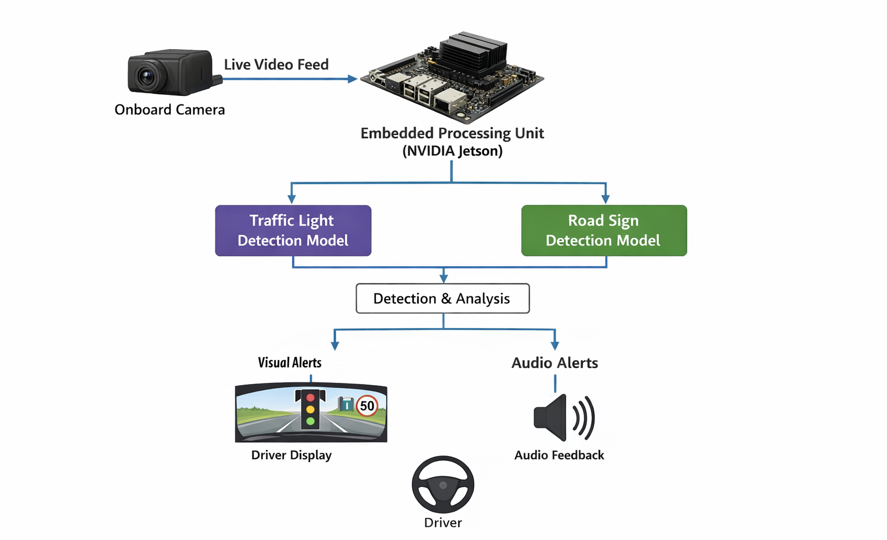
Figure 1: Proposed System Architecture

2.5.2 System Workflow
The workflow of the proposed VisionGuard system begins with the forward-facing camera continuously capturing live video of the road environment during vehicle operation. These video frames are transmitted directly to the embedded processing unit (NVIDIA Jetson), where they undergo preprocessing operations such as resizing and normalization to prepare the data for real-time inference. The processed frames are then passed through two parallel deep learning detection models, one responsible for detecting traffic lights and identifying their current state, and the other responsible for detecting and classifying road signs. The outputs from both models are combined and processed within a decision layer that filters and prioritizes the relevant detections based on the driving context. The resulting information is then transformed into simplified visual cues that are suitable for quick driver interpretation. These cues are displayed on an in-vehicle display, and may be accompanied by audio alerts when necessary. The entire process is performed continuously in real time to ensure that the driver receives up-to-date assistive feedback during driving. The workflow of the system is illustrated in Figure 2.
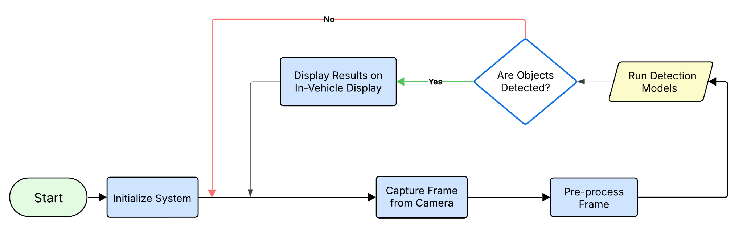
Figure 2: Proposed system Workflow

2.5.3 Hardware and Software Components
The proposed VisionGuard system consists of a set of hardware and software components that work together to enable real-time detection of traffic lights and road signs and provide assistive feedback to the driver. The system integrates embedded computing, computer vision models, and a visual interface within a unified architecture.

- Embedded Processing Unit (NVIDIA Jetson)
The NVIDIA Jetson device as shown in Figure 3 serves as the central processing component of the system. It is responsible for executing the deep learning models used for traffic light and road sign detection. The device processes incoming video frames from the camera, performs real-time inference, and manages the overall system workflow. The selection of an edge computing platform enables low-latency processing and eliminates the need for cloud-based computation, making the system suitable for real-time driving assistance.
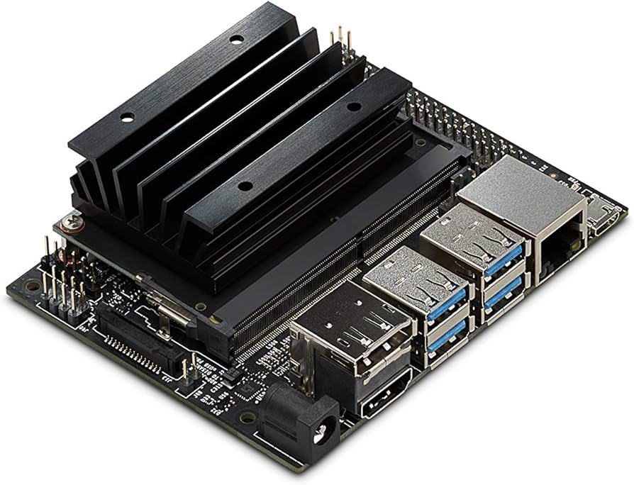
Figure 3: NVIDIA Jetson
- Camera Module
The camera module is used to continuously capture real-time video of the road environment during vehicle operation. It is mounted in a forward-facing position to ensure a clear view of traffic lights and road signs. The captured frames are transmitted to the embedded processing unit for analysis. The performance of the detection models depends on the quality of the captured images, including resolution, frame rate, and stability under different lighting conditions.
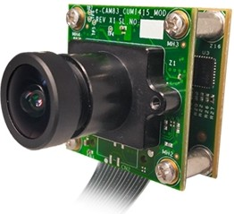
Figure 4: Camera module
- In-Vehicle Display Interface
The in-vehicle display interface presents the detection results to the driver in a simplified and intuitive format. Instead of relying solely on color representation, the system may use shape-based or symbolic indicators to improve clarity. The interface is designed to deliver information quickly without distracting the driver from the road.
- Traffic Light Detection Model
This component consists of a deep learning based object detection model trained to identify traffic lights and determine their current state (red, yellow, or green). The model processes incoming frames and outputs bounding boxes and classification results. It is optimized for real-time inference on embedded hardware to ensure minimal latency during operation.
- Road Sign Detection Model
A separate detection model is used to identify and classify road signs relevant to driving decisions. This model is trained on a dataset containing different categories of road signs and is designed to operate alongside the traffic light detection model. Running both models in parallel improves system coverage and enhances overall perception capability.
- Decision Layer
The decision layer is responsible for processing and refining the outputs of the detection models. It filters redundant detections, prioritizes relevant objects, and determines when to trigger visual alerts. This layer ensures that only meaningful and context-relevant information is presented to the driver, reducing unnecessary distractions.

Technology Considerations
The VisionGuard system requires a combination of embedded computing, computer vision models, and real-time processing technologies to ensure accurate and low-latency assistive performance during driving. Since the system operates in a dynamic environment, the selected technologies must support continuous data processing, fast inference, and reliable operation without dependence on external connectivity.

- Embedded Computing Platform:
The system is based on an embedded GPU-enabled platform such as NVIDIA Jetson. This platform is selected due to its ability to perform parallel processing using CUDA-enabled GPU cores, which allows efficient execution of deep learning models in real time. Compared to traditional CPU-based systems, the Jetson platform provides significantly lower inference latency and better performance for image-based tasks.
- Computer Vision and Deep Learning Models:
The system relies on deep learning–based object detection models to identify traffic lights and road signs. Models from the YOLO family are considered suitable due to their balance between detection accuracy and real-time performance. These models are optimized for edge deployment and are capable of processing video frames at high speed while maintaining acceptable detection accuracy under varying conditions.
- Camera and Image Acquisition:
A forward-facing camera module is used for continuous image capture. The camera must support sufficient resolution and frame rate to ensure reliable detection of small objects such as traffic lights. Image quality directly affects model performance, especially under challenging lighting conditions such as nighttime or glare.
- Software Frameworks:
Deep learning frameworks such as PyTorch or TensorFlow are used for model training and optimization. For deployment on embedded devices, optimized inference engines such as TensorRT are considered to reduce model size and improve execution speed. These frameworks support model conversion and acceleration required for real-time edge inference.
- Data Processing and Optimization:
To ensure real-time performance, preprocessing techniques such as image resizing and normalization are applied before inference. Model optimization techniques such as quantization and pruning may also be used to reduce computational load while maintaining acceptable accuracy.
- System Integration:
The system components including camera input, processing unit, detection models, and display interface are integrated within a single embedded pipeline. The system operates locally without reliance on cloud services, which ensures low latency, higher reliability, and continuous operation even in the absence of internet connectivity.

Safety Considerations
The VisionGuard system operates in a real-time driving environment where safety is a critical factor. Since the system provides assistive feedback to the driver without controlling the vehicle, it must be designed to enhance awareness without introducing distraction or incorrect guidance.
- Driver Distraction Prevention:
The assistive interface must present information in a simple and non-intrusive manner. Visual outputs such as symbols or indicators should be clear and minimal to avoid overwhelming the driver. The system should avoid displaying excessive alerts or unnecessary information that may divert the driver’s attention from the road.
- Detection Accuracy and False Alerts:
Incorrect detection of traffic lights or road signs may lead to misleading information being presented to the driver. To reduce this risk, the system must use well-trained models and validated datasets. The decision layer should filter unreliable detections and avoid triggering alerts unless a certain confidence threshold is met.
- System Latency and Real-Time Response:
The system must operate with low latency to ensure that detection results are delivered in time to be useful for the driver. Delayed alerts may result in incorrect driver reactions. Therefore, the system must maintain real-time processing performance under normal operating conditions.
- Environmental Safety Conditions:
The system performance may be affected by environmental conditions such as low lighting, rain, fog, or glare. These conditions may reduce detection accuracy. The system should be designed to handle such scenarios as much as possible, and the driver must remain aware that the system is assistive and not fully reliable in all conditions.
- Electrical and Hardware Safety:
The embedded system components, including the processing unit and camera module, must be securely installed inside the vehicle to prevent movement or damage during operation. The system should be connected to a stable power source and protected against electrical fluctuations.
- User Responsibility:
The VisionGuard system is designed as an assistive tool and does not replace the driver’s responsibility. The driver must maintain full control of the vehicle at all times and should not rely entirely on the system for decision-making.

Task Approach
The development process of the VisionGuard system is structured and follows a phased approach to ensure systematic progress throughout the project duration. The project is divided into two main phases corresponding to the Final Year Project stages, where each phase focuses on specific objectives required to achieve a complete and functional assistive driving system.
Phase 1: System Planning and Design (FYP1)
This phase focuses on establishing the theoretical foundation and system design required for the development of the VisionGuard system. The main activities performed in this phase include:
- Conducting a detailed literature review on Advanced Driver Assistance Systems (ADAS), computer vision, and real-time object detection techniques
- Studying existing traffic light and road sign detection systems and identifying their limitations
- Defining the functional and non-functional requirements of the system
- Selecting appropriate hardware and software technologies such as embedded platforms, deep learning models, and frameworks
- Designing the system architecture including sensing, processing, and output layers
- Developing system workflow diagrams to represent data flow and processing steps
- Preparing the project plan and identifying possible risks associated with system implementation
The outcome of this phase is a complete system design, clearly defined requirements, and a well-structured project plan ready for implementation.
Phase 2: System Implementation and Integration (FYP2)
This phase focuses on building, integrating, and testing the VisionGuard system to produce a functional prototype. The main activities performed in this phase include:
- Collecting and preparing datasets for traffic light and road sign detection
- Developing and training deep learning models for object detection
- Setting up the embedded system (NVIDIA Jetson) and configuring the software environment
- Deploying and optimizing trained models for real-time inference on edge hardware
- Integrating the camera module for continuous video capture
- Developing the assistive interface to display detection results to the driver
- Integrating all system components into a unified processing pipeline
- Performing system testing under different conditions to evaluate accuracy, latency, and reliability

Possible Risks and Risk Management
The project implementation process may face some expected risks that could affect the system development during the second semester. Therefore, the project team will follow specific procedures to reduce the impact of these risks and ensure smooth system implementation. These procedures include:
- The system development and model deployment will be carried out under continuous supervision and validation to ensure correct implementation of deep learning models and embedded system integration.
- The project team will gain sufficient technical knowledge in computer vision, deep learning frameworks, and embedded systems such as NVIDIA Jetson to avoid technical difficulties during implementation.
- The team will prepare and test multiple datasets for traffic light and road sign detection to improve model accuracy and reduce incorrect detections.
- The system will be tested under different environmental conditions such as low light and glare to ensure stable performance during real-world operation.
- The project team will use optimized models and efficient processing techniques to maintain real-time performance and reduce latency issues.
- Backup configurations and alternative system setups will be prepared in case of hardware or software failures during development.
- All system components will be tested individually before full integration to avoid system conflicts and ensure smooth data flow between modules.

Project Proposed Milestones and Evaluation Criteria
The VisionGuard project will be divided into several milestone stages to ensure structured progress during the development process. Each milestone represents a specific phase of the system development and includes clear deliverables and evaluation criteria to measure the completion and quality of the work. These milestones are mentioned in Table 1.
Table 1: Project milestones
Milestone | Deliverables / Tasks | Evaluation Criteria
Milestone 1 – Planning Phase (FYP1) | - Define system objectives and scope  - Conduct literature review  - Prepare system architecture and workflow diagrams | Clarity of problem definition and completeness of system design
Milestone 2 – Dataset Preparation | - Collect traffic light and road sign datasets  - Perform data labeling and preprocessing | Dataset quality and correctness of annotations
Milestone 3 – Model Development | - Train deep learning models for detection  - Evaluate model performance | Detection accuracy and model performance metrics
Milestone 4 – Embedded System Setup | - Configure NVIDIA Jetson environment  - Install required frameworks and tools | Successful system setup and readiness for deployment
Milestone 5 – Model Deployment and Optimization | - Deploy trained models on embedded system  - Apply optimization techniques for real-time inference | Real-time performance and reduced latency
Milestone 6 – System Integration | - Integrate camera, models, and interface  - Ensure data flow between components | Correct system operation and integration stability
Milestone 7 – System Testing and Validation | - Test system under different conditions  - Evaluate accuracy and reliability | System performance, stability, and response time
Milestone 8 – Final Documentation and Presentation | - Prepare final report  - Prepare system demonstration | Completeness of documentation and successful system demonstration

Project Tracking Procedures
To ensure that the VisionGuard project progresses according to the planned schedule and objectives, a set of tracking procedures will be followed throughout the development process. These procedures help monitor progress, identify issues early, and maintain coordination between team members.
- Task Assignment and Monitoring:
The project tasks will be divided into smaller subtasks and assigned to team members with clear responsibilities and deadlines. This ensures that all parts of the system are developed in parallel and progress can be monitored effectively.
- Regular Team Meetings:
The project team will conduct regular meetings to discuss progress, review completed tasks and address any technical challenges. Feedback from the supervisor will be incorporated to improve system design and implementation.
- Milestone Tracking:
Each project milestone will be reviewed upon completion to ensure that all deliverables and evaluation criteria are satisfied before moving to the next phase. This helps maintain a structured development process.
- Progress Documentation:
All progress will be documented regularly, including completed tasks, encountered issues, and applied solutions. This documentation will be used to track development status and support final reporting.
- Testing and Verification Tracking:
Each system component will be tested individually before integration. Testing results will be recorded and analyzed to ensure that the system meets the required performance and functional expectations.
- Issue Tracking and Resolution:
Any technical issue or delay will be identified and recorded. A responsible team member will be assigned to resolve the issue within a defined timeframe to prevent impact on the overall project timeline.

Expected Results and Validation
The expected outcome of the VisionGuard project is a functional assistive driving system capable of detecting traffic lights and road signs in real time and providing simplified visual feedback to the driver through an in-vehicle interface. The system is expected to operate on an embedded platform and support continuous video processing with low latency to ensure timely and reliable assistive alerts during driving. In addition, the system should be able to maintain acceptable detection accuracy under normal driving conditions while ensuring smooth interaction between all system components.
To validate the system, several testing scenarios will be conducted to ensure that all components operate correctly. These include verifying that the system can capture real-time video input from the camera, process the frames using the deployed detection models, and display the results through the assistive interface without delay. The accuracy of detecting traffic lights and road signs will be evaluated to ensure reliable performance, while the system response time will be measured to confirm real-time operation. In addition, the system will be tested under different environmental conditions such as varying lighting levels and motion scenarios to ensure stable performance in real-world situations. The validation process will also include evaluating the clarity and usability of the assistive interface, as well as ensuring that the overall system workflow operates continuously and without interruption during operation.

Test Plan
The project team will test the VisionGuard system to ensure that it satisfies all functional and non-functional requirements. The testing process focuses on validating detection accuracy, real-time performance, system integration, and overall reliability. The proposed test cases and expected outputs are summarized in Table 2.
Table 2: Test plan
Test Case | Test Steps / Procedure | Expected Output
Traffic Light Detection Accuracy Test | 1. Run the system using a test dataset containing traffic lights  2. Compare detected results with ground truth labels | The system correctly detects traffic lights with high accuracy (≥ 90%)
Road Sign Detection Test | 1. Input images containing different road signs  2. Evaluate classification results | Road signs are correctly detected and classified with acceptable accuracy
Real-Time Processing Test | 1. Run the system with live camera input  2. Measure processing time per frame | System processes frames in real time with minimal delay (≤ 100 ms per frame)
Camera Integration Test | 1. Connect camera to embedded system  2. Capture continuous video stream | Camera captures and streams video correctly without interruption
System Integration Test | 1. Integrate camera, models, and interface  2. Run full system pipeline | All components operate together correctly with smooth data flow
Interface Display Test | 1. Run system during detection  2. Observe output on display | Detection results are displayed clearly and correctly to the driver
Environmental Condition Test | 1. Test system under different lighting conditions  2. Evaluate detection performance | System maintains stable performance under normal environmental variations
System Stability Test | 1. Run system continuously for a long period  2. Monitor performance and errors | System operates continuously without crashes or performance degradation

3. Project Timeline, Estimated Resources, and Challenges

3.1 Project Timeline

3.1.1 FYP1 – Planning Phase
The first semester focuses on planning, research, and system design. It starts on January 20, 2026, and ends with the FYP1 submission on April 27, 2026. Table 3 lists each task with its start date, end date, and total duration in days.

Table 3: FYP1 Planning Phase Timeline (20 January – 27 April 2026)
Task | Start Date | End Date | Duration
Project Kickoff & Scope Definition | 20 Jan 2026 | 31 Jan 2026 | 12 days
Literature Review | 01 Feb 2026 | 28 Feb 2026 | 28 days
System Architecture & Design | 15 Feb 2026 | 10 Mar 2026 | 24 days
Dataset Collection & Labeling | 01 Mar 2026 | 25 Mar 2026 | 25 days
Model Research & Selection | 10 Mar 2026 | 05 Apr 2026 | 27 days
Project Plan Documentation | 01 Apr 2026 | 20 Apr 2026 | 20 days
FYP1 Report Writing | 10 Apr 2026 | 24 Apr 2026 | 15 days
FYP1 Presentation & Submission | 25 Apr 2026 | 27 Apr 2026 | 3 days

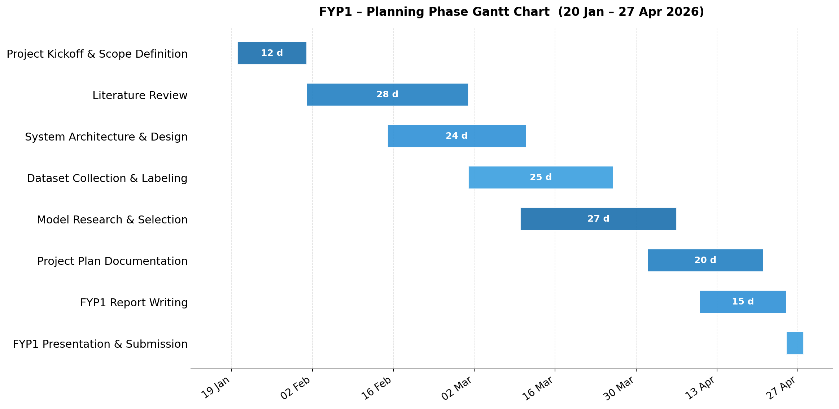
Figure 5: FYP1 Planning Phase Gantt Chart (20 January – 27 April 2026)

3.1.2 FYP2 – Implementation Phase
The second semester is fully dedicated to building and testing the VisionGuard system. It starts on September 20, 2026, and ends with the final presentation on December 25, 2026. Table 4 shows all implementation tasks with their dates and duration.
Table 4: FYP2 Implementation Phase Timeline (20 September – 25 December 2026)
Task | Start Date | End Date | Duration
Embedded System Setup (Jetson) | 20 Sep 2026 | 04 Oct 2026 | 15 days
Model Training & Tuning | 01 Oct 2026 | 25 Oct 2026 | 25 days
Model Evaluation & Analysis | 20 Oct 2026 | 05 Nov 2026 | 17 days
Model Optimization & Deployment | 01 Nov 2026 | 18 Nov 2026 | 18 days
System Integration | 15 Nov 2026 | 03 Dec 2026 | 19 days
System Testing & Validation | 01 Dec 2026 | 15 Dec 2026 | 15 days
Final Report Writing | 10 Dec 2026 | 22 Dec 2026 | 13 days
Final Presentation & Submission | 23 Dec 2026 | 25 Dec 2026 | 3 days

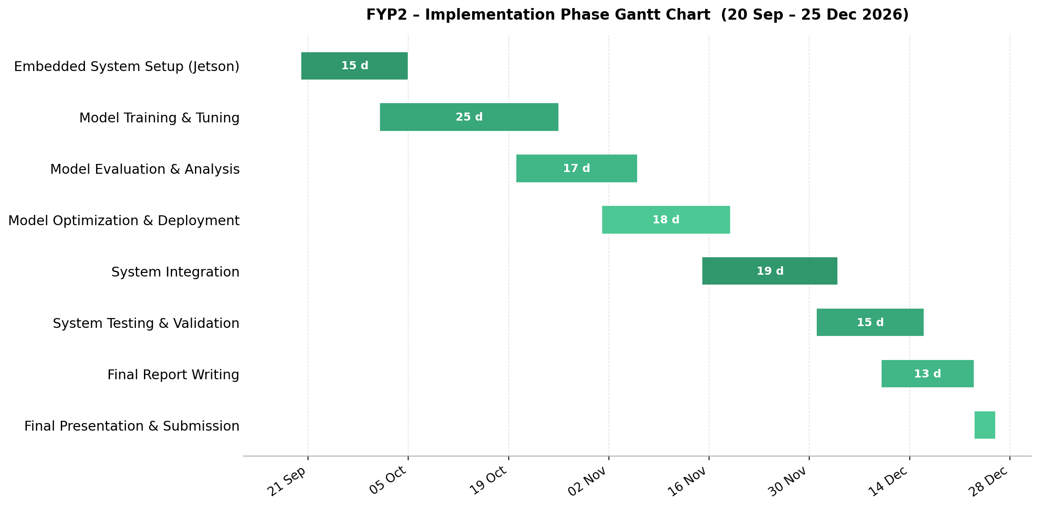
Figure 6: FYP2 Implementation Phase Gantt Chart (20 September – 25 December 2026)

3.2 Feasibility Assessment
The project was assessed from three angles to confirm that it is realistic and achievable.
- Technical Feasibility
All the technologies needed for this project are mature and well-tested. YOLOv8 has been used successfully in many real-time detection projects. The NVIDIA Jetson platform is built specifically for embedded AI tasks and has strong documentation and community support. The datasets we plan to use (GTSRB and LISA) are publicly available and have been verified in multiple published studies. The project is technically feasible.
- Operational Feasibility
The team has a solid background in machine learning and computer vision from coursework and self-study. The project is broken into manageable steps with clear deadlines, and the project supervisor will provide ongoing guidance. All software tools are freely available and the team has access to computers capable of model training. The project is operationally feasible.
- Economic Feasibility
Most of the software, frameworks, and datasets used in this project are free. The main costs are the hardware components. The total estimated cost is 220 KWD, which is a reasonable budget for a student final year project. The project is economically feasible.

3.3 Personnel Effort Requirements
The project team consists of four members. Table 5 shows the estimated number of hours each member will contribute to each task across both semesters.

Table 5: Personnel Effort Requirements
Task / Activity | Eidah  (Hrs) | Shahad  (Hrs) | Anfal  (Hrs) | Fatemah  (Hrs) | Total  (Hrs)
Literature Review & Background Research | 10 | 10 | 10 | 10 | 40
System Architecture & Requirements Definition | 8 | 8 | 7 | 7 | 30
Dataset Collection & Preprocessing | 10 | 10 | 10 | 10 | 40
Model Research & Selection | 8 | 8 | 7 | 7 | 30
Project Plan Documentation (FYP1) | 8 | 8 | 7 | 7 | 30
Embedded System Setup | 5 | 5 | 5 | 5 | 20
Model Training & Evaluation | 13 | 13 | 12 | 12 | 50
Model Optimization & Deployment | 10 | 10 | 10 | 10 | 40
System Integration | 10 | 10 | 10 | 10 | 40
System Testing & Validation | 10 | 10 | 10 | 10 | 40
Final Report Writing | 10 | 10 | 10 | 10 | 40
Presentations & Demonstrations | 5 | 5 | 5 | 5 | 20

3.4 Other Resource Requirements
In addition to the team's time, the project requires the following hardware, software, and dataset resources:
Hardware
- NVIDIA Jetson Orin Nano (8 GB) – The main platform for running the detection models in real time [13].
- High-Resolution USB Camera – Captures live road footage.
- HDMI Display Monitor (7") – Shows detection results to the driver.
- MicroSD Card (256 GB) – Storage for the operating system and project data.
- DC Power Supply & Cables – Powers the Jetson during development and testing.
- Heat Sink & Cooling Fan – Keeps the Jetson at a safe temperature during long runs.
- USB Hub & Adapters – Connects the camera and other peripherals.
Software
- JetPack SDK – NVIDIA's toolkit for configuring the Jetson and enabling AI acceleration.
- Python 3.x – The main programming language for the entire project.
- PyTorch – Deep learning framework used for YOLOv8 model training.
- Ultralytics YOLOv8 – The detection framework used for training, validation, and inference [11].
- TensorRT – Speeds up model inference on the Jetson hardware [12].
- OpenCV – Handles camera input and basic image processing.
- LabelImg / Roboflow – Tools for managing and annotating training data.
- GitHub – Used for code storage and team collaboration.
Datasets
- GTSRB (German Traffic Sign Recognition Benchmark) – 50,000+ labeled road sign images across 43 classes [9].
- LISA Traffic Light Dataset – Thousands of annotated driving frames for traffic light detection [10].
- Roboflow Universe – Extra annotated images for improving model generalization [14].

3.5 Financial Requirements
Table 6 shows the estimated project budget in Kuwaiti Dinar (KWD). All software tools and datasets are free and not included in the cost. The main expenses are the hardware components needed to build and test the system.

Table 6: Estimated Financial Budget (KWD)
# | Item | Category | Qty | Unit Price (KWD) | Total (KWD)
1 | NVIDIA Jetson Orin Nano (8 GB) | Hardware | 1 | 120.000 | 120.000
2 | High-Resolution USB Camera Module | Hardware | 1 | 18.000 | 18.000
3 | HDMI Display Monitor (7") | Hardware | 1 | 28.000 | 28.000
4 | MicroSD Card (256 GB) | Hardware | 1 | 7.500 | 7.500
5 | DC Power Supply & Cables | Hardware | 1 | 9.000 | 9.000
6 | Heat Sink & Cooling Fan | Hardware | 1 | 5.500 | 5.500
7 | USB Hub & Adapters | Hardware | 1 | 4.000 | 4.000
8 | Cloud GPU (Model Training) | Service | 1 | 22.000 | 22.000
9 | Printing & Report Binding | Material | 4 | 1.500 | 6.000
 | Total Estimated Budget |  |  |  | 220.000

Closure Materials

Conclusion
The VisionGuard project presents a structured and technically grounded approach to developing an AI-based assistive driving system. By integrating advanced object detection models with embedded edge computing and a simplified visual driver interface, the system aims to enhance road safety by providing real-time perception support for traffic lights and road signs. The project is designed to address the growing need for accessible and reliable driver assistance technology, particularly for individuals who may benefit from supplementary visual or cognitive support during vehicle operation.
The completion of this project plan marks the end of the first phase of the VisionGuard project. Throughout this semester, the team has successfully defined the project scope, researched the necessary technologies, and created a detailed design for the assistive driving system. We have identified all the required hardware and software resources, and we have a clear schedule to follow for the implementation phase.
In the upcoming semester, the team will focus on building the physical system, developing the software models, and integrating all components into a working prototype. We will carry out extensive testing to ensure the system is reliable and provides helpful information to the driver. By following the steps laid out in this plan, the team is confident in delivering a successful system that improves road safety and helps drivers navigate their environment more easily.

4.2 References
[1] National Highway Traffic Safety Administration (NHTSA), "Driver Assistance Technologies," 2023. Available: https://www.nhtsa.gov/vehicle-safety/driver-assistance-technologies
[2] C.-Y. Wang, A. Bochkovskiy, and H.-Y. M. Liao, "YOLOv7: Trainable bag-of-freebies sets new state-of-the-art for real-time object detectors," in Proc. CVPR, 2023. Available: https://openaccess.thecvf.com/content/CVPR2023/papers/Wang_YOLOv7_Trainable_Bag-of-Freebies_Sets_New_State-of-the-Art_for_Real-Time_Object_Detectors_CVPR_2023_paper.pdf
[3] G. Jocher et al., "YOLOv5," GitHub, 2020–2023. Available: https://github.com/ultralytics/yolov5
[4] D. G. Lema, R. Usamentiaga, and D. F. García, "Quantitative comparison and performance evaluation of deep learning-based object detection models on edge computing devices," Integration, the VLSI Journal, 2024. Available: https://www.sciencedirect.com/science/article/pii/S0167926023001694
[5] Q. Wang et al., "Traffic Lights Detection and Recognition Method Based on Improved YOLOv4 Algorithm," Sensors, vol. 22, no. 1, p. 200, 2021. Available: https://www.mdpi.com/1424-8220/22/1/200
[6] X. R. Lim et al., "Recent Advances in Traffic Sign Recognition: Approaches, Challenges, and Future Directions," Sensors, vol. 23, no. 10, p. 4674, 2023. Available: https://www.mdpi.com/1424-8220/23/10/4674
[7] K. Alawaji et al., "Traffic Sign Recognition Using Multi-Task Deep Learning," Sensors, vol. 24, no. 11, p. 3282, 2024. Available: https://www.mdpi.com/1424-8220/24/11/3282
[8] T. F. Tan et al., "Colour vision restrictions for driving: an evidence-based narrative review," 2023. Available: https://pmc.ncbi.nlm.nih.gov/articles/PMC10363493/
[9] J. Stallkamp, M. Schlipsing, J. Salmen, and C. Igel, "Man vs. computer: Benchmarking machine learning algorithms for traffic sign recognition," Neural Networks, vol. 32, pp. 323–332, 2012. Available: https://www.sciencedirect.com/science/article/pii/S0893608012000457
[10] M. B. Jensen et al., "Vision for Looking at Traffic Lights: Issues, Survey, and Perspectives," IEEE Trans. Intelligent Transportation Systems, vol. 17, no. 7, pp. 1800–1815, 2016.
[11] G. Jocher et al., "Ultralytics YOLOv8," GitHub, 2023. Available: https://github.com/ultralytics/ultralytics
[12] NVIDIA Corporation, "TensorRT Developer Guide," 2024. Available: https://docs.nvidia.com/deeplearning/tensorrt/
[13] NVIDIA Corporation, "Jetson Orin Nano Developer Kit," 2023. Available: https://developer.nvidia.com/embedded/jetson-orin-nano-developer-kit
[14] B. Dwyer, J. Nelson, et al., "Roboflow," 2022. Available: https://roboflow.com

