|  |  |  |
| --- | --- | --- |
| **Problem Chosen** E | **2020 MCM/ICM Summary Sheet** | **Team Control Number** 2001968 |

**Background**

By analyzing the current situation of global plastic use and sources of disposable plastic waste, we find that the production volume of plastic waste and waste generation of disposable plastic products are increasing year by year, and the recycling proportion of plastic waste is not increasing significantly. There is no doubt that the plastic pollution in the world is urgent.

**Objective**

The objective of this paper is to develop a plan to significantly reduce, if not eliminate, single-use and disposable plastic product waste, as well as estimate the maximum levels of single-use of disposable plastic product waste, the amount of plastic waste that can be reduced and the target for the minimal achievable level of global plastic waste.

Firstly, the maximum value of plastic waste in the world is related to many factors. Three representative aspects are selected after comparison. We choose to select the proportion of disposable plastic packaging in plastic production and the proportion of non-biodegradable plastic material (such as HDPE, PP) to reflect the source of the plastic waste; select the existing land plastic coverage and seas of the world's plastic pollution scale to measure the plastic pollution status; select the global available energy used to recycle plastic waste to review the availability of waste resources. Choose multiple linear regression to calculate the maximum value and estimate the urgency of the global plastic waste problem.

Secondly, facing the severe situation, we developed a global plastic waste management strategy in three steps. Firstly, we choose entropy method to evaluate the regional pollution, and according to the results, countries are divided into different groups. Secondly, optimize models. Referring to the plastic import ban adopted by Asian countries in recent years, we optimize the regional division model based on the quantitative indicators, and put forward the plastic waste recovery objectives based on the regional characteristics for the governments and environmental protection departments in different regions. From the global perspective, analyze the current situation of plastic substitutes and plan the future industrial goals. Thirdly, verify reliability. By quantitative calculation, we simulate the implementation of the model from 2020 to 2025, and verify the effectiveness of the model.

Thirdly, we optimize the industrial applicability of the model, establish indicators to reflect the impact of the recycling/incineration treatment ratio on the environment. We use the international general measurement and calculation standard of plastic waste treatment pollution to ensure the environmental friendliness of the model. Using the mature model, we estimate the minimum achievable level of global plastic waste and set a target from 2020 to 2025.

Fourthly, it is also important to consider the impact on global residents while solving the problem of plastic waste pollution. There are great differences in the development of different regions of the world, and the new plastic policy will have different impacts on residents’ lives around the world. In order to quantify and accurately distinguish this impact, we introduce the policy sensitive index of residents as the standard of quantitative calculation. We choose entropy method to better reflect the distribution of people's use and living standards around the world. At the same time, with reference to the theory of taxation, we innovatively propose a new measurement standard to analyze the impact of new policies and targets on the world's people.

**Key words**

Multiple linear regression, entropy method, Intelligent region division strategy, Innovative policy metric.

Contents

1.1 Introduction…………………………………………………………..1

1.2 Methodology…………………………………………………………1

1.3 Solution………………………………………………………………3

2.1 Model Overview……………………………………………………..4

2.2 Model Modification………………………………………………….6

2.3 Regional-specific Constraints……………………………………….7

2.4 Desired Result……………………………………………………….9

2.5 Expand………………………………………………………………12

3.1 Target………………………………………………………………..13

3.2 Imports………………………………………………………………14

4.1 Introduction…………………………………………………………17

4.2 Optimization………………………………………………………...17

5.0 Memo………………………………………………………………..19

References………………………………………………………………23

1.1 Introduction

While we are enjoying the significant benefits of plastics, the negative implications associated with increased production of plastics are concerning.

Ideally, any modelled index created to show the growth of plastics products would be based on simple principles and easily available data.

1.2 Methodology

In order to estimate the maximum levels of plastic product waste, we set the amount of plastic waste produced each year under the optimal condition without environmental pollution as X(mt), and set the maximum levels of single-use or disposable plastic product waste that can safely be mitigated without further environmental damage as Q(mt). Considering the factors given by the topic, the trend of the data is basically the same. We use the basic equation of multiple linear regression to get the value of Q.

It is well known that how plastic waste is disposed of depends on what polymers it consists of. The SPI coding, by which a number is recorded within the plastic item to specify the type of polymer used in its manufacture process, focused on the plastic packaging commonly found in the residential waste stream. The majority of plastic packaging is made of six type of polymers such as polyethylene terephthalate (PTE or PETE); high density polyethylene (HDPE); polyvinyl chloride (PVC or vinyl); low density polyethylene (LDPE); polypropylene (PP); or polystyrene (PS). Therefore SPI resin identification code assigned each of these resins a number from 1 to 6. These polymers are made from different materials and recycled in different ways, so that they have different impacts on the environment in the recycling process (Figure 1.1).

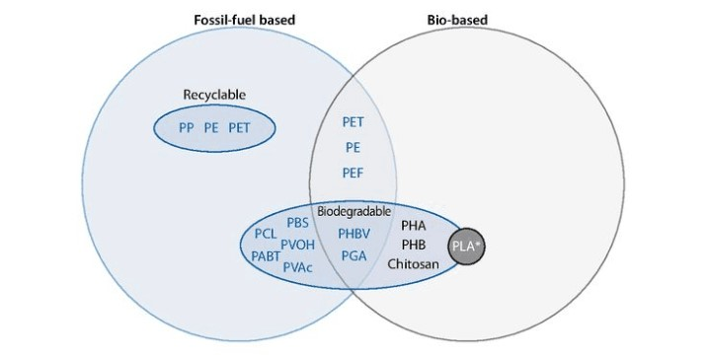

*Figure 1.1[1]-Recyclability and biodegradability of fossil fuel-and bio-based plastics*

According to the statistical data, we can know that packaging is the main source of disposable plastic waste, accounting for about 46.84%[2], which plays a decisive role in the total amount of plastic waste in the world every year. Therefore, we take this part as the main object of this investigation and the first target of Q. According to the components of packaging, we can calculate the amount of different types of plastic used (Figure 1.2). What’s more, as LDPE, HDPE, PP, PS are four main components of non-biodegradable plastics, we take the proportion of these four

plastics as the second target of Q.

--LDPE/LLPDE

--PET

--HDPE

--PP

--PS

--PVC

--PUR

Now the biodegradable plastics are treated by cracking in industry and the recycling rate of biodegradable plastics is nearly 100%. It is assumed that the recycling rate is 100% and the remaining polymers are calculated by the world's leading recycling rate (Figure 1.3). In our hypothesis, the plastic waste that cannot be cracked will be burned. Set the amount of plastic waste after plastic waste recycling as F. The equation are as follows.

F=X1*(1-16%)+X2*(1-85%)+X3*(1-16%)+X4*(1-15%)+X5*(1-21%)+X6*(1-24%)+X7*(1-100%)

F=0.84X1+0.15X2+0.84X3+0.85X4+0.79X5+0.76X6

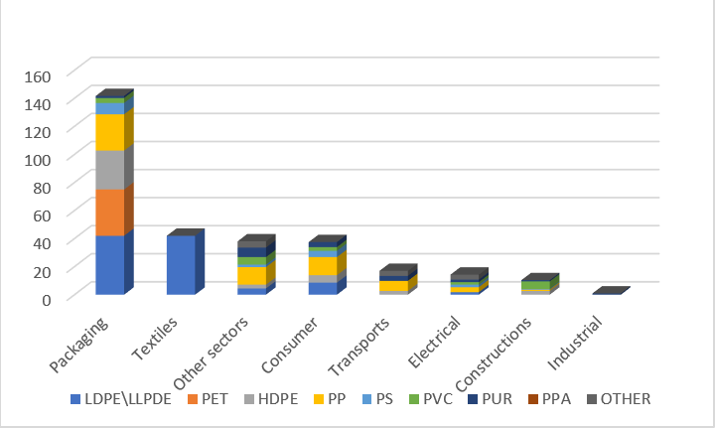

*Figure 1.2[3]- Main sources of disposable plastic waste*

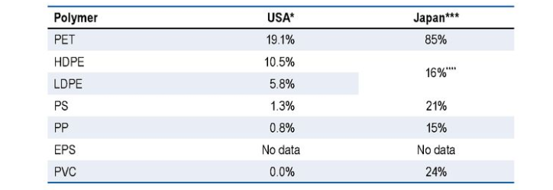

*Figure 1.3[1]-Summary of recycling rates for key polymers*

In order to estimate the global total amount of plastic waste in 2020, we develop models using Fourier least-square-fitting (Figure 1.4). The R-Square is 0.9998 and the adjusted R-square is 0.9997. We have greater confidence that the forecast data (the amount, Y is 373.3 metric ton) is reasonable.

According to the data released by the United Nations[4], the percentage of plastic waste that can be treated by incineration or heating decomposition without significant

air pollution is about 12 to 15 percent (Figure 1.5). To ensure X is the maximum predictor, we need to make sure that F12%. Considering the current pollution level of the ocean and soil, it is not allowed to bury and dump the plastic waste into the sea [1]. In that case, F should be less than 15%. Under these conditions, we can get the value of X (Figure 1.6).

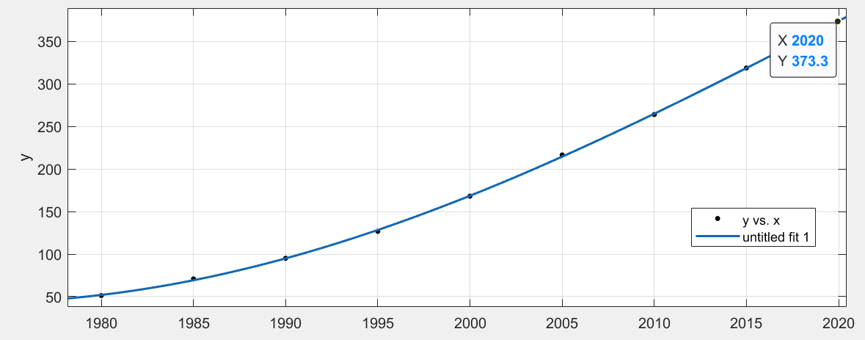

*Figure 1.4*

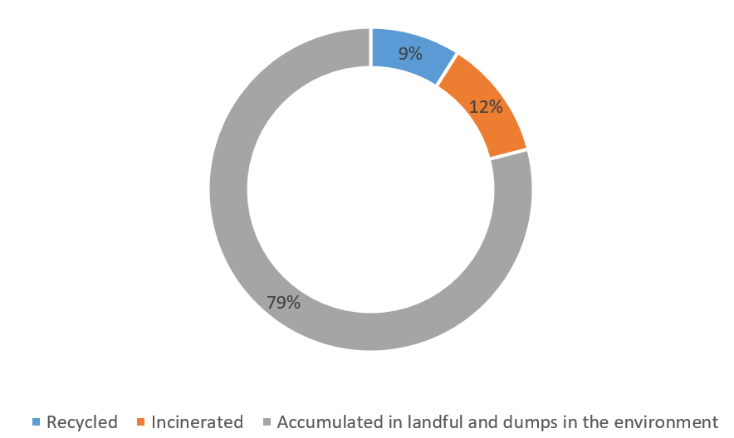

*Figure 1.5-Disposal of all plastic waste ever generated*

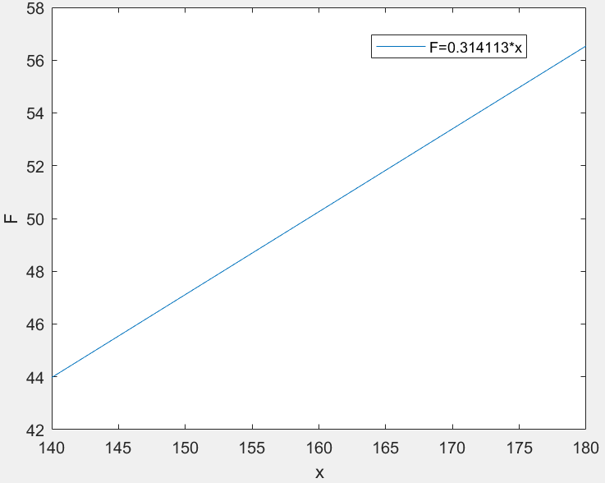

*Figure 1.6*

To get a more accurate value of Q, we set the current pollution proportion of marine area as the third target, the proportion of garbage coverage on land as the fourth target, and the reserves of resources used in waste disposal (now coal and natural gas are mainly used) as the fifth target.

1.3 Solution

According to five targets above, we can list the multiple linear regression equation.

To get the answer of ,we use the least squares method to calculate parameter

Return the results to the original equation

There are also some limits of :

1. In the light industry of the world, the production proportion of packaging is about 40% now. According to the white pollution initiative given by the United Nations [1], the production proportion of packaging cannot exceed 60%.
2. According to the existing technology, LDPE, HDPE, PP and PS belong to non-biodegradable materials, accounting for 68% of the total output value of the plastic industry [1], but in the future, this proportion may decline with the emergence of other biodegradable materials
3. The pollution proportion of marine area and the proportion of garbage coverage on land must be less than 100% [5]. Besides, both of them are hard to solve in a short time, the value should be larger than it is now.
4. On the basis of survey [6], less than 1% of natural gas and less than 4% of coal can be used to burn plastics. There are less than 86000twh existing energy production of coal and less than 50000twh existing energy production of natural gas.

The optimal solution is found according to the monotonicity of function

So the maximum levels of plastic product waste, Q=12465.152 (mt)

* 1. Model Overview

From the global plastic waste pollution data for 2010 released by the European Union (Figure 2.1), we can know that the last three columns are the standards to measure a country's plastic pollution index.

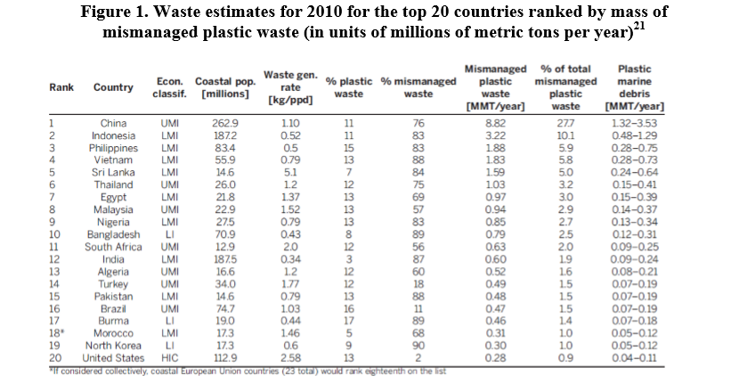

*Figure 2.1[7]-plastic waste for 2010 for the top 20 countries ranked*

The last three columns of data were scored by entropy method, and the weights of these three indicators for the current situation of plastic pollution treatment in a country are calculated objectively, and the ranking of the severity of plastic pollution in a country was given. Theoretically, this ranking can determine the policy levels of different regions.

1. Use the raw data matrix to calculate
2. Calculate the entropy value of j index
3. Calculate the variation coefficient g of index j

For index j, the larger is, the smaller the variation degree of index j is.

1. Calculate the weight of index j
2. Calculate the comprehensive evaluation value of the object I .

According to s, we can get the ranking of national severity of plastic pollution, which can theoretically determine the policy level of different regions (Figure 2.2). The higher it ranks, the more severe the relevant policies will be. Based on the trends and realities of the scores, we divided the 20 major countries into five regions for subsequent analysis.

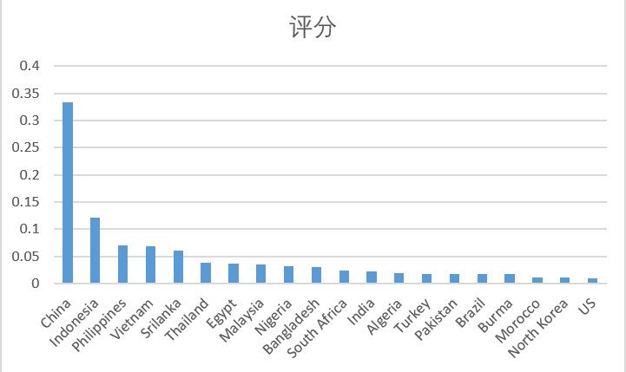

*Figure 2.2*

2.2 Model Modification

Considering that a large number of countries have enacted plastic import bans and related use of plastic in the past decade, the classification above should be revised.

First of all, though China and India issued bans in 2017 and 2019, nearly half of plastic imports were closed, due to the large accumulation, the rating remains unchanged. Affected by the rapid decline of export volume, the plastic waste treatment volume of the United States, Japan and the European Union will rise sharply [8]. Therefore, the ratings of Japan, the European Union and the United States need to be adjusted (Figure 2.3).

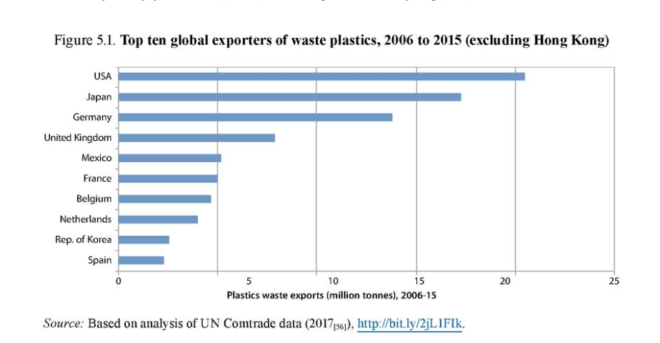

*Figure 2.3[9]-top ten global exports of waste plastics,2006 to 2015 (excluding Hong Kong)*

Based on the above model and the following six analyses (Figure 2.4), the model is modified and the new grouping situation is obtained.

1. China holds the largest amount of mismanaged plastic waste and plastic
2. marine debris in the world, and the severity of the problem can be seen clearly in the index level. Moreover, due to the huge amount of mismanaged plastic, the problem should be paid more attention to.
3. Southeast Asian countries have nearly the same index ratings for plastic pollution, and after China's strict ban, Southeast Asian countries will become the world's largest plastic importer. Besides, after China, its mismanaged plastic is second-biggest in the world, the problem is urgent.
4. Due to the influence of light industry capacity in some Asian and African countries, much plastic waste cannot be completely treated, resulting in a large amount of waste accumulation.
5. due to lax policies, inadequate treatment capacity and other factors, some developing countries are facing general plastic pollution.
6. Some developed countries produce a large amount of industrial output and plastic waste every year, which exceed the industrial capacity of some domestic waste treatment industries and cause a certain degree of pollution. Considering that the amount of waste exported to China and southeast Asian countries has been sharply reduced, the pollution may further increase, and the pollution is worth noting.
7. Although the plastic industry in the European Union and Japan also have strong production capacity, the pollution is relatively light due to the developed domestic plastic recycling industry and residents' strong awareness of recycling.

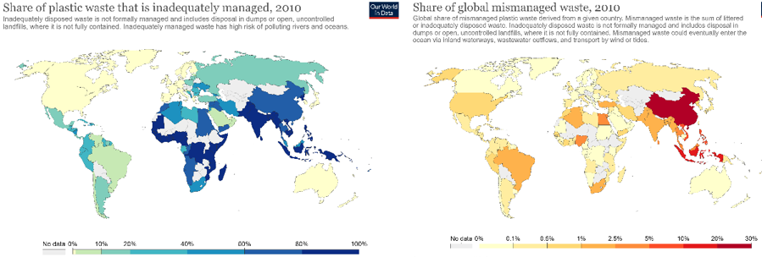

*Figure 2.4[10]*

Based on the above analysis, we revised the grouping, find out the plastic recycling proportion of each group and the mismanaged plastic waste proportion of each group in the world in 2015 (table 2.1)

*Table 2.1*

|  |  |  |  |
| --- | --- | --- | --- |
| No. | Classification | Recycling rate | Proportion |
| (1) | China | 12% | 28% |
| (2) | Indonesia, Philippines, Vietnam, Sri Lanka | Less than 10% | 27% |
| (3) | Thailand, Egypt, Malaysia, Nigeria, Bangladesh | 13%-15% | 14% |
| (4) | South Africa, India, Algeria, Turkey, Pakistan, Brazil, Myanmar | About 20% | 11% |

|  |  |  |  |
| --- | --- | --- | --- |
| (5) | Morocco, South Korea, the United States | 20%-25% | 3% |
| (6) | European Union, Japan | 40% | 1% |
| (7) | Others | Average 19.5% | 16% |

* 1. Regional-specific constraints

After getting the new revised rating (Figure 2.5), we can make corresponding policy for each group, make certain limits on the severity or taxes, and make corresponding regulations on import and export.

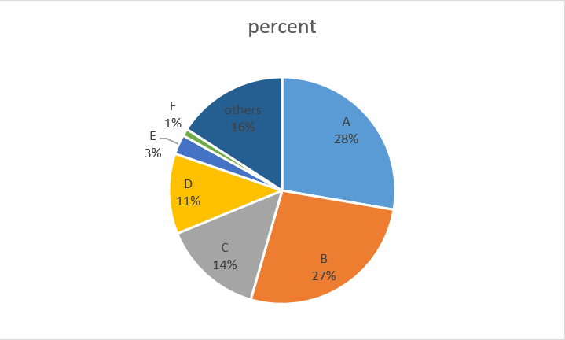

*Figure 2.5*

According to the proportion of mismanaged plastic waste in different groups in the world, we set a target of plastic recycling rate in different groups and set corresponding policies to achieve our goal of reducing plastic waste and achieving environmentally safe level (table 2.2).

*Table 2.2*

|  |  |  |  |  |
| --- | --- | --- | --- | --- |
| No. | Classification | Recycling rate | Recovery requirement | Relevant policy |
| (1) | China | 12% | Add an additional 40 percent every five years to the natural growth rate | The ban on plastic waste imports is as severe as 90 percent. It also bans the sale of some single-use plastic products, with an additional tax of $0.03 per piece |
| (2) | Indonesia, Philippines, Vietnam, Sri Lanka | Less than 10% | Add an additional 40 to 60 percent every five years to the natural growth rate | The ban on plastic waste imports is as severe as 50 percent, and the sale of some single-use plastic products is also banned, with a tax of $0.025 per piece |

|  |  |  |  |  |
| --- | --- | --- | --- | --- |
| (3) | Thailand, Egypt, Malaysia, Nigeria, Bangladesh | 13%-15% | Add an additional 30 percent every five years to the natural growth rate | The ban on plastic waste imports is as severe as 20 percent, and the sale of some single-use plastic products is also banned, with an additional tax of $0.02 per piece |
| (4) | South Africa, India, Algeria, Turkey, Pakistan, Brazil, Myanmar | About 20% | Add an additional 20 percent every five years to the natural growth rate | Ban on sale of some disposable plastic products. An additional tax of $0.015 per disposable plastic product. |
| (5) | Morocco, South Korea, the United States | 20%-25% | Add an additional 10 percent every five years to the natural growth rate | Impose a ban on the sale of some single-use plastic products. An additional tax of $0.015 per disposable plastic product. the government introduces incentives for individuals or manufacturers to recycle alternative materials |
| (6) | European Union, Japan | 40% | Develop new technologies while maintaining natural growth rates | An additional tax of $0.015 per disposable plastic product. the government introduces incentives for individuals or manufacturers to recycle alternative materials |
| (7) | Others | Average 19.5% | Maintain natural growth rate | An additional tax of $0.015 per disposable plastic product. the government introduces incentives for individuals or manufacturers to recycle alternative materials |

p.s.: The types and proportions of single-use plastic products banned from sale in different countries are not exactly the same. Considering the development of light industry in different regions and the consumption needs of residents, governments or relevant environmental organizations can conduct relevant meetings and negotiations to reach a global overall agreement and regulation.

2.4 Desired result

According to the image of the natural growth of plastic waste circulation in the world, fit the curve function of the natural growth of plastic waste disposal rate over the years (Figure 2.6).

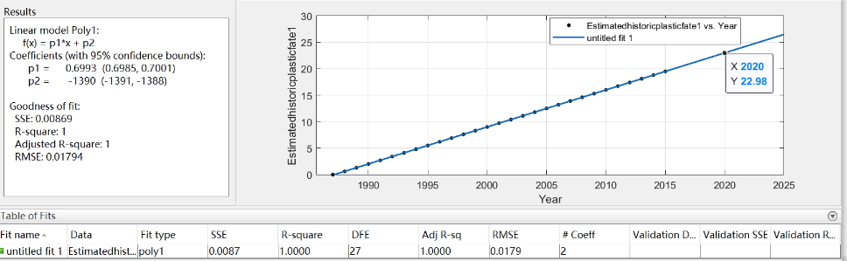

Figure 2.6

Since we know the recycling ratio in 2015, we choose to use the period from 2015 to 2020 for effective growth estimation [4], and calculate the natural growth of plastic waste disposal rate b between 2015 and 2020 based on the obtained function.

After implementing the policy and setting the target of plastic recycling rate in different groups, we set the growth ratio as

In that case, we can get the plastic recycling rate of different groups in 2020 (table 2.3).

*Table 2.3*

|  |  |  |  |  |  |
| --- | --- | --- | --- | --- | --- |
| No. | Classification | Recycling rate(2015) | Recovery requirement | the growth ratio(2015-2020) | Recycling rate(2020) |
| (1) | China | 12% | Add an additional 40 percent every five years to the natural growth rate | 4.9% | 16.9% |
| (2) | Indonesia, Philippines, Vietnam, Sri Lanka | Less than 10% | Add an additional 40 to 60 percent every five years to the natural growth rate | 4.9%-5.25% | 11.9-13.25% |
| (3) | Thailand, Egypt, Malaysia, Nigeria, Bangladesh | 13%-15% | Add an additional 30 percent every five years to the natural growth rate | 4.55% | 17.55%-19.55% |

|  |  |  |  |  |  |
| --- | --- | --- | --- | --- | --- |
| (4) | South Africa, India, Algeria, Turkey, Pakistan, Brazil, Myanmar | About 20% | Add an additional 20 percent every five years to the natural growth rate | 4.2% | 24.2% |
| (5) | Morocco, South Korea, the United States | 20%-25% | Add an additional 10 percent every five years to the natural growth rate | 3.85% | 23.85%-28.85% |
| (6) | European Union, Japan | 40% | Develop new technologies while maintaining natural growth rates | 3.5% | 43.5% |
| (7) | Others | Average 19.5% | Maintain natural growth rate | 3.5% | 23% |

According to the results of question one, Y (the total amount of plastic waste in the world) is expected to be 373.3 (mt) in 2020. On the basis of plastic waste proportion of these 7 groups, Y should be divided into 7 parts to represent the amount of plastic waste per group in 2020.

Let the global recycling amount of plastic waste(After the policy implementation) in 2020 be W, and the amount of each group is .

The succeeded recycling radio (After the policy implementation) =18.4%

Let the global recycling amount of plastic waste (without improvement) in 2020 be Z

The succeeded recycling radio (without improvement) =16.8%

It can be seen from the comparison between W and Z and the comparison between the succeeded recycling radio that the proposed policy on plastic recycling rate is effective.

In order to see the effect more clearly and to prove the reliability of our hypothesis, we use the same method above to calculate and graph the effect in 2025 (figure 2.7).

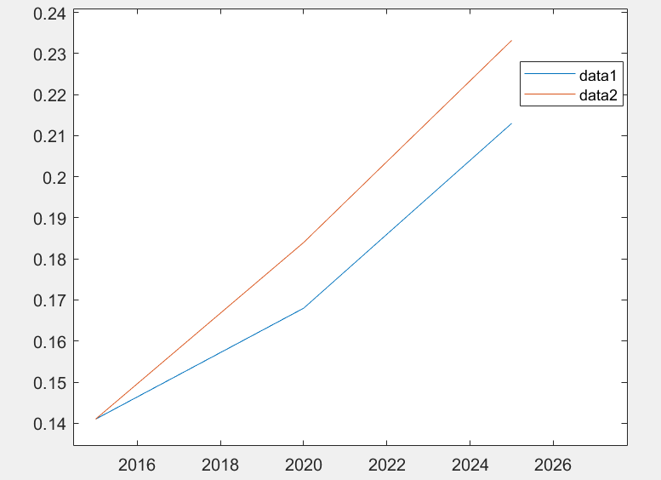

*Figure 2.7*

data1 represents the succeeded recycling radio (After the policy implementation)

data2 represents the succeeded recycling radio (without improvement)

It is also evident from our calculated values that we can significantly increase the recycling rate and the total amount of recycling plastic waste with our policy implementation from 2015 to 2025 (table 2.4).

*Table 2.4*

|  |  |  |  |  |  |
| --- | --- | --- | --- | --- | --- |
| year | The global recycling amount of plastic waste | The amount (with the policy implementation) | d-value | plastic recycling rate | recycling rate(with the policy implementation) |
| 2015 | 46.79 | - | - | 14.1% | - |
| 2020 | 62.8 | 68.76 | 5.96 | 16.8% | 18.4% |
| 2025 | 106.18 | 97.05 | 9.75 | 21.3% | 23.32% |

Considering that some values will change over time, after a period of time, the accumulated plastic waste in the countries which have formulated the ban has been disposed of. At that time, we should regroup and implement a new plan based on the current amount.

* 1. Expand

If the availability of alternatives to plastics is strong, the amount of plastic waste can be further reduced. At present, most of the plastic products are still the umbilical industry of the oil industry, and the price of plastic particles fluctuates greatly under the influence of the oil price. The rising price of plastic often attracts a large number of researchers. In addition, in recent years, with the increasingly serious environmental problems, plastic substitutes have begun to explore and research in a voice. But up to now, plastic substitutes that can be quantified and mass-produced are still not available, and the development of plastic substitutes industry is still in the exploration stage. Now it is generally believed that there are two possible development directions for future plastic substitutes:

1. Natural fiber substitute

Natural fiber substitutes are mainly used in general plastic products and transportation. They can be used as high-quality substitutes for disposable non-renewable plastic bags and some cars’ interior plastics. It mainly uses flax

fiber as production material, which can be regenerated repeatedly and composted, and has good environmental friendliness. But the problem is that its high dependence on flax fiber is easy to cause food problems all over the world step by step, and its popularization needs to be verified

1. Substitute of bioengineering materials

Bioengineering materials are mainly used in the packaging of food. They are high-quality substitutes for domestic water bottles and other plastic containers. The main components are starch, PLA and cellulose, so they have better biological activity and regeneration, and the recycling process is relatively environmental protection. However, as the technology is not mature at this stage, there is no alternative product that can be widely used

All in all, Under the trend of the world's gradual pursuit of resource recycling, the replaceable products industry of plastics will certainly develop with paying more attention to the environmental protection. However, due to the long time-consuming of product development, it is difficult to bring obvious quantitative impact on the output value of the world plastic industry and the world plastic output in a short time. The growing maturity of plastic substitute industry may bring new vitality to solve the global plastic pollution problem.

3.1 Target

The remaining plastic that can't be cracked and burned is disposable plastic. As we calculate above, we have got the recycling rate (the proportion of the plastics cracked) with the policy implementation of 2025.

In order to ensure the environmental protection of the treatment as much as possible, we optimize the incineration process. At present, there are two main forms of plastic waste incineration: incineration and pyrolysis. To find the best ratio of the two methods, we set variable a and list the equation.

According to the environmental impact ratio (Figure 3.1), we can know that when a>125%, the climate impact index=.

Besides, the proportion of plastic waste incineration per year should not be less than 50%, otherwise it will cause biological pollution of the environment. When 100%<a<125%, the climate impact index= .

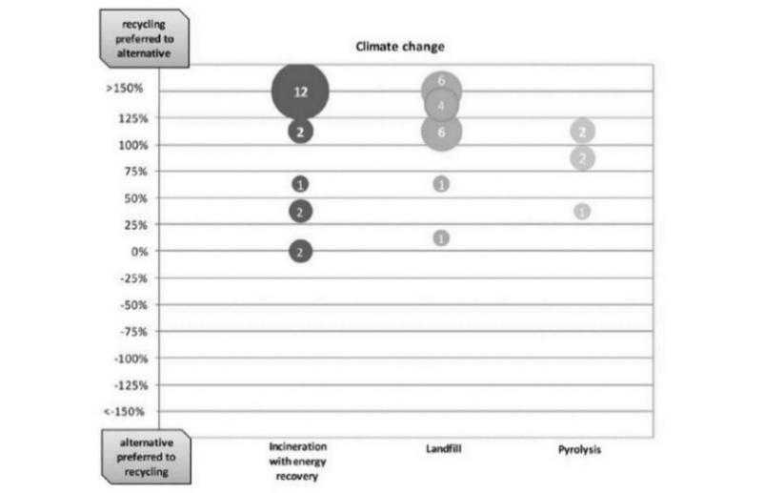

*Figure 3.1[11]-relative difference between the climate change impacts of different end-of-life options vs. recycling for plastics*

To satisfy that F meet the limitation above and ensure the climate impact index takes the minimum value, , a=1.3775. This ratio is the most environmentally friendly solution to deal with the incineration/pyrolysis portion of waste within our current limits.

According to our hypothesis, the proportion of cracked waste in 2025 is 23.32%, So, the proportion of plastic waste burned

The maximum sum of the proportion of waste cracked and the proportion of waste cracked

So we set the target for the minimal achievable level of global waste of single-use or disposable plastic products in 2025 as c (Figure 3.2).

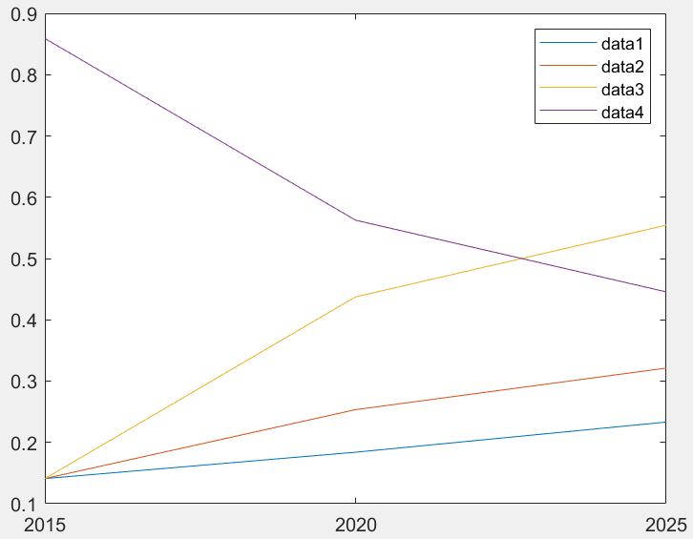

*Figure 3.2- Estimated amount of cracking and burning waste*

*data1 represents the radio of cracked plastic waste, data2 represents the radio of burned plastic waste, data3 represents the sum of data1 and data2, data4 represents the trend of c*

3.2 Impacts

To quantify the impacts for achieving levels above, considering that there are great differences in lifestyles and living standards of people in different regions, we set Residents' policy sensitivity index as k.

We choose 22 countries from the first six groups as our observation objects. To

measure the living standards of people in different countries about plastic products, we set GDP as the first target (Figure 3.3), the average plastic consumption of residents as the second target and the population as the third target.

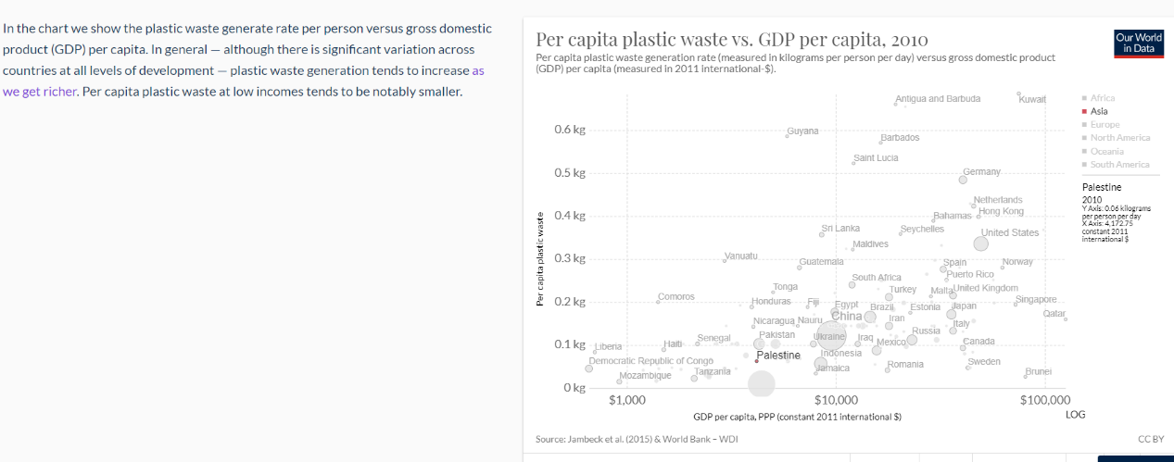

*Figure 3.3[12]-GDP can determine the average plastic consumption of residents*

*This figure shows the plastic waste generate rate per person versus gross domestic product(GDP) per capita. plastic waste generation tends to increase as we get richer.*

These three targets can be scored by entropy method. Theoretically, we can rank the living standards of people in these 22 different countries about plastic products.

1. Use the raw data matrix to calculate
2. Calculate the entropy value of j index
3. Calculate the variation coefficient g of index j

For index j, the larger is, the smaller the variation degree of index j is.

1. Calculate the weight of index j
2. Calculate the comprehensive evaluation value of the object I.

According to s, we can get the ranking of living standards of people in these 22 different countries about plastic products (Figure 3.4). The higher the country ranks, the more plastic its residents use on average. The impact of a policy is determined

jointly by the residents’ lifestyle, standard of living and the way the government collects taxes in each country, so we believe that taxes (set as f) and sensitivity index (k) jointly determine the impact of the policy (set as H). The size of H determines the change degree of residents' lifestyle with the country's relevant tax collection strategy

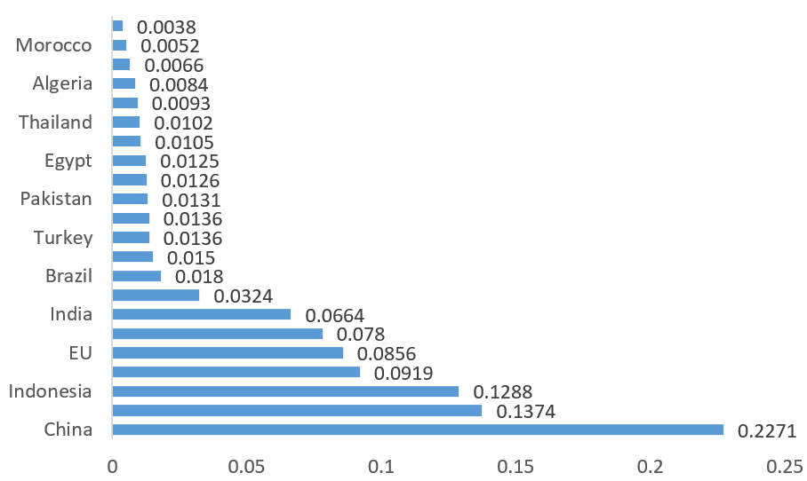

*Figure 3.4*

We can figure out the value of H based on the corresponding f and k (Figure 3.5). The higher the value of H is, the more the citizens of the country are affected by the tax collection policy

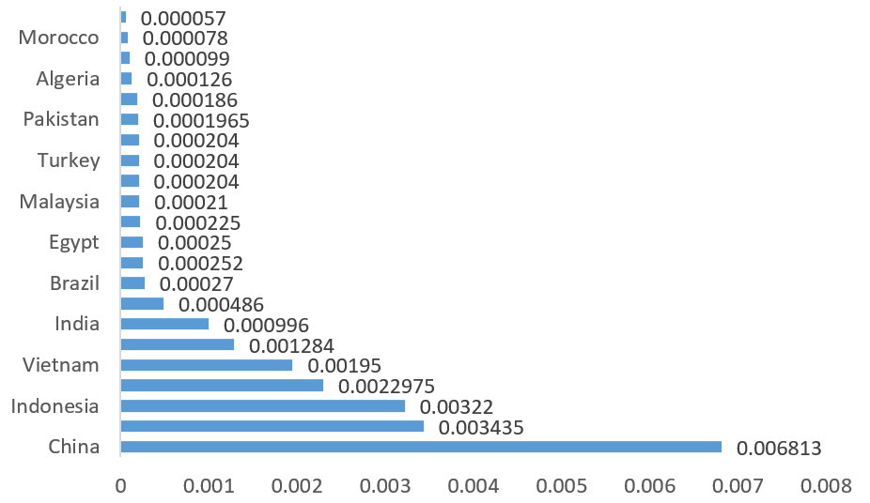

*Figure 3.5*

From the above analysis, it can be seen that the impact of policies on people around the world can be divided into three parts.

1. Developing countries with high GDP and per capita plastic use.

These kind of countries are in the industrial and social transition period, people have larger plastic use demand, but at the same time, domestic plastic processing industry is not developed, so plastic tax policy on which causes big economic pressure. Within 1 to 3 months after the issuance of the tax policy, it can produce significant results: the amount of disposable plastic products will decrease obviously, but long-term tax will cause bigger economic burden to local residents. The government should adopt certain regulation to achieve the balance and long-term of the policy.

1. Developed countries with high GDP and per capita plastic use

In developed countries with high GDP and per capita plastic use, the residents are obviously rich, have strong consumption capacity, and have great demand for plastic. However, due to the relatively developed plastic processing industry, the impact of plastic tax policies on the people in these countries is not too obvious,

the long-term tax policies can effectively reduce the amount of disposable plastic waste in this region (Greece piloted a tax increase on plastic bags in 2012, resulting in a 75% reduction in the use of plastic bags in one quarter. In the UK in 2012, the introduction of higher taxes on suppliers and buyers resulted in an 80% reduction in the use of plastic bags within six months). Considering the average literacy level and economic ability of the people, long-term taxation of disposable plastics can be implemented. On this basis, dividend policies can also be adopted to reward people who recycle alternative products or use less disposable plastics. A certain tax system can ensure the fine development of residents' plastic use in this area.

1. Backward countries with low GDP and per capita plastic use (Most of them are in Africa and Central Asia)

Due to the weak economic capacity of residents and the insufficient demand for plastic products, the local government can make corresponding adjustments based on the existing tax policies according to the local conditions, so as to reduce the economic burden of local residents.

All in all, according to the above analysis, the regional plastic treatment strategy proposed by us has a strong pertinence and a certain universality in the world. It can effectively improve the disposable plastic use habits of human beings, gradually reduce the amount of disposable plastic use and ensure the stable life of residents in different areas.

4.1 Introduction

While the plastic waste problem is a global problem, the causes and effects are not equally distributed across nations or regions. The total output of plastic waste of each country can basically reflect the proportion of plastic waste disposal in each country, so the output of plastic waste produced by each country can be taken as the basic reference for the share of disposal. In that case, we use the total output of plastic waste of each country to distribute the equity issues first (figure 4.1).

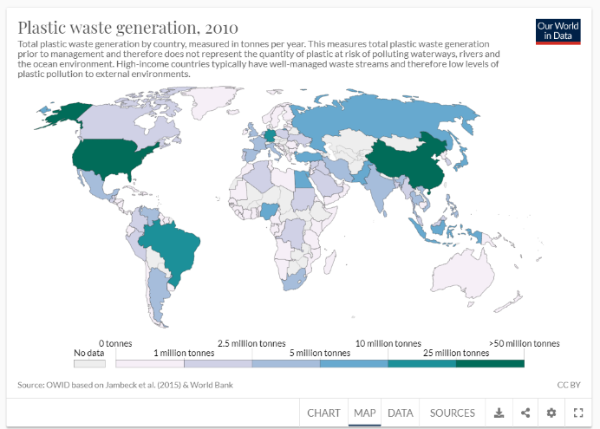

*Figure 4.1[12]*

4.2 Optimization

The first method to optimize:

The proportion of the inadequately disposed describe the proportion of waste that is not adequately treated in each country, which can effectively estimate the development level of a country's plastic industry and the treatment capacity of plastic waste. Considering that there is not obvious regional characteristic in the proportion distribution of the inadequately disposed in the world, it is better to consider the world as a whole. IMC can implement the Tax Difference Theory that consults the proportion of the inadequately disposed:

Exporting plastic waste from industrially developed countries (the proportion of the inadequately disposed is low) to less industrially developed countries (the proportion of the inadequately disposed is high) requires an export tax on exporting countries to give developed countries that dump plastic waste trade pressure to protect the natural environment of backward or developing countries.

To the country with developed plastic processing industry (the proportion of the inadequately disposed is low), IMC can implement certain Import Dividend Policy:

If the country imports plastic waste from countries with less developed plastic processing industries and get rid of plastics waste according to international standards, its import duties can be exempted or partially reduced (figure 4.2).

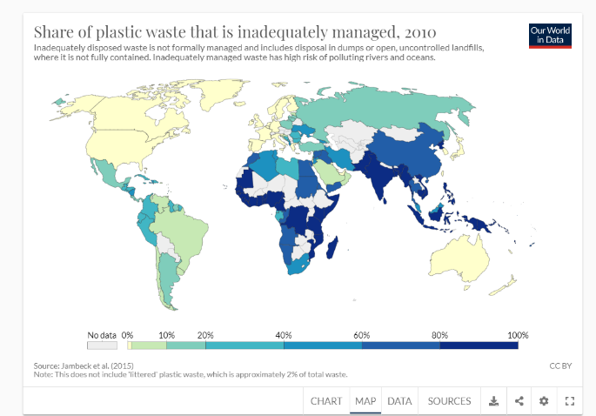

*Figure 4.2[12]*

The second method to optimize:

The proportion of the mismanaged waste describe the proportion of the untreated part of plastic waste in the world of each country, which is internationally recognized that it can reflect the pollution of plastic waste in a country. If the proportion of the mismanaged waste is high, it means that the domestic plastic waste treatment system (including the surplus value of plastic import and export, the treatment method of plastic waste, and the local strategies for plastic waste problems) is unreasonable and impractical. The higher the proportion is, the more serious the problem is (figure 4.3). In order to effectively manage these urgent countries and ensure the balanced and sustainable development of the world, ICM can adopt the following strategies for this type of countries:

1. Introduce policies and bans to effectively control its plastic waste import trade.
2. Lay down a certain agreement, including reducing the growth rate of domestic waste production (if the growth rate of plastic waste exceeds a certain amount, additional waste will be taxed every year)
3. Considering the proportion of the inadequately disposed, if the value of the inadequately disposed is also significantly high, it proves that the waste treatment industry of the country may have some problems. An investigation team should be sent to study the local plastic waste treatment process to help formulate new plastic pollution treatment strategies.

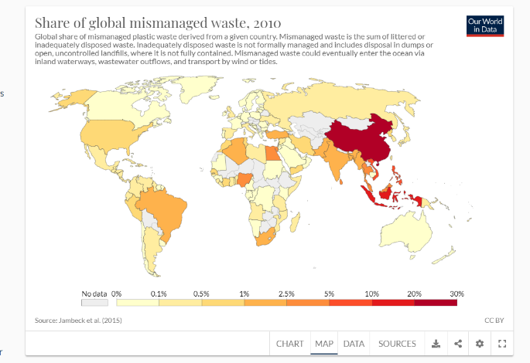

*Figure 4.3[12]*

The third method to optimize:

As we all know, the marine pollution caused by plastics is increasingly serious, which has an irreversible impact. In 2015, the coverage of marine plastic waste in the world reached 80% [13]. A major cause of marine pollution is the huge amount of plastic waste discharged from rivers all over the world. Asian rivers (especially the Yangtze River and Ganges River) discharge more than 85% of the world's plastic waste into the ocean every year (figure 4.4), making the Pacific Ocean and the Indian Ocean the most polluted ocean in the world (figure 4.5), seriously affecting the global marine environment and related marine industries (such as fisheries, marine industry), and even causing great harm to the life and health of coastal residents.

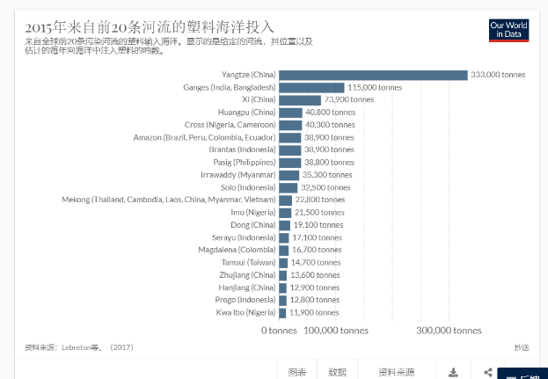

*Figure 4.4[14]-Plastics from the first 20 rivers into the ocean in 2015*

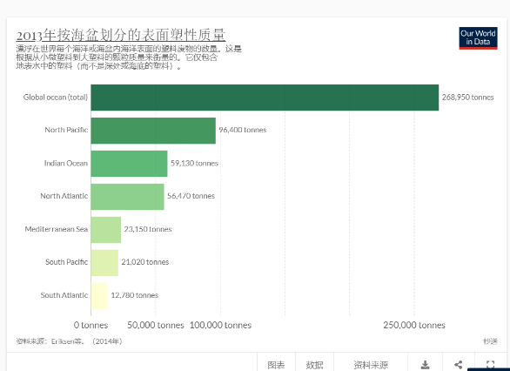

*Figure 4.5[15]-Surface plasticity quality by basin in 2013*

ICM can investigate the plastic treatment methods related to major rivers in Asia and the plastic industry in large coastal cities, to find out the problems and formulate relevant regional policies to effectively reduce the amount of plastic waste in rivers.

5.0 Memo

(1) The maximum level of global single-use or disposable plastic product waste.

The level of global plastic waste is a complex and fluctuation value related to many factors. In order to simplify the model and ensure the accuracy of the estimated value, the limit value is estimated from three targets. We set the proportion of disposable plastic packaging in plastic pollution as the first target of Q; the proportion of these four plastics as the second target of Q; the current pollution proportion of marine area as the third target; the proportion of garbage coverage on land as the fourth target; and the reserves of resources used in waste disposal (now coal and natural gas are mainly used) as the fifth target. With considering the current environmental parameters of the earth, we use multiple linear regression method to get the value of Q ( the target minimum achievable level of plastic waste)

1. The target for the minimal achievable level of global waste of single-use or disposable plastic products.

At present, the global accumulated value of plastic waste has reached 7000mt, compared with Q, the severity of global plastic problems can be clearly felt. With reference to the data of plastic waste recycling rate and incineration treatment rate in the world, we use the Time series method and Fourier base fitting method to estimate the target minimum value of the highest environmental friendliness in the world, which is expected to be 373.3 (mt) in 2020.

1. Solutions for global disposable plastics and the world's lowest scrap rate under ideal conditions

Considering regional differences, we choose mismanaged plastics waste, global mismanaged waste rate, plastics marine debris and landfill as parameters, use the entropy weight method to score the regional pollution, divide countries into different groups and put forward different policies (table 5.1).

*Table 5,1*

|  |  |  |  |
| --- | --- | --- | --- |
| No. | Classification | Recovery requirement | Relevant policy |
| (1) | China | 40% addition | 90% imports, 0.03 per piece |
| (2) | Indonesia, Philippines, Vietnam, Sri Lanka | 40%-60% addition | 50% imports, 0.025 per piece |
| (3) | Thailand, Egypt, Malaysia, Nigeria, Bangladesh | 30% addition | 20%imports, 0.02 per piece |
| (4) | South Africa, India, Algeria, Turkey, Pakistan, Brazil, Myanmar | 20% addition | Ban ,0.015 per piece |
| (5) | Morocco, South Korea, the United States | 10% addition | Ban, 0.015 per piece |
| (6) | European Union, Japan | natural growth rate | 0.015 per piece |
| (7) | Others | natural growth rate | 0.015 per piece |

With reference to the current global environment and plastic pollution situation, if the situation is ideal, the minimal achievable level of global waste of single-use or disposable plastic products is expected to be 44.5567% in 2025 (figure5.1).



*Figure 5.1- Estimated amount of cracking and burning waste*

1. The circumstances that may accelerate or hinder the achievement of the target and timeline

Favorable factors:

According to the UN survey document, in the past five years, the production capacity of alternative plastic products has been increasing in an exponential way. In the future, part of the demand of the plastic industry may be replaced by this production capacity, and the annual output of plastic waste may decline.

Since 2013, many Asian countries have successively introduced import bans on plastic waste. Under the long-term implementation of the bans, the global plastics garbage distribution and pollution index may change significantly.

With the development of the chemical industry, the research on biodegradable and compostable plastics has made a breakthrough. Around 2017, a variety of biodegradable plastics were invented, which were considered by many environmental experts as the future of plastic governance. Although the industry is still in its infancy,

the future expansion of biodegradable plastic production capacity could effectively reduce single-use plastic waste pollution

Adverse factors:

The environment of the earth is determined by many factors. The impact of other pollution on the environment may seriously reduce the carrying capacity of the environment and increase the pressure of plastic waste disposal

According to the investigation, in many developing countries and backward countries in the world, there are still a lot of behaviors harmful to the environment, such as burning without permission, burying plastic waste, as well as illegal behaviors of tax evasion and tax evasion, which will play a certain resistance to the effect of policy implementation.

References:

[1] OECD(2018)，Improving Markets for Recycled Plastics: Trends, Prospects and Policy Responses, OECD Publishing, Paris.

<http://dx.doi.org/10.1787/9789264301016-en>

[2] Hannah Ritchie and ax Roser(2020)一"Plastic Pollution". Published online at OurForldInData. org.

<https://ourworldindata.org/plastic-pollution>

[3] Roland Geyer, jenna R Jambeck, Kara Lavender Law Published 19 July 2017.Sci.Adv.3,e1700782(2017)

DOI:10.1126/sciadv.1700782

[4] Geyer, R., Jambeck. J R. ,& Law, K. L (2017)Production, use, and fate of all plastics ever made. Science Advances, 3(7). e1700782.

http://advances. sciencemag.org/content/3/7/e1700782.full

[5] Eriksen, M., Lebreton, L. C., Carson, H. S., Thiel, M., Moore, C. J., Borerro, J. C., ... & Reisser, J. (2014). Plastic pollution in the world's oceans: more than 5 trillion plastic pieces weighing over 250,000 tons afloat at sea. PloS one, 9(12), e111913. <http://journals.plos.org/plosone/article?id=10.1371/journal.pone.0111913>.

[6] Vaclav Smil (2017). Energy Transitions: Global and National Perspectives. & BP Statistical Review of World Energy.

<http://vaclavsmil.com/2016/12/14/energy-transitions-global-and-national-perspectives-second-expanded-and-updated-edition/>;

<https://www.bp.com/en/global/corporate/energy-economics/statistitcal-review-of-world-energy.html>

[7] Jenna R Jambeck et al. (2015), Plastic waste inputs from land into the ocean, Science, 347 (6223), 768-771

DOI: 10.1126/science.1260352

[8] Brooks, A. L., Wang. S., & Jambeck, J. R. (2018). The Chinese import ban and its impact on global plastic waste trade. Science Advances, 4(6), eaat0131.

<http://advances.sciencemag.org/content/4/6/eaat0131>

[9] UN(2017), Comtrade Database,

<https://comtrade.un.org/>

[10] Jambeck, J. R., Geyer, R., Wilcox, C., Siegler, T. R., Perryman, M., Andrady, A., … & Law, K. L. (2015). Plastic waste inputs from land into the ocean. Science, 347(6223), 768-771.

<http://science.sciencemag.org/content/347/6223/768/>

[11] Michaud, Farrant and Jan (2010), “Environmental benefits of recycling", WRAP, [www.wrap.org.uk/files/wrap/Environmental_benefits_of_recycling_2010_update.3b174d59.8816.pdf](http://www.wrap.org.uk/files/wrap/Environmental_benefits_of_recycling_2010_update.3b174d59.8816.pdf)

[12] Jambeck, J. R., Geyer, R., Wilcox, C., Siegler, T. R., Perryman, M., Andrady, A., … & Law, K. L. (2015). Plastic waste inputs from land into the ocean. Science, 347(6223), 768-771.

<http://science.sciencemag.org/content/347/6223/768/>

[13][https://read.oecd-ilibrary.org/environment/improving-markets-for-recycled-plastics_9789264301016-en#page46](https://read.oecd-ilibrary.org/environment/improving-markets-for-recycled-plastics_9789264301016-en" \l "page46)）

[14] Lebreton, L. C., Van der Zwet, J., Damsteeg, J. W., Slat, B., Andrady, A., & Reisser, J.

(2017]. River plastic emissions to the world's oceans. Nature Communications, 8, 15611.

<https://www.nature.com/articles/ncomms15611>

[15]Eriksen M, Lebreton L.C, Carson H.S, Thiel, M. Moore,C,J,Borerro,J,C…&Reisser J(2014).Plastic pollution in the world’s oceans:more than 5 trillion plastic weighting over 250,000 tons afloat at sea. PloS one,9(12),e111913.

http://journals.plos.org/plosone/article?id=10.1371/journal.pone.0111913