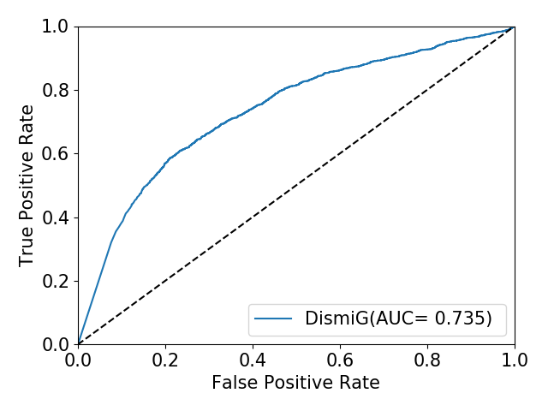

/usr/bin/python2.7 /home/phuping/AI/DimiG-master/DimiG.py

/home/phuping/.local/lib/python2.7/site-packages/sklearn/ensemble/weight_boosting.py:29: DeprecationWarning: numpy.core.umath_tests is an internal NumPy module and should not be imported. It will be removed in a future NumPy release.

from numpy.core.umath_tests import inner1d

2

read expresion file: data/GTEx_Analysis_v6p_RNA-seq_RNA-SeQCv1.1.8_gene_median_rpkm.gct.gz

# of tissues 53

1481757 18883

173662 17686 1725

6188

non zero 435570

548

disease 248

/home/phuping/AI/DimiG-master/DimiG.py:263: RuntimeWarning: invalid value encountered in divide

X_new = X/X.sum(axis=1)[:, None]

/home/phuping/AI/DimiG-master/DimiG.py:1485: RuntimeWarning: divide by zero encountered in power

r_inv = np.power(rowsum, -1).flatten()

(7222, 7222) (7222, 54) (7222, 248) (4950,) (1238,) (1034,)

('Epoch: 0001', 'loss_train: 6.2214', 'loss_val: 5.6785', 'time: 3.0433s')

('Epoch: 0002', 'loss_train: 5.7022', 'loss_val: 5.2511', 'time: 2.6653s')

('Epoch: 0003', 'loss_train: 5.4587', 'loss_val: 4.8492', 'time: 2.8795s')

('Epoch: 0004', 'loss_train: 5.0331', 'loss_val: 4.4848', 'time: 2.6928s')

('Epoch: 0005', 'loss_train: 4.6423', 'loss_val: 4.1567', 'time: 2.6638s')

('Epoch: 0006', 'loss_train: 4.3194', 'loss_val: 3.8492', 'time: 2.6248s')

('Epoch: 0007', 'loss_train: 4.0285', 'loss_val: 3.5633', 'time: 2.7195s')

('Epoch: 0008', 'loss_train: 3.7627', 'loss_val: 3.2904', 'time: 2.7487s')

('Epoch: 0009', 'loss_train: 3.3779', 'loss_val: 3.0429', 'time: 2.6199s')

('Epoch: 0010', 'loss_train: 3.1319', 'loss_val: 2.8165', 'time: 2.5883s')

('Epoch: 0011', 'loss_train: 2.9725', 'loss_val: 2.5932', 'time: 2.5442s')

('Epoch: 0012', 'loss_train: 2.7639', 'loss_val: 2.3732', 'time: 2.5801s')

('Epoch: 0013', 'loss_train: 2.5501', 'loss_val: 2.1671', 'time: 2.6257s')

('Epoch: 0014', 'loss_train: 2.2868', 'loss_val: 1.9609', 'time: 2.8329s')

('Epoch: 0015', 'loss_train: 2.1332', 'loss_val: 1.7547', 'time: 2.5754s')

('Epoch: 0016', 'loss_train: 1.9250', 'loss_val: 1.5884', 'time: 2.6421s')

('Epoch: 0017', 'loss_train: 1.7302', 'loss_val: 1.4675', 'time: 2.6605s')

('Epoch: 0018', 'loss_train: 1.6681', 'loss_val: 1.3659', 'time: 2.6022s')

('Epoch: 0019', 'loss_train: 1.4360', 'loss_val: 1.2567', 'time: 2.6206s')

('Epoch: 0020', 'loss_train: 1.3468', 'loss_val: 1.1473', 'time: 2.6407s')

('Epoch: 0021', 'loss_train: 1.2517', 'loss_val: 1.0497', 'time: 2.6610s')

('Epoch: 0022', 'loss_train: 1.1063', 'loss_val: 0.9558', 'time: 2.7409s')

('Epoch: 0023', 'loss_train: 1.0525', 'loss_val: 0.8683', 'time: 2.6448s')

('Epoch: 0024', 'loss_train: 0.9654', 'loss_val: 0.7971', 'time: 2.6349s')

('Epoch: 0025', 'loss_train: 0.8883', 'loss_val: 0.7477', 'time: 2.6508s')

('Epoch: 0026', 'loss_train: 0.8171', 'loss_val: 0.7214', 'time: 2.6281s')

('Epoch: 0027', 'loss_train: 0.7969', 'loss_val: 0.7074', 'time: 2.6638s')

('Epoch: 0028', 'loss_train: 0.7460', 'loss_val: 0.6979', 'time: 2.8053s')

('Epoch: 0029', 'loss_train: 0.7310', 'loss_val: 0.6950', 'time: 2.6231s')

('Epoch: 0030', 'loss_train: 0.7128', 'loss_val: 0.6911', 'time: 2.7710s')

('Epoch: 0031', 'loss_train: 0.7132', 'loss_val: 0.6851', 'time: 2.6023s')

('Epoch: 0032', 'loss_train: 0.6723', 'loss_val: 0.6778', 'time: 2.7910s')

('Epoch: 0033', 'loss_train: 0.6815', 'loss_val: 0.6675', 'time: 2.9539s')

('Epoch: 0034', 'loss_train: 0.6671', 'loss_val: 0.6554', 'time: 2.7700s')

('Epoch: 0035', 'loss_train: 0.6522', 'loss_val: 0.6518', 'time: 2.6037s')

('Epoch: 0036', 'loss_train: 0.6411', 'loss_val: 0.6496', 'time: 2.6327s')

('Epoch: 0037', 'loss_train: 0.6464', 'loss_val: 0.6479', 'time: 2.6287s')

('Epoch: 0038', 'loss_train: 0.6368', 'loss_val: 0.6451', 'time: 2.6961s')

('Epoch: 0039', 'loss_train: 0.6336', 'loss_val: 0.6421', 'time: 2.6188s')

('Epoch: 0040', 'loss_train: 0.6297', 'loss_val: 0.6386', 'time: 2.6340s')

('Epoch: 0041', 'loss_train: 0.6337', 'loss_val: 0.6344', 'time: 2.6381s')

('Epoch: 0042', 'loss_train: 0.6257', 'loss_val: 0.6295', 'time: 2.6255s')

('Epoch: 0043', 'loss_train: 0.6309', 'loss_val: 0.6244', 'time: 2.8137s')

('Epoch: 0044', 'loss_train: 0.6144', 'loss_val: 0.6186', 'time: 2.5900s')

('Epoch: 0045', 'loss_train: 0.6112', 'loss_val: 0.6098', 'time: 2.5894s')

('Epoch: 0046', 'loss_train: 0.5920', 'loss_val: 0.5979', 'time: 2.6181s')

('Epoch: 0047', 'loss_train: 0.5963', 'loss_val: 0.5818', 'time: 2.6035s')

('Epoch: 0048', 'loss_train: 0.5756', 'loss_val: 0.5747', 'time: 2.6013s')

('Epoch: 0049', 'loss_train: 0.5627', 'loss_val: 0.5741', 'time: 2.7403s')

('Epoch: 0050', 'loss_train: 0.5708', 'loss_val: 0.5740', 'time: 2.6485s')

Optimization Finished!

Total time elapsed: 133.8089s

(1034, 248)

248 1034

disease

scoring

91

('Test set results:', 'loss= 0.2243')

0.7352396556531198

Process finished with exit code 0