GYM EXP
PROJECT COC
Complete Project Bible / Constitution / Source of Truth
GYM EXP / TOJI PROTOCOL
Futuristic Fitness RPG • Adaptive Fitness Operating System
13 August 2026
MASTER VERSION — reconstructed from the retained GYM EXP project discussions and decisions

0. COC PURPOSE
This COC is the authoritative project bible for GYM EXP. It is intentionally broader than a product brief: it records the product vision, information architecture, page responsibilities, interaction rules, calculations, RPG systems, visual language, engineering direction, phase order, known corrections, and future expansion path.
The COC separates current decisions from historical/changed ideas so that an older iteration does not accidentally override a newer decision.
Item | Status | Authority / Notes
GYM EXP / Toji Protocol | CURRENT | Project/product identity used in the current project context.
Mobile-first website before native app | CONFIRMED | Web product is the first implementation target.
Dark VOID HUD + Liquid Glass | CONFIRMED | Visual identity: translucent glass, fine borders, cyan energy, technical/angular HUD.
Dashboard as command center | CONFIRMED | Shows today's protocol/mini-schedule and Start Workout.
Schedule / planning | CONFIRMED | Plans daily activities; does not become the execution screen.
Workout / execution | CONFIRMED | Actual workout session and exercise logging.
Workout Library / exercise source | CONFIRMED | Reusable exercise/workout source; integrated with planning workflow rather than replacing Workout.
Intelligent calorie calculator | CONFIRMED | Explicitly restored after being omitted from an earlier blueprint.
EXP starts at Level 1 / 0 XP | CONFIRMED | Baseline progression state.
Ranking abuse prevention | CONFIRMED REQUIREMENT | Self-entered weights cannot be treated as unquestionable proof.

1. PRODUCT VISION
GYM EXP is not intended to be merely a workout tracker. The target product is a futuristic fitness operating system with RPG progression: training is planned, executed, measured, interpreted, rewarded and progressively adapted.
- Fitness planning + execution + tracking.
- RPG progression through EXP, levels, achievements and consistency.
- Adaptive intelligence using training, body metrics, calories and recovery context.
- Premium HUD / Liquid Glass presentation inspired by Solo Leveling without turning into cluttered cyberpunk.
- Strava-style historical tracking and progress visibility.
- AI coaching as a later intelligence layer.

1.1 Product mental model
PROFILE | PLAN | EXECUTE | MEASURE | INTERPRET | REWARD | ADAPT
PROFILE → PLAN → EXECUTE → MEASURE → INTERPRET → REWARD → ADAPT
The product loop is deliberately closed: a planned activity creates an execution context; execution creates data; data changes progress/EXP/recovery; those signals improve the next plan.

2. INFORMATION ARCHITECTURE
The authoritative conceptual separation is:
Surface | Primary question | Responsibility | Must NOT become
Dashboard | What should I do now? | Command center; today's protocol/mini-schedule; Start Workout. | A second Schedule page.
Schedule / planning | What is planned for each day? | Calendar, daily assignment, workout editing/planning. | Actual set-by-set execution.
Workout | What am I doing right now? | Active session, exercise logging, completion. | A calendar/planning editor.
Library | What reusable exercises/workouts exist? | Exercise/workout source and discovery. | The active workout logger.
Progress | What is changing? | Weight, measurements, strength, adherence, trends. | A raw database dump.
Profile | Who am I / what are my targets? | Identity, goals, preferences, settings. | Training execution.

2.1 Core structure visual
EXERCISE DATA | WORKOUT / TEMPLATE | SCHEDULED DAY | ACTIVE WORKOUT | WORKOUT LOG | PROGRESS + XP
EXERCISE DATA → WORKOUT / TEMPLATE → SCHEDULED DAY → ACTIVE WORKOUT → WORKOUT LOG → PROGRESS + XP
A reusable exercise definition can be placed into a workout/template; that activity can be assigned to a day; the day becomes an executable workout; the session creates immutable-ish historical records; analytics and progression consume those records.

2.2 Important historical correction
Earlier iterations blurred Library, Schedule and Workout. The current COC preserves the corrected principle: planning and execution are distinct. The workout/exercise source can be surfaced inside the planning workflow, but Workout remains the execution/logging context.

3. DASHBOARD / COMMAND CENTER
- Today's protocol / mini schedule.
- Primary Start Workout action.
- Quick status of today's completion.
- Current level and XP state.
- Useful progress/recovery summary.
- A concise view of what matters today rather than duplicating every page's controls.

3.1 Dashboard flow
OPEN APP | TODAY'S PROTOCOL | START WORKOUT | LOG SESSION | SESSION COMPLETE | XP / RECOVERY / PROGRESS
OPEN APP → TODAY'S PROTOCOL → START WORKOUT → LOG SESSION → SESSION COMPLETE → XP / RECOVERY / PROGRESS

4. SCHEDULE — DAILY WORKOUT PLANNING
Schedule is the planning/settings layer. It answers which activity is assigned to which day and provides the controls for editing that planned activity.
- Calendar-based daily planning.
- Select or build a workout/activity for a day.
- Edit exercises in the planned workout.
- Add/search exercises from the reusable source.
- Reorder exercises.
- Choose whether a change is day-only or updates a reusable template where applicable.
- Assign a workout template to a day.
- Maintain future planning without pretending that the plan is proof the workout happened.

4.1 Schedule intelligence
The Schedule area is also the home for planning-related calorie intelligence: target/date, intake, estimated expenditure and deficit/projection context can be surfaced alongside the plan.

5. INTELLIGENT CALORIE CALCULATOR
This is a first-class feature, not a generic static BMR calculator. The goal is an adaptive energy model that uses profile inputs, actual intake, training expenditure and observed progress.
Input / signal | Role
Body weight | Baseline and progress normalization.
Goal + target date | Defines desired direction and required rate.
Calories consumed | Observed energy intake.
Exercise type | Changes expenditure model.
Body weight during exercise | Improves expenditure estimate.
Duration / intensity | Major expenditure inputs.
Sets / reps / load / rest | Resistance-training context; not treated as a simple sets×reps×weight formula.
Accumulated deficit | Tracks energy balance over time.
Projected weight | Converts accumulated modeled deficit into a transparent estimate.
The retained project discussion used ~7,700 kcal per kg as an estimate for translating modeled energy deficit into projected weight change. This should be presented as an estimate, not a biological guarantee.
Exercise expenditure must not be reduced to 'sets × reps × weight'. Resistance training expenditure needs a broader model incorporating body weight, exercise characteristics, duration, intensity and rest/context.

5.1 Weight logging
- Allow pre-workout and post-workout weight.
- Allow KG or LBS input.
- Normalize storage to kilograms while retaining the user's entered unit/context where useful.
- Maintain weight history.
- Do not interpret a same-day pre/post change as equivalent to fat loss.
- Use the appropriate weight source for calculations instead of blindly mixing short-term fluctuations with baseline trend data.

5.2 Calorie intelligence loop
PROFILE | TARGET | INTAKE | ACTIVITY | ENERGY BALANCE | WEIGHT TREND | ADJUST TARGET
PROFILE → TARGET → INTAKE → ACTIVITY → ENERGY BALANCE → WEIGHT TREND → ADJUST TARGET
The system should eventually use observed multi-week trend data to adjust recommendations rather than treating the first calculated calorie number as permanent.

5.3 Illustrative calorie target chart
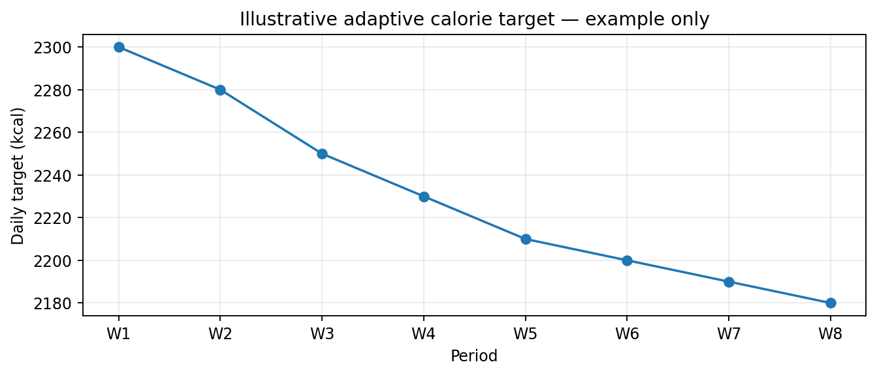
Illustrative only — values are not user measurements or product defaults.

6. WORKOUT / EXERCISE LIBRARY
The Library is the reusable source of exercises and workouts/templates. It should support discovery and composition without taking over the execution page.
- Exercise definitions.
- Exercise search.
- Muscle / body-area metadata.
- Equipment metadata.
- Movement/category metadata.
- Reusable workout templates.
- Selection into scheduled workouts.
- Future extensibility for exercise media/instructions and richer metadata.

7. WORKOUT — ACTIVE EXECUTION
- Open the workout assigned to today or started from the Dashboard.
- Show the planned exercise sequence.
- Log actual sets, reps, weight/load and relevant performance data.
- Provide previous-performance context for progression.
- Allow completion of exercises and the overall session.
- Create the historical workout record used by Progress, XP, recovery and muscle-volume systems.

7.1 Workout data flow
PLANNED EXERCISE | SET 1 | SET 2 | … | SET N | EXERCISE COMPLETE | SESSION COMPLETE
PLANNED EXERCISE → SET 1 → SET 2 → … → SET N → EXERCISE COMPLETE → SESSION COMPLETE

8. PROGRESS & ANALYTICS
- Body-weight trend.
- Measurements such as waist and other user-selected metrics.
- Exercise performance / strength progression.
- Personal records.
- Workout adherence.
- Training volume and muscle exposure.
- Calorie/energy trend.
- XP/level progression.
- Historical workout context.

8.1 Illustrative weight graph
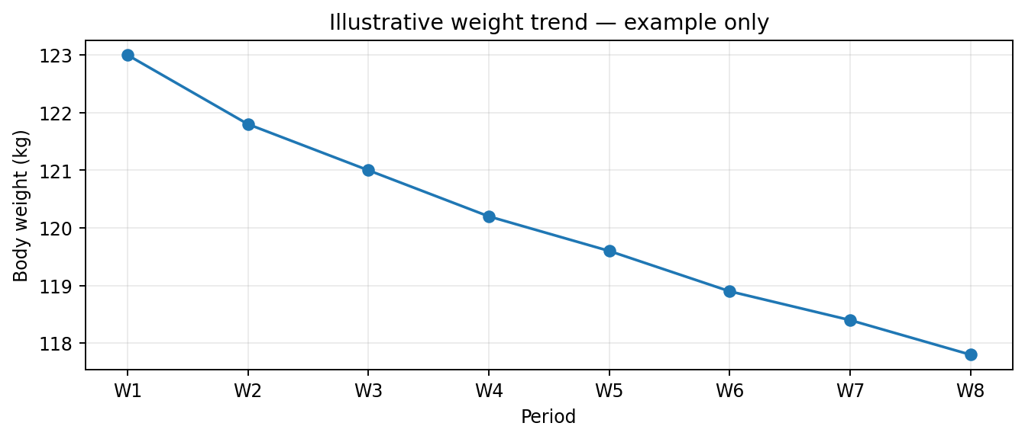
Illustrative only — example visualization of the kind of trend GYM EXP can show.

8.2 Illustrative strength graph
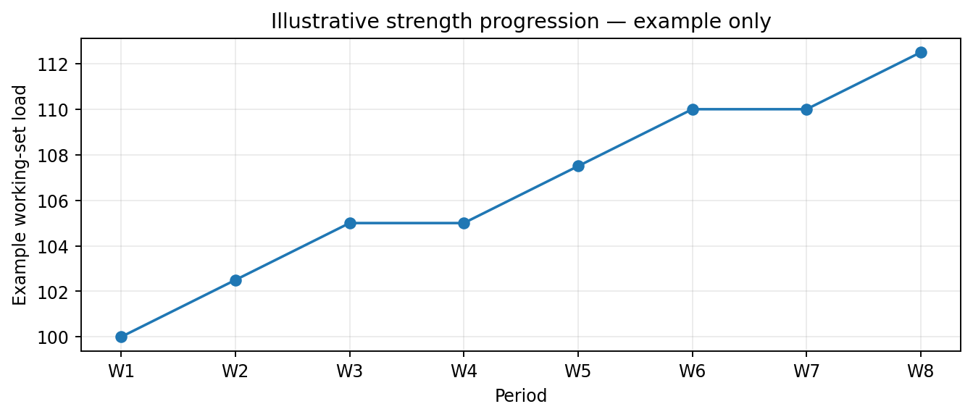
Illustrative only — example visualization, not a prescribed progression.

9. RECOVERY / ADAPTIVE TRAINING
The long-term system should not blindly repeat a static routine. It should understand recent training context and help decide what makes sense next.
- Recent muscle/activity exposure.
- Training frequency and volume.
- Recent performance.
- Rest/recovery context.
- Schedule constraints.
- Potentially accumulated fatigue signals.
- Adapt future plans without silently rewriting user intent.
RECENT TRAINING | RECOVERY CONTEXT | CURRENT PLAN | ADAPTATION | NEXT SESSION
RECENT TRAINING → RECOVERY CONTEXT → CURRENT PLAN → ADAPTATION → NEXT SESSION

10. EXP / RPG SYSTEM
Starting state: Level 1, XP 0.
- XP should reward meaningful fitness behavior, not just arbitrary numeric entry.
- Level progression should be understandable and visible.
- Achievements/milestones can reinforce meaningful consistency.
- Streaks/challenges can reinforce adherence.
- XP should be server-authoritative where appropriate.
- Ranking should not be designed around raw self-reported weight alone.

10.1 XP integrity problem
A user can theoretically type an inflated dumbbell/barbell weight. If XP is directly proportional to that number, the ranking system becomes trivial to exploit.
USER INPUT | VALIDATION | PLAUSIBILITY / ANOMALY CHECK | XP RULES | XP AWARD | RANKING
USER INPUT → VALIDATION → PLAUSIBILITY / ANOMALY CHECK → XP RULES → XP AWARD → RANKING
- Use plausibility/range checks.
- Detect implausible progression jumps.
- Avoid unlimited reward from one manually entered metric.
- Use multiple signals: completion, consistency, progression, session quality and other validated/reported context.
- Flag suspicious data rather than blindly rewarding it.
- Keep ranking eligibility stricter than ordinary personal logging if necessary.

10.2 Illustrative XP progression
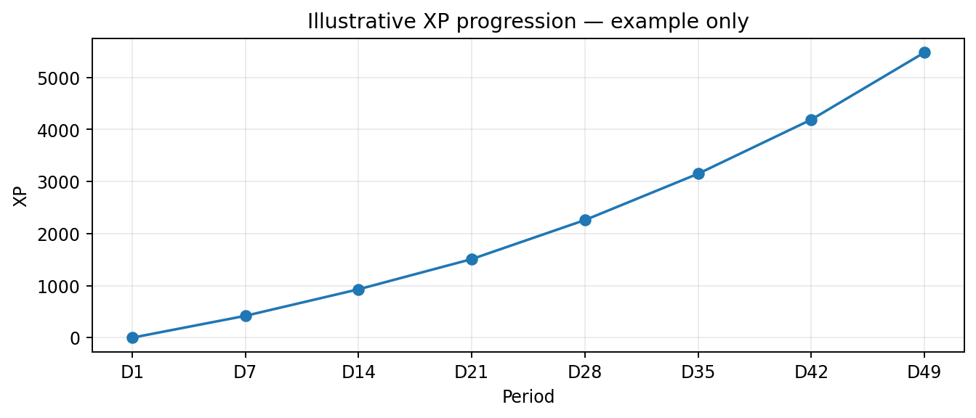
Illustrative only — the actual XP curve remains a product-design decision.

11. RANKINGS / COMPETITION
- Ranking is a future/social layer, not a license to make self-reported numbers the sole source of truth.
- Rankings should use abuse-resistant XP and eligibility rules.
- Potential suspicious data should be handled through validation/flags rather than public accusations.
- Competition should reward consistent legitimate engagement, not simply the largest typed weight.

12. AUTHENTICATION & IDENTITY
- Signup/login is required.
- Preferred methods: Google sign-in and email.
- Username must be unique.
- Duplicate username error text: 'username already exists'.
- Account identity should anchor schedules, workout history, progress, XP and settings.
SIGN UP / SIGN IN | ACCOUNT | USERNAME | PROFILE | PERSONAL DATA | GYM EXP
SIGN UP / SIGN IN → ACCOUNT → USERNAME → PROFILE → PERSONAL DATA → GYM EXP

13. VISUAL DESIGN SYSTEM
The visual identity is locked around a dark futuristic VOID HUD with Liquid Glass qualities: translucent/blurred panels, fine borders, restrained glow, technical/angular structure, cyan energy accents and monospace telemetry. The intended influence is Solo Leveling / RPG HUD, but the product should remain premium and minimal rather than becoming noisy cyberpunk.
Visual element | Direction
Base | Dark / VOID-like environment.
Panels | Translucent glass, blur, subtle depth.
Energy accent | Cyan / restrained glow.
Typography | Clean premium UI + technical/monospace telemetry where appropriate.
Geometry | Technical/angular panels and controlled HUD framing.
Motion | Purposeful feedback; avoid excessive animation.
Overall | Premium, minimal, futuristic.
Avoid | Neon overload, clutter, gimmicky cyberpunk styling.

13.1 UI composition principle
INFORMATION HIERARCHY | GLASS PANEL | PRIMARY ACTION | TELEMETRY | DETAIL
INFORMATION HIERARCHY → GLASS PANEL → PRIMARY ACTION → TELEMETRY → DETAIL
Liquid Glass is a visual language, not an excuse to make every element translucent. Important actions and data must remain readable.

14. SYSTEM / DATA ARCHITECTURE
Entity | Purpose | Key relationship
User | Identity/account. | Owns profile, schedules, sessions and progress.
Profile | Goals/preferences/body baseline. | Belongs to User.
Exercise | Canonical reusable exercise definition. | Used by workouts/templates.
Workout Template | Reusable workout structure. | Can be assigned to scheduled days.
Scheduled Workout | Planned activity on a date. | References template/content and belongs to User.
Workout Session | Actual performed workout. | Created from a scheduled workout or started directly.
Exercise Set Log | Actual set-level performance. | Belongs to Workout Session / Exercise.
Body Weight Entry | Weight history. | Belongs to User; unit normalized.
Measurement Entry | Body measurements. | Belongs to User.
Calorie Record | Intake/energy-balance context. | Belongs to User/date.
XP Event | Reason XP was awarded. | Auditable progression record.
Achievement | Milestone definition/state. | Linked to user progress.
Recovery Signal | Training/recovery context. | Feeds adaptive logic.

14.1 Core data relationship visual
USER | PROFILE | EXERCISE / TEMPLATE | SCHEDULED WORKOUT | WORKOUT SESSION | SET LOGS
USER → PROFILE → EXERCISE / TEMPLATE → SCHEDULED WORKOUT → WORKOUT SESSION → SET LOGS
SET LOGS | BODY METRICS | CALORIE DATA | ANALYTICS | XP / ACHIEVEMENTS | ADAPTIVE ENGINE
SET LOGS → BODY METRICS → CALORIE DATA → ANALYTICS → XP / ACHIEVEMENTS → ADAPTIVE ENGINE

15. ENGINEERING PRINCIPLES
- Build mobile-first.
- Persist user-owned data in a real backend rather than relying on UI-only state.
- Separate planned entities from actual historical entities.
- Keep business logic such as XP and important calculations authoritative where possible.
- Design APIs/data models so a future native app can consume the same backend.
- Keep exercise definitions reusable and independent from individual workout logs.
- Preserve historical workout records rather than overwriting them when a template changes.
- Treat manual data as user-reported data and build validation around high-impact metrics.

16. ITERATION HISTORY & CORRECTIONS
Earlier problem / iteration | Correction / current lesson
Schedule was initially too static; only workout template felt editable. | Schedule must be a real daily planning/editing surface.
Library and Schedule relationship was unclear. | Use the workout/exercise source inside the planning workflow while retaining clear planning vs execution responsibilities.
Schedule and Workout were accidentally conflated in summaries. | Schedule = plan; Workout = execute.
A prior blueprint omitted intelligent calorie calculation. | Calorie intelligence is explicitly part of the COC.
Concern that rankings can be faked through manual weight entry. | XP/ranking require anti-abuse design.
UI risk of excessive futuristic styling. | Keep the dark HUD/Liquid Glass aesthetic premium, minimal and restrained.

17. MASTER DEVELOPMENT PHASES

PHASE 0 — COC / FOUNDATION
- Lock product vocabulary and architecture.
- Lock visual design system.
- Define core entities and relationships.
- Define authentication foundation.

PHASE 1 — MOBILE WEB FOUNDATION
- Responsive mobile-first shell.
- Authentication.
- Profile and account.
- Core navigation.
- Exercise/workout data foundations.

PHASE 2 — PLAN + EXECUTE
- Dashboard command center.
- Schedule/calendar.
- Workout/exercise library/source.
- Workout editing and exercise ordering.
- Templates.
- Active workout and set logging.
- History.

PHASE 3 — PROGRESS + CALORIE INTELLIGENCE
- Weight and measurements.
- Strength history.
- Trend charts.
- Calories consumed.
- Exercise expenditure estimation.
- Deficit/projection.
- Adaptive calorie target.

PHASE 4 — EXP / RPG
- Level 1 / 0 XP baseline.
- XP event system.
- Levels.
- Achievements.
- Streaks/challenges.
- Anti-abuse logic.

PHASE 5 — RECOVERY + ADAPTIVE ENGINE
- Training exposure.
- Recovery signals.
- Adaptive recommendations.
- Smarter scheduling support.

PHASE 6 — AI COACH
- Contextual coaching.
- Training explanations.
- Progress interpretation.
- Nutrition/calorie interpretation.
- Personalized next-step recommendations.

PHASE 7 — SOCIAL / ACTIVITY / WEARABLES
- Rankings.
- Challenges.
- Activity integrations.
- Wearables.
- Trust and anti-abuse expansion.

PHASE 8 — NATIVE APPLICATION
- Native mobile app after web foundations and backend are mature.
- Reuse the established data model and business logic.

17.1 Dependency visual
FOUNDATION | AUTH | EXERCISE DATA | PLAN | EXECUTE | TRACK | CALORIE INTELLIGENCE | XP | ADAPT | AI | SOCIAL | NATIVE APP
FOUNDATION → AUTH → EXERCISE DATA → PLAN → EXECUTE → TRACK → CALORIE INTELLIGENCE → XP → ADAPT → AI → SOCIAL → NATIVE APP

18. SCREEN / MODULE INVENTORY
Screen / module | MVP? | Primary purpose
Dashboard | YES | Today's protocol and command center.
Schedule | YES | Daily planning/calendar.
Workout | YES | Active workout execution/logging.
Workout/Exercise Library | YES | Reusable source and discovery.
Workout History | YES | Past sessions.
Progress | YES / early | Trends and performance.
Profile | YES | Identity, goals, settings.
Authentication | YES | Signup/login.
Calorie Intelligence | YES / staged | Energy target and projection.
XP / Level | YES / staged | RPG progression.
Achievements | STAGED | Milestones.
Rankings | FUTURE | Competition.
Recovery | FUTURE / staged | Adaptive training context.
AI Coach | FUTURE | Contextual coaching.
Wearables | FUTURE | Activity data.
Native app | FUTURE | Mobile application.

19. CROSS-PRODUCT UX RULES
- A user should always know whether they are planning or executing.
- Primary actions should be obvious and touch-friendly.
- Do not make users repeatedly rebuild a workout that already exists as a template.
- When editing a scheduled workout, clearly distinguish day-only changes from template changes.
- Workout completion should create a historical record rather than merely toggling a calendar checkbox.
- Charts should show trends, not overwhelm the user with raw data.
- Calorie outputs should communicate estimates and assumptions.
- XP feedback should feel rewarding without encouraging unsafe or dishonest data entry.
- Futuristic visuals must never reduce readability or make controls ambiguous.

20. FUTURE EXPANSION MAP
- More advanced adaptive training.
- Exercise substitution intelligence.
- Automated deload/recovery recommendations.
- Richer nutrition tracking.
- Meal/nutrition integration.
- AI conversational coaching.
- Wearable/activity synchronization.
- Social challenges and leaderboards.
- Verified performance signals.
- Advanced analytics and personal benchmarking.
- Native mobile application.

21. COC GOVERNANCE RULES
- The latest explicit user decision supersedes an earlier ambiguous suggestion.
- Do not resurrect rejected architecture without an explicit new decision.
- When a feature is uncertain, label it PROPOSED rather than silently treating it as CONFIRMED.
- Do not collapse planning and execution concepts merely because both involve workouts.
- Do not omit cross-cutting systems such as calorie intelligence, EXP integrity or authentication from future blueprints.
- When the project changes architecture, record the change in the COC rather than deleting the historical decision.

22. MASTER BUILD CHECKLIST
☐ COC / vocabulary locked
☐ Visual design system
☐ Mobile-first shell
☐ Authentication
☐ Google sign-in
☐ Email sign-in
☐ Unique username validation
☐ Dashboard command center
☐ Exercise database
☐ Workout / template library
☐ Schedule calendar
☐ Daily workout editing
☐ Exercise search
☐ Exercise reorder
☐ Day-only vs template-update logic
☐ Active workout
☐ Set / rep / load logging
☐ Pre/post workout weight
☐ Workout history
☐ Progress charts
☐ Body measurements
☐ Intelligent calorie calculator
☐ Exercise expenditure estimation
☐ Deficit / projected weight
☐ Adaptive calorie target
☐ Level 1 / 0 XP
☐ XP events
☐ Achievements
☐ Streaks
☐ Anti-cheat / anomaly detection
☐ Rankings
☐ Recovery engine
☐ Adaptive scheduling
☐ AI Coach
☐ Wearable/activity integrations
☐ Social/challenges
☐ Native application

23. ONE-PAGE PRODUCT SUMMARY
GYM EXP / TOJI PROTOCOL is a futuristic, premium fitness RPG and adaptive fitness operating system. The first implementation is a mobile-first website. The user signs in, establishes a profile and goals, sees a command-center Dashboard, plans training through Schedule, selects from reusable exercises/workouts, executes through Workout, and generates historical data. Progress, calorie intelligence, recovery and EXP consume that data. The RPG layer starts at Level 1 / 0 XP and must be resistant to fake self-reported performance. The long-term product adds adaptive training, AI coaching, rankings, activity/wearable integrations, social systems and eventually a native app. The visual identity is a dark VOID HUD with Liquid Glass, cyan energy, technical/angular panels and restrained Solo Leveling-inspired telemetry.

24. COMPLETENESS / LIMITATION NOTE
This COC is substantially expanded and incorporates the project details available through the retained GYM EXP project context and the recovered prior project decisions. It is designed as the master source of truth. Where a prior conversation detail is not present in the retained context, it cannot be reconstructed verbatim without access to that original transcript. Such a detail should not be invented.

