Project Final Report

Group 1:

Demir Altay, Michael Butzlaff, Shea Frembling, Wesley Glover

# Table of Contents:

**Table of Contents:** **1**

**Project Report** **2**

Install: 2

Description: 2

User Function: 3

Login: 3

Blank SQL query: 4

Viewing the Company: 5

Viewing the user accounts: 6

Viewing the login information for users: 7

Viewing addresses: 7

Viewing the payments: 8

Viewing the products: 9

Viewing the orders: 9

Viewing Deliveries: 10

Viewing the Warehouse stocks: 11

Viewing Supplier Information: 11

Viewing the Truck Driver Information: 12

Viewing Store Information: 13

Viewing the Aisle Information: 14

Viewing the shelves: 15

Viewing manager information: 15

Viewing the employee information: 16

Viewing delivery drivers: 17

Inserting information into a table: 18

Deleting information from a table: 18

Logout: 18

# 

# Project Report

## Install:

Language: Python

IDE: vscode

Database: MySQL workbench

In the .zip file there is the DDL.sql, Grocery Store Table Insertions.sql, and main.py. In MySQL workbench run the DDL.sql to create the tables in a database. After the tables are created run the Grocery Store Table Insertions.sql to then fill the tables with information to start. Afterwards you can run the python file “main.py” that will connect to the database with the information you provide on login.

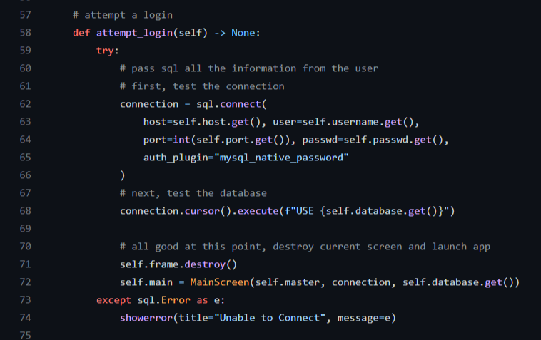

We used the python package mysql.connector to connect to the database. Here is the code used to connect.

## Description:

This project is a method for users to login to a system to check various tables in the database system. The system will allow people to check into a warehouse to see what products are available. Or to check what truck drivers are carrying what products. It also is capable of holding information of the employees, managers, and delivery drivers that work for the grocery store. Someone is also capable of seeing what items are in what aisle on what shelf in the store.This is a system meant to make it easier for the stores to be managed as well as for the company to check on their stores and the flow of products using SQL.

## User Function:

### Login:

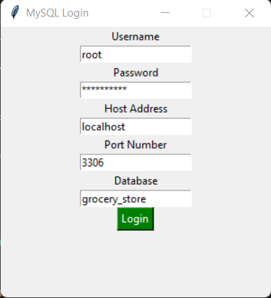

### Blank SQL query:

### Viewing the Company:

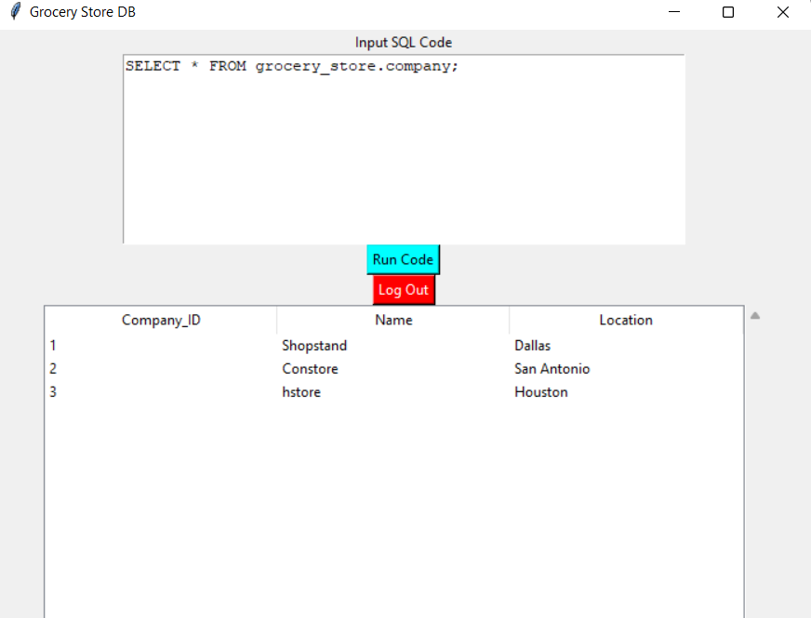

### Viewing the user accounts:

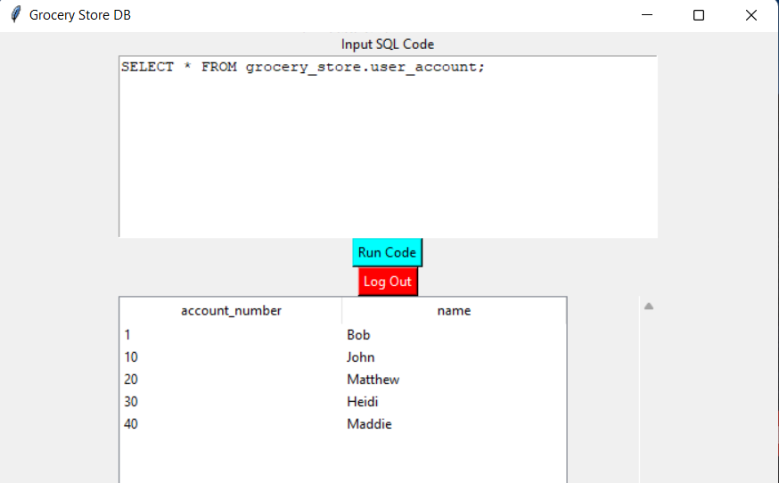

### Viewing the login information for users:

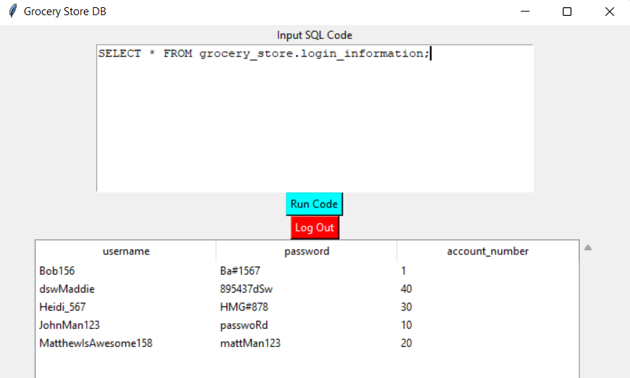

### Viewing addresses:

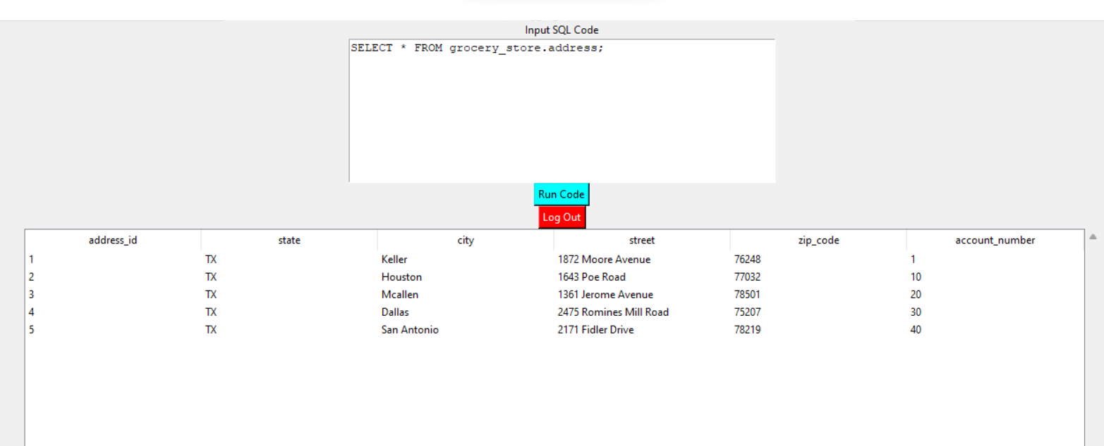

### Viewing the payments:

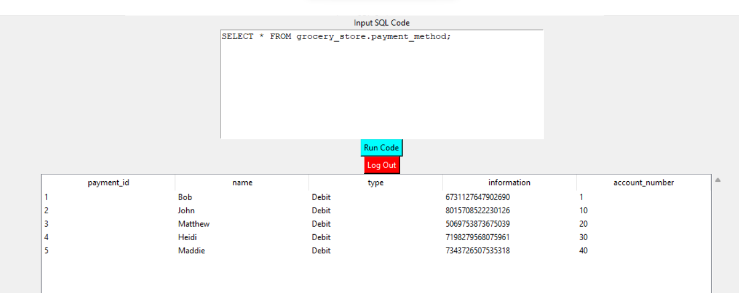

### Viewing the products:

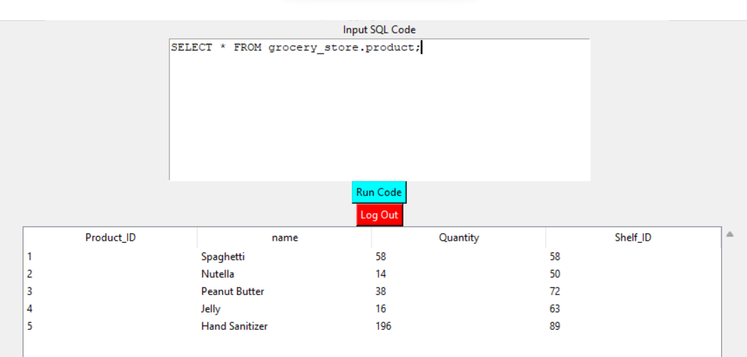

### Viewing the orders:

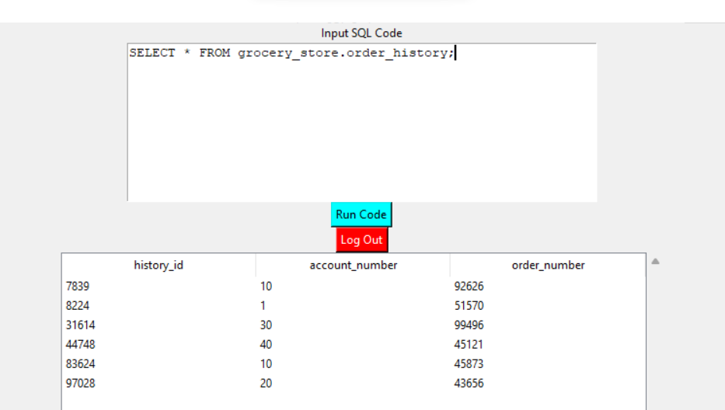

### Viewing Deliveries:

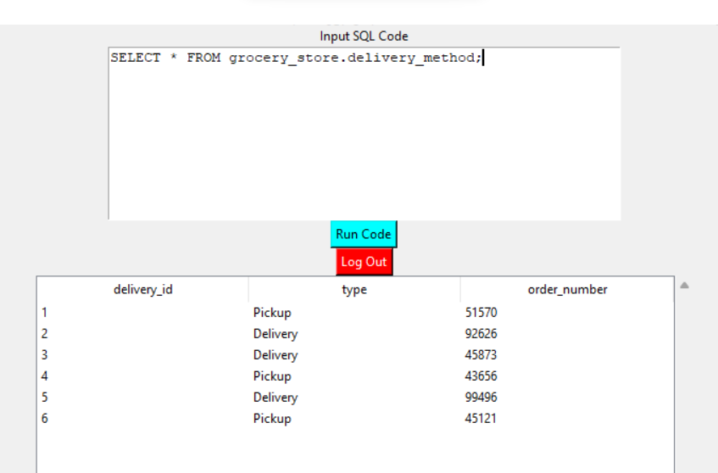

### Viewing the Warehouse stocks:

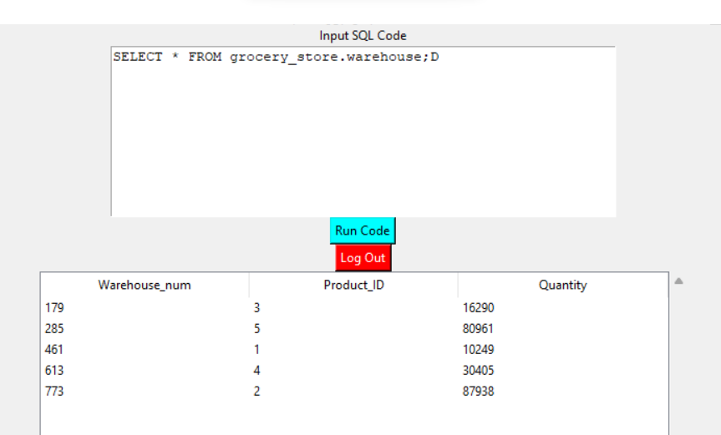

### Viewing Supplier Information:

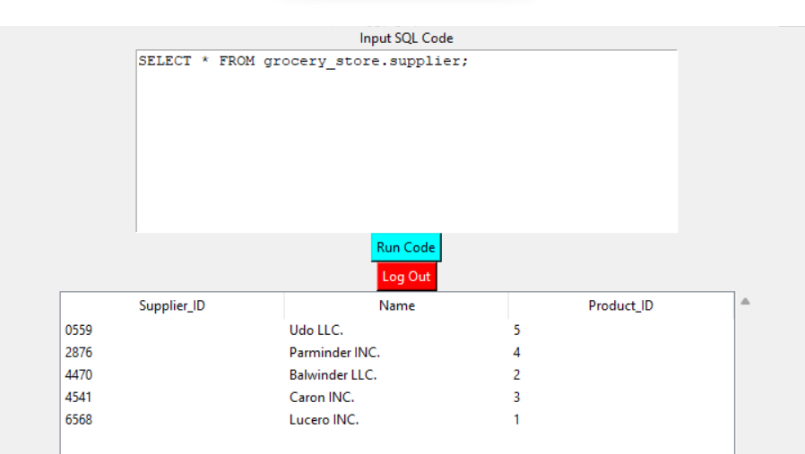

### Viewing the Truck Driver Information:

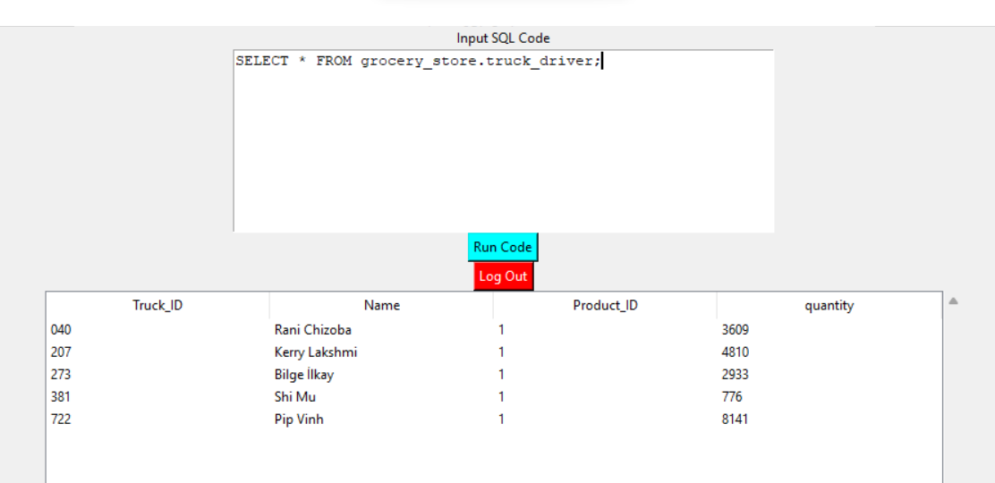

### Viewing Store Information:

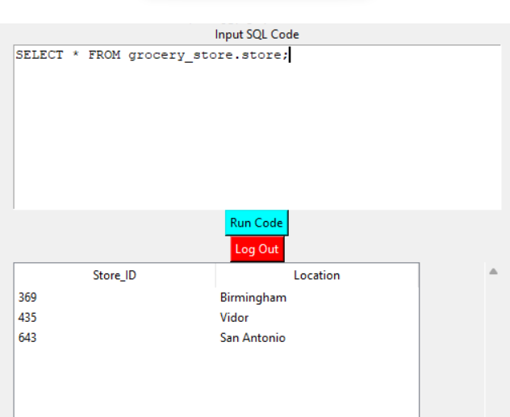

### Viewing the Aisle Information:

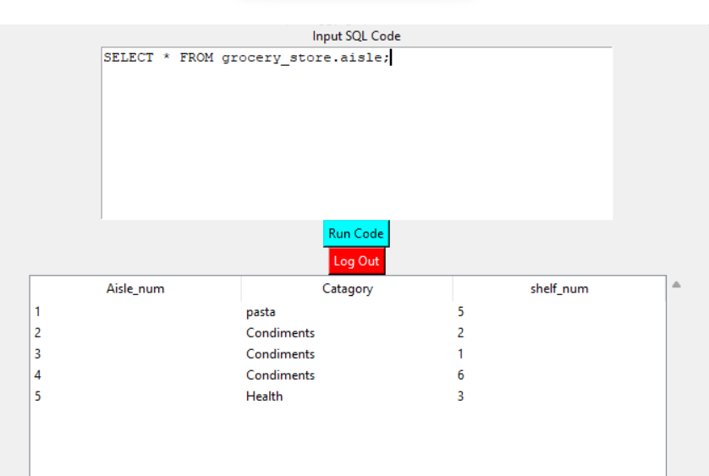

### Viewing the shelves:

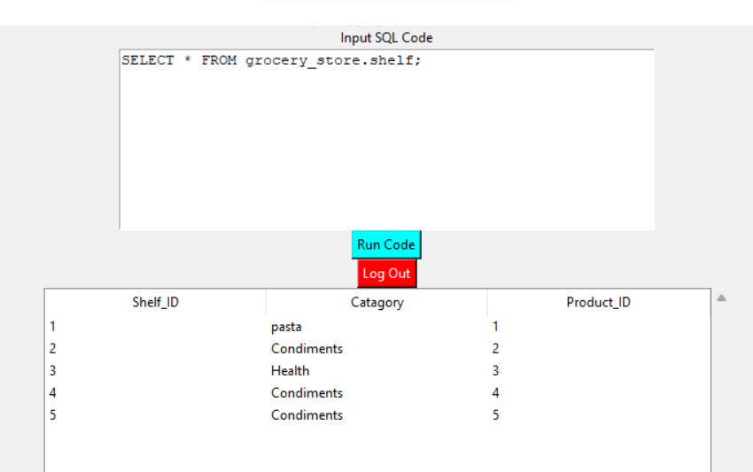

### Viewing manager information:

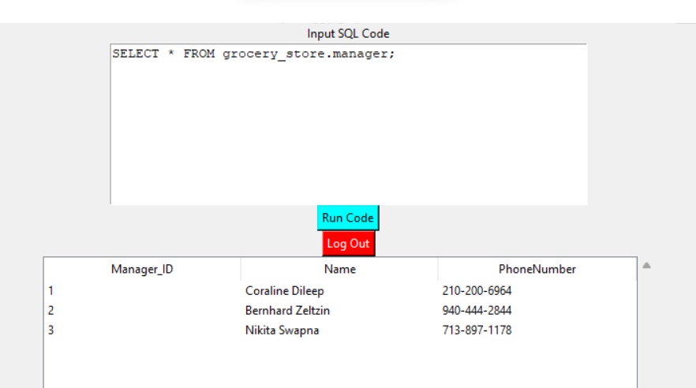

### Viewing the employee information:

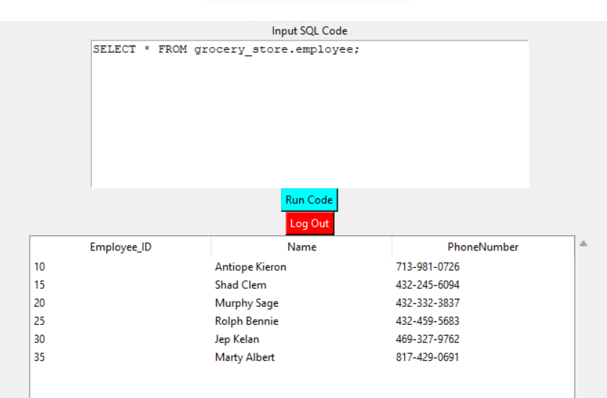

### Viewing delivery drivers:

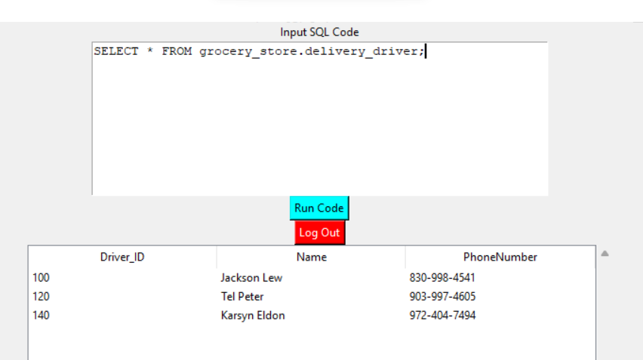

### Inserting information into a table:

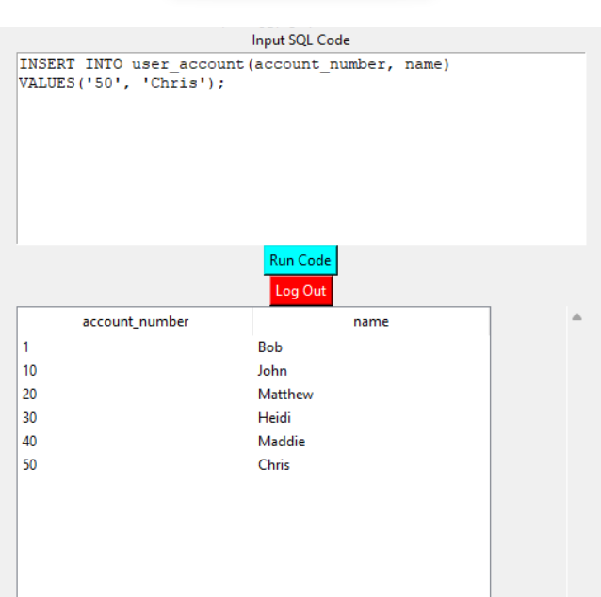

### Deleting information from a table:

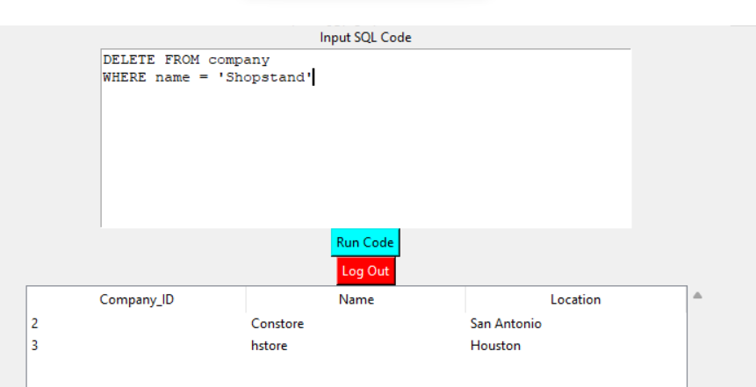

### Logout:

